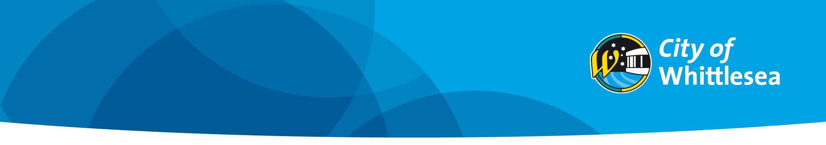

CRM No:…………….
Adjoining Owner Comments

Application for Report and Consent
To Vary the Building Regulations

To: The Municipal Building Surveyor
City of Whittlesea
Locked Bag 1
Bundoora MDC 3083

Adjoining owner/s name/s: ……………………………………………………………………………

Adjoining owner/s of allotment located at: ………………………………………………………..

I/we have sighted and signed the plans for the following proposed building works: (Describe the non-compliance)
……………………………………………………………………………………………………….......
……………………………………………………………………………………………………………
……………………………………………………………………………………………………………

At the following subject allotment: ……………………………………………………..................

Please tick:
I/we □ Object to the City of Whittlesea granting the siting consent as described above and shown on plans provided to me (please provide reasons below)
……………………………………………………………………………………………………….......
……………………………………………………………………………………………………………
……………………………………………………………………………………………………………
I/we □ Have No Objection to the City of Whittlesea granting the siting consent as described above and shown on plans provided to me

Signed: …………………………………………………………………………………………………

Dated: .......................................................................................................................................

Ph: (Mob) ................................................................ H:…………………………………………….

W:…………………......................................................................................................................

Email Address:………………………………………………………………………………………….

Please Note:
▪ The plans/drawings the adjoining owners have sighted are also to be signed and dated.
▪ If you object to the proposed siting dispensation, you are required to provide reasons why you object.

To facilitate the process and ensure Council considers your comments and has received your response, you can scan the documents and email them to buildplan@whittlesea.vic.gov.au
INFORMATION PRIVACY: The information supplied on this form is shared with the Victorian Building Authority, the Electoral Commission and other government agencies as required by law and in accordance with Council’s Privacy Policy which is published at www.whittlesea.vic.gov.au.

