Over the next four years we will continue to work to foster an inclusive, healthy, safe and welcoming community where all ways of life are celebrated and supported. Our community priorities are: Public safety, festivals, events, arts, culture, heritage and markets, social connection: access and inclusion, sports facilities and infrastructure and community groups and community infrastructure.

**Our outcomes**

## 



**Strategic Priorities**

Council recognises that communities are strengthened by their connections with others and the importance of aligning strategic outcomes with the needs and aspirations of our community. Informed by an understanding of our community and research on the challenges and opportunities related to achieving a connected community, Council has eight key focus areas.

|  |
| --- |
| Deliver and facilitate expansion of programs and services that keep older residents independent, connected and supported close to home. |
| Deliver the commencement of Home Care Packages to help older residents stay in their own homes, live independently, and enjoy a high quality of life as their needs change. |
| Partner with the Victorian Government and stakeholders to implement the Best Start, Best Life Reform, including free kindergarten for 3- and 4-year-old children and extending kindergarten hours. |
| Deliver and facilitate culturally safe services and programs for First Peoples children and their families, suited to local needs. |
| Advocate for funding from other levels of government to establish a dedicated youth hub and create additional youth-friendly spaces where young people can thrive. |
| Deliver Council’s Fair Access Policy to ensure women and girls can equally use local sports facilities and feel supported to get involved in sport and recreation. |
| Deliver and operate the Regional Sports Precinct in Mernda consisting of an indoor stadium with four multi-purpose courts, lit outdoor netball courts, a netball pavilion, car parking, pathways, lighting, landscaping and wetlands. |
| Deliver the new Wollert Sports Reserve consisting of playing fields with lighting, a new multi-purpose sporting spaces, playground, car parking and a community pavilion, |
| Deliver the Huskisson Reserve Multi-Purpose Facility in Lalor consisting of new multi-purpose community pavilion, redevelopment of the existing tennis courts into new courts with lighting, car parking, pathways and landscaping. |
| Deliver the new Edgars Creek Recreation Reserve in Wollert consisting of a new multi-purpose community pavilion, an additional oval, outdoor sport courts, open space and a recreation area and car parking. |
| Deliver the new Ashley Park Recreation Reserve in Doreen consisting of two playing fields with lighting, a new multi-purpose community pavilion, playground and car parking. |
| Partner with external emergency and welfare services to explore the feasibility of a Safer  Neighbourhoods Expo to enhance community education and awareness of available services. |
| Partner with First Peoples communities to co-design and deliver programs and activities at the Aboriginal Gathering Place throughout the municipality that support social, physical, cultural, emotional and wellbeing needs. |
| Facilitate increased awareness and advocate about the risks of gambling harm in the City of Whittlesea. |
| Advocate and facilitate the expansion of local services to support individuals experiencing homelessness and those at risk. |
| Facilitate local services to improve access to fresh, healthy, affordable, culturally appropriate food; respond to food insecurity and promote healthy eating. |
| Advocate for equality and partner on initiatives that build a safe, respectful community with  zero tolerance for all forms of violence, including family, gender-based, racial, faith-based and  LGBTQIA+ violence. |
| Advocate for and facilitate improved access to mental health services and partner to raise awareness and deliver preventative programs. |
| Support service providers to expand initiatives that promote inclusion and participation of people with disabilities in community life, employment and education. |
| Deliver a revitalisation program for the Plenty Ranges Arts and Convention Centre (PRACC) to enhance its role as a hub for performing arts and creative industries. |
| Deliver accessible precincts for people living with a significant disability and their carers, including enhanced facilities, sensory spaces and greater flexibility in utilising community facilities. |
| Partner with other Councils to renew the regional Library Services Agreement and to transition the service to a new entity as required by the Local Government Act 2020. |
| Deliver the West Wollert Community Centre providing kindergarten/early years rooms, maternal child health consulting rooms, a community hall, lounge and library space, meeting rooms and a community garden. |
| Deliver the Murnong Community Centre in Donnybrook providing kindergarten/early years rooms, maternal child health consulting rooms, a community hall, lounge and mini-branch library space and meeting rooms. |

# 

Over the next four years we will ensure our City is well planned and that our neighbourhoods and town centres are convenient and vibrant places to live, work and play. Our community priorities are: new and upgraded parks and playgrounds, transport improvements, local shops, social and affordable housing, clean streets and spaces, traffic management and road safety.

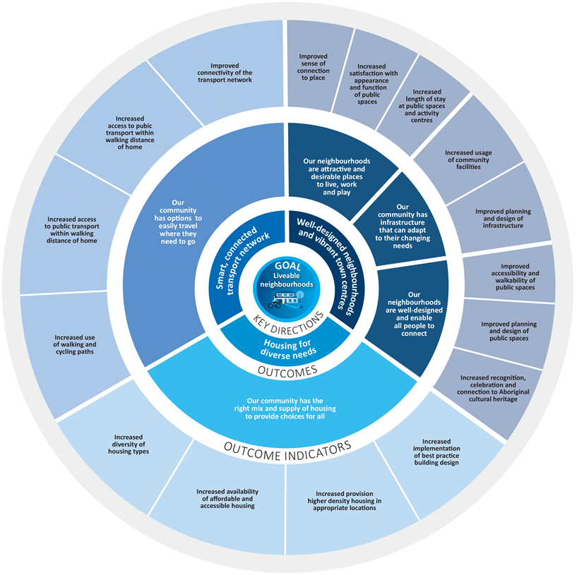**Our outcomes**

**Strategic Priorities**

Our neighbourhoods comprise a range of elements that contribute to their liveability. Council has four key focus areas related to neighbourhood liveability.

|  |
| --- |
| Deliver the Yan Yean Pipe Track and Edgars Creek Trail shared paths to increase recreation opportunities and sustainable transport options in line with the City of Whittlesea Walking and Cycling Plan and Northern Trails Strategy. |
| Deliver a Parking Policy to manage the allocation and regulation of parking, balancing the needs of all users while supporting Council’s safety, efficiency, and environmental sustainability goals. |
| Advocate for expanded transportation options and improvements to the transport network, including road upgrades, enhanced shared pathways, and increased public transport, such as the Wollert Rail. |
| Deliver the Granite Hills Major Community Park featuring an adventure park and playground, open-air pavilion, public barbecues, giant slides, nature and water play and public toilets with a changing places facility. |
| Deliver the staged construction of VR Michael Reserve Master Plan in Lalor providing an upgraded dog off leash area, central lawn, circuit paths, toilet facilities, exercise fitness station and car parking. |
| Deliver feasibility assessments for key future infrastructure for our growing community. |

|  |
| --- |
| Deliver the staged construction of Whittlesea Park Master Plan in Whittlesea Township providing trees, play spaces, circuit paths, bridges and car parking. |
| Deliver the staged construction of Lalor Recreation Reserve Master Plan in Lalor, Lowalde Recreation Reserve Master Plan in Epping, Nick Ascenzo Reserve in Thomastown, Whittlesea Public Gardens in Lalor and Mernda Recreation Reserve Master Plan in Mernda. |
| Deliver improved lighting of shared paths to provide the community with extended hours for exercise and recreation, enhance perceptions of safety, and provide increased sustainable transport options. |
| Deliver the Suburb Place Frameworks to enhance the municipality’s distinct character, improve safety, enhance public spaces and upgrade infrastructure. |
| Deliver revitalised and upgraded neighbourhood streetscapes and shopping precincts to enhance accessibility local spending. |
| Deliver a review of the Whittlesea Planning Scheme to ensure planning policies and controls achieve high quality design and sustainable development outcomes. |
| Deliver an affordable housing plan which defines Council’s role and proposes future projects that deliver diverse housing opportunities for our community. |
| Deliver the Ashline Street Affordable Housing Project in Wollert, partnering with a community housing organisation to provide affordable homes and a community park. |
| Deliver the Johnsons Road residential development in Mernda, comprising at least 35 homes, including affordable housing, open spaces, and pathways linking to the Plenty River. |



Over the next four years we will seek to make our City a smart choice for innovation, business growth and industry investment as well as supporting local businesses to be successful, enabling opportunities for local work and education. Our community priorities are: supporting local business, local employment, economic development, delivering libraries, schools and early years education, technology and innovation and creating employment pathways.

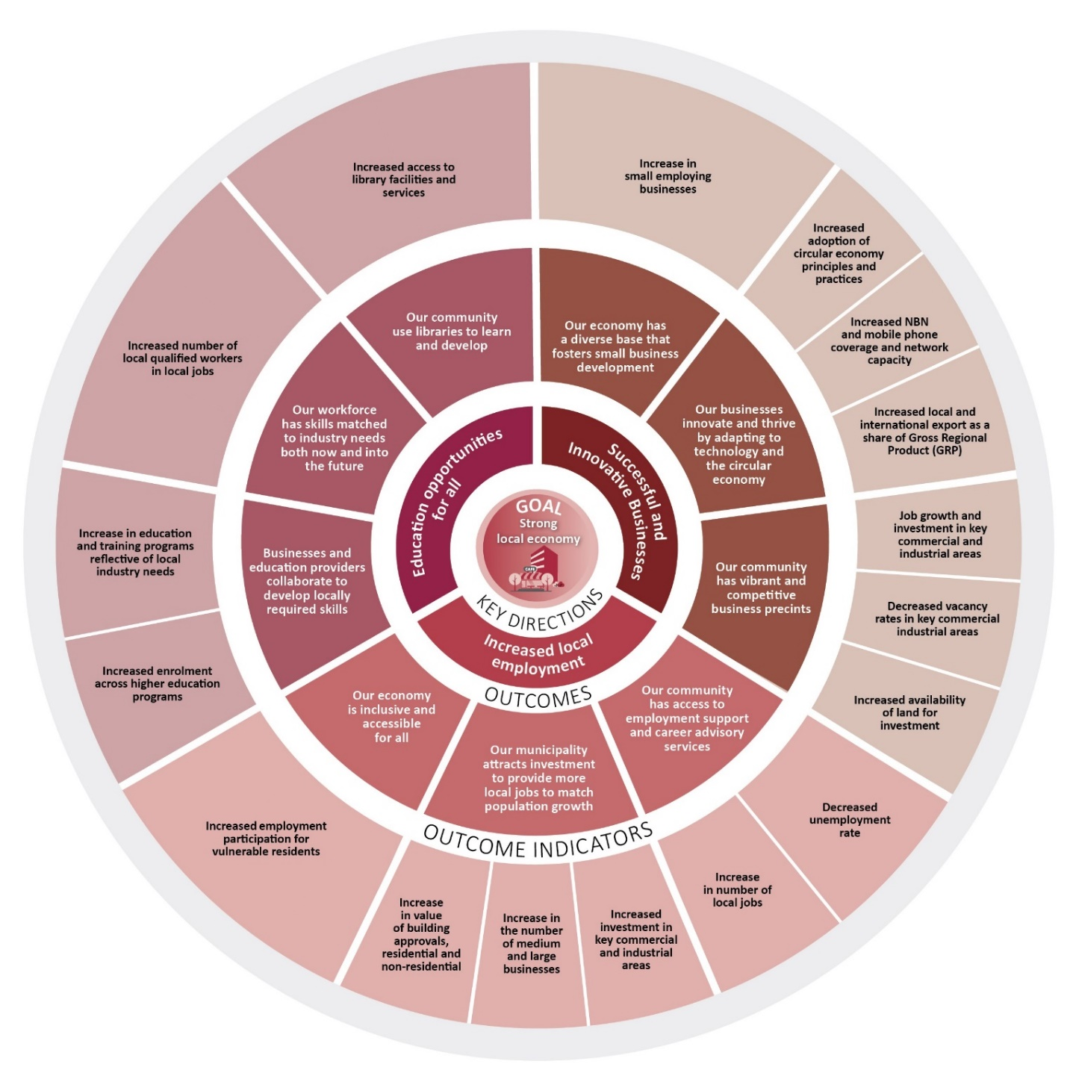**Our outcomes**

**Strategic Priorities**

|  |
| --- |
| Advocate for the creation of local jobs and other community benefits as outcomes from the planning and development of the Intermodal Freight Precinct in Beveridge which on completion will be the largest intermodal precinct in Australia transforming the nation’s supply chain and providing economic benefits to the region. |
| Deliver a campaign to attract major festivals and events to the region to increase visibility and promotion and promote social cohesion. |
| Facilitate greater community use and activation of Council-owned facilities to encourage a broader range of uses, participation across all life stages and improved accessibility for everyone in the community. |
| Develop and implement a new Strong Local Economy Strategy to support the growth of the local business community, promote investment, local employment, and education opportunities, enhancing social connections and economic sustainability. |

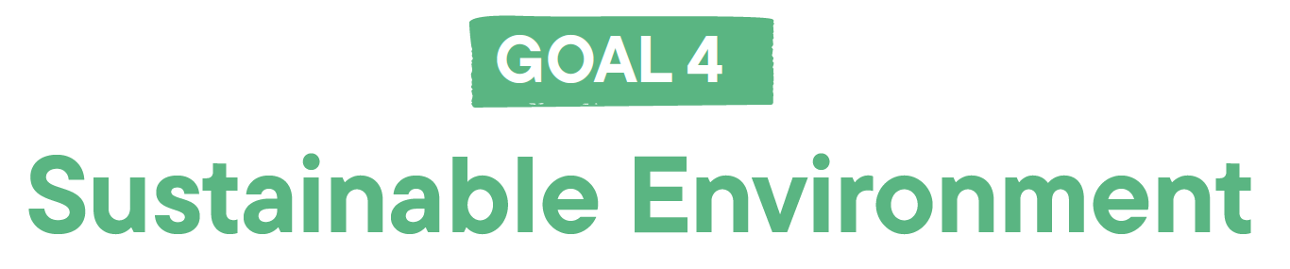

Over the next four years we will prioritise our environment and take action to reduce waste, preserve local biodiversity, protect waterways and green spaces and address climate change. Our community priorities are: waste management, biodiversity, community education and awareness, maintaining and increasing the number of trees, sustainable energy and infrastructure , water quality and security and climate change action and awareness.

**Our outcomes**

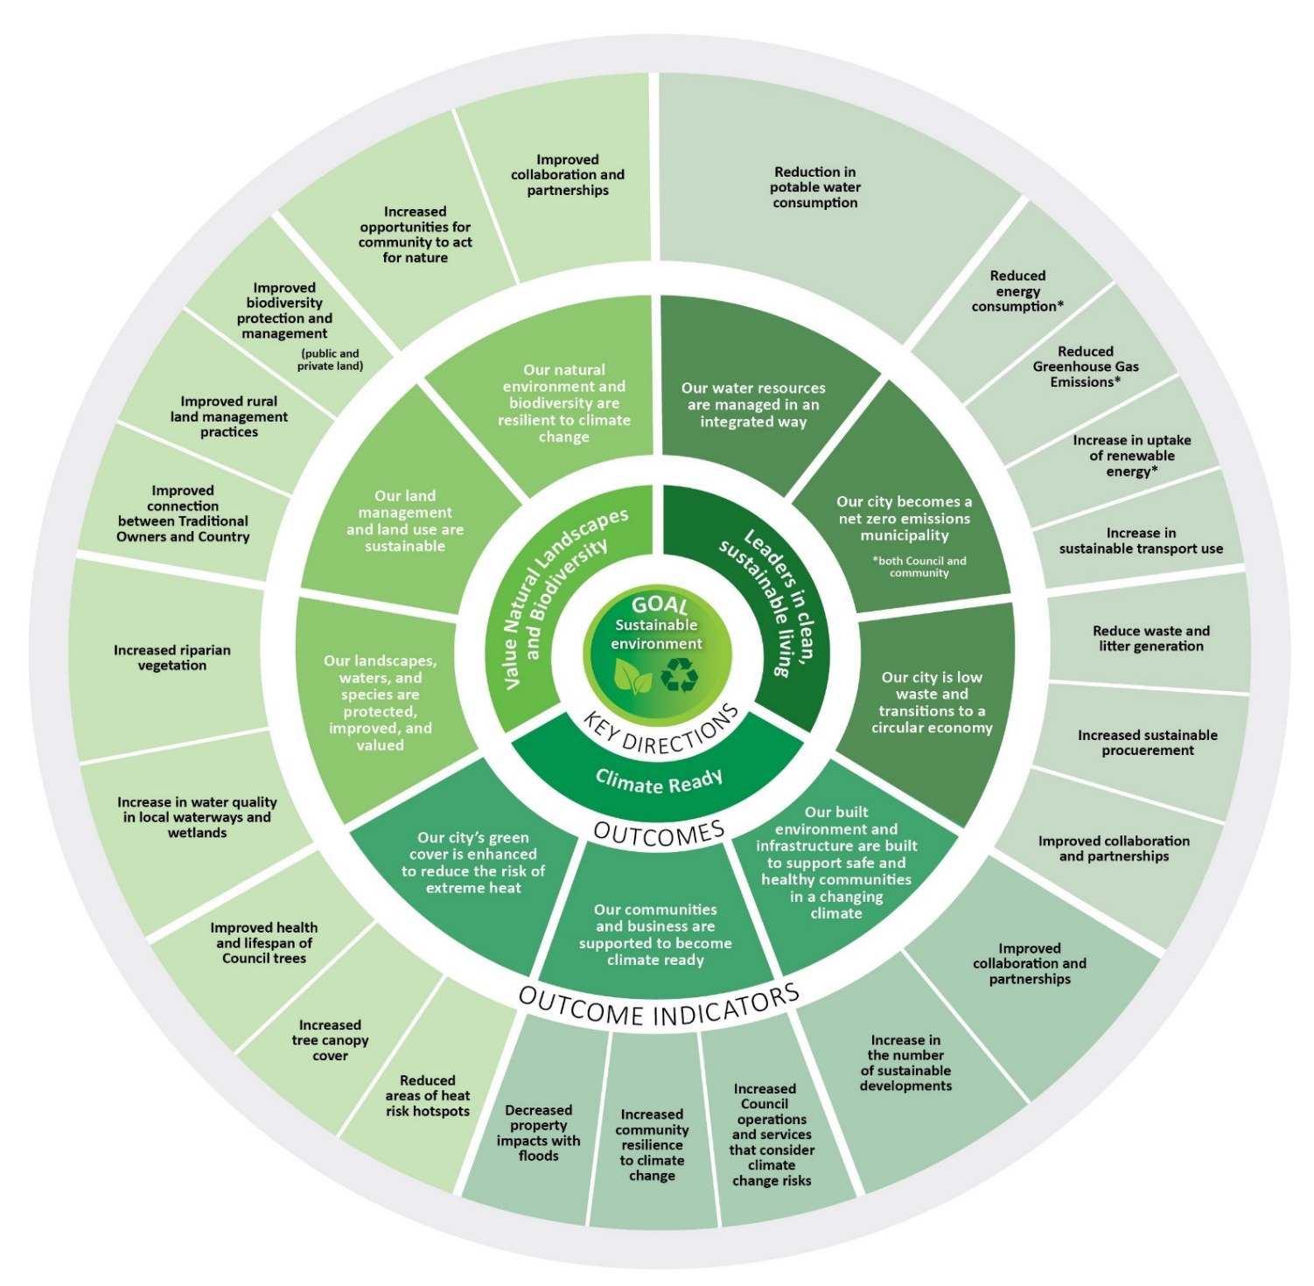

**Strategic Priorities**

Our environment is a complex system comprising of dynamic and interacting natural, built, and human elements. This Strategy covers seven key focus areas related to environmental sustainability.

|  |
| --- |
| Deliver and advocate for initiatives that help people and businesses make homes and workplaces more comfortable, energy-efficient, and environmentally friendly. |
| Provide additional opportunities to generate local carbon offsets on Council owned and private land to help reduce municipal wide carbon emissions. |
| Deliver the City Forest program, planting over 60,000 trees and working towards a target of an additional tree per resident across the municipality, to increase canopy cover, decrease urban heat and enhance biodiversity. |
| Deliver new stormwater harvesting at Council-owned sports fields and facilities to reduce potable water reliance, enhance water conservation and generate savings. |
| Deliver a targeted program to eliminate rubbish dumping, including stronger enforcement, shorter wait times for collection, and community education on waste minimisation, illegal dumping, and recycling. |
| Deliver the food and garden waste service to all households in the municipality and trial new waste and recycling collection services for waste such as soft plastics. |
| Deliver increased reuse and repurposing of materials in Council's asset maintenance and renewal programs. |
| Deliver the revitalisation of Peter Hopper Lake in Mill Park to improve water quality and habitat for flora and fauna and enhance local area. |



Over the next four years we will work to ensure Council engages effectively with the community, delivers efficient and effective services and initiatives, makes decision in the best interest of the community and delivers value to the community. Our community priorities are: customer service and responsiveness, communication and engagement with our community, service quality and Council performance.

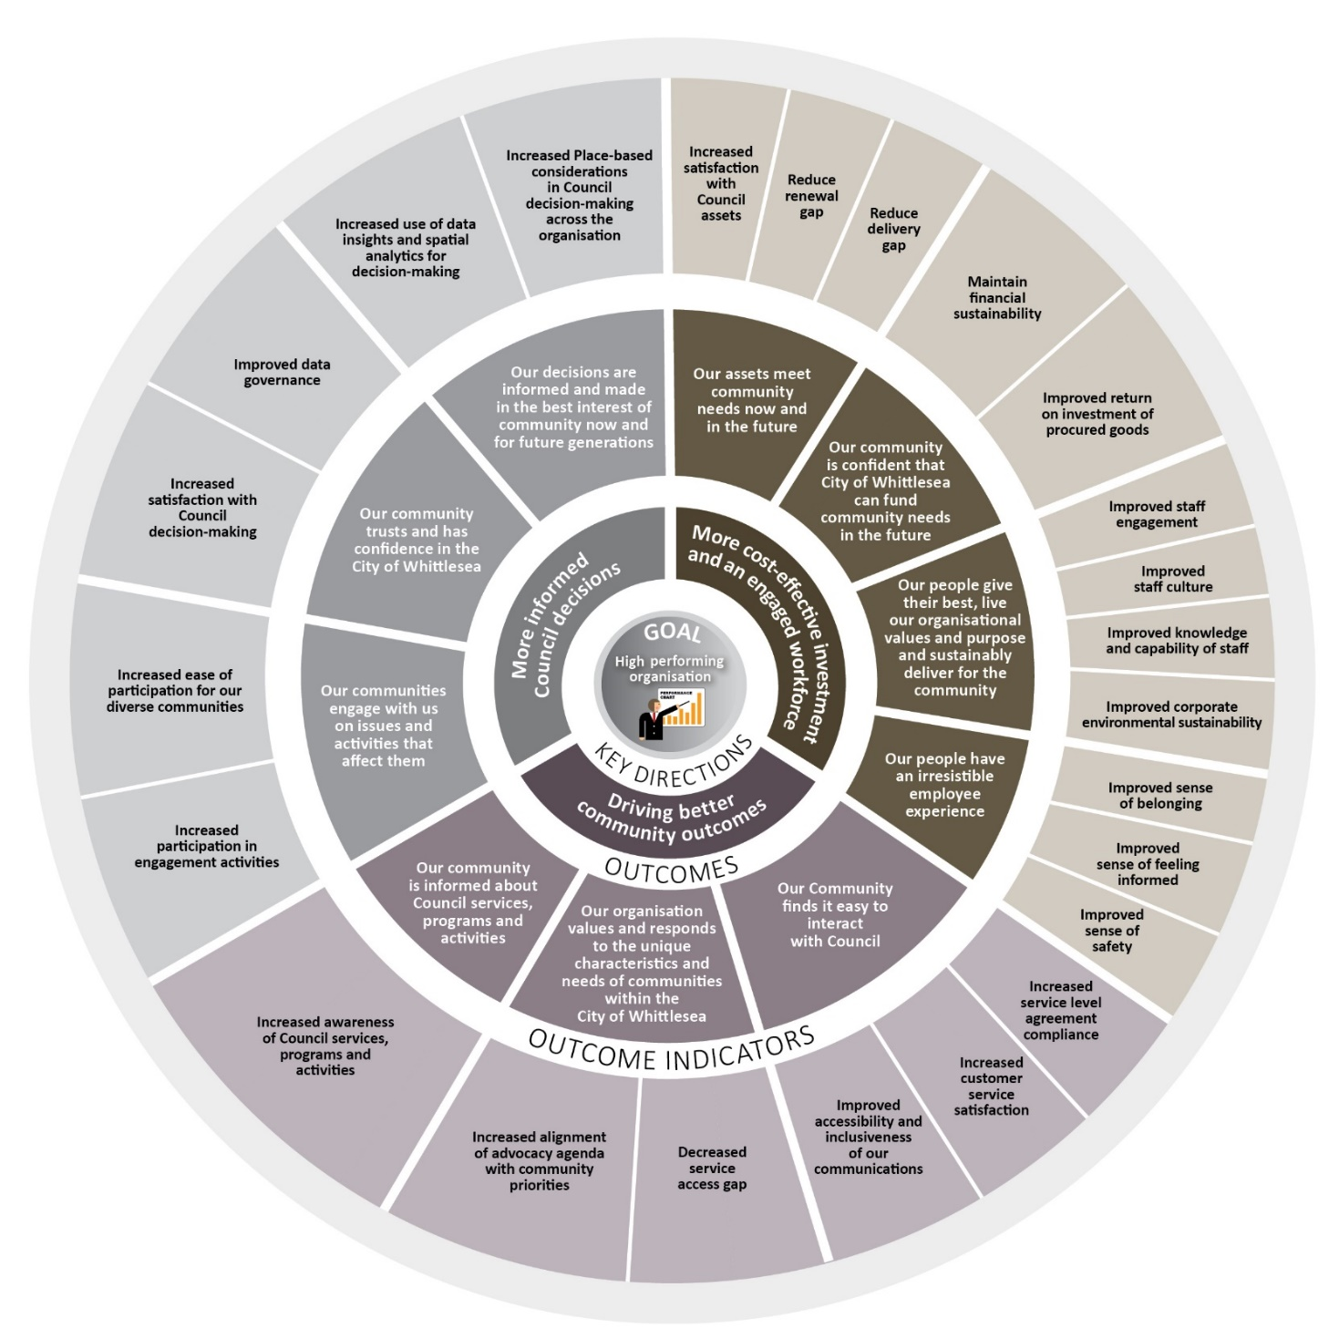**Our outcomes**

**Strategic Priorities**

The City of Whittlesea is responsible for enabling the rapid growth and development of our region, meeting the ever-expanding needs of our community, and maintaining our commitment to excellence in all that we do. This Strategy covers the seven key focus areas identified as critical to the organisation’s performance.

|  |
| --- |
| Deliver innovative and technology-driven solutions to continually enhance customer experience and improve the effectiveness and efficiency of Council’s operations. |
| Facilitate the reduction, removal and prevention of barriers for marginalised and at risk groups to contribute to Council decisions. |
| Deliver service and innovation reviews to identify ways to improve efficiency, investing in technology like artificial intelligence to boost productivity, optimise resource use and lower costs. |
| Deliver the long term financial sustainability of Council through the optimisation of resources, infrastructure and asset management. |