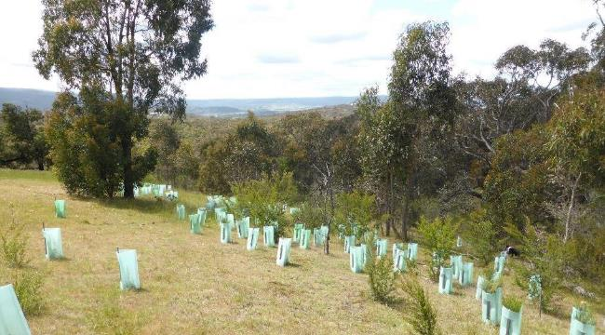

Environmental Works Grant Program Application Guidelines 2026-2027

Updated: 26 August 2026

Contents
Environmental Works Grant Program Application Guidelines 2026-2027 1
What is the Environmental Works Grant Program? 3
Key Dates 4
Application details 4
Who can apply? 4
What can be funded? 4
Small grants 4
Project grants 5
Who cannot apply? 6
What cannot be funded? 6
Decision making 6
Grant assessment criteria 6
Assessment process 9
How to apply 9
Successful applications 10
Unsuccessful applications 10
Mandatory conditions 10
Eligible grant activities and funding arrangements 11

Cover image:
Revegetation enhancing remnant vegetation, Beveridge

Acknowledgement of Traditional Owners
The City of Whittlesea recognises the rich Aboriginal heritage of this country and acknowledge the Wurrundjeri Willum clan and Taungurung People as the Traditional Owners of lands within the City of Whittlesea.

What is the Environmental Works Grant Program?
The City of Whittlesea’s Environmental Works Grant Program (EWGP) is an incentive program that provides financial support to rural landowners undertaking projects that protect and enhance remnant vegetation and promote local wildlife conservation.
The EWGP supports the delivery of the Sustainable Environment Goals outlined in Whittlesea 2040: A place for all as well as Council’s Sustainable Environment Strategy 2022-2032.
The primary focus of this program aligns with Key Direction 1 – valued natural landscape and biodiversity.
The program supports the achievement of key outcomes:
- our landscapes, waters and species are protected, improved and valued;
- our land management and land use are sustainable, and
- our natural environment and biodiversity are resilient to climate change.
To be eligible for the grant, applicants must:
- propose a project that aligns with the Sustainable Environment Goals and outcomes
- meet the eligibility criteria outlined in this document
- demonstrate a willingness to contribute - whether through financial investment, provision of materials, or in-kind labour.
Grant Pool:
- small grants – up to $3,000 per applicant
- project grants – up to $6,000 per applicant
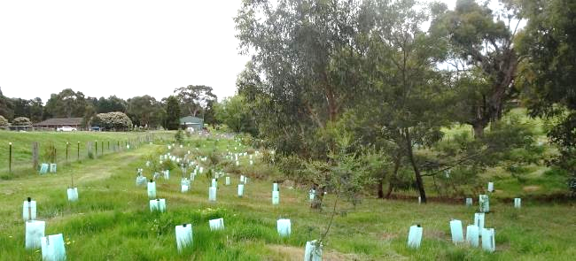
Revegetation enhancing scattered remnant vegetation along a creek line, Eden Park.

Key Dates

September to November 2026 | Applications open
September to November 2026 | Site inspections
30 January 2027 | Applicants notified of outcome
30 September 2027 | Project completion
30 September 2027 | Project acquittal completed
September to November 2027 | Project inspections

Application details

Who can apply?
To be eligible to apply for the Environmental Works Grant Program, the property must be:
- Located in the City of Whittlesea.
- 2 hectares (~5 acres) or greater in size.
- Land zoned for rural purposes (Green Wedge Zone, Green Wedge A Zone, Rural Conservation Zone). For properties with multiple land use zoning, the project site must be within one of the zones listed above.
Landowners can apply for a grant in consecutive years, provided that previous projects are completed prior to a new application being submitted.

What can be funded?

Small grants
Funding for small grants of up to $3,000 is available for projects which protect and enhance City of Whittlesea’s remnant vegetation and support local wildlife.
Small grants are ideal for landowners seeking additional support from Council or those planning smaller-scale environmental projects, including initiatives staged over several years. For successful applicants, Council can assist in the procurement and coordination of funded items, such as native plants, tree guards, and nest boxes upon request.
Proposals may include more than one activity; for example, establishing a shelterbelt may include fencing and revegetation, or erosion works may include providing geotextiles and plants for soil stabilisation. A list of standard grant activities is shown below. For activities not included on this list, contact Council’s Rural Land Management Officer prior to applying to ensure the proposal aligns with the Sustainable Environment Goals and eligibility requirements.
Eligible small grant activities include:
Activity | Unit price
Fencing remnant vegetation | $20 / metre
Fencing farm dam with remnant vegetation | $20 / metre
Revegetation (up to 300 plants) | $4 / plant (incl. stake & guard
Environmental weed control | $500 / treatment
Wildlife habitat (up to 15 nest boxes) | $90 / nest box, $500/constructed hollow
Erosion mitigation (minor) | N/A
Livestock Guards | $50 / guard (incl. 3-star pickets)
Fencing to establish vegetation | $15 / metre
Fencing farm dam (no remnant vegetation) | $15 / metre

Project grants
Funding for larger projects is available for up to $6,000. Project grants are designed to assist landowners undertaking larger scale on-ground environmental works which demonstrate a significant improvement in the City of Whittlesea’s environmental values.
Applications for a project grant must be supported by a clear project plan and quotes for materials and labour (where applicable). The project must be delivered by someone with proven experience and capacity to complete the works, whether that is the landowner or an external contractor.
Project grants are ideal for landowners with a proven track record and the capacity to manage their own projects - such as those who have successfully completed smaller grants and are ready to scale up their efforts.
Examples of eligible projects includes:
- larger scale revegetation incorporating site preparation, weed management, temporary fencing and planting by contractors
- fencing and revegetating a farm dam, along with the purchase and installation of a water trough and solar-powered pump system to provide an alternative water source for stock
- installation of deer proof fencing to support the protection of threatened species
- integrated rabbit/fox control across three adjacent properties including warren/den destruction combined with baiting or trapping.
Note: Proposals to undertake works along waterways (e.g. fencing, weed control and revegetation) should first be discussed with Melbourne Water. The Liveable Communities, Liveable Waterways Program can provide funding for activities along priority waterways identified in the Healthy Waterways Strategy (2018).
The EWGP is offered through a competitive process.
Applicants will need to demonstrate the merits of their project against the Grant Assessment Criteria.
Applicants are encouraged to contact Council’s Rural Land Management Officer prior to applying to ensure the proposal aligns with the Sustainable Environment Goals and eligibility requirements.

Who cannot apply?
There are a range of reasons a property of the eligible size and land use zoning may not be able to apply for funding, these include:
- community groups
- landowners who have not complied with acquittal requirements for any of the City of Whittlesea’s other grant programs
- properties owned and/or managed by utility and urban development companies
- landowners who have not completed a previously funded project to the satisfaction of Council
- landowners who have not satisfactorily maintained previous works as per the Project Agreement
- properties with outstanding environmental planning permit conditions, e.g. Land Management Plans, Section 173 Agreements
- properties with unresolved contraventions of the Whittlesea Planning Scheme
- properties with outstanding debt to Council
- Councillors, and members of their household, immediate family or close friend are ineligible to apply for all grants.

What cannot be funded?
- removal of indigenous vegetation
- boundary fencing or internal paddock fencing
- revegetation with non-indigenous plants
- remediation works associated with planning enforcement action
- control of weeds prescribed as noxious under the Catchment and Land Protection (CaLP) Act or City of Whittlesea Community Local Law as landowners have a legal responsibility to manage those weeds
- control of pasture weeds including Capeweed
- projects / works that have begun or been completed prior to funding approval.

Decision making

Grant assessment criteria
The City of Whittlesea prioritises projects that contribute to the protection and enhancement of local biodiversity - particularly those that safeguard remnant native vegetation, support wildlife habitat and connectivity, and promote the conservation of threatened species. The grant is offered through a competitive process, the following criteria will be used to assess and prioritise projects:
1. Environmental significance – 25%
The extent to which the proposal protects and enhances areas of environmental significance. These are areas containing threatened vegetation communities and/or threatened species.
2. Location and Landscape connectivity – 25%
Whether the project is located in proximity to areas of environmental significance such as waterways, a public conservation reserve, environmental overlays. Priority will be given to projects that are within or near areas of environmental value, significance and importance at a local and landscape scale. The degree to which the project enables wildlife to move between patches of native vegetation and across the landscape.
3. Budget – 25%
The budget identifies how the grant will assist the applicant to meet their project needs. Applicants can also record their own in-kind contributions such as time or money they contribute to the project.
4. Long term results – 25%
Whether the project will secure permanent and measurable environmental improvement outcomes such as permanent fencing of remnant bush, establishing habitat for wildlife through nest box installation.

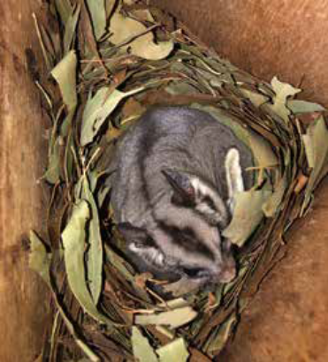
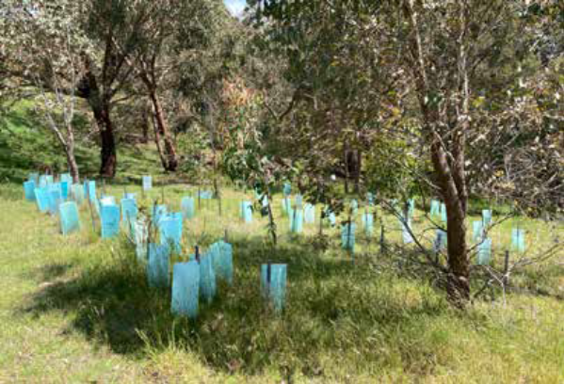
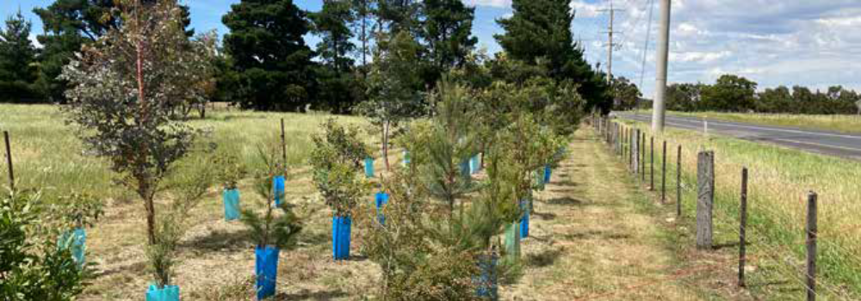

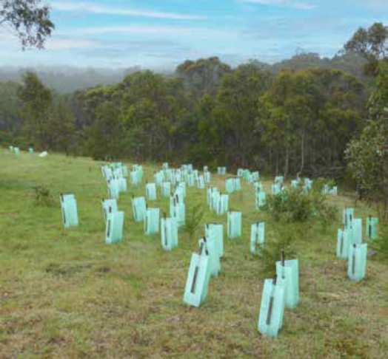
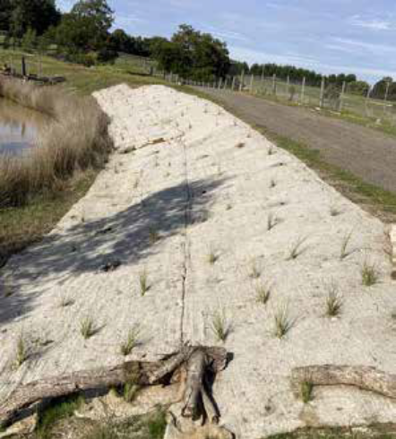

Top: Shelterbelt establishment with indigenous trees and shrubs on property boundary.
Middle left: Revegetation complementing remnant vegetation and connecting existing remnant trees.
Middle right: Nest boxes can provide valuable habitat for our local wildlife including Krefft’s Glider (formerly Sugar Glider) recorded as part of our monitoring program.
Bottom left: Erosion matting on dam embankment with additional revegetation provides soil stabilisation and weed suppression.
Bottom right: Revegetation to expand on remnant vegetation in gulley.

Assessment process
Review of eligibility
Following a submission, all applications are assessed to determine if they meet the eligibility criteria of property size and land use zoning.
Property visit
A Council Officer will arrange to meet landowners whose project meets the eligibility criteria at the property. The property meeting may result in changes to your proposed project, with any changes to be agreed upon by both parties. If there are agreed changes, the application will be amended by the Council Officer in SmartyGrants to reflect this.
The amended application will be used in the next stage of the assessment.
Applications for properties within the Bushfire Management Overlay (BMO), or where there may be increased fire risk to an adjoining property, may be discussed with Council’s Municipal Fire Prevention Officer to provide input into the proposal.
Review of application against the Grant Assessment Criteria
Council Officers will assess each application on its merits against the grant assessment criteria (p.8) and its ability to contribute to Council’s Sustainable Environment Goals.
Recommendations
Recommendations are submitted by the Rural Land Management Officer to an approval panel made up of the Manager of the Grants Team and Manager of the Sustainable Environment Department who will review all aspects of the application from eligibility to assessment and decide to either approve or not approve your application.
A summary of all approved and/or refused grants is provided to Council’s Grant Management Steering Committee and all approved grants will be published on the City of Whittlesea website and form part of a publicly available Council Report.

How to apply
Each round of the EWGP is delivered as an open competitive funding round. Interested landowners must apply online through SmartyGrants and are required to have an email address to register as a SmartyGrants user. The link to apply is provided on Council’s website. Landowners who have difficulty with the application process can contact Council’s Rural Land Management Officer for assistance on 9217 2170.
Landowners are encouraged to discuss their project with Council’s Rural Land Management Officer prior to applying, however this is not a mandatory requirement.

Successful applications
Successful landowners will be required to enter into a Project Agreement with the City of Whittlesea.
The Project Agreement sets out the conditions placed on the landowner in accepting the grant and clearly identifies the project area on their property. Once the Project Agreement is signed and returned to Council, materials and / or funds will be distributed to successful applicants.
Works must be completed by 30 September 2027.
An online project acquittal will be required to be completed by this date in SmartyGrants, with receipts / invoices and photographs of completed works to also be provided. Once an acquittal has been lodged, a Council Officer will make contact to arrange an inspection of the completed project.
Grants must be used in accordance with the terms outlined in the Project Agreement or funds will be required to be repaid to the City of Whittlesea.

Unsuccessful applications
If your application is unsuccessful, you will receive a letter from the City of Whittlesea outlining the reason(s) why. An unsuccessful application will not hinder any future applications.

Mandatory conditions
To ensure fair and equitable consideration towards all applications submitted, all grant types will have the following mandatory conditions included:
1. Declaration of Conflict of Interest
To ensure fairness and transparency a Declaration of a Conflict of Interest must be completed by all applicants who are affiliated with Council with any of the following roles:
- Councillors
- Council Staff
- volunteer
- appointed to committee or working group
- contractor or consultant.
Failure to disclose your affiliations and subsequent completion of the Conflict of Interest section in your application, will result in your application being deemed ‘Unsuccessful’ due to not disclosing your Conflict of Interest’.
2. Acknowledge Council support
All grant recipients are required to acknowledge Council for their support. Acknowledgement requirements will be set out in the ‘Conditions of Grant’ once a grant is approved and offered.
3. Grant Acquittals summary
Grant acquittals are the last step of the grant process where you have completed your project or event and you provide a report on how the grant money was spent and how successful your activity was. This is also a great opportunity to showcase your activity through photos, videos and other media. Acquittals must be completed to:
- capture the great initiatives delivered across City of Whittlesea through grants
- be sure successful grant recipients use the grants for the intended purpose applied for
- show the impact of your project or event through stories, photos, media and other means (e.g. web links, Youtube links, posts etc).
- confirm how you used the grant money, provide receipts and return any unspent funds.
4. Consent
Through the application process, Council will seek consent to contact third parties noted in your application in order to verify details where required.
Contact with third parties noted in your application will be to verify only details specific to your application for the grant, where required.

Eligible grant activities and funding arrangements

Funded Item | General Conditions
Indigenous plants for revegetation | - Only locally indigenous species will be funded  - Proposed plantings must be a minimum width of 10m and include tree and understory species (unless deemed not required by Council)  - Shelterbelt establishment must consist of 3 rows of plants, planted 3m apart  - Species lists for all projects will be developed in consultation with Council offices  - For small grants, plants will be bulk ordered by Council and provided to landowners.
Environmental weed control within good quality vegetation or control of high threat weeds* | - For small grants, Council officers will coordinate the works with an environmental contractor selected from a list of Council’s preferred suppliers  - Funds for environmental weed control will be transferred to the landowner’s bank account by EFT or contractors will invoice Council directly.  - For larger project grants applicants will obtain quotes from a list of Council’s preferred suppliers and coordinate and engage the contractors directly.
Nest boxes or the construction of artificial hollows for wildlife | - Nest boxes will be ordered by Council and provided to the landowner  - Installation can be arranged by Council, or alternatively, landowners may choose to manage the installation themselves.  - For constructed wildlife hollows Council Officers will coordinate the works with a qualified arborist selected from a list of Council’s preferred suppliers.  - Once installed, a Council Officer will GPS the location of nest boxes or hollows. They will then be included for inspection through Council’s ongoing monitoring program.
Funding for fencing:  - To protect remnant vegetation (i.e. patches of bush and paddock trees) with permanent stock-proof fencing  - To establish shelterbelts with permanent stock-proof fencing  - To protect farm dams from livestock access | - Must be constructed so that it is permanent and cannot be damaged by livestock. Fencing must include properly constructed corner and end assemblies.  - Fencing must not include barbed wire  - Fencing around paddock trees must extend a minimum of 3m outside of canopy drip line  - Fencing around farm dams must extend a minimum of 4m from the top of the dam bank  - Fencing for shelterbelts must be a minimum of 10m wide  - Funds for fencing projects will be transferred to the landowner’s bank account by EFT.
Livestock-guards (approx. 1.2m tall wire mesh guard) to assist with establishing / protecting seedlings in grazing paddocks | - Livestock guards will be ordered by Council and provided to the landowner.  - Three steel star pickets will be provided with each guard
Erosion mitigation works | - For small grants for minor erosion works, materials will be ordered by Council and provided to the landowner for installation.  - For larger scale erosion works landowner to source two quotes from suitably qualified contractors.  - Funds for larger erosion projects will be transferred  to the landowner’s bank account by EFT.
Sustainable farming infrastructure including water troughs and water pumps, solar electric fencing. | - Landowner to source two quotes for the materials and/or installation.  - Reimbursement of funded amount will be provided to the landowner through EFT.
Integrated pest animal control – rabbits and foxes | - Integrated rabbit/fox control that includes warren/den destruction and is conducted across an area of at least 10 hectares or with two other adjacent landowners.  - Council will reimburse by EFT the agreed funding  amount or contractors will invoice Council directly.
* High threat weeds are weeds with the potential to rapidly expand displacing native species or are new and emerging weeds in the region (i.e. not yet established weeds).
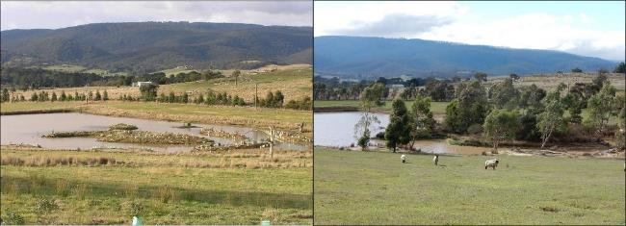

Ten-year-old revegetation around a farm dam, Whittlesea.
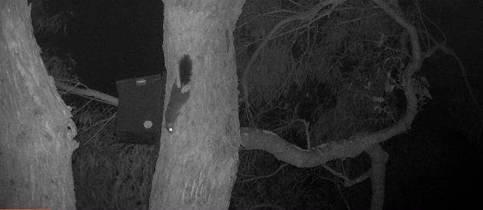
Installing nest boxes can provide critical habitat for local wildlife including the threatened Brush-tailed Phascogale. Image courtesy: Suzi Duncan.

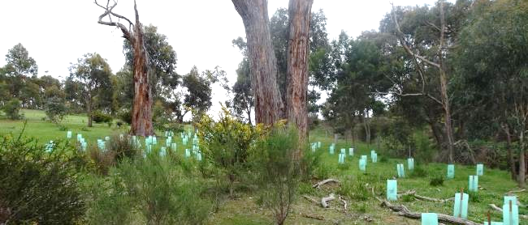

Revegetation complementing remnant vegetation and connecting large isolated trees to a well vegetated creek corridor, Beveridge.

