`

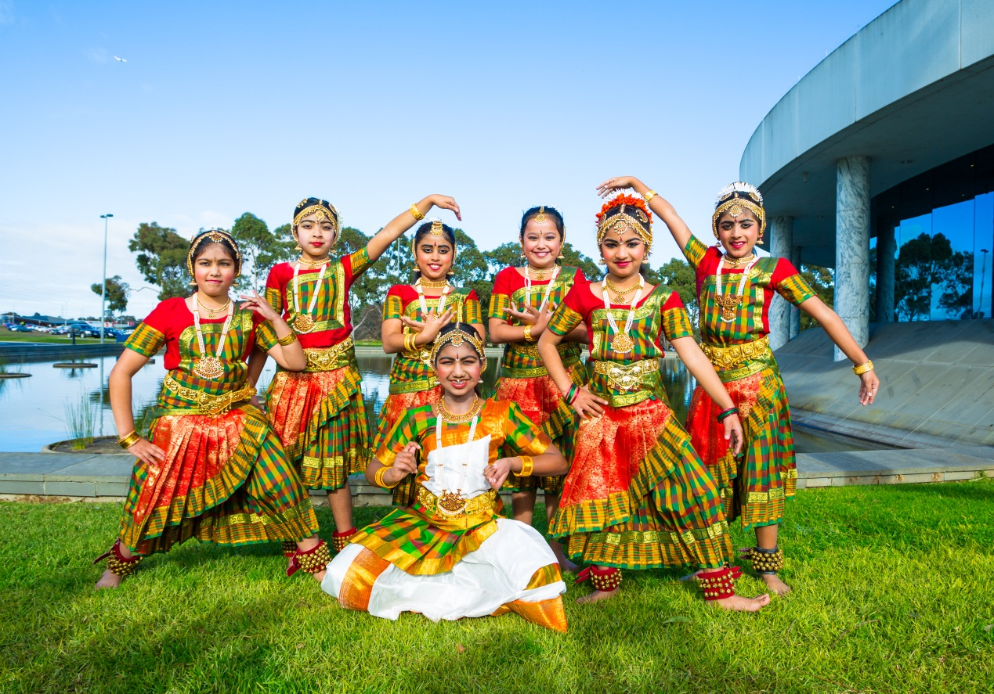

Building Respect: Whittlesea’s Anti-Racism Strategy 2015-2019

Table of Contents
Acknowledgement of Traditional Owners 3
Glossary of terms 4
A message from the Mayor 5
Introduction 6
City of Whittlesea Demographics 8
Anti-Racism Policy Statement and Principles 9
An Integrated Systems Approach 10
A Snapshot of our Achievements-to-Date 11
Development of the Strategy 12
Policy, Strategy and Legislation Linkages 13
Findings from the LEAD Program 15
Recent Research & Stakeholders 16
Key Directions 18
Anti-Racism Action Plan 2015–2019 19
References 22

Acknowledgement of Traditional Owners

The City of Whittlesea recognises the rich Aboriginal heritage of this country and acknowledges the Wurundjeri Willum Clan as the traditional owners of this place.

Diversity has been part of the Australian landscape since before colonisation, when distinct Aboriginal and Torres Strait Islander nations spoke around 700 different languages. The histories, cultures, values, beliefs, languages, lifestyles and roles of Aboriginal and Torres Strait Islander people both past and present provide a central tenet to modern diversity. It is important that this is acknowledged and that full recognition is given to the fact that modern cultural diversity and multiculturalism operates within the context of Aboriginal and Torres Strait Islander history.

Glossary of terms
Aboriginal – referring to Victoria’s original inhabitants and custodians. Elsewhere, the terms ‘Indigenous’ or ‘Aboriginal and Torres Strait Islander’ may be used to describe Australia’s first people.
Anti-racism – a thought and/or practice that seeks to confront, and or eradicate and/or ameliorate racism.
Culture – distinctive patterns of values, beliefs and ways-of-life of a group of people that may share ethnicity, race, gender or other characteristics. It is a dynamic concept that is influenced by environmental, historical, political, geographical, linguistic, spiritual and social factors.
Ethnicity – describing a social group whose members share a sense of common origins, claim common and distinctive history and destiny, possess one or more dimensions of collective individuality and feel a sense of unique collective individuality. ii
Health – a state of complete physical, mental and social well-being and not merely the absence of disease or infirmity.
Mental health – is the embodiment of social, emotional and spiritual well-being. It provides individuals with the vitality necessary for active living, to achieve goals, and to interact with one another in ways that are respectful and just.
Multiculturalism – is used to mean a public policy approach that respects and values the diversity of ethnicities, cultures and faiths within a society and encourages and enables their ongoing contribution within an inclusive context that empowers all members of the society.
Racism – behaviours, practices, beliefs and prejudices that underlie avoidable and unfair inequalities across groups in society based on race, ethnicity, culture or religion. Racism can be: ii
- Internalised — when a person incorporates racist attitudes, beliefs or ideologies into their view of the world
- Interpersonal — during interactions between individuals, eg. bullying, harassment, rudeness, being ignored or excluded
- Systemic — when systems, institutions and cultures operate to produce inequalities in the control of, and access to, resources in a society.

A message from the Mayor

Welcome to Building Respect: Whittlesea’s Anti-Racism Strategy 2015–2019.

Whittlesea is one of the fastest growing and most culturally-diverse municipalities in Australia. It is important that our residents can live, play, work, prosper and belong in a safe community that respects difference and diversity. Our residents come from more than 140 countries, and almost half of our community speaks a language other than English at home. This cultural diversity is a valuable part of our community identity, and provides a range of invaluable economic and social contributions.

We also know that disadvantage and discrimination have very negative effects on people and their ability to fully participate in workplaces and communities. At the City of Whittlesea we understand that a community in which all members can participate makes a stronger community for everyone.

This is why we are proud to have developed Building Respect: Whittlesea Anti-Racism Strategy 2015–2019. The Strategy is a continuation of our previous commitments to creating vibrant communities that value cultural diversity.

The Strategy articulates a number of actions that we will deliver over the next four years to continue Council’s strong record of inclusiveness and equity. These actions have been developed as a direct result of consultation with the local community, key agencies, Council staff and service providers.

Our Strategy will ensure we are making every effort to reduce racism and therefore reduce its negative effects at the individual, organisational and community levels and begin to deliver positive benefits for people and communities. We are committing to taking action to prevent racism within Council, enhance positive attitudes towards our intercultural and interfaith communities and create safe spaces and places for intercultural contact and dialogue. We will also report against our commitments ensuring we are truly a Council that leads the way in addressing race-based discrimination.

I would like to thank everyone who has been involved in the development of the Building Respect: Whittlesea’s Anti-Racism Strategy 2015–2019 and look forward to reporting the positive outcomes it delivers.

Cr Ricky Kirkham
Mayor

Introduction
Building Respect: Whittlesea Anti-Racism Strategy 2015–2019 (‘the Strategy’) is Council’s commitment to reducing, preventing and responding to racism in Council and across our communities. The Strategy builds on Council’s history of achievements in fostering reconciliation and supporting multiculturalism. Our local Aboriginal and culturally diverse community make a range of valuable contributions to our local community and economy. However, discrimination on the basis of race, religion, culture or ethnicity is a common occurrence for many members of our community. Recent research conducted by Council in partnership with Melbourne University and VicHealth found:
- 97% of those surveyed from the Victorian Aboriginal community had experienced racism in the previous 12 months and over 70% had experienced eight or more racist incidents.
- Nearly two-thirds of those surveyed from our Culturally and Linguistically Diverse Communities (CALD) had experienced racism in the previous 12 months; with 40% experiencing six or more incidents.
The negative impact of racism is well-documented. Racism can negatively impact a person’s ability to access resources and to positively contribute to the local community. There is also evidence of strong links between experiences of racism and poor mental and physical health; especially increased levels of anxiety and depression.
Economic research suggests that select mental disorders attributed to racial discrimination (anxiety, depression, post-traumatic stress disorder and psychological disorders) costs an estimated $46.4 billion in lost GDP to the Australian economy per annum; roughly 3.7% of the average annual GDP for the period 2001-11.
Despite these negative impacts, Victorians strongly support our Aboriginal and multicultural communities. v
- The overwhelming majority of Victorians (95%) believe it is important that people from different racial or ethnic backgrounds are treated fairly.
- 83% of Victorians believe that Aboriginal Australians ‘hold a special place as the first Australians’.
- 84% of people surveyed across the City of Whittlesea agreed that something should be done to reduce discrimination experienced by people from racial or ethnic minority groups in Australia.
Building on Council’s pioneering record in addressing racism, the Strategy has been developed in response to this community concern and the known negative impacts of racism.

To deliver the Strategy, Council will implement three key directions that were developed in consultation with the community and are grounded in evidence-based practice. These are:
Key direction 1: Raising awareness and understanding
Key direction 2: Places free from racism
Key direction 3: Strengthening Council’s organisational capacity

Council has the following three roles:
In delivering the Strategy, Council will have three defined roles:
- Provider: Deliver direct-participation programs aimed at increasing positive attitudes and behaviours in the community
- Advocate: Deliver pro-diversity messages on behalf of our Aboriginal and culturally diversity communities.
- Facilitator: Support local-level agencies, such as sports clubs and libraries, to create places free from racism.

This strategy has two parts:
Section One of the Strategy provides:
- A background to the City of Whittlesea
- Council’s Anti-Racism Policy Statement
- The rationale for having an Anti-Racism Strategy
- The consultation and development process, and
- Links to other Council Plans and current Federal and State Government legislation.

Section Two of the Strategy defines the specific actions to be completed over the next four years and a detailed Action Plan stipulating 19 evaluation measures.

City of Whittlesea Demographics
The City of Whittlesea is a culturally-diverse community located approximately 20 kilometres north of the CBD on Melbourne’s metropolitan fringe. Covering 490 square kilometres, it is a large municipality containing established ‘urban’, ‘growth’ and ‘rural’ areas. The City of Whittlesea is one of the fastest growing municipalities in Australia; in 2015 the estimated population of the City is 195,000 and this is expected to grow by 38 per cent over the next 10 years.

City of Whittlesea – A Culturally Diverse City
- Home to migrants from more than 140 countries
- Home to more than 1200 Aboriginal people
- About 40 per cent of residents speak a language other than English at home
- 35 per cent of residents speak English ‘not well’ or ‘not at all’
- The most common languages spoken are Arabic, Macedonian, Italian, Greek, and Vietnamese
- Thomastown, Lalor and Epping contain a greater proportion of people from non-English speaking backgrounds than other parts of the municipality
- In 2015 it was estimated by Council and local service providers that over 800 asylum seekers reside within the municipality. (Accurate statistics on asylum seekers are very difficult to obtain as they are not released by the Department of Immigration and Border Protection).

Anti-Racism Policy Statement and Principles
The City of Whittlesea’s Anti-Racism Policy Statement is an affirmation of Council’s ongoing commitment to the community it serves.

The City of Whittlesea will provide leadership in working towards a racism-free community that respects, embraces and connects everyone; especially our local Aboriginal and culturally and linguistically diverse communities.

Policy Principles
The Anti-Racism Policy Principles are designed to guide and underpin the Strategy.
- We will respect, acknowledge and listen to Traditional Owners.
- We will work within a human rights framework.
- We will work in partnership with all communities, peak bodies, leading academic researchers and agencies.
- We will enhance awareness and understanding of the negative impacts of racism.
- We will make evidence-based decisions.
- We will work towards preventing racism.

An Integrated Systems Approach
Whilst the Strategy works towards preventing the occurrences of racism before they occur through creating fair and inclusive environments for all, it is equally important to support culturally diverse and Aboriginal communities to respond to the disadvantage and discrimination they experience. As such the Strategy is intentionally interdependent to Council’s Reconciliation Action Plan 2012-2015 and Multicultural Action Plan 2014-2018. Together these three Strategies and associated Action Plans provide a co-ordinated range of activities aimed at preventing race-based discrimination whilst supporting local Aboriginal and multicultural communities.
Multicultural Action Plan 2014–2018
The City of Whittlesea Multicultural Action Plan 2014–2018 is built on Council’s history of achievements in multicultural affairs and guides Council’s program and service delivery, advocacy, engagement and collaboration with our culturally and linguistically diverse (CALD) communities. The plan has four key directions; 1) Council’s organisational capacity; 2) Community engagement and resilience; 3) Council, community and service providers working together, 4) Evaluation and Monitoring.

Reconciliation Action Plan 2012–2015
The City of Whittlesea’s Reconciliation Action Plan sets the direction for Council to make a meaningful contribution to reconciliation with local Aboriginal communities. The plan builds on Council’s past reconciliation achievements and establishes actions that acknowledge and value Aboriginal people and provide Aboriginal people in the City of Whittlesea with enhanced and new opportunities. The plan is built on the three pillars of Relationships, Respect and Opportunities.

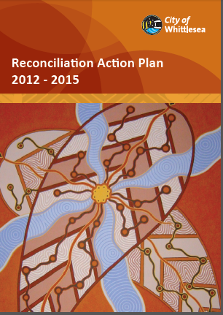
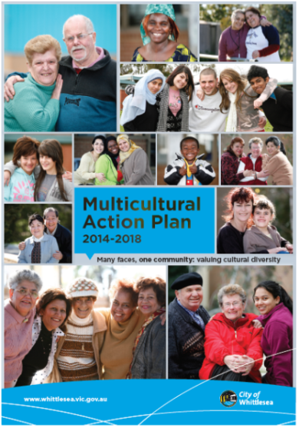
The Anti-Racism Strategy 2015-2019, the Reconciliation Action Plan 2012–2015 and the Multicultural Action Plan 2014–2018 should be viewed as a coherent whole-of-Council commitment to effectively address and prevent racism.

A Snapshot of our Achievements-to-Date

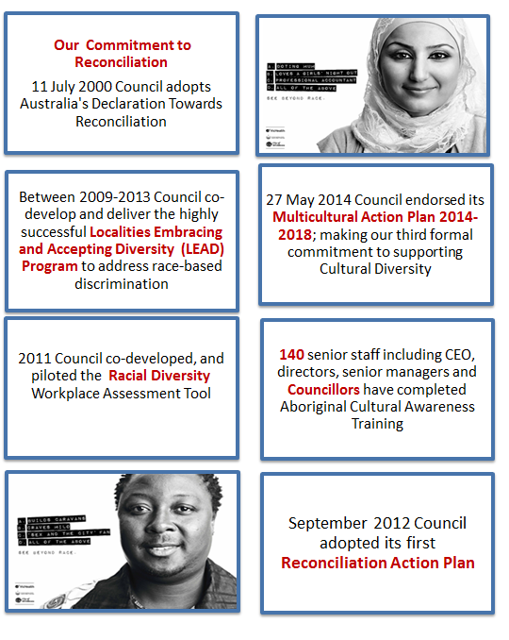

Development of the Strategy
The development of the Strategy involved reviewing existing policies and legislation, Council plans, recent research, Localities Embracing and Accepting Diversity (LEAD) program findings and detailed consultations with our local Community and Service providers.

Policy, Strategy and Legislation Linkages
The Strategy is linked to a range of existing Council Plans and Policies, most notably, Shaping Our Future: Whittlesea 2030 Strategic Community Plan. The Community Plan details our community’s vision for the City of Whittlesea to the year 2030. It provides direction for the provision of key projects and services that enable us to meet the needs of our community and deliver quality and culturally-appropriate services and facilities. It identifies seven Future Directions to achieve this vision. This Strategy directly supports Future Direction 1 – Inclusive and Engaged Community.
There is also a number of International, Commonwealth or Victorian policies, Acts and other signatory conventions that guided the development of the Strategy, most notably the Racial Discrimination Act 1975 (RDA) and Australia’s National Anti-Racism Strategy.
Racial Discrimination Act 1975
The Racial Discrimination Act 1975 (RDA) is a statute passed by the Australian Parliament. The RDA makes racial discrimination unlawful in Australia; this occurs under the RDA when someone is treated less fairly than someone else in a similar situation because of their race, colour, descent or national or ethnic origin.
Racial discrimination under the RDA can also occur when a policy or rule appears to treat everyone in the same way but actually has an unfair effect on people of a particular race, colour, descent or national or ethnic origin than others.
It is against the law to discriminate in areas such as, Employment (Section 15) Land, Housing or Accommodation (Section 12), provision of Goods and Services (Section 13), access to places and facilities for use by the public (Section 11), Advertising (Section 16) and joining a Trade Union (Section 14).
Under the Act certain offensive behaviour will also be found discriminatory if it is likely to offend, insult, humiliate or intimidate people of a certain race, colour or national or ethnic origin (Section 18 B-F).
The RDA is considered by many as the foundation of Australia’s strong legislative and policy protection against racism.
National Anti-Racism Strategy
In 2011, the Australian Government committed to develop and implement a National Anti-Racism Strategy for Australia. The Strategy commenced implementation in July 2012 and focusses on Public Awareness, Education Resources and Youth Engagement. The aim of the National Anti-Racism Strategy is to promote a clear understanding in the Australian community of what racism is, and how it can be prevented and reduced, through three objectives:
- Create awareness of racism and how it affects individuals and the broader community
- Identify, promote and build on good practice initiatives to prevent and reduce racism
- Empower communities and individuals to take action to prevent and reduce racism and to seek redress when it occurs.

Broader Policy Linkages
International
International Convention on the Elimination of All Forms of Racial Discrimination (1965) | International Covenant on Economic, Social and Cultural Rights (1966) and the International Covenant on Civil and Political Rights (1966) |  |  | United national declaration on the Rights of Indigenous People (2007)
Australian Government
Racial Discrimination Act 1975 | The People of Australia – Australia Multicultural Policy |  |  | National Anti-Racism Strategy
Multicultural Access and Equity Policy: Respecting diversity, improving responsiveness |  |  | Australia’s Human Rights Framework
Victorian Government
Multicultural Victoria Act 2011 | Equal Opportunity Act 2010 |  |  | Charter of Human Rights and Responsibilities Act 2006
Racial and Religious Tolerance Act 2001 |  |  | Victoria’s Advantage: Unity, Diversity, Opportunity
Local Government
Municipal Association of Victoria Statement of Commitment to Cultural Diversity
City of Whittlesea Policy Links
City of Whittlesea Council Plan 2013-17 |  | Connect : Children, young people and families 2013–18 |  |  | Multicultural Communications Plan 2014
Municipal Public Health Plan |  | Refugee Welcome Zone |  |  | Joint Statement by Victorian Local Governments on Asylum Seekers
Disability Action Plan 2013-2016 |  | Family Violence Strategy  2014-18 |  |  | Recreation Strategy 2012-2017
Multicultural Action Plan  2014-18 |  | Aboriginal Employment Pathways Strategy & Action Plan 2012-17 |  |  | Reconciliation Action Plan 2012-15

Findings from the LEAD Program
In 2009 Council partnered with VicHealth and a number of other agencies to establish the Localities Embracing and Accepting Diversity (LEAD) program. The LEAD program was Council’s most significant commitment to reducing race-based discrimination within our communities and services. This work was foundational to the development of the Strategy. The aims of the program were to:
- Promote positive attitudes towards cultural diversity and decrease discriminatory attitudes and behaviours
- Encourage the implementation of policies and practices that promote diversity and reduce discrimination within local organisations
- Create more inclusive local environments
- Support the capacity of local governments and their communities to engender harmony.

Throughout the program Council developed and implemented a range of strategies including organisational audits, pro-diversity training, reviews and development of organisational policy, intercultural events and social marketing. The program demonstrated Council’s ability to address and prevent racism. Evaluation findings indicated:
- Preventing racism is likely to be more effective and efficient than responding to harmful incidents.
- The program generated changes in participants’ motivation to act in non-discriminatory ways.
- To be successful the program must be relevant and aligned with existing organisational priorities.
- Within an organisational context senior management engagement and support as ‘champions’ is critical to success.
- Programs that are delivered over an extended timeframe are considered more effective and sustainable than one-off programs delivered over short time periods.

Recent Research & Stakeholders
The development of the Strategy was informed by a number of existing frameworks, programs, and research reports, most pertinent are:

Impacts of Race-Based Discrimination: Building on Our Strengths Framework
The 2009 publication Building on Our Strengths: A Framework to Reduce Race-Based Discrimination and Support Diversity in Victoria (‘the Framework’) established the case for action with regard to the impacts of race-based discrimination.
This report found that despite support for diversity, discrimination on the grounds of race, ethnicity, culture and religion remains unacceptably high. Nearly 85%of Victorians agree that there is racial prejudice in Australia. Further research finds that Aboriginal and culturally-diverse community members continue to report high rates of discrimination.
Building on Our Strengths also noted the strong evidence that race-based discrimination impacts negatively on both individuals and communities and leads to poor health and in particular mental health, such as increased levels of anxiety and depression.
2013 Survey of Victorians’ attitudes to race and cultural diversity
In 2013 VicHealth conducted the ‘Victorian Attitudes to Race and Cultural Diversity Survey 2013’. Key findings included: v
- Eight in 10 respondents agree that Aboriginal people hold a special place as the first Australians.
- Eight in 10 respondents agree that people from minority ethnic groups benefit Australia.
- Around three in 10 disagree that “being Aboriginal makes it harder to succeed” and two in five believe that “Aboriginal people get more government money than they should”.
- A small majority (59%) of respondents ‘felt cold’ towards at least one (ethnic or racial) group. Respondents felt ‘most warmly’ about Mediterranean-European and Anglo-Australian groups and ‘least warmly’ about Muslim, Middle Eastern and Refugee groups.

Mapping Social Cohesion – The Scanlon Foundation Survey 2014
This report highlights that Australia remains a highly cohesive society, yet there are areas of concern.
- Australia ranks first within OECD nations with populations over 10 million for ethnic diversity at an estimated 27%.
- A proportion (25%) of respondents reported being negative towards Muslims.
- 18% of respondents reported experiences of discrimination, this remains close to the highest levels recorded.
- A majority of respondents (85%) agreed that multiculturalism has been good for Australia.

Stakeholders Consultation
A range of community consultations were conducted to elicit responses in relation to discriminatory issues impacting CALD and Aboriginal communities. Consultations were undertaken using a community participatory approach that fostered commitment through collaboration, consultation and participation. The consultations were conducted in an open, inclusive and culturally-appropriate manner, involving people in meaningful and productive ways.
Consultations were conducted with a diverse range of stakeholders including local community groups such as community networks, new and emerging communities, Whittlesea’s Reconciliation Group, Service providers and Council staff.

These consultations have also strongly influenced the development of the Strategy and provided enhanced local context and strong alignment to the research and policy documents reviewed above.

Key Directions
The three key directions were developed in consultation with the community and are grounded in evidence-based practice. While articulated for our local context, all actions are aligned with the key themes for action identified in the Building On Our Strength Framework.
Key direction 1: Raising awareness and understanding
Key direction 2: Places free from racism
Key direction 3: Strengthening Council’s organisational capacity

Building On Our Strengths Framework
All actions within the Action Plan align with the VicHealth’s Building On Our Strengths Framework eight themes for action. Each theme from the framework has been specifically incorporated into the locally tailored actions and evaluation measures.
The eight themes for action are:
1. Increasing empathy
2. Raising people’s awareness of their own beliefs, attitudes and behaviours
3. Providing accurate information
4. Increasing personal accountability
5. Assisting people recognise incompatible beliefs
6. Breaking down barriers between groups
7. Increasing organisational accountability
8. Promoting positive social norms.
Evaluation and Reporting
The Action plan consists of three objectives and 19 actions. Throughout the implementation period an (internal) Council and (external) community governance group will be established to monitor the progress and actions of the plan against the plan’s pre-determined measures. Upon completion a detailed Evaluation Report will be submitted to Council stipulating key achievements against the three stipulated objectives, all actions and overarching key directions. The final evaluation report will take into consideration broader measures such as VicHealth’s Community Indicators, Scanlon Foundation’s Mapping Social Cohesion data and other reliable indicators of change.

Anti-Racism Action Plan 2015–2019
Key Direction 1: Raising Awareness and Understanding
Objective: Council will deliver actions that foster positives attitudes and behaviours towards local Aboriginal and culturally-diverse communities.
Actions | Measure
1.1 Develop and deliver Sharing Our Stories Project. | Local stories combating racism and intolerance are promoted through multi-media channels.
1.2 Develop and deliver direct participation project aimed at breaking down barriers between Aboriginal communities and others. | One project that enhances positive attitudes and provides accurate intercultural information delivered annually through a Community Activity Centre.
1.3 Develop and deliver direct participation project aimed at breaking down barriers between the Islamic community and others. | One project that enhances positive attitudes and provides accurate intercultural information delivered annually through a Community Activity Centre.
1.4 Deliver youth-specific programs that increase positive attitudes towards culturally-diverse and Aboriginal communities. | Delivery Indigenous games for a minimum of 100 young people per year.
1.5 Foster positive attitudes towards Aboriginal and culturally-diverse communities. | Key messages of the impacts of racism developed and communicated (externally). Council’s Aboriginal Inclusion Charter disseminated.
1.6 Develop an external communication plan. | Plan implemented by December 2015.
1.7 Partner with local media to generate positive communications in local media. | Quarterly communications developed and distributed.

Key Direction 2: Places Free From Racism
Objective: Council will continue to support local settings that are fair, welcoming and inclusive for all, and free from racism.
Actions | Measure
- Continue to support Yarra Plenty Regional libraries as a space free from racism. | - Acknowledgment of Traditional Owner plaques on all library buildings.  - Knowledge shared from Council’s Aboriginal Employment Pathway Strategy to enhance diversity employment.  - Libraries signed-up to Refugee Welcome Zone / Statement.
- Develop initiatives that encourage open and public spaces to be inclusive and free from racism. | Deliver a social media awareness raising campaign.  Evidence aimed at preventing racism included in Council’s Community Safety Strategy (under development).
- Provide resources to sports clubs and associations that support anti-racism and enhance inclusiveness. | - Feedback sought and evaluated from clubs and associations.  - Implementation of level 2 Everyone Wins resource within two local clubs.
- Support local schools in long-term anti-racism initiatives. | Advocate with Whittlesea Community Futures & Whittlesea Youth. Commitment regarding issues of cultural diversity, inclusivity and Aboriginal young people.  Deliver a minimum of five Refugee Awareness Information Sessions in local schools annually.

Key Direction 3: Strengthening Council’s Organisational Capacity
Objective: Council will continue to build a workplace environment that is fair, welcoming and inclusive for all and free from racism.
Actions | Measure
3.1 Measure attitudes towards Cultural Diversity and racism. | Minimum 30% of staff complete pre survey.
3.2 Aboriginal cultural awareness training. | Minimum of 80 Council staff per annum complete training.
3.3 Implement the 2014 Workplace Cultural Diversity Assessment Tool. | Findings from the assessment implemented.
3.4 Conduct four (4) bystander workshops. | 20 staff per annum complete workshops and self-report an increase in capacity to take bystander action.
3.5 Develop an internal communications strategy. | Strategy in Implementation Phase – December 2015.
3.6 Increase Council’s knowledge and understanding of leading practice in relation to increasing social cohesion. | The Human Rights Commission’s - Increasing Social Cohesion Resource implemented.
3.7 Measure attitudes towards Cultural Diversity and racism. | Minimum 30% of staff complete post survey, positive attitudes towards cultural diversity and racism increase.
3.8 Anti-racism training. | Training provided to Council Staff, Councillors and the Corporate Leadership Team

References

Bonnett A. Anti-Racism. London: Routledge; 2000
Paradies, Y, Chandrakumar, L, Klocker, N, Frere, M, Webster, K, Burrell, M & McLean, P 2009, Building on our strengths: a framework to reduce race-based discrimination and support diversity in Victoria, Victorian Health Promotion Foundation, Melbourne
World Health Organisation (WHO) 1948, Preamble to the Constitution of the World Health Organisation as adopted by the International Health Conference, New York, 19-22 June, 1946, signed on 22 July 1946 by the representatives of 61 States (Official Records of the World Health Organisation, no. 2, p. 100) and entered into force on 87 April 1928.
VicHealth 2005, VicHealth Mental Health Promotion Plan 2003-2009, Melbourne, Australia
VicHealth 2014, Findings from the 2013 survey of Victorians’ attitudes to race and cultural diversity.
Elias A. Measuring the economic consequences of racial discrimination: PhD thesis. Deakin University, 2015
VicHealth 2014, Localities Embracing and Accepting Diversity (LEAD) Program: summary report, Victorian Health Promotion Foundation, Melbourne Australia.
Mapping Social Cohesion 2014: The Scanlon Foundation Surveys Full Report (2014).

