# **MULTI-UNIT DEVELOPMENT COUNCIL COLLECTION SERVICE - CHECKLIST**

This document is provided in good faith of proper usage, it is not considered a Waste Management Plan. This document should only be used for residents whom reside in a Multi-Unit Development the City of Whittlesea and currently have a service delivered privately.

## **Applicant Details**

Name: Click or tap here to enter text.

Organisation: Click or tap here to enter text.

Contact Number*: Click or tap here to enter text.

Contact Email*: Click or tap here to enter text.

On behalf of whom are you requesting a Council collection for (state name and relationship)? Click or tap here to enter text.

Are you the property owner?

Yes

Body Corporate

Renter/Tennent

Other: Click or tap here to enter text.

## **Dwelling (Building) Details**

Address: Click or tap here to enter text.

Single Dwelling

Two to five dwellings (1-2 storey)

Six or more dwellings (2+ storey)

Number of properties requesting Council collection: Click or tap here to enter text.

Permit number: Click or tap here to enter text.

Year of build: Click or tap here to enter text.

Year of purchase: Click or tap here to enter text.

Current Collection Details: Click or tap here to enter text.

Please look at the images below that demonstrates the expected kerbside presentation for Council collection and answer the questions one to eight. 

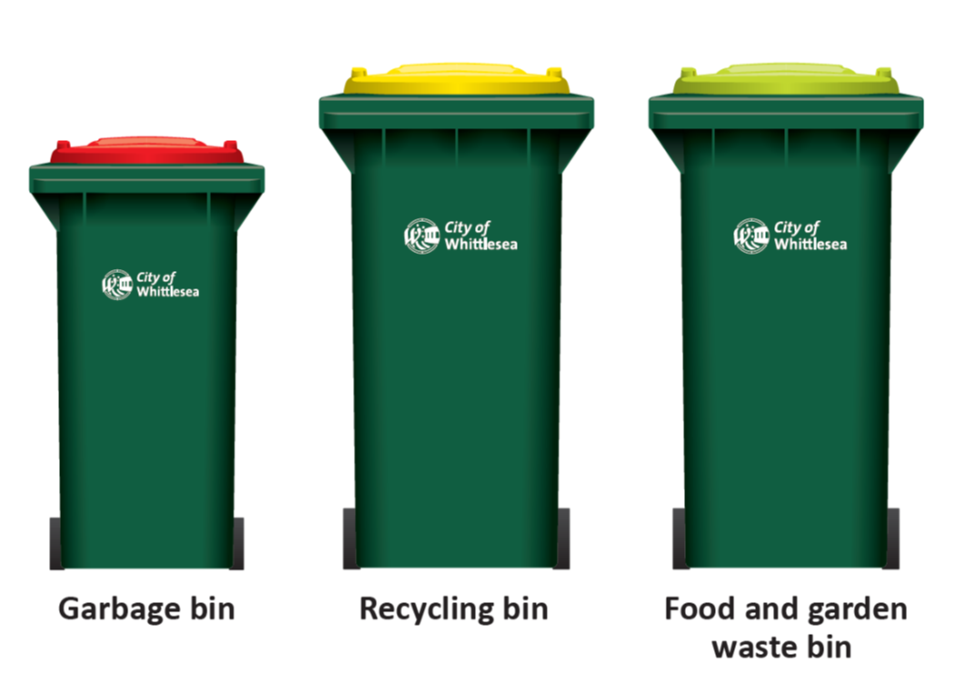

1. How many Garbage bins do you expect to present for collection (weekly)?Click or tap here to enter text.
2. How many Recycling bins do you expect to present for collection (fortnightly)?Click or tap here to enter text.
3. How many Recycling bins do you expect to present for collection (fortnightly)? Click or tap here to enter text.

Would the owner/occupier of the property be able to place their bins to the kerbside for collection, without using driveways/roads or using other private property?

Yes, there is ample room on the kerbside for the garbage and green/recycling bin

Maybe, for each property there is at least 1 metre of kerbside

Maybe, there is a large (over 3m) kerbside for multiple bins

1. How wide is the road adjacent to the kerbside for presentations (m)? Click or tap here to enter text.
2. Can the truck enter and exit in a forward motion?

Yes

No

6. Can the truck turn around safely?

Yes

No

1. 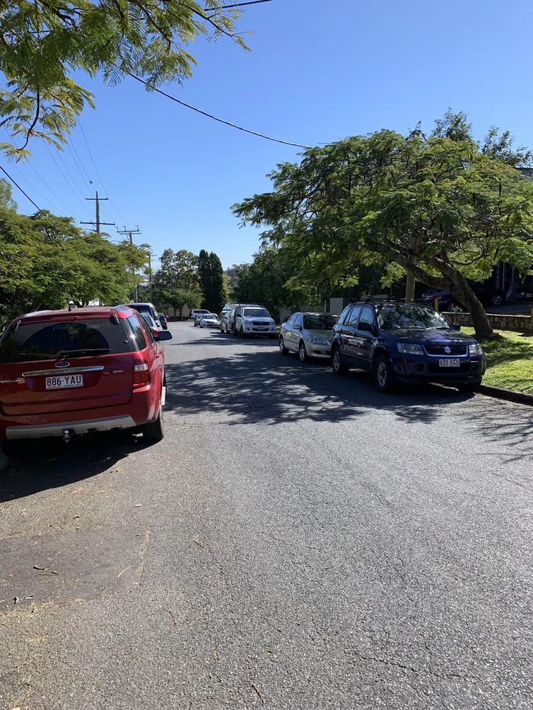Can two cars park on either side and a medium sized vehicle still travel in-between(see image below)?

Yes

No

Maybe

1. How long is your nature strip (m)? Click or tap here to enter text.
2. Does collection require a truck to **enter private property, reverse** and/or **enter a private road**?

Yes

No