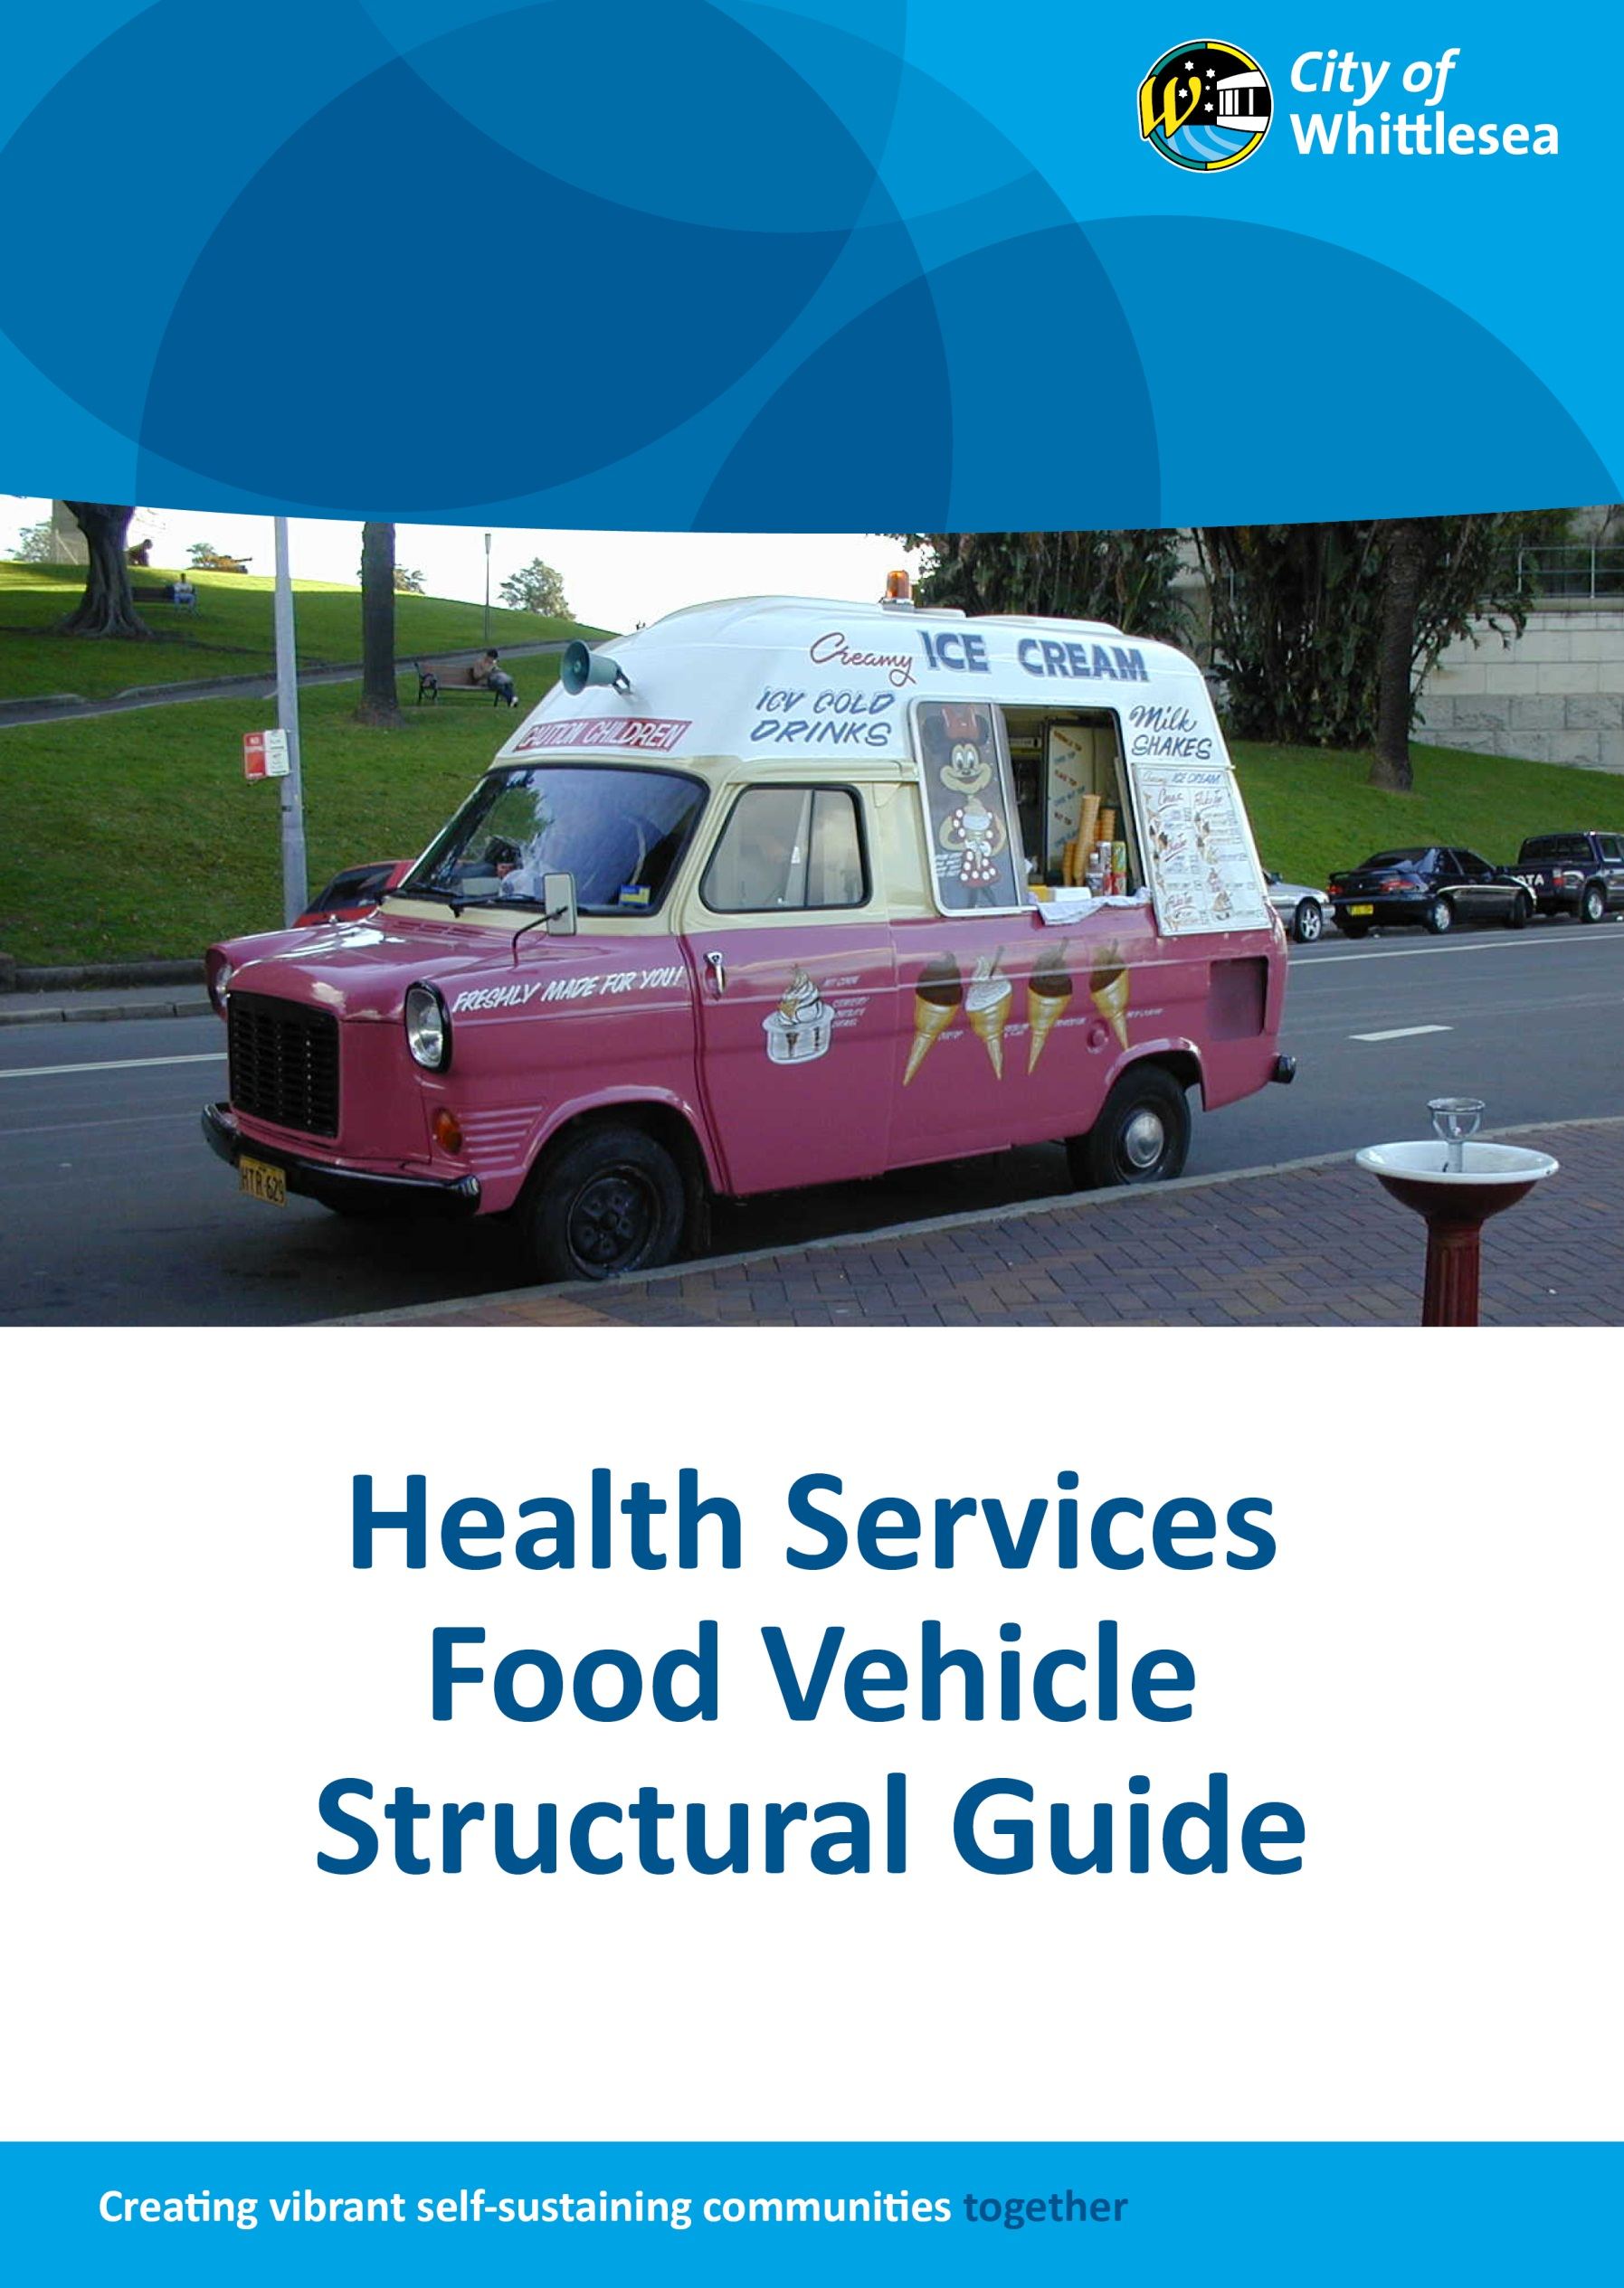

Food Vehicle Structural Specifications
Food Act
Contents
No table of contents entries found.

Introduction
The City of Whittlesea Public Health Services Department welcomes your interest in building a food vehicle and we hope that you will find this guide useful. It is intended to help you design your food vehicle efficiently and effectively to meet current Victorian Food Hygiene standards and we encourage you to read this guide and the associated information carefully before contacting Council’s Environmental Health Officer to discuss your particular proposal.

Mobile food vehicle
Your food vehicle is required to be built to the same standard as a permanent food premises, be self-sufficient in water supplies and waste disposal.
When designing the layout of your food vehicle be mindful that you will be working in a confined space, so you will need to consider how many staff (food handlers) will be in the vehicle at any one time to allow for a safe working, food handling and storage environment.

Food transport vehicle
If the vehicle is only intended to transport food it is to be designed and constructed to protect the food if there is any likelihood of food being contaminated during transport.
Vehicles transporting un-packaged foods must consider air borne contamination, dust, rain, insects, fumes to prevent any potential contamination by bacteria and foreign objects.
Cooked and raw food may be carried on the same vehicle provided that they are adequately separated or packaged so there is no risk of spillage or contact. Raw, unwashed vegetables should be kept separate from cooked and ready-to-eat foods. Designing the vehicle to include partitions, separate compartments, shelves etc can assist in segregating food to prevent cross contamination.
Food compartments are to be separate from the driver’s compartment or any passenger areas. This prevents personal items such as pens and cigarette butts being near or in the food compartment.
Note: Food contact surfaces in parts of the vehicle used to transport food must be designed and constructed to be effectively cleaned and if necessary sanitised.
This is for un-packaged food that comes in direct contact with the interior surfaces of the vehicle; such as milk tankers. The surface must be capable of withstanding sanitising with steam, hot water or chemicals.

Other authorities
The registering authority responsible for the transportation of meat, chicken and seafood is Primesafe - contact number (03) 9685 7333.
The registering authority responsible for the transporting of dairy foods is Dairy Food Safety Victoria – contact number (03) 9810 5900. :

General requirements
- Provide all internal surfaces with a material suited to the process ie:
  - smooth and impervious
  - free of open joints, to ensure that pests do not gain access to the vehicle from holes/cracks
  - enable effective cleaning and sanitising.
    - Provide adequate space for the activities which are to be conducted.
- Food vehicles are to be properly maintained at all times to prevent contamination of food from flaking plaster, paint, timber, broken glass, leaking pipes etc.
- Ensure that the equipment works as intended.

Water supply, sinks & hand wash basins
SINKS
- Provide a double bowl sink for food processing, manual cleaning and sanitising of utensils and equipment.
- Provide a water storage tank with a minimum of 25 litre holding capacity for cleaning purposes. Additional water can be stored in suitable food grade containers which can be easily cleaned.
- For cleaning and sanitising purposes, the hot water provided must reach a minimum temperature of 60°C.
- All sinks are to be provided with a splashback – extending 100mm from the edge of each side of the sink.
- Sinks must be of an adequate size to accommodate the largest pot(s) or equipment which is to be used.
HAND WASH BASINS
- Provide a hand wash basin with an adequate supply of hot and cold water through a single outlet (for warm running water between 20°C - 40°C).
- Ensure that it is located so that it’s easily accessible and is not obstructed by other equipment.
- It should be of adequate size for its purpose of hand washing.
- It is to be used only for hand washing.
- It is to be affixed to the wall and provided with an impervious splashback – extending 100mm from the edge of each side of the basin.
- To be of an approved hands-free basin (ie:. foot, knee or electronic sensor operated).
- In addition, all sinks and hand wash basins are to be provided with:
- Liquid soap and soap dispenser.
- Single use paper towel dispenser and paper towel, or an electronic air dryer.
- A waste bin where disposable paper towels are used.

Garbage storage & waste water
GARBAGE BINS
- Provide suitable garbage bin(s) with lid(s) which will adequately contain the volume and type of garbage being generated.
- As necessary, provide a suitable bin outside of the vehicle for disposing of take away food containers and other litter.
WASTEWATER (DRAINAGE)
    - The wastewater from all sinks and refrigeration units is to be discharged directly into a wastewater tank, which is external to the vehicle and be of at least 50 litre capacity.
Note: The wastewater tank is to be large enough to adequately contain all the wastewater generated from the vehicle; (wastewater must not be discharged directly onto the ground).
    - Ensure that the wastewater tank is fitted with an outlet for easy flushing and cleaning.
    - Ensure that all wastewater is disposed into a drain which is connected to sewer.

Mechanical exhaust systems
    - Provide a mechanical exhaust system with a hood in accordance with Australian Standard 1668 above any cooking appliances to remove odour, steam or grease.
    - All exhaust hoods are to be constructed of stainless steel or other approved or impervious and fire proof material.
    - Surfaces are to be smooth and capable of being easily cleaned.
    - All joints must be joined, seamed and/or riveted.

Lighting
    - Provide adequate lighting in accordance with the Australian Standard 1680, for both interior lighting and the visual environment (outside), allowing for safe and hygienic food handling which is to be conducted in the vehicle.
    - Adequate lighting is 240 lux.
    - All light fittings shall be recessed into the ceiling or flush mounted.
    - All light fittings must be enclosed in unbreakable diffusers.

Floor
    - Floor surfaces within the vehicle to be impervious, easily cleanable, and coving is to be provided to a height of not less than 70mm up the wall.
    - The coving is to be securely sealed to the floor and wall surface.
    - Suitable flooring surface materials include sealed vinyl tiles, commercial sheet vinyl with welded seams, and laminated plastic sheeting.

WALLS & CEILING
WALLS
- Walls and ceiling must be designed and constructed in a way that is appropriate for the activities which are to be conducted in the food vehicle.
- Walls must be provided where they are necessary to protect food from contamination.
    - Walls are to be impervious, easily cleanable and of light colour.
- They are to be free of open joins or cracks, to prevent dust, dirt and pests accessing the vehicle.
    - Any paint used is to be of light colour and washable.
- Suitable wall materials include stainless steel or aluminium sheeting, laminated plastic sheeting, and commercial sheet vinyl with welded seams.
CEILING
- The ceiling provided is to be smooth, dustproof, impervious and easily cleanable.
- It is to be free of cracks, crevices and open joints.
- It is to be finished so as to not harbour pests.

Fixtures, fittings & equipment
BENCHES
- The benches provided must be smooth, impervious, free of cracks and crevices and be easily cleaned.
- Are to be sealed/secured to the wall or easily movable.
- Benches are to be raised 150mm off the floor, for the purpose of easy cleaning.
- Suitable material for benches include laminated plastic or stainless steel surfaces.
SHELVING
- The shelving provided must be smooth, impervious, free of cracks and crevices and easily cleanable.
- Provided with a 25mm clearance from the walls or sealed/secures to the wall.
- Do not install shelving above cooking equipment situated beneath a mechanical exhaust canopy.

EQUIPMENT
- Equipment is to be constructed of materials with smooth, impervious and easily cleanable surfaces.
- All parts of equipment installed in the vehicle are to be accessible for easy cleaning.
- Equipment is to be installed on legs with at least 150mm clearance, or sealed to the floor/wall.
- Hot water heaters and motors are to be mounted on metal frames, (do not install inside of storage cupboards).
- Ensure service wires, pipes or hoses (gas, water and electricity) can be easily disconnected or alternatively are long enough so that the equipment can be moved.

PEST PROOFING
OPENINGS, DOORS & SERVICE HATCHES
    - Ensure that the service hatches provided are of a minimal size to reduce the likelihood of contamination from insects, fumes, dirt and dust.
    - Ensure that adequate fly proofing is supplied to all openable doors, windows and any roof vents.
    - Adequate fly proofing include fly screens for windows and roof vents and fly strips for doors.
    - During travel ensure that all service openings such as doors and windows are kept closed (ensure that they are close fitting and vermin proof).

REFRIGERATION
- Cold storage units:
Refrigerators must operate at or below 5°C
Freezers must operate at or below 15°C
- You are to provide adequate cold storage units for your vehicle; so that all food required to be kept under refrigeration is stored appropriately and under temperature control.

MISCELLANEOUS
    - Ensure that you have a probe thermometer on-site at all times.
    - Ensure that there is adequate storage facilities for personal belongings which must be kept separate to any food /food packaging items.
    - Provide adequate storage for all cleaning chemicals and equipment which must be kept separate to any food /food packaging items.
    - Proprietors name is to be painted/affixed to the vehicle (in accordance with Food Act 1984) lettering is to be at least 60mm in height.
    - The colour of the lettering is to be easily seen, in contrast with the background.

