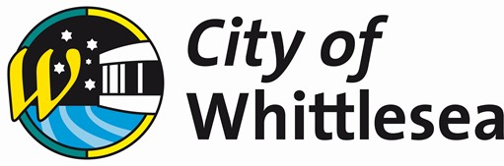

Agenda
Joint Council Meeting
Tuesday 3 October 2023 at 5:00 pm

You are advised that a Joint Council Meeting between Whittlesea City Council, Hume City Council and Mitchell Shire Council has been called via Council resolutions for Tuesday 3 October 2023 at 5:00 pm for the transaction of the following business.

This meeting will be held in the Whittlesea City Council Chamber at Civic Centre, 25 Ferres Blvd, South Morang and will be livestreamed via Council’s website.

Councillors / Administrators
Cr Joseph Haweil Mayor, Hume City Council
Cr Karen Sherry Deputy Mayor, Hume City Council Cr Jim Overend Councillor, Hume City Council
Lydia Wilson Chair of Council, Whittlesea City Council Peita Duncan Administrator, Whittlesea City Council Christian Zahra AM Administrator, Whittlesea City Council Cr Fiona Stevens Mayor, Mitchell Shire Council
Cr Louise Bannister Deputy Mayor, Mitchell Shire Council Cr Rob Eldridge Councillor, Mitchell Shire Council
Senior Officers
Craig Lloyd Chief Executive Officer, Whittlesea City Council Sheena Frost Chief Executive Officer, Hume City Council Brett Luxford Chief Executive Officer, Mitchell Shire Council
Emma Appleton Director Planning & Development, Whittlesea City Council Rachel Dapiran Director of City Planning & Places, Hume City Council
Tim Partridge Acting Director Economy, Growth & Infrastructure
Mitchell Shire Council

Jacinta Stevens Executive Manager Office of Council & CEO, Whittlesea
City Council

Order of Business

The Chief Executive Officer submits the following business:
- Opening 4
  - Meeting Opening and Introductions 4
  - Acknowledgement of Traditional Owners Statement 4
  - Diversity and Good Governance Statement 4
  - Attendance 5
- Declarations of Conflict of Interest 5
- Officers' Reports 6
  - Connected Communities 6
3.1.1 Joint Council Meeting for the Regional Partnership: Cloverton Metropolitan Activity Centre 6
- Closure 13

Opening

Meeting Opening and Introductions
The Chair, Cr Joseph Haweil, Mayor, Hume City Council will open the meeting and introduce the Councillors and Administrators in attendance:

From Whittlesea City Council:
Chair Administrator, Lydia Wilson Administrator, Peita Duncan Administrator, Christian Zahra AM
From Mitchell Shire Council:
Mayor, Cr Fiona Stevens
Deputy Mayor, Cr Louise Bannister Cr Rob Eldridge
From Hume City Council:
Deputy Mayor, Cr Karen Sherry Cr Jim Overend

The Chair will also introduce Officers in attendance:

Chief Executive Officer, Craig Lloyd, Whittlesea City Council Chief Executive Officer, Sheena Frost, Hume City Council Chief Executive Officer, Brett Luxford, Mitchell Shire Council
Director Planning and Development, Emma Appleton, Whittlesea City Council Director of City Planning & Places, Rachel Dapiran, Hume City Council
Acting Director Economy, Growth and Infrastructure, Tim Partridge, Mitchell Shire Council Executive Manager Office of Council and CEO, Jacinta Stevens, Whittlesea City Council

Acknowledgement of Traditional Owners Statement
The Chair will read the following statement:

“On behalf of Council, I recognise the rich Aboriginal heritage of this country and acknowledge the Wurundjeri Willum Clan and Taungurung People as the Traditional Owners of lands within the City of Whittlesea.

I would also like to acknowledge Elders past, present and emerging.”

Diversity and Good Governance Statement
The Chair will read the following statement:

“We are proud of our diversity and the many cultures, faiths and beliefs that make up our community. We strive to be an inclusive welcoming Cities that fosters active participation, wellbeing and connection to each other and this land. We collectively commit to making informed decisions to benefit the people of the three municipalities now and into the future to support our communities visions.”

Attendance

Declarations of Conflict of Interest

Officers' Reports

Connected Communities

Joint Council Meeting for the Regional Partnership: Cloverton Metropolitan Activity Centre

Responsible Officer: Executive Manager Office of Council & CEO, Whittlesea City
Council

Author: Director Planning & Development, Whittlesea City Council Director of City Planning & Places, Hume City Council
Acting Director Economy, Growth & Infrastructure, Mitchell Shire Council

Attachments:

- Attachment 1 Locational Map of Cloverton Metropolitan Activity Centre [3.1.1.1 - 1 page]
- Attachment 2 Vision Principles [3.1.1.2 - 1 page]
Purpose
For Hume City Council, Whittlesea City Council and Mitchell Shire Council to formally endorse the Regional Partnership to continue its joint work and advocacy to the Victorian Government and the landowners to support the planning and delivery of the Cloverton Metropolitan Activity Centre (MAC).
Brief Overview
The Cloverton MAC straddles the boundaries of Hume, Whittlesea and Mitchell Councils (refer Attachment 1). The Cloverton MAC is a unique opportunity to become the new capital of the northern growth corridor. At 5 hectares, Cloverton MAC will service a catchment of approximately 380,000 residents across the three council areas. It will also sustain an estimated 7,500 jobs within the MAC, and approximately 50,000 jobs more broadly.

The Cloverton MAC is relatively small and roughly half the size of the commercial areas of Box Hill and Dandenong that have a similar role and include regional infrastructure comparable to that proposed (and needed) at Cloverton. This highlights the need for an innovative approach to the co-location of services and facilities on the smaller footprint of this MAC.

The growth area setting of the Cloverton MAC provides a rare opportunity to integrate the facilities and services the community will need to thrive.

Under a Memorandum of Understanding (MOU) between the three councils, officers have been working collaboratively in a Regional Partnership on the planning for the Cloverton MAC.

The three councils have now resolved to hold this joint council meeting to:
  - confirm the strategic importance of Cloverton MAC to all three councils;
  - formally endorse the Regional Partnership;
  - formally endorse the high-level vision and principles that underpin the Partnership’s approach to the planning of the Cloverton MAC (refer Attachment 2); and
  - to seek coordination and assistance from the Victorian Government in Cloverton’s planning and delivery.
Recommendation
THAT Hume City Council, Whittlesea City Council and Mitchell Shire Council:
- Note this joint Council meeting is being held in accordance with section 62 of the

Local Government Act 2020.
- Acknowledge the significant opportunity that the Cloverton MAC presents and its strategic role in Melbourne’s northern growth corridor.
- Endorse the Regional Partnership as a unified voice of the three councils for the planning of the Cloverton MAC.
- Endorse the vision and principles underpinning the Partnerships approach to the planning of the Cloverton MAC as detailed in Attachment 2 of this report.
- Endorse the Partnership of Hume Council, Whittlesea Council and Mitchell Shire Council advocating for coordination and assistance from the Victorian Government for the planning and delivery of the Cloverton MAC in a genuine spirit of partnership.
- Resolve the Mayor of Hume Council, Chair Administrator of Whittlesea Council and Mayor of Mitchell Shire Council sign a joint letter to the Premier of Victoria and key Ministers seeking State Government support to partner with the Regional Partnership around the coordination, planning and implementation of the Cloverton Metropolitan Activity Centre and recognising the area for its state significance.
- Resolve to issue a joint media statement.
Key Information
The Cloverton MAC is identified in Plan Melbourne as a future Metropolitan Activity Centre. Located where Hume, Whittlesea and Mitchell meet, the MAC will play a crucial role in Melbourne’s northern growth corridor.

If planned strategically, the Cloverton MAC will play the role of a capital city of the outer north, becoming the primary source of job opportunities and community services for the growing suburbs of Mickleham, Kalkallo, Donnybrook, Beveridge and Wallan, and including major employers in the health, education and government sectors. The Cloverton MAC will be home to an estimated 10,000 residents in the city centre and service approximately 370,000 residents in the wider area. The MAC alone will sustain an estimated 7,500 jobs and approximately 50,000 jobs more broadly.

The original masterplan for the MAC, which included in the Lockerbie Precinct Structure Plan, is now over a decade old and no longer matches what we expect for our communities. To ensure development of the MAC is better aligned with community needs, the three Councils must work together and with key stakeholders to prepare an updated masterplan.

The growth area setting of the Cloverton MAC provides both challenges and enormous opportunities. To meet the opportunity of enabling a place for a thriving community, challenges both short and long term will require a coordinated collaborative approach. Recognising the significance of the opportunity and the need to work together, officers from all three Councils have been working collaboratively as a first-of its-kind Regional Partnership. The Regional Partnership has been formalised through a MOU signed by the three CEOs.

The site of the MAC is owned by a single developer, Stockland, who have begun working on a new masterplan for the MAC with members of the Regional Partnership. This process seeks to build on the previous planning work and respond to the MAC’s updated vision and current planning practices, particularly around sustainability and innovation. High level vision and principles (Attachment 2) have been prepared to guide the Partnership’s input and approach to the planning of the Cloverton MAC.

Given the strategic role the Cloverton MAC will play in the wider northern growth corridor, each of the three Councils have separately resolved to hold and participate in this joint meeting of the Hume City Council, Whittlesea City Council and Mitchell Shire Council under Section 62 of the Local Government Act 2020. The resolution also endorsed the terms of reference for the operation of this joint meeting.

The commitment demonstrated through this joint council meeting and endorsing the Regional Partnership ensures:
- a unified position in advocating to State Government for planning and coordination to deliver the outcomes sought; and
- endorses the continued involvement of officers from across all three councils to deliver the outcomes of the MAC, in partnership with the State Government and the landowner.

Community Consultation and Engagement
This joint council meeting is a public meeting and notice of the meeting has been provided on the three council websites.
Considerations
Environmental
The updated masterplan for the Cloverton MAC seeks to incorporate precinct wide sustainability outcomes. This is an opportunity for the Regional Partnership to ensure social infrastructure is designed and built to the highest possible sustainability standards.

Social, Cultural and Health
If planned strategically, the Cloverton MAC will become the social and cultural hub of the northern growth corridor. The centre is intended to include regional scale social infrastructure, including community uses, sport and recreation, education, health and government services.

Economic
If planned strategically, the Cloverton MAC will become the economic hub of the northern growth corridor. The centre itself will support a diverse range of jobs and is intended to include major employers in the health, education and government sectors. The MAC will also support the economic growth of the wider northern growth corridor.

The MAC will support critical employment nodes in the corridor such as the Merrifield Business Park, Cooper Street Employment Area and the future Beveridge Intermodal Freight Terminal (BIFT)

Financial Implications
There are no financial implications associated with this joint council meeting.
Link to Strategic Risk Strategic Risk
A business-as-usual approach to the planning and development of the Cloverton MAC will represent a lost opportunity, and will fail to meet the social, economic and environmental needs of the community in Melbourne’s northern growth corridor.
Implementation Strategy
Communication
A joint statement will be issued on behalf of the three Councils.

Critical Dates
There is no implementation strategy from this joint council meeting.

Declaration of Conflict of Interest
Under Section 130 of the Local Government Act 2020 officers providing advice to Council are required to disclose any conflict of interest they have in a matter and explain the nature of the conflict.

The Responsible Officer reviewing this report, having made enquiries with relevant members of staff, reports that no disclosable interests have been raised in relation to this report.
Conclusion
If planned strategically, the Cloverton MAC will be a sustainable and thriving new city in Melbourne’s north, supporting the economic, educational and social needs of the wider northern growth corridor.

It is recommended that the representatives of Hume, Whittlesea and Mitchell formally endorse the Regional Partnership and high-level vision and principles to underpin the Partnerships approach to the continued planning of the Cloverton MAC, and seek, coordination and assistance from the Victorian Government in its planning and delivery in a spirit of genuine partnership.

Attachment 1 - Locational Map of Cloverton Metropolitan Activity Centre
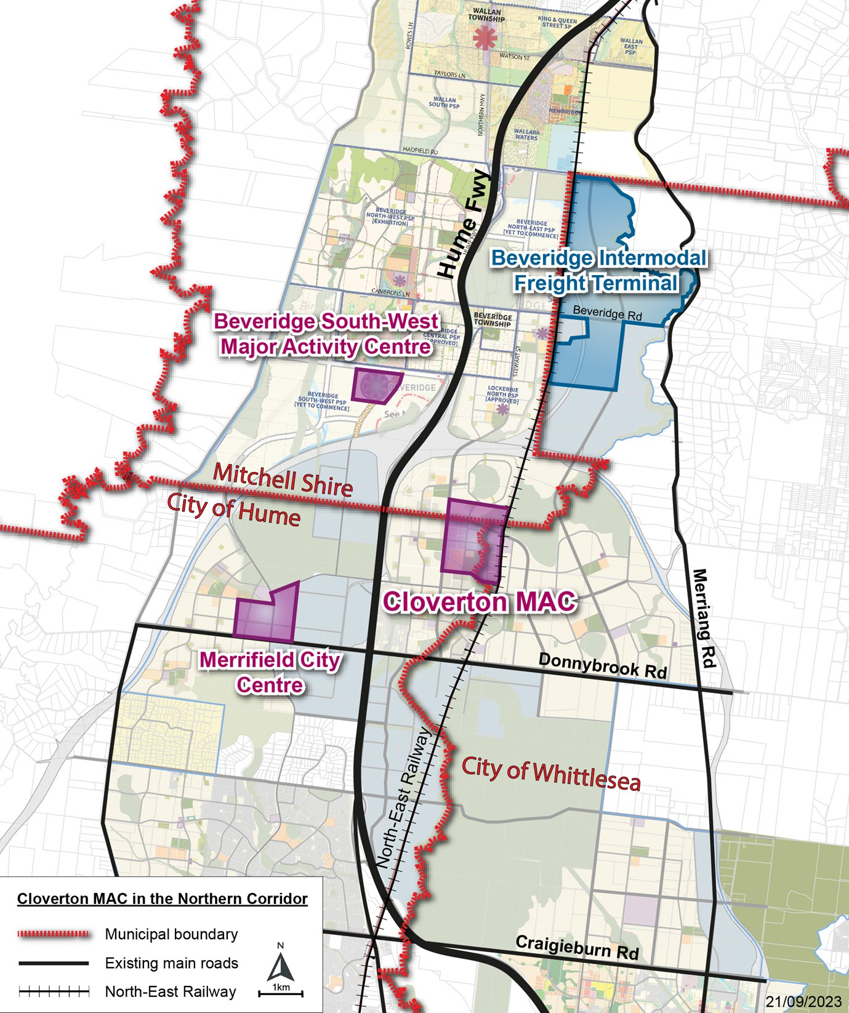

Attachment 2 – Vision & Principles

Vision for the Regional Partnership

The Regional Partnership recognises that the Cloverton Metropolitan Activity Centre (MAC) is a once in a generation opportunity to plan and deliver a new city to service Melbourne’s growing northern corridor. The Partnership will be united in advocacy and work collaboratively to explore innovative outcomes in the planning and development of the Cloverton MAC to achieve the best outcomes for the current and future community.

Principles

United voice – whilst the three councils proudly represent our three communities, we are united in planning and advocating for what will be a new city that sits across our three boundaries and serves the wider northern growth corridor region.

Bold thinking – the Cloverton MAC presents a unique circumstance that requires a different approach to the planning of the centre of a whole and the delivery of infrastructure within the MAC. We are driving towards creating a brand new model for a new city.

Collaboration and innovation – the Partnership will look at innovative ways to plan and deliver the services and facilities needed by the community, with a focus on achieving best outcomes for the community. Working together, we will create a value add, where outcomes will be profound because of the Partnership, than a single council could achieve by acting alone.

Sustainability and innovation – the partnership will pursue outcomes that embed sustainability from the very beginning to deliver an exemplar precinct that achieves resilient outcomes for the community not seen in a greenfield context before. This will include innovative ways to deliver more sustainable built form, transport, water, power, reduce urban heat island and resilient design. The city centre will be a model of environmental stewardship and sustainability.

Design excellence – the Partnership is willing to explore innovative models, including those that adapt things to the local context. Design across the city centre will be site responsive, authentic in character and reflect the connection to the landscape and cultural heritage.

Resilience and community first – the Partnership will ensure the planning for the MAC puts the community at the heart of all decisions to deliver an active, vibrant and inclusive city. The Partnership will adopt a human-centered approach that always puts people at the heart of our thinking, we embrace in our practice and planning the United Nations 2030 Agenda for Sustainable Development which provides a worldwide plan for resilience, diversity, equality, dignity, peace and prosperity for people and the planet, now and into the future.

AGENDA - Joint Council Meeting 3 October 2023

Closure

