Community Engagement Policy 2023-2027
Policy statement
The City of Whittlesea is committed to providing a structured and transparent framework for purposeful, genuine and meaningful community engagement. This policy sets out how Council will provide opportunities for our diverse community to share ideas, opinions and feedback about activities, projects and issues that are important to them.
Council commits to engage in a deliberative, proactive and flexible way to ensure the voices of its community are heard and considered in Council decision-making.
Purpose
The purpose of the Community Engagement Policy 2023-2027 is to:
- promote inclusive decision-making by ensuring community members have the opportunity to have their say on matters and decisions that impact their life
- build trust between the community and the City of Whittlesea whereby opinions are sought, valued and considered and used to shape the future of the City
- contribute to exemplary governance with informed and responsible decisions informed by community input
- remain transparent by being clear on why, when and how we engage our community and how feedback is used to inform the decisions of Council
- foster community connection and collaboration by involving and consulting with community
- promote civic participation and foster a sense of ownership and shared responsibility
- promote accountability and support inclusivity by outlining how Council will provide a range of tailored engagement opportunities for our diverse community
- ensure legislative compliance with the Local Government Act 2020 (Vic).
Scope
This Policy applies to all City of Whittlesea Councillors, Council Officers, contractors, external consultants, project partners, volunteers or any other persons engaged by Council to deliver community engagement activities.
Council will use community feedback to inform decision-making alongside other factors including research, best-practice, specialist technical advice, legislation, risk, safety, budget implications, best value and planning.
As defined in the Local Government Act 2020 (Vic) the Council is the decision maker on matters of policy and governance. The Chief Executive Officer (CEO) ensures the effective and efficient management of the day-to-day operations of the Council and is responsible for overseeing the implementation of Council decisions.
This policy does not replace legislative requirements and statutory processes including those relating to permit applications and planning scheme amendments governed by the Planning and Environment Act 1987 and associated Regulations. Nor does it apply to other council processes such as service requests or complaints.
Alignment to Whittlesea 2040
The Community Engagement Policy 2023-2027 primarily guides Council’s work toward the following Goal as outlined in Whittlesea 2040: A place for all: High Performing Organisation
This Policy enables the City of Whittlesea to meaningfully engage with community on impactful projects, services and plans, and incorporate outcomes into planning and decision-making as projects unfold.
Additionally, this Policy is informed by:
- Local Government Act 2020
- Local Government Act 1989
- Equal Opportunity Act 2010
- Disability Act 2006
- Privacy and Data Protection Act 2014
- Planning and Environment Act 1987
- Road Management Act 2004
- Multicultural Victoria Act 2011
- Subordinate Legislation Act 1994
- Public Health and Wellbeing Act 2008
- Gender Equality Act 2020
- Charter of Human Rights and Responsibilities Act 2006
- Public Administration Act 2004
- Child Safe Standards, Victorian Commission for Children and Young People

Overarching Governance Principles
The development of this Policy considered the Local Government Act 2020’s Overarching Governance Principles and the following were applied:
Lawful | ☒ |  | Community engagement | ☒ |  | Financially viable | ☐
Best community outcome | ☒ |  | Innovation & improvement | ☒ |  | Consistent with government plans | ☐
Sustainable | ☐ |  | Collaboration with government bodies | ☐ |  | Transparent | ☒
Lawful: This Policy has been developed in accordance with the requirement for local governments to develop a Community Engagement Policy per the Local Government Act 2020.
Best community outcome: This Policy ensures that decision-making at the City of Whittlesea is informed by the interests of our diverse community, and that steps are taken to proactively ensure all representative voices are heard.
Community engagement: This Policy informs a best-practice approach to all community engagements with the City of Whittlesea community, to ensure all Council decisions are made in the interest of community.
Innovation & improvement: This Policy and related processes will be reviewed periodically with a focus on continuous improvement and innovation to ensure they remain relevant with legislation and community priorities.
Transparent: Council is accountable for the decisions it has been entrusted to make. This Policy ensures that Council is clear on why and how we engage our community to inform these decisions.
Gender Equality, Human Rights and Child Safe Compliance
The City of Whittlesea commits to actively seeking representation from all diverse groups within the municipality. Inclusive stakeholder engagement recognises the diversity within each community and of individuals. It also recognises that intersectionality can further exacerbate barriers to public participation and engagement.
Applying a gender lens to stakeholder engagement means taking time to actively seek out the knowledge, perspectives and experiences of women, men and gender diverse groups on all policies, programs and services, not just initiatives targeted at them. It is about creating a more empowering space for all members of the community to take part.
As a Child Safe organisation, we seek to include the voices of children and young people in our organisational activities and actively seek to understand what makes them feel safe, and provide them with opportunities to contribute to decisions that impact them. You can read the City of Whittlesea’s Child Safe Commitment Statement, Child Safe Policy and Code on our website at www.whittlesea.vic.gov.au/childsafety
All City of Whittlesea policies comply with the Victorian Charter of Human Rights and Responsibilities, Gender Equality Act, Climate Change Act and the Child Safe Standards.
Definitions
Act means the Local Government Act 2020 (Vic)
Chief Executive Officer means the person appointed by Council to be its Chief Executive Officer (CEO); or any person acting in that position.
City means the City of Whittlesea
Collaborate means to partner with the community in each aspect of the decision including the development of alternatives and identification of preferred solutions
Community means the people who live, work, visit, study, or do business in the City of Whittlesea
Community Engagement (also known as stakeholder engagement, public participation or community consultation) means a planned process with the specific purpose of encouraging active participation from the community in decisions that impact them or are of interest to them
Consult means obtaining public feedback and analysis, alternatives and/or decisions
Consultation means the planned engagement process of seeking feedback or advice on a specific project or topic
Council means the City of Whittlesea, or City, being a body corporate constituted as a municipal Council under the Local Government Act 2020 (Vic)
Council officer means the Chief Executive Officer and staff of Council appointed by the Chief Executive Officer
Councillors means the individuals holding the office of a member of Whittlesea Council or an appointed Administrator
Deliberation means careful and comprehensive consideration or discussion and movement toward consensus
Deliberative engagement means a well-planned engagement process that encourages the community to critically test, weigh up and consider a range of information, perspectives, inputs and evidence to reach a consensus or make recommendations
Diverse communities means individuals or groups who live, work, play, visit, study or invest in our City. Often defined by specific geographic locations, or those with common interests, practices, affiliations or identities.
Empower means to place final decision making in the hands of the public
Gender equality means the equal rights, responsibilities and opportunities of women, men, transgender and gender-diverse people. Equality does not mean that women, men, transgender and gender-diverse people will become the same, but that their rights, responsibilities and opportunities will not depend on their gender
IAP2 Spectrum of Engagement means the International Association of Public Participation engagement spectrum that ranges from proving information to inform the community (low level of influence on a project/decision) through to collaborating with and empowering the community in decision-making (high level of influence on a project/decision)
Inform means providing the community with information to assist them understanding he problem, alternatives, opportunities and/or solutions
Intersectionality means the interconnected social categorisations such as race, class, and gender as they apply to a given individual or group
Involve means working directly with the community throughout the engagement process to ensure their concerns and aspirations are consistently understood and considered
Mayor means the councillor elected to the Office of Mayor of the City, Deputy Mayor acting in the role of Mayor or any person appointed by Council to be acting as Mayor, or an appointed Chair of a panel of Administrators
Stakeholder means an individual or group that has an interest in or may be impacted by a project decision or who can influence the decision-making

Our commitment to engage
The Local Government Act 2020 (Vic) articulates Council’s responsibility to conduct community engagement. The Act states that Councils must adopt and maintain a community engagement policy.
The City of Whittlesea will identify individuals and groups who may be impacted or interested in the project or decision and encourage participation in the engagement.
The City of Whittlesea will endeavour to reduce physical, social and cultural barriers to participation in community engagement activities that may include Aboriginality, age, ability, ethnicity, gender identity, race, religion, sexual orientation and other attributes.
In accordance with the Local Government Act 2020 (Vic) Council must specifically engage on the following:
- Community Vision
- Council Plan
- Financial Plan
- Asset Plan
- Making a Local Law
- Acquiring or selling land, or leases in prescribed circumstances.
The City of Whittlesea may also engage with the community when:
- a proposed change to Council activities or strategic direction may significantly impact the community in terms of the economy, lifestyle, environment, wellbeing or amenity of the municipality
- when developing new or reviewing existing policies or strategies
- introducing a new service, discontinuing an existing service or substantially changing or reviewing a service that may significantly affect how services are provided
- planning and development of major projects and capital works, including public buildings, town centres, parks or other infrastructure
- urban development/redevelopment proposals, such as structure plans, that may significantly alter the existing amenity or characteristics of a geographic area.
In addition to formal engagement, Council invites our community to engage with us at any time and in any way that is appropriate, respectful and constructive.
What is Community Engagement?
Community engagement is a planned process that provides a range of opportunities for public involvement in Council’s decision-making, relationship building and community strengthening
Community engagement has the specific purpose of encouraging active participation from the community in decisions that impact them or are of interest to them. Engagement can take many forms including:
- sharing information, educating the community and providing updates
- seeking community perceptions, opinions, feedback and ideas
- collaborating with key stakeholders to address specific local issues.
When community engagement may be limited
There are times when Council’s level of engagement with the community and key stakeholders may be limited. In some circumstances, Council may only be able to inform the community and stakeholders of Council’s decisions and actions.
This may occur when:
- Council is not the lead agency
- an immediate resolution is required
- specialist or technical expertise is required
- there are no negotiables or opportunities to influence the decision
- an initiative involves confidential or commercial information
- there are clear and defined legislative responsibilities that must be met
- developing or reviewing internal policies and procedures
- there is a risk to public safety.
The spectrum of engagement
Council’s approach to community engagement is guided by the International Association of Public Participation (IAP2) Spectrum of Engagement, which is recognised as the best practice tool for community engagement.

The IAP2 Spectrum identifies five levels of engagement with corresponding goals and actions. It makes clear the role of the community in decision-making at each level.
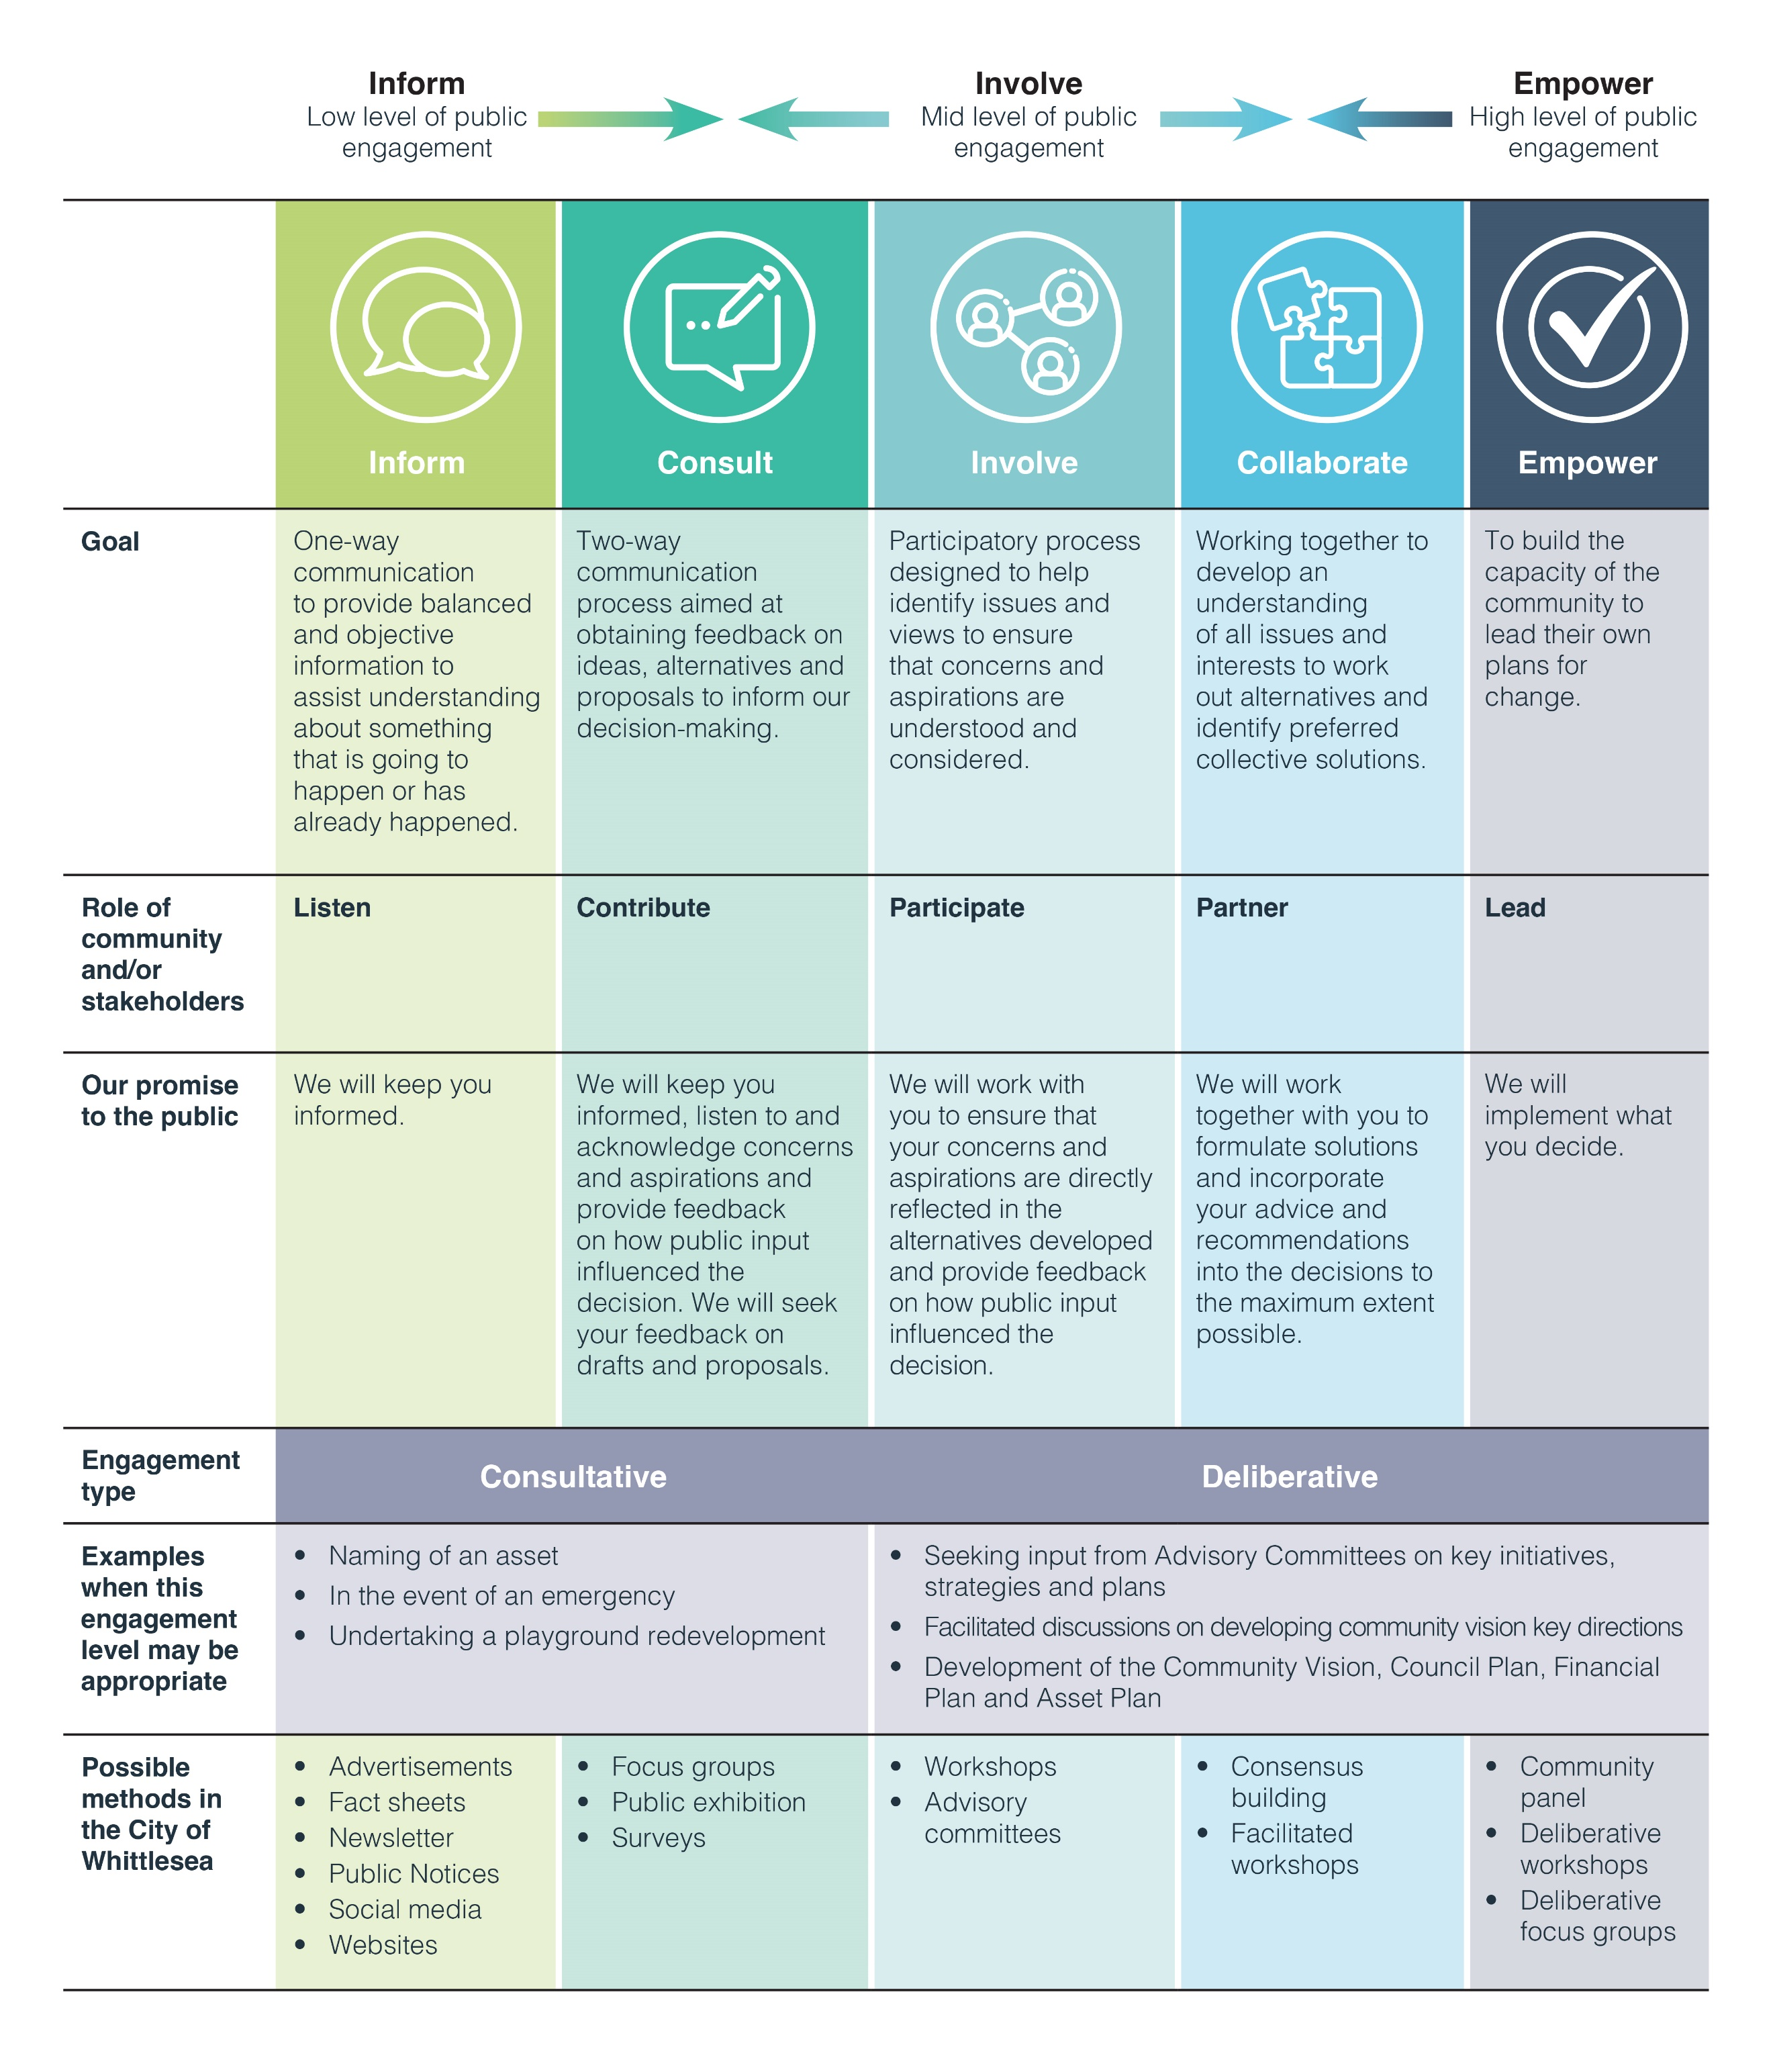

Types of engagement

Council undertakes a range of community engagement activities and engagement can occur at multiple stages across a project.
The two main types of community engagement are:
Consultative or participatory engagement
This has a lower level of influence, generally aligning with the ‘Inform’ or ‘Consult’ range of the IAP2 spectrum. Participation at this level usually includes a broad range of community members and stakeholders and occurs when views, opinions or ideas are invited on a specific project, draft policy, plan or document.
Examples of consultative engagement practices include:
- surveys
- polls
- ideas boards
- listening posts and pop-up stalls
- formal submissions.
Deliberative engagement
This practice has the highest level of influence, generally aligning with the ‘Involve’, ‘Collaborate’ or ‘Empower’ range of the IAP2 spectrum. It encourages community members to critically test, weigh up and consider a range of information, perspectives, inputs and evidence to make a recommendation or reach consensus if needed.
Deliberation can be scaled to suit a project based on its scope, complexity or impact and may require independent facilitation to ensure a fair and equitable process.
Examples of a deliberative practice includes:
- working with committees, advisory groups or reference groups over time
- panels of community members
- focus groups and workshops.
Principles and commitments
The City of Whittlesea is committed to the community engagement principles outlined in section 56 (a) to (e) of the Local Government Act 2020. These principles emphasise the importance of accessibility, inclusivity, transparency, timeliness, accountability and continuous improvement.
Community Engagement Principle | Our commitment
A community engagement process must have a clearly defined objective and scope | - All community engagements are planned in line with this policy and identify the purpose, scope and objectives of the project/decision  - Council will clearly inform participants and the community what they can and cannot influence, how they can participate, and what opportunity there is for them to influence a decision
Participants in community engagement must have access to objective, relevant and timely information to inform their participation | - Council will provide the community with objective, relevant and timely information that provides all necessary information for community to participate meaningfully in the engagement  - Information will be presented in plain language that is easily understood  - Council will make use of accessible formats and information in other languages where appropriate to support participation in the community engagement  - Council will use a variety of traditional and digital communication channels to inform about the opportunity to engage  - All relevant information will be made available on Council’s Engage Whittlesea platform, which is translatable into several languages spoken by the City of Whittlesea’s diverse community
Participants in community engagement must be representative of the persons and groups affected by the matter that is the subject of the community engagement | - Council will identify individuals and groups who may be impacted by or interested in the project or decision and encourage participation in the engagement  - Council will use different engagement methods to ensure it hears from key stakeholders and our community at a time and in a way that suits them  - Council will undertake activities that seek to hear from a representative cross-section of the community  - Council will utilise existing networks and groups to increase inclusiveness and reach  - Where appropriate Council will partner with other organisations to maximise collective effort, impact and the opportunity to engage with the community

Community Engagement Principle | Our commitment
Participants in community engagement are entitled to reasonable support to enable meaningful and informed engagement | - Council will design engagement opportunities that are inclusive and accessible and make reasonable adjustments where necessary to remove barriers to participation  - Council will provide sufficient time to provide feedback to ensure those impacted can participate in a meaningful way  - For community who may experience barriers to participation, additional resources may be considered  - Council will work with participants to reduce physical, social and cultural barriers to their participation.  - Consideration will be given to time, location and methodology such as face-to-face or online engagement activities
Participants in community engagement are informed of the ways in which the community engagement process will influence Council decision making | - Council will identify the appropriate level of engagement as outlined in this policy  - Council will advise key stakeholders and the community how community input will be considered as part of Council’s decision-making  - Council will communicate how and when the decision will be made and identify other factors that will influence the decision-making process  - Council will report back to the community in a timely manner to share what we heard and how that community feedback informed the decision-making process
Block out periods
Council will endeavour to avoid carrying out formal consultation around key dates such as Christmas/New Year, long weekends and school holidays, where possible unless it allows specific groups more opportunity to participate.
Elections
In the lead up to Council elections, community engagement will be guided by Council’s Election Period Policy.

Roles and responsibilities
Community engagement is part of Council’s core business and is the responsibility of all Council business areas and employees. Our specific roles and responsibilities are outlined in the table below.
Role | Responsibilities
Mayor and Councillors | Champion the commitment and principles of engagement through leadership, modelling best-practice and decision-making.
CEO and Executive Leadership Team | Stewardship of a culture that fosters best-practice engagement and modelling the principles through leadership, process and implementation of this policy.
Council officers | Ensure their community engagement planning and delivery is consistent with this policy as appropriate to their role and function.
Community Engagement Team | Oversee adherence to the Community Engagement Policy 2023-2027 and support the development and delivery of Council’s community engagement program practice through the provision of advice, training and mentoring, resources and tools. The team is responsible for building organisational capacity and knowledge in community engagement.
Community members | Constructively participate in engagement processes by sharing local knowledge, values and perceptions while being respectful of the engagement process, Councillors, Council Officers and the ideas and opinions of other community members.  The City of Whittlesea is committed to being accessible and responsive to all those willing to participate in community engagement activities. However, any unreasonable customer/community conduct, which may negatively impact on our staff’s safety and wellbeing will be responded to in alignment with Council’s Unreasonable Complainant Conduct Guidelines.
Beyond planned engagement
Council welcomes community feedback at any time and will always respect, gather and be receptive to community input via our customer channels and community interactions.
Insights and information captured through community engagement activities will be used to improve our understanding of the current experience of our community and may be used to help inform Council’s progress toward its vision and goals.
How was the policy developed?
First adopted by Council in 2021, the A Voice For All Community Engagement Policy 2021 was refreshed in 2023.
Since the Policy’s inception Council has continued to foster community participation and has shaped the update of this policy in line with ongoing community feedback.
The policy was updated following an internal review as well as benchmarking best practice community engagement in the public sector.
The draft Community Engagement Policy 2023-2027 was released for community feedback before being adopted by Council.
Privacy statement
As part of our engagement process Council may at times collect demographic data. We are committed to the responsible collection and handling of personal information, consistent with the principles in the Privacy and Data Protection Act. If you believe we have handled your personal information inappropriately, please contact the Information Privacy Officer on 03 9217 2170 or email privacy@whittlesea.vic.gov.au.

