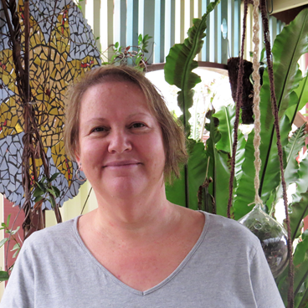
KAREN HASSED

FAMILY DAY CARE EDUCATOR

CITY OF WHITTLESEA

PROFILE

OPEN: Monday to Thursday: 8.00am to 5.00pm
YEARS IN CHILD CARE SECTOR: 28 years
QUALIFICATIONS: Diploma of Early Childhood Education and Care
SUBURB: Lalor

ABOUT ME
- I have been with the City of Whittlesea Family Day Care service for 28 years. During this time I have been involved with many families and children. I have watched each child develop and grow from an infant to a confident school aged child.
- I decided to become an FDC Educator as I have always had an interest working with children. I have worked prior to this as a nanny and in centre based child care.
- I have three grown up children, two beautiful dogs and a collection of goldfish.
- I enjoy working with mosaics, art and craft, cooking and the gym.

ABOUT MY SERVICE
I provide a fun, relaxed and secure environment. I provide the children with lots of play based and open-ended activities. These are based on the children’s interests. We regularly visit and have adventures at the local parks, bush playgroup, Family Day Care playgroups and library story time.

ABOUT MY FACILITIES
I have a safe fun environment both indoors and outside. I have a large family room set up for the children and open shelves so children can make choices. The back yard is partially covered with a lovely garden and a great outdoor area for messy play, riding bikes and ball games.

CONTACT
PHONE: 0422 141 623
WEBSITE: https://www.whittlesea.vic.gov.au/community-support/children-and-families/family-day-care/
For more information about Family Day Care phone 9404 8870 or email famdaycare@whittlesea.vic.gov.au

