Complaints Policy
Policy statement
The City of Whittlesea values and encourages community feedback. Where there are complaints about our services, actions, decisions, and policies we are committed to:
- enabling members of the public to make complaints about the Council
- responding to complaints by taking action to resolve complaints as quickly as possible
- learning from complaints to improve our services.
We treat every complaint we receive on its individual merits, through clear and consistent processes. Our complaints policy applies to all complaints from members of the public about Council staff, Council contractors and decisions made at Council meetings. This policy does not apply to complaints about individual Administrators/Councillors.
Purpose
The Complaints Policy aims to:
- put in place an open and transparent customer complaint handling system;
- establish our timeframes for addressing complaints (where statutory timelines apply; they will override the timelines in this Policy);
- ensure Council Officers handle complaints fairly and objectively;
- set out how Council Officers record and analyse complaint data to identify where we can improve our services; and
- put in place open and transparent procedures for managing unreasonable complainant conduct to ensure unreasonable complainants are dealt with fairly and objectively.
Principles
The Complaints Policy is informed by the following City of Whittlesea Community Building Principles:
Equity, access and inclusion
We support the development of a safe and inclusive community, and promote respect for diverse values, abilities, beliefs, cultural practices and ways of living. Council ensures that the distribution of our services and resources is a transparent and socially inclusive process that delivers equitable outcomes.

Community and civic participation
We are committed to delivering accessible information, facilities, programs and services that encourage all people to build social connections and participate in community life. We work to ensure citizens are informed and consulted by governments about the decisions that affect their lives and are able to fully participate in decision making processes.
Community outcomes
We are focused on achieving positive and equitable community outcomes by ensuring a consistent approach to recording, managing, and reporting on complaints received from the community regarding service standards and delivery. Complaint data is important community feedback and is an integral part of the continuous improvement process.
Context/Rationale
Development of a Complaints Policy is a requirement under the Local Government Act 2020 which states that a Council must develop and maintain a complaints policy.
A robust Complaints Policy enables effective and consistent management of complaints and provides data to inform service refinements and improvements.
Scope
This policy is applicable to all members of Council staff, volunteers, and contractors.
Key linkages
All City of Whittlesea policies comply with the Victorian Charter of Human Rights and Responsibilities.
This policy has links to several Council documents and legislation.
- Council’s Complaint Handling Guidelines
- Council’s Managing Unreasonable Complainant Conduct Guidelines
- Council’s Community Plan
- Council’s Code of Conduct for Staff and Others
- Council and complaints - A good practice guide (Victorian Ombudsman’s Office)
- Charter of Human Rights and Responsibilities Act 2006
- Freedom of Information Act 1982
- Privacy and Data Protection Act 2014
- Local Government Act 2020
- Public Interest Disclosures Act 2012
- Equal Opportunity Act 2010

Procedural guidelines
Definition
A complaint includes a communication (verbal or written) to the Council which expresses dissatisfaction about:
- The quality of an action, decision or service provided by Council staff or a Council contractor
- A delay by Council staff or a Council contractor in taking an action, making a decision or delivering a service
- A policy or decision made by the Council, Council staff or a Council contractor.
In this policy:
- ‘Council staff’ is any person employed by the Council to carry out the functions of the Council, and the Council’s CEO, this includes volunteers.
- ‘Council contractor’ is any third-party engaged by the Council to carry out functions on the Council’s behalf.
- ‘the Council’ means the body of elected Councillors/ the Panel of Administrators.
A complaint is not:
- A request for service, which is contact with Council to seek either assistance, access to a new service or advise us about a matter for which Council has responsibility.
- Feedback, which is information provided to council on the quality of service provided by its officers or contractors.
How to make a complaint
Any member of the public can make a complaint. Complaints can be made by:
- Telephone: 03 9217 2170
- Online: www.whittlesea.vic.gov.au
- Email: Info@whittlesea.vic.gov.au
- Post: City of Whittlesea, Locked Bag 1 Bundoora, MDC, 3083
- In person: Council Offices, 25 Ferres Boulevard, South Morang

All complainants are asked to raise their concerns directly with the Council staff member or contractor involved in the first instance to allow Council the opportunity to resolve the complaint. If the complaint is not resolved, the complaint can be escalated to a senior officer. After all avenues of review at the Council level have been met and if the complainant is not satisfied with Councils response they will be advised of the external avenues for appeal.

It is helpful for a complainant to provide the following to Council:
- Name and contact details. Complaints can be made anonymously, but this may limit how Council responds
- Identify the action, decision, service or policy in question, and precisely what is causing the dissatisfied
- Relevant details, such as dates, times, location or reference numbers, and documents that support the complaint
- The outcome being sought from making a complaint
- Whether the complainant has any communication needs
We are committed to ensuring our complaints process is accessible to everyone. Tell us if you have specific communication needs or barriers, and we can assist you by:
- using an assistance service, such an interpreter or TTY (for free)
- talking with you if you have trouble reading or writing
- communicating with another person acting on your behalf if you cannot make the complaint yourself.
Our complaints process
Diagram 1. Flowchart of the complaints process
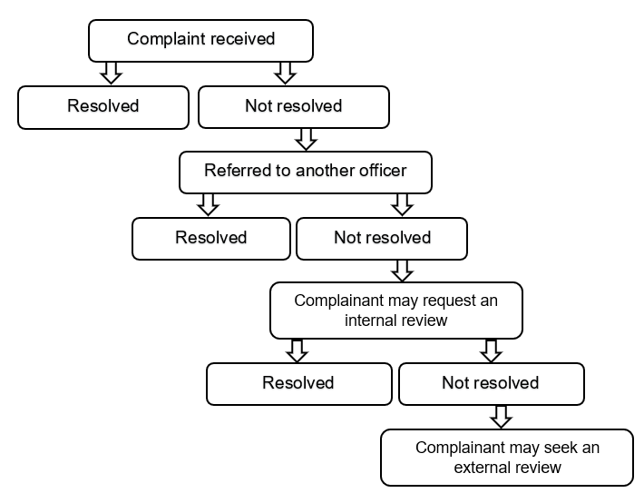
When you complain to us, we will record the complaint immediately and acknowledge your complaint within one business day. We will initially assess your complaint to decide how we will handle it. This may happen while we are talking with you.

After our initial assessment, we may:
- take direct action to resolve your complaint
- refer your complaint to the relevant team or manager for investigation
- refer your complaint to the relevant external agency for investigation
- decline to deal with your complaint if you have a right to a statutory review of your complaint (such as a right of appeal to VCAT).
Where possible, we will attempt to resolve your complaint at the time you first contact us. If we decide not to act on your complaint, we will explain why, and, where possible, inform you about other options.

If we cannot resolve your complaint quickly, we will refer it to the relevant team or manager to investigate. We will tell you who you can contact about the investigation.

We aim to complete investigations within 20 business days and will tell you if the investigation will take longer. We will update you regularly (but no longer than 20 business days) about progress until the investigation is completed. We will inform you of the outcome of your complaint and explain our reasons.

As part of our investigation we will:
- Assess the information against relevant legislation, policies and procedures
- Refer to Council documents and records
- Meet affected parties to consider possible solutions
- Advise you in writing of the outcome and our reasons
We require our staff to be respectful and responsive in all their communications with members of the public. We expect the same of you when you communicate with our staff.
We may change the way we communicate with you if your behaviour due to either its nature or frequency raises health, safety, resource or equity issues for Council staff involved in the complaints process.
How to request an internal review
If you are dissatisfied with our decision and how we responded to your complaint, you can request an internal review.

The internal review will be conducted by a senior Council officer with the required subject matter knowledge but who has not had any prior involvement with your complaint.

We will inform you of the outcome of the internal review and explain our reasons within 20 business days.
How to request an external review
There are external bodies that can deal with different types of complaints about us. After all avenues of review at the Council level have been met and if you are not satisfied with Councils response, we will advise you of the relevant external avenue for appeal.

You can request an external review from the following organisations.

Complaint | Organisation to contact for external review
Actions or decisions of a Council, Council staff and contractors.  This includes failure to consider human rights or failure to act compatibly with a human right under the Charter of Human  Rights and Responsibilities Act 2006 (Vic) | Victorian Ombudsman www.ombudsman.vic.gov.au
Breaches of the Local Government Act 2020. Concerns about a councillor, council staff, a person providing advice to Council, or Council elections. | Local Government Inspectorate www.lgi.vic.gov.au
Breach of privacy.  Complaint about a freedom of information application | Office of the Victorian Information Commission www.ovic.vic.gov.au
Corruption or public interest disclosure (‘whistle-blower’) complaints | Independent Broad-based Anticorruption Commission www.ibac.vic.gov.au
Management of child safety | Commission for Children and Young people  www.contact@ccyp.vic.gov.au
Discrimination | Victorian Human Rights and Equal Opportunity Commission www.humanrights.vic.gov.au
Council elections | Victorian Electoral Commission www.vec.vic.gov.au
How we learn from complaints
Complaints from people who use or who are affected by our services provide us with valuable feedback about how we are performing.

We regularly analyse our complaint data to identify trends and potential issues that deserve further attention. We use this information to come up with solutions about how we can improve our services.
Your privacy
We keep your personal information secure. We use your information to respond to your complaint and may also analyse the information you have provided for the purpose of improving services that relate to your complaint.

When gathering information to respond to a complaint, we will only use it to deal with the complaint or to address systemic issues arising from the complaint.

The following information will be recorded for each complaint:
- The complainant’s details
- How the complaint was received
- A description of the complaint
- The complainant’s desired outcome (if known)
- The Council Officer responsible for handling the complaint
- Any action taken, including contact with the complainant, response times and the outcome
- Any recommendations for improvement, and who is responsible for implementing them.
Where we publish complaint data, personal information is removed.

