CRM No:…………….

BUILDING ACT 1993
BUILDING REGULATIONS 2018
Building Regulation 116

Application For Siting of Public Protection
for works requiring a Building Permit

To: Ashley Hansen, Municipal Building Surveyor, City of Whittlesea
Locked bag 1,
BUNDOORA MDC 3083
Telephone: 9217 2170 email: buildplan@whittlesea.vic.gov.au

From: Applicant Name:…………………………………………………………………….
Postal Address:………………………………………………………………………
Telephone:……………………………Mobile:……………………………………… Email:…………………………………………………………………………………

Relevant Building Surveyor:……………………………………………………….
Postal Address:……………………………………………………………………..
Telephone:……………………………Mobile:…………………………………….
Email:…………………………………………………………………………………

Site/Project Address:……………………………………………………………………….

Proposed Erection Date:……………………………………………………………………

Proposed Removal Date:…………………………………………………………………...

The following information MUST accompany this application:

Relevant Building Surveyor’s
Consent letter and endorsed plans
for any proposed protection
Measures enclosed

Details of existing damage to
footpath/kerb/road provided

Copy/evidence of Public Liability
Insurance for protection measures
provided

□ Yes □ No

□ Yes □ No

□ Yes □ No

Applicant’s Signature: Date:
INFORMATION PRIVACY: The information supplied on this form is shared with the Victorian Building Authority, the Electoral Commission and other government agencies as required by law and in accordance with Council’s Privacy Policy which is published at www.whittlesea.vic.gov.au.
- Application Fee
- The precautions must be approved by the Relevant Building Surveyor before building work is commenced.
- Before and during the carrying out of building work all excavations must be fenced or otherwise guarded against being a danger to life or property; to the satisfaction of the Relevant Building Surveyor.
- Any damage caused/occurring during construction must be repaired to council’s specification at the cost of the applicant.
- Please note that any existing damage that is not recorded or advised to Council at the time of the application will be the responsibility of the applicant. Damages are to be repaired to Council’s specification.
- Please note that this permit is strictly for the siting of public protection only. A separate permit is required for Cranes, Cross Overs, Work Zone permit, road occupancy, Road Opening, Road closer, Rubbish bins, Rubbish Chute and Skip bins.
- Please note that no Hoarding Permit will be granted in relation to building works unless evidence of the public liability insurance is provided (minimum cover of $5 million) against any claims of injury or damages resulting from the protection measures.

CRM No:…………….

APPLICATION FOR USE OF COUNCIL ASSETS
(In association with a Hoarding Permit)

To
Ashley Hansen, Municipal Building Surveyor, City of Whittlesea
From:
Owner or Agent: Telephone:
Address: …………………………………………………………………………………...
Email Address……………………………………………………………………………..

I hereby apply for authorisation to utilise a portion of Council assets for the purposes of installing Hoarding around a building site at the following address.
Property details:
Number Street/Road City/Suburb/Town
Lot/s ………………………………………………… LP/PS
Municipal District

Start Date:………………………………………………
Finish Date:…………………………………………….

Signature of owner or agent Date

APPLICATION CHECKLIST
Completed application form (including this page) with the attached documents.
Copy of contractor’s public liability insurance $20 million minimum.
Pedestrian access / traffic management plan(s) for the proposed works.
Note: These may require external agencies approval – refer to list below.
Copy of courtesy letter for any full road closures and or approved detour routes as indicated on your traffic management plan.

One fully dimensioned (metric scaled) site plan showing:-
- street names and North point
- extent of proposed works and / or protection works
- footpath and roadway widths and extents of all occupations required
- location of all vehicles, plant and equipment associated with works.
- location of any existing features such as street furniture, trees, fire hydrants, parking signs, traffic signs, parking meters, on street parking conditions public transport stops, and site access.
- details of tree protection measures
One (metric scaled) drawing, including elevations and sections of scaffolding and protection works / barriers showing:
- location, type, height and footing system of temporary hoardings / barriers extending across the site, footpath and road reserve.
- height and depth of any tower / mobile scaffolding, safety mesh screens, catch platforms, overhead gantries etc
- location, type and dimensions of pedestrian signage, temporary road / footpath crossings, night lights etc
VicRoads - MOA (Memorandum of Authorisation) approval if required
Public Transport Companies approvals.
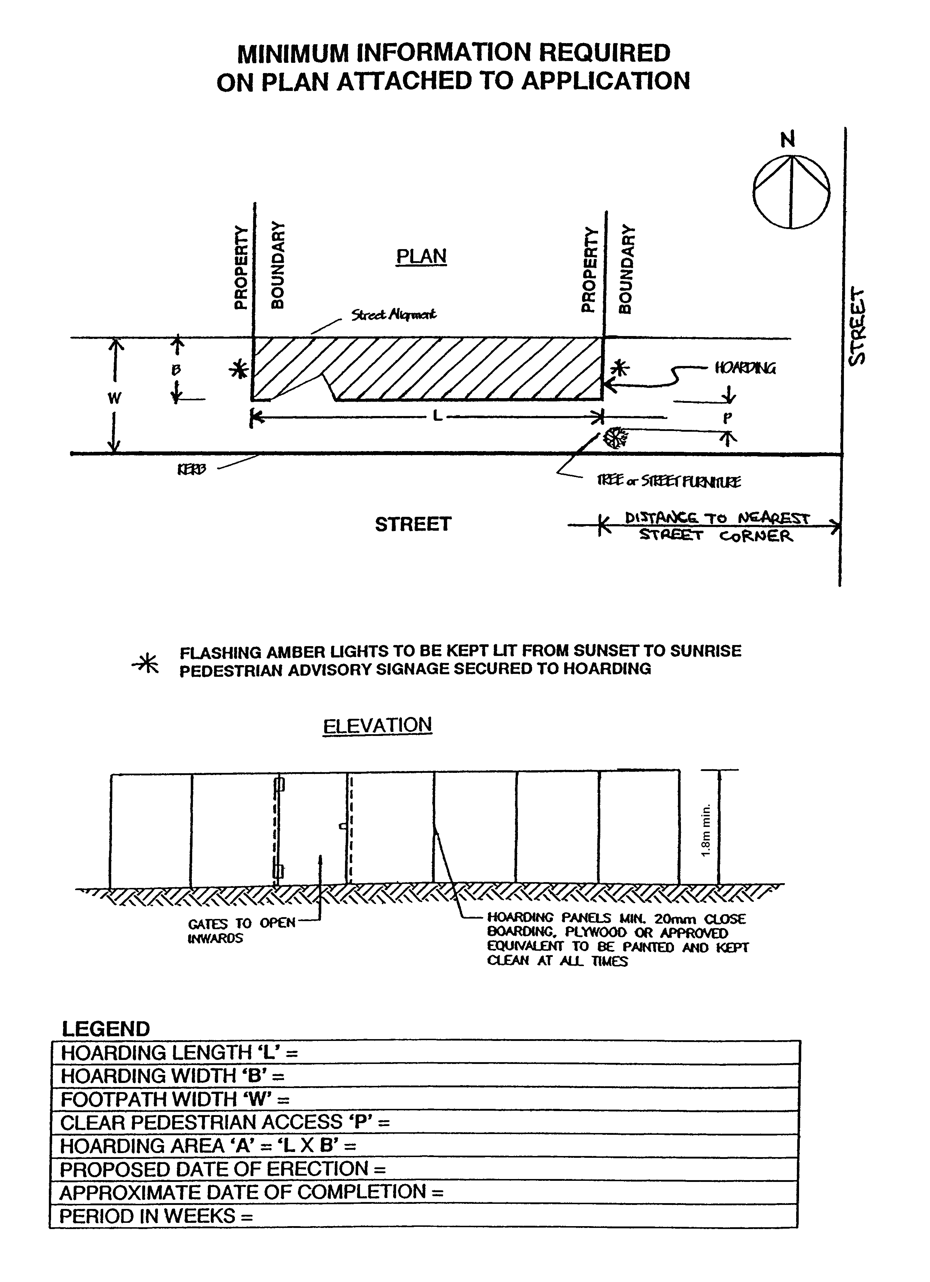
INFORMATION PRIVACY: The information supplied on this form is shared with the Victorian Building Authority, the Electoral Commission and other government agencies as required by law and in accordance with Council’s Privacy Policy which is published at www.whittlesea.vic.gov.au.

