 

*the right   
place for*   
**Agribusiness**

Chair, Panel of Administrators

Photograph of Ms Lydia Wilson

CHAIR, PANEL OF ADMINISTRATORS,   
MS LYDIA WILSON

The City of Whittlesea strongly supports the agricultural sector and encourages new agribusinesses to grow and prosper in our region.

Our vision is to utilise innovative, best practice, farming techniques and solutions to become a major contributor to Melbourne’s peri-urban food bowl.

To maximise our local agricultural capability, Council is actively seeking to attract investment into new and existing agribusinesses and encourage sustainable farming practices.

With productive and viable farming land located in close proximity to major regional transport and infrastructure, along with access to recycled water, a skilled workforce and local farmers’ markets, agribusinesses are set to thrive in the City of Whittlesea.

We are investigating opportunities for agriculture in our region, including:

* Identifying and protecting high quality farm land
* Pathways to starting an agribusiness
* Building the supply and value-add chain
* Agritourism
* Networking events for new and existing agribusinesses and farmers

This prospectus showcases current initiatives such as the Wollert Community Farm and Food Collective – a collaboration with Melbourne Polytechnic, Whittlesea Community Connections and Yarra Valley Water to develop a mixed farming enterprise.

This is just one of many projects in the pipeline designed to support our emerging agricultural industry.

We look forward to partnering with you to further develop opportunities identified in this prospectus and uncover more creative, exciting and innovative agribusinesses all within an enviable urban fringe location.

Contents

Agriculture snapshot 4

Whittlesea’s competitive advantage 6

Major Initiatives 8

State Government Advocacy 8

Land Capability Assessment 8

Wollert Community Farm and Food Collective 8

Regenerative Agriculture and its potential for enhancing climate resilience 9

Future opportunities 10

# Agriculture snapshot

Total agriculture gross value (increased output and product value) has increased despite a gradual decline in the total number of businesses and sales over the past five years, which is attributable to common challenges faced within all peri-urban areas.

These challenges include:

* Competing land uses;
* Fragmentation of farm land;
* Changing demographics and lifestyle of our green wedge residents
* Climate change

With these challenges come opportunities:

* Encouragement of small-scale agriculture and sustainable, regenerative farming practices
* Increased access to land for all residents wanting to farm
* Increased number of businesses and sales
* Focus on small volume-high value outputs
* Uptake of technological and data improvements
* Improved production efficiency
* Creation of an agritourism industry

Increased the gross value of total agriculture by   
$54m   
from $161.2m in 2016 to $215.3m in 2018

Made major contributors to each industry below in 2018:

* Mushroom production
* Outdoor nurseries
* Poultry, cattle & calves
* Eggs
* Apples & strawberries

INDUSTRY GROSS VALUE

- Vegetables for human consumption are the largest contributor in 2018 and increased from 2016 to 2018
- Nurseries, cut flowers or cultivated turf are the second largest contributors in 2018 and increased substantially from 2016 to 2018
- Livestock slaughtered and other disposal are the third largest contributors in 2018 and remained consistent from 2016 to 2018
- Fruit and nuts (excl grapes) are the fourth largest contributor in 2018 and remained consistent from 2016 to 2018

The City of Whittlesea forms part of the Statistical Analysis 4 region, which includes the Shire of Nillumbik, City of Banyule, part of the City of Darebin, part of the Shire of Mitchell and part of the Shire of Murrundindi.

# Whittlesea’s competitive advantage

Doing agribusiness in the City of Whittlesea has a number of economic and lifestyle advantages.

* Productive and viable farming land on our urban fringe
* Proximity and access to major regional transport and infrastructure, educational institutions and the Melbourne Wholesale Fruit and Vegetable Market
* On the doorstep to Melbourne Polytechnic’s ‘paddock to plate’ vocational education
* Access to local buyers and Victoria’s premier food hub
* Dedicated agribusiness support
* Council commitment to protect and encourage agricultural land use
* Availability of recycled water
* Access to local Farmers Markets
* Access to a skilled workforce

MAJOR LOCAL AGRIBUSINESSES AND PRODUCERS

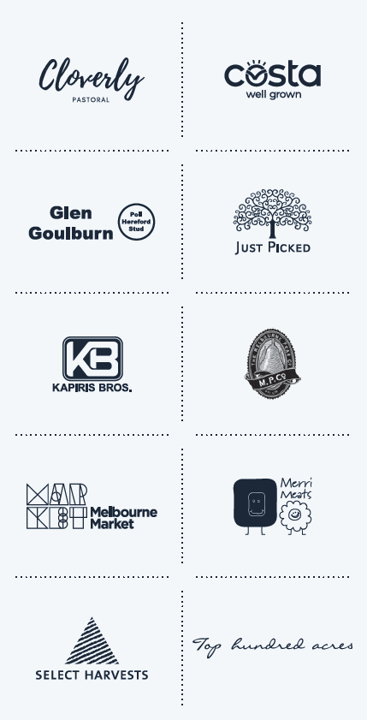

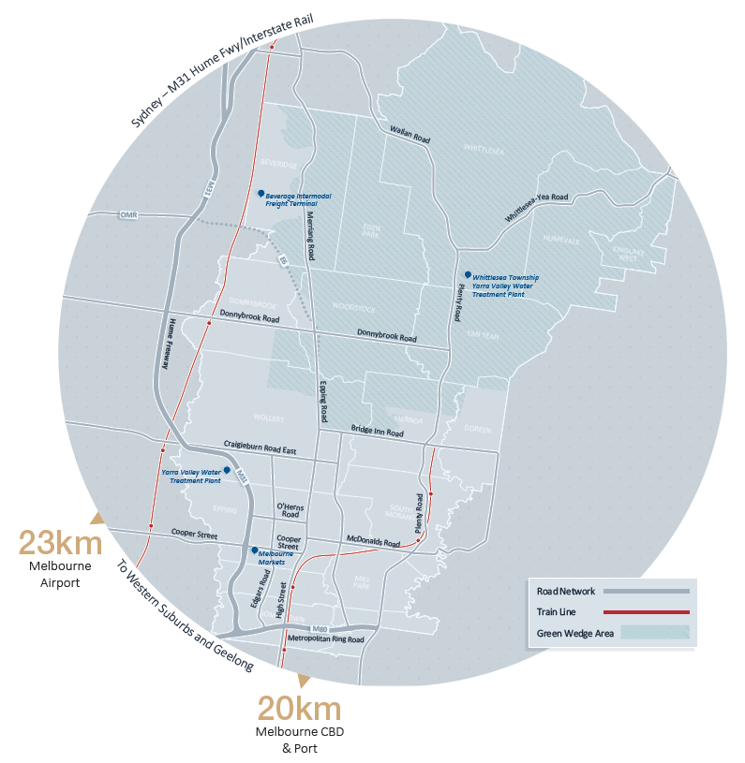

# Major Initiatives

We are committed to assisting our current and future agribusinesses become more innovative and sustainable in consistently changing economic and climatic environments.

## State Government Advocacy

The City of Whittlesea is dedicated to the protection of farmland in the Green Wedge through its advocacy to the State Government on strengthening the Urban Growth Boundary and planning policies.

Strengthening the Urban Growth Boundary improves land accessibility for future farming generations by reducing land speculation and competition for viable farming land. It will also promote agricultural use on land previously left vacant in anticipation of development opportunities.

Planning policies which support and encourage farming provide farmers and agribusinesses with confidence that they will be able to continue operating into the future and provide an opportunity to grow the agricultural sector.

## Land Capability Assessment

The City of Whittlesea partnered with Deakin University and the local farming community to investigate the potential of agriculture in the rural north and its role in supporting the economic and environmental sustainability, and social wellbeing of our community.

To underpin this investigation, a Land Capability Assessment was conducted. The assessment looked at a range of commodities, tested their suitability/viability, and plotted this data on story maps. These can be found on our website.

The Land Capability Project gives Council the information to formulate policy and strategy to protect and support agricultural production, as well as highlight opportunities for our future and existing agribusinesses in a changing climate.

## Wollert Community Farm and Food Collective

The Wollert Community Farm and Food Collective is a collaboration between the City of Whittlesea, Melbourne Polytechnic, Whittlesea Community Connections and Yarra Valley Water.

The project involves the development of a mixed farming enterprise. This will provide food for distribution into the local emergency relief network, volunteering, education and employment opportunities and investigation of best practice sustainable agriculture systems for peri-urban areas.

This project will provide our agribusinesses with insight into:

* Innovative farming options;
* The use of recycled water to enhance production;
* The benefits of diversification;
* Sustainable farming practices which achieve high productivity and promote biodiversity.

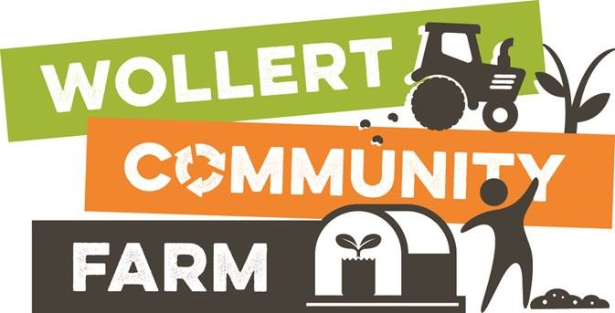

## Regenerative Agriculture and its potential for enhancing climate resilience

The City of Whittlesea partnered with Deakin University to consider the concept of regenerative agriculture and its potential to support transformative change of peri-urban agriculture for greater climate resilience.

“Regenerative Agriculture” describes farming and grazing practices that, among other benefits, reverse climate change by rebuilding soil organic matter and restoring degraded soil biodiversity. This results in both carbon drawdown and improving the water cycle.

As part of this project, five best practice regenerative agriculture practitioners were interviewed, and a case study for each was developed. These can be found on our website.

The findings from this project will be used to encourage sustainable farming practices and land restoration, which will result in long-term positive outcomes for agriculture and the environment.

# Future opportunities

## Melbourne Food Innovation and Export Hub

* The City of Whittlesea is partnering with the Melbourne Market Authority to advocate to State government for the development of a business case and implementation of the Melbourne Food Innovation and Export Hub adjacent to the Melbourne Wholesale Fruit, Vegetable and Flower Market.
* It will incorporate manufacturing, research and development, education and logistics.
* It will provide a diverse range of employment opportunities.
* It presents an opportunity for collaboration between businesses, educational institutions and producers to discover and implement innovative and improved ways of producing, manufacturing and exporting food.

## Epping Food and Kitchen Incubator

* The City of Whittlesea has partnered with Melbourne Polytechnic to develop a Food and Kitchen Incubator Network that will provide a variety of critical services to local food and beverage entrepreneurs.
* It will include access to affordable and flexible commercial kitchen space and critical business support services and mentoring.
* It will provide access to local networks and supply chains as well as direct access to markets.
* This partnership provides an opportunity to upskill and reskill the community and support a shorter supply chain from farm to plate in the municipality.

## Education

* Proximity to La Trobe University, Melbourne Polytechnic and RMIT University allows agribusinesses to upskill, improving operations and gaining efficiencies.
* Opportunity for agribusinesses to develop a unique education offering on small-scale farming given the increasing demand for locally and ethically produced food.

## Agri-Tourism

* Development of an action plan to support the growth of agricultural businesses in the emerging visitor economy sector.
* Opportunity for income diversification and increased resilience to climate change.
* Wider range of sales channels from local farmers markets to farmgate.

## Share farming / leasing of farmland in the green wedge area

* Investigation of a platform to connect landholders in the green wedge to future farmers to provide access to land.
* Improved accessibility and expansion opportunities for new and existing agribusinesses without capital outlay.
* A growing farming community can contribute to greater collaboration and market influence.

## Urban Agriculture

* Advancements in the Internet of Things and ‘big data’ provide opportunities for high yields from small production areas making these systems ideal for the urban environment.
* Availability of industrial land in our existing and growth areas presents a major opportunity for the development of indoor vertical farms using this technology.

# Contact us today

The Economic Development team look forward to working with you to support your investment and contribution to the local economy and community.



## Contact details

**P** 9217 2081

**E** [agribusiness@whittlesea.vic.gov.au](mailto:agribusiness@whittlesea.vic.gov.au)

**W** [whittlesea.vic.gov.au/agriculture](https://whittlesea.vic.gov.au/agriculture)

**LinkedIn** [linkedin.com/company/city-of-whittlesea](https://linkedin.com/company/city-of-whittlesea)