QUARRY HILLS BUSHLAND PARK MASTERPLAN,

SOUTH MORANG - DRAFT

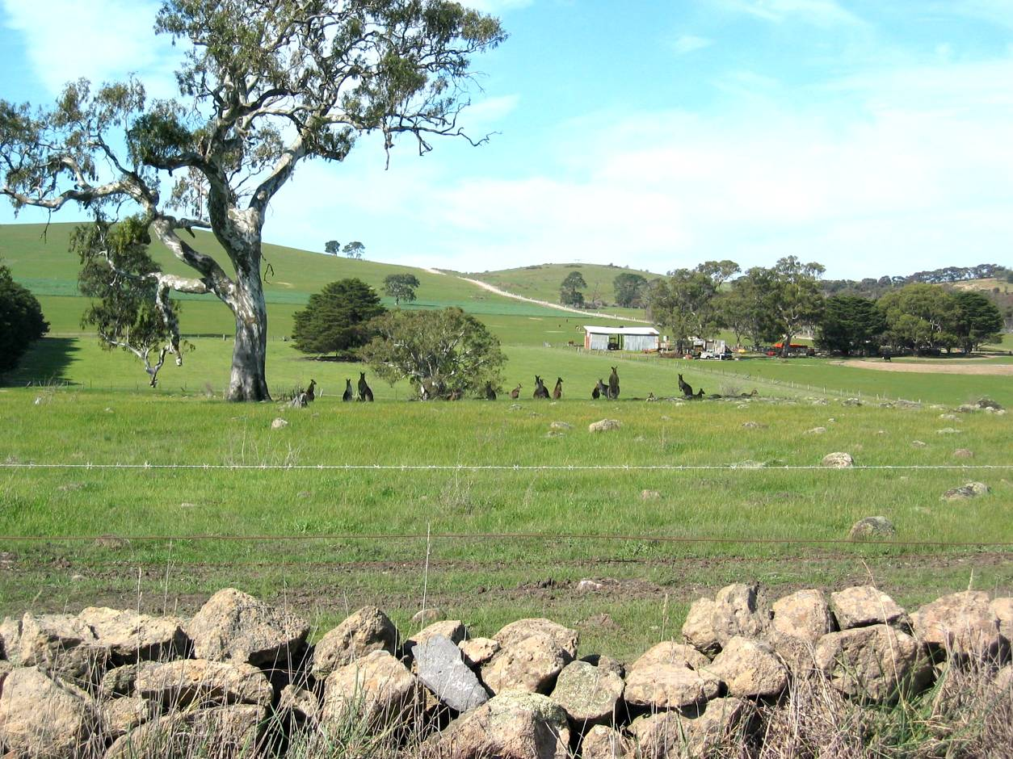

Prepared for The City of Whittlesea

June 2009

ACKNOWLEDGEMENTS 3
Phase 1. Site Investigation and Literature Review 4
Methodology 4
Investigation Area 4
Site Description 5
Geology and Geomorphology (Refer to Map 1) 6
Flora and Fauna (Refer to Map 2) 6
Cultural Heritage 7
Views and Surveillance (Refer to Map 3) 8
Access and Circulation (Refer to Map 4) 10
Parkland Interface (Refer to Map 5) 11
Existing Recreation Use Patterns (Refer to Map 6) 12
Paving and Drainage (Refer to Map 7) 12
Key Opportunities (Refer to Map 8) 12
Key Issues and Constraints (Refer to Map 9) 13
Phase 2. Future Parkland Expansion 15
Methodology 15
Future park Footprint Investigation Area 15
Environmental values 16
Habitat corridors 17
Views and viewsheds 17
Recreation and commercial opportunities 18
Slope issues and urban boundary 19
Key sites for early inclusion into the park footprint 20
Sites for inclusion in the medium term (south of Bridge Inn Road) 21
Sites for inclusion in the long term (north of Bridge Inn Road) 21
Design standards for interface with residential development 21
Park entries 21
Park boundary fencing 22
Buffer zones 22
Priorities and timing for implementation 23
Existing structures 23
Expanded park Investigation area footprint 24
Phase 3. Parkland Design and Management 25
Methodology 25
1. General Standards 25
Pathway design and layout 25
Pathway types 26
Maintenance access 27
Fencing 28
Drainage 30
Signage 31
Amenities 32
2. Short term Footprint 34
Path layout 34
Maintenance access 35
Fencing 35
Drainage 35
Signage 35
Amenities 36
3. Long term Footprint 36
Path layout 38
Maintenance access 39
Fencing 39
Drainage 39
Signage 39
Amenities 39
BIBLIOGRAPHY 40
APPENDICES 41

ACKNOWLEDGEMENTS

This report has been prepared for the City of Whittlesea by the following personnel of
CDA Design Group Pty Ltd:

Barrie Gallacher
Meg Bigelow
Ken Gunn

The consultants would like to thank the following individuals and organisations for their assistance and contribution to the preparation of this report:

City of Whittlesea
Bruce Schroder Manager Parks and Gardens
Rod Spivey Open Space Planner, Parks and Gardens
Tim Connell Environmental Works Officer, Parks and Gardens
Darren Jackson Amendments & Policy Co-ordinator, Strategic Planning Unit
Leah Wittingslow Team Leader Strategic Projects, Strategic Planning Unit
Bozena Wojcik GIS Project Officer

Melbourne Water
David Taylor Program Leader, Waterway Improvement North East
Jessica Halstead-Smith Waterway Planner – Northern Yarra Tributaries

Parks Victoria
James Gallacher Senior Commercial Officer
Gerard Delaney Team Leader Recreation Planning

Department of Sustainability and Environment
Alan Webster Flora and Fauna Officer, Port Phillip Region

Stockland
Warren Lee Planning and Design Manager, Development Division

Boral Quarries Vic Metro
Amanda Pyers Customer Service Manager
QUARRY HILLS BUSHLAND PARK, SOUTH MORANG
MASTER PLAN

Phase 1. Site Investigation and Literature Review

Methodology

Project briefing by Council staff including the project aims and objectives plus a discussion of current park issues.

Review of existing documentation:

- Quarry Hills Parkland Strategy Plan Report, Thomson Berrill Landscape Design, 2000;
- Quarry Hills and Darebin Creek Regional Parklands – Urban Growth Area Integration: Flora and Fauna Overview, Ecology Australia, 2005;
- Quarry Hills and Darebin Creek Regional Parklands – Urban Growth Area Integration: Cultural Heritage Assessment, Heritage Insight, 2005;
- Quarry Hills Investigation Area: Geology and Geomorphology Statement of Significance, Neville Rosengren, 2005;
- Quarry Hills and Darebin Creek Regional Parklands – Urban Growth Area Integration: Infrastructure and Servicing Study, MWH Australia, 2004;
- Quarry Hills and Darebin Creek Regional Parklands – Urban Growth Area Integration: Urban Design and Landscape Impact Assessment, Contour Design Australia, 2005;
- Environmental Management Plan: Weed Control Plan 2001 for Quarry Hills Park and Foothills Park, South Morang, Rik Brown Botanical Consultant, 2001.

Site inspections of existing Quarry Hills Park and surrounding areas including the 105 Hunter’s Lane property (with the Open Space Planner - Parks and Gardens, Environmental Works Officer - Parks and Gardens, Amendments & Policy Co-ordinator – Strategic Planning Unit).

Liaison with the Council GIS Project Officer to obtain copies of data and aerial photographs.

Preparation of a base plan to include all properties and features in the investigation zone for the potential expanded park.

Preparation of site analysis plans with descriptions as follows; these include analyses of both the existing Quarry Hills parkland and the surrounding areas.

Investigation Area
Quarry Hills Bushland Park is located on Melbourne’s northern fringe in South Morang, to the immediate north of the City of Whittlesea Civic Centre. The existing park area is approximately 115 hectares, consisting of land to the hills and ridges surrounding the Henderson’s Creek valley containing the Mill Park Lakes and Waterstone Hill residential developments. This includes the Quarry Hills and Foothills parks to the western side of the valley and the isolated section of Granite Hills to the east. The land is zoned as Rural Conservation Zone and is subject to a Significant Landscape Overlay.

Ownership of the property at 105 Hunter’s Lane (former Junor property) immediately to the north of the existing park has recently been transferred to Council but is currently leased back to the original owner until 2012. This transfer and lease back arrangement was facilitated by the developer of the former Twin Peaks residential development (now on sold and being developed as the Pallisades estate) north of the Waterstone Hill estate. This transfer will add a further 105 hectares (approximately) of parkland at the head of the valley, connecting the eastern and western sides of the park, and form the basis of the short term footprint of the expanded Quarry Hills Park. The boundaries of the investigation area for potential long term park expansion include Bindt’s Road to the west, Mason’s Lane to the north, Regent Street / Craven’s Road / Hunter’s lane to the north-east, Plenty Road to the east, and Findon Road to the south. This roughly equates to the 185 metre contour level in the southern part of the site and the 195 metre contour level to the north. The reason for this boundary change in the north was simply in recognition of the naturally increasing land elevation further to the north.
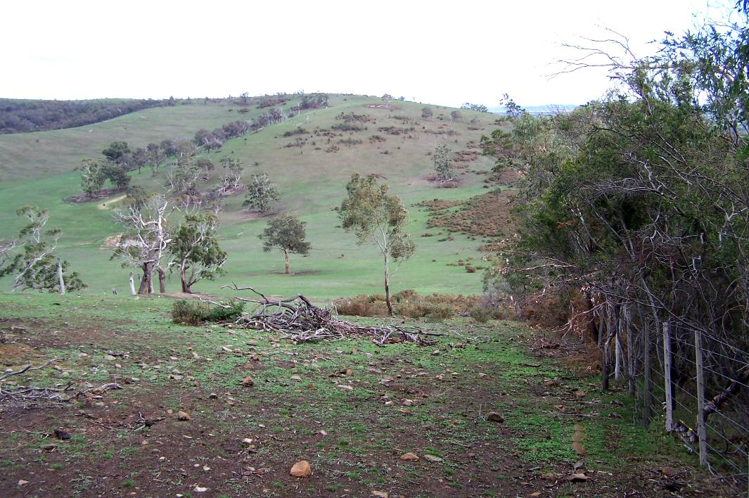
Site of Valley node from the east

Site Description
Quarry Hills and Granite Hills provide a marked contrast to the low plains of the adjacent areas due to their topographic relief and undeveloped nature. The elevation and slope of the hills are due to a granitic intrusion into ancient sedimentary rock resulting in a hard capping resistant to weathering. Beyond the metamorphic capping to the north, the hills of softer sedimentary rock have been extensively eroded to a lower elevation. The hills are surrounded with newer basalt lava flows on the plains, dotted with large remnant River Red Gums. The basalt plains are not generally flat but consist of small local undulations due to drainage lines and rocky outcrops or stony rises (refer to Geology section below). The Darebin Creek valley is on the western side of the Quarry Hills and the lower northern hills. The creek is a highly disturbed ephemeral stream for most of its length but retains a few River Red Gums. A large quarry (Boral) is actively being used against the south-western slopes of Quarry Hills. Electrical transmission easements with large steel towers occupy the south-western corner of the potential park area. The undeveloped rural land, with patches of remnant vegetation, contrasts with intensive suburban development in the Henderson’s Creek valley and to the south-west, south and east.

Geology and Geomorphology (Refer to Map 1)
The area between the Plenty River and Darebin Creek consists of Dargile Formation marine sediments some 410 millions years old. These mudstones and sandstones were folded and faulted in a roughly north-south alignment about 380 million years ago. The sedimentary rocks have been intruded by a small granitic body. The igneous intrusion changed the nature of the sedimentary rock by heat and pressure, resulting in a broad zone of metamorphic rock. The granite / granodiorite and the metamorphic hornfels and quartzite are more resistant to weathering than the original sedimentary rocks. This explains the areas of higher relief and steep ridges represented by the Granite Hills and Quarry Hills. The middle and lower slopes are covered by materials weathered from the insitu rocks. The surrounding valleys have been filled with later flows of basalt lava that are probably less than one million years old. The lower northern hills are developed from the Dargile Formation sediments that weather more quickly than the metamorphic rocks. The Quarry Hills region is an area of contrasting terrain that clearly reflects the influence of rock type and structure (Rosengren 2005).

Flora and Fauna (Refer to Map 2)
The study area contains vegetation from two bioregions: the Victorian Volcanic Plains and the Central Victorian Uplands. The extent of existing vegetation is considerably reduced in relation to the assumed extent circa 1750. Remnants of the Grassy Woodland EVC on the ridges and slopes of Quarry Hills / Granite Hills support the highest flora and fauna values in the area. These include Manna Gum, Yellow Box, Drooping Sheoak and Cherry Ballart trees with associated understorey species. A wooded knoll to the north of the main hills in Property no. 21 supports a stand of approximately 75 mature Yellow Box trees. River Red Gums are scattered on the basalt plains, mainly to the west of Darebin Creek; the greatest concentration occurs within Property no. 25. The wetland vegetation along Darebin Creek is severely depleted although some small pockets of aquatic plants survive adjacent to rock-lined pools.

Vegetation to the majority of the western slopes, the basalt plains and the northern hills consists of exotic pasture grasses and weeds, plus windbreak and fence line planting of non indigenous trees and exotic trees. Other exotic plantings surround rural homesteads. Some indigenous grasses survive among rocky outcrops which are unable to be cultivated. Woody weeds such as gorse, cape broom and sweet briar are frequent, particularly within Property nos. 23, 25 and 26.

As noted above, the remnant woodlands to the slopes and ridges of the Quarry Hills and Granite Hills contain the highest value fauna habitat. The large areas of gorse, while being a serious weed, provide habitat for kangaroos and other fauna. Large old red gums provide important resources for fauna species. Kangaroos utilise the woodlands and gorse for shelter and the exotic pastures for grazing. Grazing competition with domestic animals is currently a problem.

The City of Whittlesea’s data base includes a plan showing potential habitat links; these are shown on Map 8. It is important that the future park plan will make allowances for wildlife movement corridors, particularly for terrestrial fauna. Local roads and high fences are currently barriers to movement. The future development of the E6 arterial and upgrading of Bridge Inn Road will exacerbate this problem, particularly for the large macropods. The opportunity appears to have been lost on the eastern side where an underpass could have been constructed in conjunction with upgrading of Plenty Road. Darebin Creek provides the greatest potential for north-south movement, especially if the creek corridor is revegetated. Easy movement under the Mason’s Road bridge is currently prevented by fencing / steel mesh barriers erected to restrict stock from wandering into adjoining paddocks.

Cultural Heritage
The occupiers and traditional owners of the South Morang area prior to European settlement were the Wurundjeri Willam patriline of the Wurundjeri Balug clan. The clan belonged to the Woi wurrung language group of the Kulin nation. Water courses such as Darebin Creek provided an important source of fresh water, fish, eels, bird life and plant resources, while the adjacent grasslands and woodlands provided habitat for larger game species, plus vegetable foods such as the yam daisy or murrnong. The study area contains a number of Aboriginal archaeological sites, particularly along Darebin Creek between Bridge Inn Road and Harvest Home Road. The Quarry Hills investigation area falls within the boundaries of the Coranderrk Koorie Co-operative Pty Ltd but this organisation has now been disbanded. The Wurundjeri Tribe Land Compensation and Cultural Heritage Council Inc. is now the responsible body under the jurisdiction of Aboriginal Affairs Victoria.

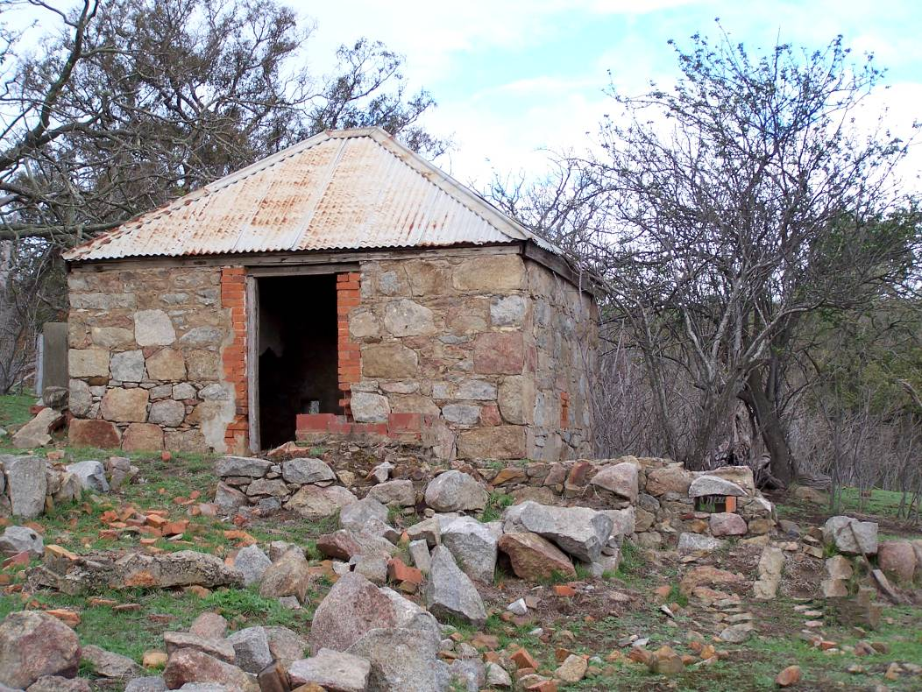
Stone Dairy

European settlement commenced in 1836 with squatters moving in to the area for cattle and sheep grazing. From 1843, some squatting runs were subdivided into smaller farms of 640 acres. Cropping and meat production to service the north-eastern gold fields gave way to dairying, wood-cutting and other pursuits after 1865. Post-European settlement structures of interest include bluestone houses and stone outbuildings and have been noted for Property nos. 1, 26, 27, 31 and 36. Properties fronting Bindt’s Road and Mason’s Road include a number of dry-stone walls. The original bluestone/reinforced concrete bridge over Darebin Creek at Bridge Inn Road has heritage listing; a new bridge has been built on the southern side to allow the road to by-pass the heritage bridge. The study area contains a number of properties along Bindt’s Road that were connected with early German settlers. The area south of Bridge Inn Road was the site of the 640 acre “Separation” subdivision (c. 1892) but few traces of this remain. Further east, the view from Hunter’s Lane across the basalt plains to the Plenty and Eastern Ranges, “studded with ancient River Red Gums”, was described by Meredith Gould (1990) as the best pastoral landscape left in the immediate vicinity of Melbourne. The area has been associated with landscape painters since the earliest colonial days, including the Heidelberg School (Arthur Streeton), John Rowell, Max Middleton, Arnold Shore, William Frater, Kenneth Jack, Len Annors, Fred Williams and John Borrack.

Views and Surveillance (Refer to Map 3)
The Quarry Hills are visible from many parts of the municipality and beyond. The hills north of Bridge Inn Road are lower and less well-defined. The existing park allows extensive views from the western ridgeline: to the west, south to the city and east over the Henderson’s Creek Valley. Park shelters provide viewing points at Eagle Lookout, Soaring Shelter and Landing Shelter. The Foothills shelter provides low level views to the north, east and south. The summit of the Granite Hills on the eastern side of the valley provides views over the Henderson’s Creek Valley and south to the city. The pastoral views to the north from Hunter’s lane have been referred to above, although now modified by urban subdivision.

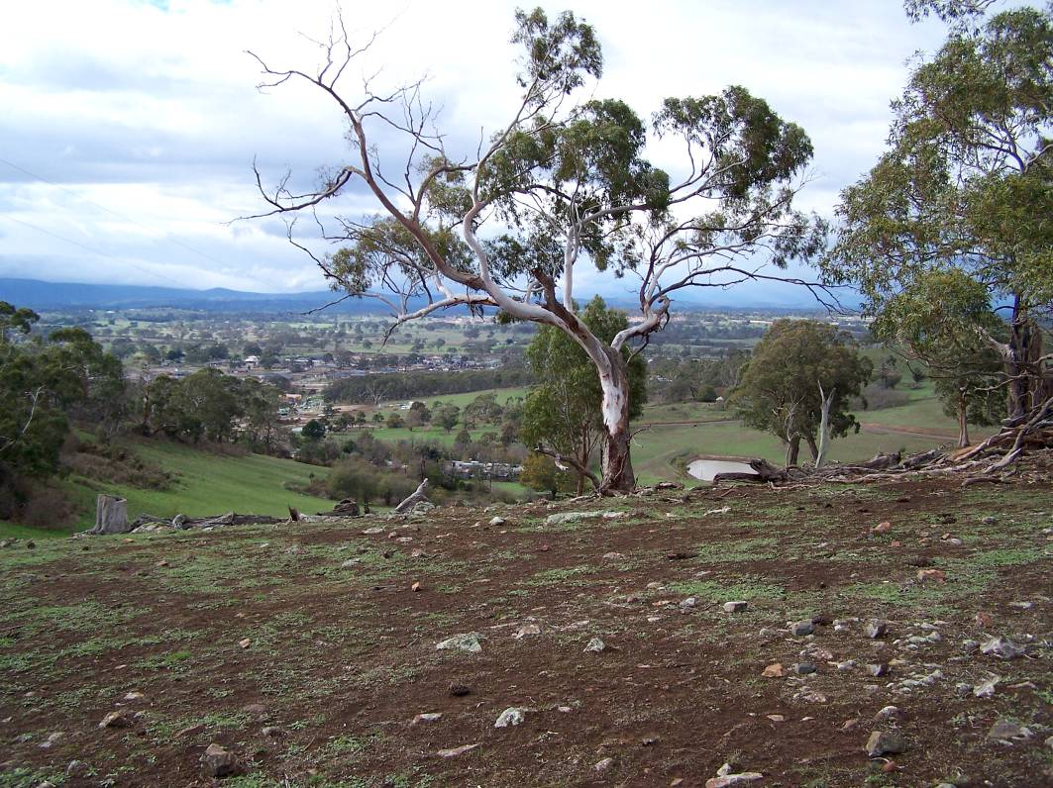
Current view to the north-east

Beyond the existing park boundaries, the most extensive 360° views are obtained from the trig point on the 272m high hilltop north-west of the Eagle Lookout. The view to the north includes the lower elevation hills south of Mason’s Road; to the west, the Darebin Creek valley; to the south, the Boral Quarry. Yarra Valley water tank installation is well concealed by high ridges and can’t be seen from below.

Other views from elevated points outside the park boundaries looking down onto the surrounding plains include from the saddle at the north-western end of the Henderson’s Creek Valley (views to north and south), from the former Junor property ridge (views to the north-east and south-west) and from Granite Hills to the east overlooking the Plenty Valley. The former Junor property (Property no. 1) also provides views into the remnant vegetation on the property to the immediate north (Property no. 14). The lower elevation hills above the 195m contour level provide views beyond the urban growth boundary to the north, to the Darebin Creek Valley to the west, to the Quarry Hills to the south and to both rural land and urban development on the eastern side.

Views towards the Quarry Hills and potential park areas are obtained from surrounding roads (Findon Rd, Harvest Home Rd, Bindt’s Rd, Mason’s Lane, Bridge Inn Rd, Sackville St, Regent St, Craven’s Rd, Hunter’s La, Plenty Rd, Gordon’s Rd). Views from the west are across the Darebin Creek Valley to the Quarry Hills north-south ridge providing a variety of landscapes: from stone fences, River Red Gums, and open grazing land to the Boral Quarry with its prominent tree screening.

Views to the hills can also be obtained from surrounding urban development including south of Findon’s Road, from Henderson’s Creek Valley and from new subdivisions in the north-east.

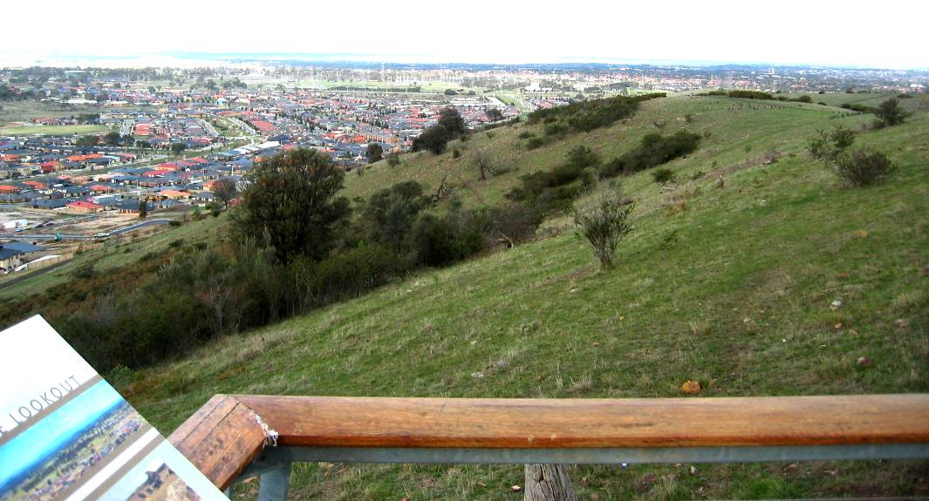
View from the Eagle Lookout

Surveillance of activities within the existing park is from rear yards of the Henderson’s Creek Valley urban development and from some court head at ends of streets. The high paling fences of the development backing on to the park actually increase security risk by concealing views into the park. For the proposed park expansion areas, surrounding roads will initially provide casual surveillance opportunities. The construction of future visitor nodes and access roads, the permanent presence of park management staff, and appropriate walking trails, will provide increased surveillance and security.

Access and Circulation (Refer to Map 4)
Existing park access is poor and is limited to private vehicles, cyclists or pedestrians from within the adjacent subdivisions, although public buses run nearby along The Lakes Boulevard. Current access points are concealed by urban development in the Henderson’s Creek Valley. The streets are narrow and don’t cater easily for buses or large emergency vehicles. It is critical that future development surrounding the park recognises the future intent of proposed access nodes and a suitable road hierarchy is achieved to accommodate the access demands of the various sites. This issue is currently being addressed as part of the detailed design phase of the Pallisades estate and will be incorporated into other future abutting housing estate designs as these progress. Bus access will be provided for through the Pallisades estate.

Currently, the only official vehicle access is via the Swamp Gum Gully entry, off Gravlier Way. The car park is limited and access hours are restricted. Vehicle access within the park is for 4WD maintenance vehicles or small fire vehicles only and is restricted by the steep slopes. Large fire trucks and ambulances would have difficulty with the grades.

In general, due to local topographical constraints, it is considered that much of the existing and proposed Quarry Hills Park will present access difficulties for those with limited mobility. Access nodes will in general be fully accessible.

Circulation within the existing park is limited to the existing trail layout. Some of the trail gradients are steeper than 1 in 14 and prevent disabled access, particularly at the base of the hills. The trails are generally 2.5m wide and are surfaced with crushed rock. A single trail connects the western and eastern sides of the park via a narrow corridor; this connection should be relocated to the north when the Pallisades subdivision takes place.

Pedestrian access to the existing Quarry Hills walking trail includes the following, commencing from the south-west: Warne Grove (off Longwood Drive / Findon Road), Foothills barbecue area, Mill Park Lakes / Henderson’s Creek reserve, and Swamp Gum Gully. Access to a walking trail at the rear of properties can also be gained from several court heads on the western side of the Mill Park Lakes subdivision.

The Granite Hills walking trail on the northern and eastern side of the valley is accessed off Topaz Grove and the northern end of Meridian Drive. There are no parking facilities at either location although with future residential development to the east of Topaz Grove, parking for a small number of vehicles at this minor access node will be accommodated. In addition, there are no easily understood vehicle routes to Meridian Drive from The Lakes Boulevard at the northern end of the Waterstone Hill Estate.

There will be a clear need for directional signage to the park from surrounding major road networks but generally only to major access nodes.

Proposed park extension areas are reasonably well-served by perimeter roads to the west, north-west and north-east and these may provide access to future entry points. There is no direct north-south link between Mason’s Lane and Bridge Inn Road. It is understood that Bridge Inn Road will be upgraded to a four-lane arterial similar to the E6 extension along, or parallel to, Bindt’s Road. Access to the south-west corner of the proposed expanded park is restricted by the Boral Quarry, and the future E6 arterial road, although the electrical transmission easement provides an opportunity for walking and cycling trails. The proposed extension to the south-east is restricted by steep topography.

Parkland Interface (Refer to Map 5)
The existing park is defined by land between property boundaries to the western ridgelines of Quarry Hills, plus a section of Granite Hills to the east, and land above the 185m contour line surrounding the northern end of Henderson’s Creek valley. The valley contains the subdivisions of Mill Park Lakes and Waterstone Hill. Urban development will extend to the head of the valley on property no. 1 with the proposed Pallisades subdivision.

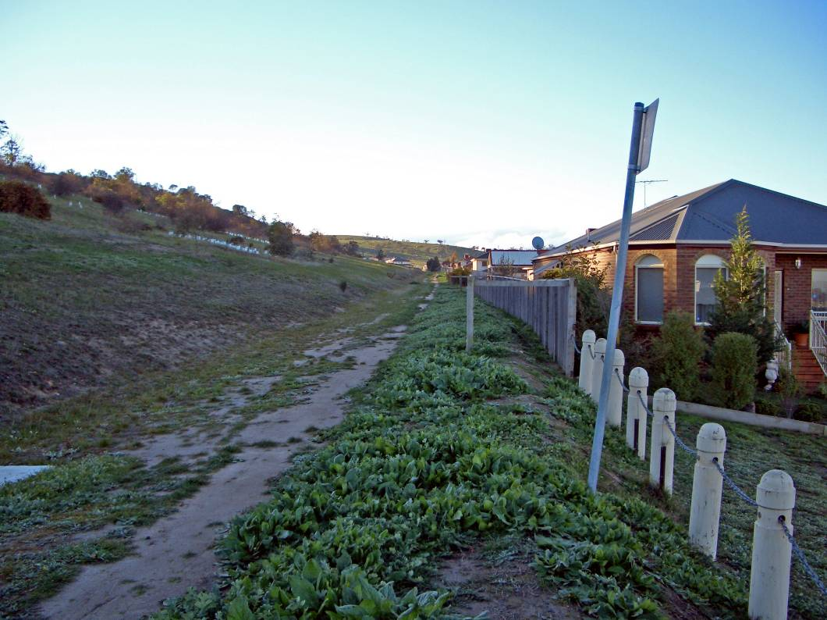
Boundary interface

The parkland interface with the subdivisions consists of high timber paling rear fences, a grassed drainage swale and a maintenance track. A 10m wide slashed grass zone is for firebreak purposes. The adjacent slopes are generally steep resulting in a narrow buffer zone, making park management difficult - deally, the subdivision boundaries should not have been planned to encroach as far up the slopes as they have. (The slopes vary from 1 in 7.5 (13.3%) on the west to 1 in 6 (15%) on the east.) Future development abutting the Quarry Hills Park should give greater consideration to slope analysis in terms of determining the suitability of the land for residential development. On the eastern or Granite Hills side, there are drainage problems where sandy soil from weathered granodiorite is allowing seepage into adjacent properties. Slope characteristics should be carefully reviewed with future abutting residential development.

Rural land surrounds the existing park on the west, north and east. The Planning Scheme notes this as Environmental Rural Zone to the immediate vicinity of the southern hills and slopes (for soil and water conservation, biodiversity, habitat, heritage conservation, landscape values and local identity). The land is generally cleared, open grassland but contains some remnant woodland, particularly near the summits of hills and on steep slopes. Land to the west and north-west of the ERZ is listed as Green Wedge Zone and includes the Darebin Creek valley. The creek is also covered by a Rural Floodway Overlay. Property no. 25 is heavily infested with gorse on the western slope down to Darebin Creek, but good quality River Red Gums exist on the western side of the creek up to Bindt’s Road; this property has potential for a future park access point and wildlife corridor. The Urban Growth Boundary includes the Henderson’s Creek Valley and continues around the eastern and north-eastern side of the hills; land is zoned as Residential 1.

Non-rural land use, in or adjacent to potential park expansion areas, includes the Boral quarry to the south-west and Hanson quarry to the north-west, Yarra Valley water tanks at or below ridge lines to the west and north-east, electrical transmission easements to the south-west and the Urban Growth Boundary below 185m / 195m to the east and north-east. The quarry operations require 400m buffer zones for dust control while in operation. Interconnecting pipelines will soon be constructed connecting the Epping North and Mernda water storage tanks through the western slopes of the existing park footprint, via the Pallisades development as well as also connecting the tanks into the local water supply system.

Existing Recreation Use Patterns (Refer to Map 6)
The steep nature of the terrain within the existing Quarry Hills parkland restricts recreation to walking on the trail network, enjoying views from the existing shelters, plus cycling / mountain biking. Bird watching and plant identification can be enjoyed by people with skills in these pursuits. There are no drinking or toilet facilities; these should be provided as part of new entry nodes in the expanded park. Motorised trail bikes and horse riding are currently not permitted.

Recreation centres in the existing subdivisions adjacent to the park are shown on the accompanying plan. It is noted that there are several properties on the northern slopes of Quarry Hills where horses are kept, including a horse stud. These properties are in close proximity to the Findon Pony Club.

The growth of subdivisions to the east and north will increase the need for additional recreation facilities, particularly active recreation requiring sports grounds on flatter areas. Horse riding could be accommodated on lesser slopes. The development of BMX tracks in suitable locations would reduce pressure on the Quarry Hills parkland. Further investigation of potential suitable sites should be undertaken.

Paving and Drainage (Refer to Map 7)
The Plenty River and Darebin Creek have formed drainage lines in the basalt plains to the east and west of the Quarry Hills, whereas Henderson’s Creek originates in the sedimentary soils of the Quarry Hills. The basalt soils generally retain water and display poor drainage characteristics. By contrast, the sandy granitic soils of the Granite Hills on the eastern side of the valley are well-drained but may create seepage problems (see Parkland Interface above for problems in this area). Vegetation removal from the slopes of the Granite Hills will therefore have a greater tendency to cause erosion.

Drainage swales on park slopes above residential development are connected into the stormwater drainage system.

Key Opportunities (Refer to Map 8)
The following dot-points relate to the proposed expansion of the Quarry Hills park and represent existing values to be retained or enhanced in addition to future opportunities:
- Retention of landscape values;
- Retention and enhancement of biodiversity;
- Retention and enhancement of a range of remnant vegetation / EVC’s and wildlife habitats;
- Education / interpretation opportunities for land and vegetation types, geology / geomorphology, fauna and avifauna, ecology, cultural heritage (archaeological sites, buildings, stone walls);
- Revegetation with locally indigenous plant material to increase the existing habitat area and improve its long term sustainability and viability;
- Opportunity to create wildlife corridors and a linked park land system, e.g., to the north linking with red gum woodland north of Mernda Village and west to Craigieburn grasslands. Habitat links to the Plenty River valley are viable for avifauna only. Wildlife corridors should be linked where possible;
- Darebin Creek linear parkland and wildlife corridor linking the Yarra River to the north – walking and cycle trails, restoration/revegetation of habitat corridor. Trails can pass under road bridges;
- Potential for wildlife corridor bridge and pedestrian crossing over Bridge Inn Road cutting;
- Link across Darebin Creek to River Red Gums and Bindt’s Road to west via property no. 25; potential for park entry node;
- Yellow box woodland on knoll to property no. 21 should be incorporated into park;
- Extension of trail system around northern end of Henderson’s Creek valley;
- Provision of major park entry node at the former Junor property off Craven’s Road / Hunter’s Lane;
- Transmission easements create opportunities for trails to the south-west;
- Yarra Valley Water lookout shelter on Granite Hills;
- Opportunity to retain existing houses/buildings for small cafés, management offices or for resident staff;
- Boral Quarry site : potential location for residential or industrial development and a potential water body for recreational purposes;
- Provision of a range of compatible recreation experiences with associated facilities; active recreation on flatter land to west of Darebin Creek, horse riding and bikes on gentle northern slopes.

Key Issues and Constraints (Refer to Map 9)
The following dot-points relate to the expanded area of the Quarry Hills park and represent some issues and concerns that need to be overcome in future planning:
- Urban development pressures from adjacent subdivision leading to loss of vegetation and habitat, restriction of wildlife movement;
- Impact of domestic animals (cats, dogs) and vermin (rabbits, foxes) on threatened species;
- Need to balance future park land/open space with development to enable transfer of park land;
- Heritage sites should be incorporated into park land where possible;
- Clearing of vegetation and dumping of rubbish on existing rural land (where proposed to be included in the future park boundaries);
- Rubbish dumping within the park boundaries (building rubbish, garden waste);
- Fire hazards due to the proximity of residential development to the parkland will require buffer zones, access for fire vehicles and planning of alternative escape routes;
- Surveillance of illegal or nuisance activities in parkland;
- Unauthorised trail bike use within parkland;
- Mountain bike usage of formed trails and their suitability for this activity;
- Weed control within existing parkland and proposed parkland (includes gorse, sweet briar, cape broom, cape weed, blackberry, artichoke thistle, Patterson’s curse, Serrated tussock, Chilean needle grass, etc., as well as control of garden escapes from residential areas);
- A large maintenance / management budget will be required for the expanded park area;
- Lower category roads act as barriers and constrain wildlife movement;
- An active management plan needs to be developed to ensure the viability of the group(s) of kangaroos if future development and road reconstruction create permanent barriers to movement;
- The proposed E6 route along Bindt’s Road on the western side provides a barrier to east-west wildlife movement and park access; access underneath could be designed to coincide with any Darebin Creek tributary stream crossings;
- Adequate buffer zones are required between the park land and urban subdivision for maintenance access and fire control; buffer zones should have a maximum slope of 1:6 for slashing;
- Buffer zones for development on slopes below granitic soils need to be wide enough to minimize seepage issues;
- The interface between parkland and urban development should be defined by a perimeter road - this will allow for increased surveillance and improve access for emergency services;
- Small, isolated pockets of urban development between the western slopes and Darebin Creek should be avoided; long, narrow development parcels increase exposure to parkland (requiring road frontage) and increase potential wildlife disturbance.
- A buffer zone should be established to Darebin Creek to control soil erosion, to allow for revegetation and creation of habitat and to allow for walking cycle trails; the buffer should be at least 30m from each stream bank (or centreline where no defined creek bed exists); the buffer should extend to the top of rock escarpments where present;
- Note that the Darebin Creek passes to the west of the property no. 37 owned by Council; this may require negotiation with Hanson Quarries for additional land purchase or creation of an easement;
- An extended park trail system should avoid passing through high quality remnant vegetation;
- New trails should follow existing contours where possible;
- Access control will be required to limit creation of unauthorised pedestrian and bike tracks;
- Road width leading to park entries should be wide enough to accommodate buses and emergency vehicles;
- Adequate parking must be provided to entry points;
- Limited services will be available to park users; toilets, drinking water may be available at some entry nodes.
- Disabled access to the existing park and trail network is virtually impossible except for the Woodlands shelter in the south-west. The expansion of the boundaries to the west should provide greater opportunities for access;
- Impact of construction and ongoing management of water supply and other services infrastructure within the park boundary;
- Deterioration of former Junor property whilst not under Council’s management.

Phase 2. Future Parkland Expansion

Methodology
- Preliminary plan prepared for future potential park boundaries following issues raised in Phase 1.
- Meeting held with City of Whittlesea to discuss proposals.
- Telephone discussion with DSE (Alan Webster) re: kangaroo population management.
- Telephone discussion with Melbourne Water (David Taylor) re: future proposals for Darebin Creek.
- Obtained copy of draft Darebin Waterway Management Activity Plan from Melbourne Water (2002 draft is currently under review).
- Further site inspection of boundary-related issues, potential property acquisition and wildlife movement corridors.
- Table of justification prepared for determining possible future park boundary in relation to existing allotments.
- Meeting held with City of Whittlesea to further discuss boundaries.

Future park Footprint Investigation Area

The future park footprint Investigation Area has been developed from findings in Phase 1 and Council’s previously proposed development plan, in consultation with Council officers. A composite site analysis plan has been prepared showing overlays of the more important features or characteristics to be taken into account. The issues involved in developing the future boundaries are discussed below. However, it is understood that boundary locations will also be affected by some or all of the following factors:

(a) the ability to extend the Urban Growth Boundary where appropriate;
(b) the availability of properties;
(c) the physical suitability of properties for urban development;
(d) the presumption that portions of properties can be handed to Council for public open space where development rights are granted.
Some properties within the Investigation Area fall outside these criteria and if considered critical in determining the final footprint, may need to be purchased outright to obtain the preferred park footprint. Where urban development is not possible to the north-western area, due to existing quarries and associated buffer zones, property acquisition may be a longer term consideration, as long as the land is managed responsibly by current owners within the current Rural Conservation Zone.

Since the majority of the work undertaken to develop this masterplan report and associated plans, the State Government has commenced in earnest an investigation into a realigning of Melbourne’s current Urban Growth Boundary with much of the land in and around the Quarry Hills within the associated investigation area. Council’s submission to the State Government with respect to this review has incorporated its desire to expand the current Quarry Hills Park in line with the general intent of this park masterplanning process.

Further to the above, since the investigation and analysis phase for this report was undertaken, the status of the E6 arterial road has changed substantially. This road generally aligns with the western boundary of the park Investigation Area (Bindts Road) and at the time its future status was considered to be no more than a four land divided arterial road. The recent release of Melbourne’s future transport plan has identified this road as an extension of a major outer ring road for Melbourne with a proposed road reservation of at least 100 metres. It is likely that this will have a significant impact on properties abutting Bindts Road included in the expanded park Investigation Area.

Environmental values
A prime consideration for park expansion relates to retention of environmental values and the preservation of open space. The expanded park will not only form part of an urban “green wedge”, but has the potential through revegetation to enhance biodiversity in the future. The expanded parkland will also provide for the future enjoyment and recreation by residents of an increasingly developed urban area. Paramount to this consideration is the retention of remnant vegetation and habitat. This includes both the hilltop woodlands and at least some of the open (mainly exotic) grasslands. The opportunity exists to expand habitat areas by encouraging vegetation regeneration or by additional planting, admittedly a considerable undertaking to be managed over time, however, such regeneration presents a substantial opportunity for carbon-offset planting. While it is impossible to re-create the conditions that will lead to the re-establishment of original vegetation types or Ecological Vegetation Classes (EVCs), the approximate boundaries of “pre-European settlement vegetation” should be used as a guideline for future planting works. The vegetation types are linked to the region’s diverse geology and topography, including elevated steep ridges formed by metamorphic rock and granite, plus gentler slopes of sedimentary hills within the surrounding basalt plains. Examples of stony basalt knolls and wetland areas adjacent to Darebin Creek should be included in the expanded park as these grassland areas carry different vegetation types and habitat to remnant hilltop vegetation. Development within the Darebin Creek catchment should be kept to a minimum to retain environmental flows and to maximize rainwater infiltration into the soil.

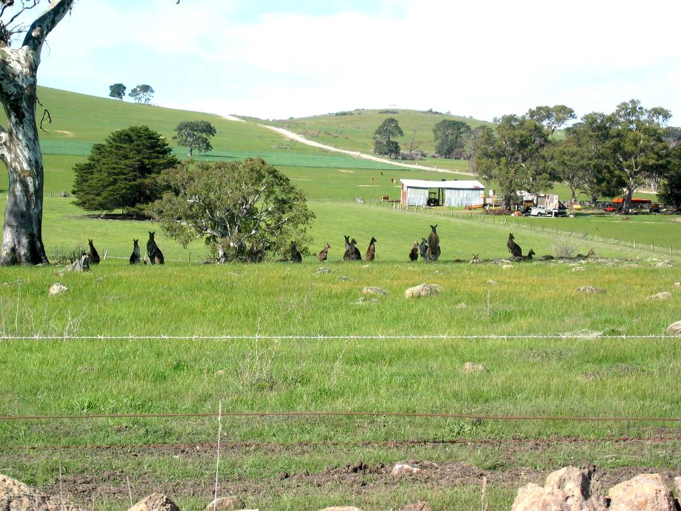
Quarry Hills Wildlife

Habitat corridors
The establishment of wildlife movement corridors is linked to environmental values and is ranked high in importance for an expanded park. The conversion of rural land into urban development, and the associated upgrading of transport corridors, creates barriers to movement and will increase stress on local fauna populations, particularly the larger terrestrial animals such as kangaroos. Restricting the park boundaries with urban development will result in a reduced gene pool for such animals in the long term. Culling of the kangaroo population that establishes in the park may be necessary after good rainfall and subsequent breeding seasons to keep numbers to a manageable level and reduce grazing competition. Where possible, allowances for wildlife underpasses should be included in construction details for road upgrading, particularly for the E6 corridor on the west. Note that issues could occur with owners of grazing properties objecting to wildlife corridor establishment if containment of grazing stock is affected by fence removal. One way around this objection is to insist on the fencing of the creek corridor. Fencing of the creek in the short term will have a beneficial effect to Darebin Creek by restricting stock access and minimising erosion and bank damage.

The opportunity appears to be lost for a wildlife corridor link to the east of the park under Plenty Road (refer to TBLD Report 2000 and Ecology Australia Report 2005). However, the existing Darebin Creek bridges at Bridge Inn Road and Mason’s Road need only slight modifications to encourage movement of terrestrial fauna along Darebin Creek. Future bridge design associated with road widening needs to address this issue.

Revegetation of Darebin Creek is an essential part of the strategy for a north / south wildlife corridor that will also serve as part of a trail system linking to the Yarra. Much of this work will be controlled by Melbourne Water who has strategies to manage flooding, to handle runoff from increased development, to improve water quality and to provide habitat / vegetation cover using elements of the original vegetation communities (refer to the Darebin Creek Waterway Management Activity Plan 2003 Draft). Any bridges over the Darebin Creek should be designed to allow passage for pedestrians, cyclists and wildlife. Note that if land cannot be obtained to the north of Bridge Inn Road for the park, allowing control of the creek corridor, then public access trails will need to stop at this point. However, revegetation by Council or property owners will still encourage wildlife movement. Revegetation of the Darebin Creek’s tributary streams from the western slopes of Quarry Hills will assist in creating links with the hilltop woodlands and forming partial east / west corridors. The electrical transmission easements in the south-west have some potential as movement corridors, although mainly for avifauna. Vegetation within these easements carries a height restriction of 3m maximum thus minimising perching opportunities for larger birds.

Views and viewsheds
Views from the main ridgelines and hilltops to the surrounding plains will continue to form one of the highlights for visitors to the Quarry Hills Bushland Park. The existing trail system with a series of viewing shelters at appropriate locations is proposed to be extended. Trails in the extended system will lead to the western summit or trig point, the eastern Granite Hills summit where a shelter is proposed to be constructed by Yarra Valley Water, and to the lower northern hills along the ridgelines. The E6 arterial, plus the Boral and Hanson Quarries, will impact negatively on views to the west. Council should seek to ensure suitable landscape embellishment associated with the construction of the new road and rehabilitation of the Quarry addresses this.

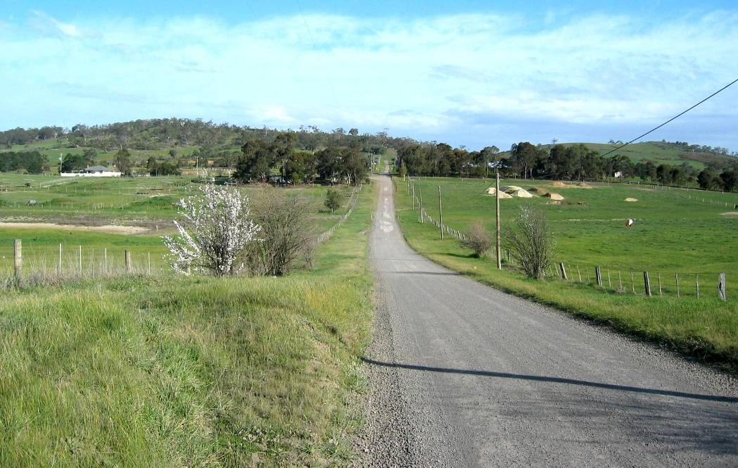
View to the Northern Slopes of Quarry Hills from Sackville Street

Views from the main perimeter roads towards the hills need to be protected by prevention of development on visible slopes. The ridgelines and upper slopes have been identified as highly sensitive areas (Contour Design Australia 2005). The acceptance of the 185m and 195m contour lines as arbitrary park boundaries, for the southern and northern hills respectively, provides a basic level of protection. While degree of slope is an ultimate restriction to construction, development should be kept back from the base of prominent ridgelines and spurs. The introduction of height restrictions to permit single storey buildings only at park edges should be investigated. Note that development should also be prevented from being pushed into intermediate valleys. While existing vegetation in the valleys may be degraded, it can always be replanted. It is important that some gentle slopes be incorporated within the park to provide for a range of habitats and potential siting of access locations. Any residential or industrial development of the south-western Boral Quarry in the shorter term must include a condition for landscape works to soften the face of escarpments.

Recreation and commercial opportunities
The expanded Quarry Hills Bushland Park should provide for a range of experiences for park users. The most popular uses will be walking, jogging and cycling. Other potential recreation activities include picnicking, cross country / orienteering, kite flying, hot air ballooning and hang gliding. Activities such as BMX tracks and horse riding should be restricted to designated areas, possibly adjacent to the more gentle slopes of the northern hills, where these activities can be controlled and will not lead to environmental degradation. The use of motor bikes or 4WD vehicles within the park should be prohibited, except for maintenance purposes or emergency vehicles. Facilities should not be provided for organised team sports.

Proposals include the following:
- Walking trails to provide an opportunity for recreation and nature-based eco-tourism. The principal trails will consist of an extension to the existing park trail system, connecting ridge lines and summits with their potential viewing locations and extending to new entry locations. Note that there will be a major problem with trails crossing over Bridge Inn Road to the north, particularly when the road is widened to 4 traffic lanes as proposed. There are two possibilities that could be considered: (a) a pedestrian underpass at the Darebin Creek bridge and/or (b) an overpass above the Bridge Inn Road cutting. A secondary trail system includes the construction of a shared pathway along Darebin Creek (in conjunction with Melbourne Water) and connection to the ridgeline trails, possibly at the low saddle between the southern and northern hills. This trail could also link to Bindt’s Road / E6 arterial via Property 25. Some secondary trails can include loop circuits that provide access to points of local interest, such as remnant vegetation, geological sites or heritage structures. The south-western electrical transmission easements provide the opportunity for linking trails to the west. Consideration should be given to possible links to heritage sites (non-Aboriginal) along Bindt’s Road. However, if development is permitted west of Darebin Creek for Properties 26 to 28, these opportunities will be lost unless the heritage structures become part of defined urban open space.
- The provision of a future lake to the Boral quarry, filled by treated stormwater runoff from adjacent residential or industrial development, as well as drainage from the E6 arterial.
- Flatter land to the west of Darebin Creek and within the northern hills and slopes has potential for riding trails and trail bike facilities, as long as the activities are distanced from remnant vegetation and wildlife corridors. The provision of such facilities should ease pressure caused by non-authorised recreation in more environmentally sensitive areas within the expanded park boundaries. Drainage from these activity zones should only be discharged to Darebin Creek via wetland treatment ponds to avoid transfer of nutrients.
- Potential use of existing houses that may be suitable for restaurants / cafés with additional function rooms. Potential buildings are located in Property 1 (former Junor homestead - central to Quarry Hills) and Property 5 (good views to the south-east). Note that domestic residences will need detailed scrutiny for conversion to public buildings and compliance with health regulations, etc. Consideration needs to be given to how after-hours access into such facilities within the park is to be controlled. Such buildings also have potential for ranger’s offices or residences. Leasing back the houses to existing property owners may also be an option.

Slope issues and urban boundary
Slopes to the northern and eastern side of Quarry Hills / Granite Hills and the south-eastern side of the lower northern hills have a major effect in determining limits of the expanded park / urban development boundary. Slope consideration will apply to the park edge from McArthur’s Road in the south to Mason’s Road at the northern end. The immediate perimeter of the park should ideally have slopes that do not exceed 1 in 6 to allow for safe slashing with maintenance equipment. This strip should be at least 10m wide, or more, if a perimeter swale drain is included to limit run-off to adjacent residential blocks. The interface between the park boundary and future urban development should consist of a road reserve at least 13m in width. This allows for park surveillance from the road and adjacent properties as well as providing access for maintenance and emergency vehicles. The preferred cross-fall for perimeter road construction is 1 in 30 for a straight road. The road reserve would need to be widened to allow for reverse camber to road curves when closely following contours around ridgelines. Road reserves with cross-gradients greater than 1 in 30 will not be rejected but steeper slopes will create increasing engineering difficulties requiring cut-and-fill batters. Note that disabled access to entry nodes, and possibly lower trails, requires slopes less than 1 in 20 to avoid handrails and ramps.

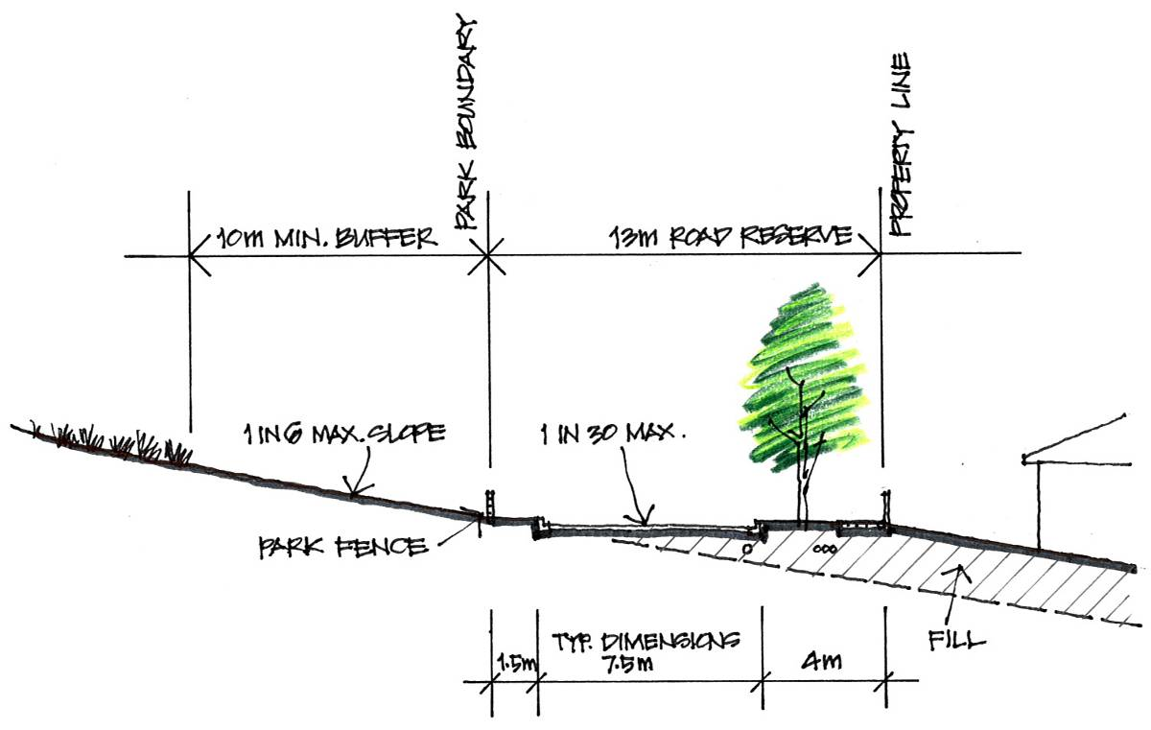
Park interface with steep slope

Key sites for early inclusion into the park footprint
The following details some of the key properties which include land important for incorporation into the future park footprint.

Sites adjacent to the existing Quarry Hills park:
- Property no. 1 to the head of the valley. This property is now in ownership of Council but is subject to a very restrictive five year lease back arrangement to the former owner which prevents Council from undertaking (or requiring the lessor to undertake) appropriate site management practices.
- Property nos. 26, 27, 28 includes the main portion of the western ridgeline and Trig point summit.
- Property no. 4 to the eastern hills including a steep portion of Granite Hills and remnant vegetation.

Western boundary of proposed park:
- Property no. 23 contains a portion of Darebin Creek, some remnant wetland and the southern portion of the northern hills.
- Property no. 24 contains a portion of Darebin Creek and the saddle between the northern and southern hills.
- Property no. 25 contains a portion of Darebin Creek, good quality remnant River Red Gums an is part of the important east / west wildlife corridor. It is also a potential site for an entry node from the west.

Northern side of Quarry Hills:
- Property no. 20 is an important link between the southern and northern hills.
- Property no. 21 contains a significant stand of Yellow Box on a small hill, which are a priority for inclusion within the park boundary.
- Property no. 14 contains some of the most important remnant vegetation. Although this land is currently well-managed, much of it is desirable for inclusion in the park in the longer term.

Eastern side of Quarry Hills:
- Property nos. 5 and 6 contain the eastern slopes facing Plenty Road.

Sites for inclusion in the medium term (south of Bridge Inn Road)
- Property no. 29: Boral Quarry.
- Property no. 30 in the south-west – this provides access to electrical transmission easements.
- Property nos. 10, 11, 13, 15, 18, 19 and 22.

Sites for inclusion in the long term (north of Bridge Inn Road)
- Property nos. 31 and 34 contain the majority of the northern hills;
- Property nos. 32 and 33 (both of these properties have recently been acquired by Stockland in anticipation of expanding the Mernda Villages estate to the west. The opportunity to incorporate the associated Investigation Area land within the park footprint may present itself in the relatively short term. The Growth Area Boundary review has facilitated this).
- Property nos. 35 and 36 contain the northern end of Darebin Creek.
- Property no. 37 is owned by Council but does not include Darebin Creek. An easement needs to be created so that the creek and an appropriate buffer zone can be under the control of future park management. The owner of the abutting land to the west has recently installed a 1.8 metre high chain mesh fence on the property boundary separating the creek off from Council’s land.

Design standards for interface with residential development
The following points need to be taken into consideration when establishing the location of park boundaries and setting requirements for adjacent residential development design.

Park entries
The design and location of park entries is critical to the process that allows for linking of the park’s internal trail system with external access from major roads and residential subdivision. Ideally, entry nodes should be located close to obvious points of interest, such as elevated areas for views. They should also be accessible by public transport. The area set aside for major entry nodes should be large enough to accommodate vehicle movements, parking areas and amenities, all within a gently sloping site that is clearly visible from the approach road (Refer also to Phase 3 section of this report). In addition, the access roads should provide a clear, logical, well-sign posted route from within subdivisions to ensure that the park entries are easy to find, not only for potential visitors, but also by emergency services. This is currently not the case with the existing entries to Quarry Hills Park, such as the Foothills Park picnic area or Swamp Gum Gully. Similarly, a proposed entry (“Valley Node”) at the head of the Henderson’s Creek valley and the Pallisades estate will be difficult to find, due to the labyrinthine design of the approach roads and adjacent subdivisions.

Access roads to principal entry nodes need to be sufficiently wide to accommodate all anticipated vehicle movements. These include motor bikes, cars, buses, delivery vans, and emergency vehicles including police, fire trucks and ambulance. Maintenance vehicles may have separate entrances. The road reserve width should, where possible, be a minimum of 20m to allow for pedestrian footpaths or shared paths plus a central median; a width of 24m is preferred.

Secondary entry road reserves can be reduced in width to allow for two traffic lanes and one footpath where bus access or parking and turning facilities are not provided. The road reserve should be between 13m and 16m.

Entry sites should avoid steep gradients greater than 1 in 6. Gradients between 1:20 and 1:14 will require ramps with handrails for disabled access, if disabled access is to be taken into consideration. Pedestrian access may include 2.5m wide shared bicycle/pedestrian paths where these form part of the residential subdivision design. The design of entry locations should minimise cut and fill operations during construction. Any remnant vegetation must be protected.

Park boundary fencing
There are three situations for boundary fencing between the park and residential development as follows below. Note that fences for the short term park footprint, the boundary with adjacent rural properties will be retained to exclude grazing animals, but not kangaroos. Internal rural fencing no longer required should be removed. Fencing design around major entry nodes will form part of the detail design for these facilities: for example, the existing timber post & rail fencing to the Swamp Gum Gully entry and parking area.

(a) Fences adjacent to road reserves or open space: a 900mm high post and cable or post and rail fence is proposed to restrict entry by unauthorised vehicles and trail bikes, but allow pedestrians to cross. Where adjacent to areas of high quality habitat or remnant vegetation, timber post with intermediate droppers and 1.2m high ring-lock fencing should be used. Access gates should be provided for maintenance and emergency vehicles, with openings for pedestrians at appropriate intervals.

(b) Fences to the rear of residential properties: where properties are directly adjacent to the park, rear fences should be a minimum of 1.5m high chain wire mesh (or similar) to discourage access into the park by domestic pets. See through fencing is preferred, in lieu of high timber paling fences, to maximize resident surveillance of unauthorised park usage. Rear gates from residential properties should be prohibited.

(c) Fences to Darebin Creek buffer zone: where the Darebin Creek forms a portion of the western park boundary, fences should be a minimum of 1.5m high chain wire mesh (or similar) to discourage access into the park by domestic pets and to protect the wildlife movement corridor. Rear gates from residential properties should not be permitted.

Buffer zones
A buffer zone needs to be established between the park boundary and residential development for maintenance access (where perimeter roads can’t be constructed), fire control and surveillance purposes. Buffer zones should have a minimum width of 10m, or 30m where adjacent to the Darebin Creek wildlife movement corridor. High visibility surveillance of parkland shall be provided at the park interface from the perimeter road and fronts of housing allotments; the rear of housing allotments adjacent to the park should have transparent fencing (see above). The buffer zone may include a drainage swale to prevent stormwater runoff from steep slopes into adjacent residential properties. Drains should lead to stormwater filtering and treatment areas, where possible if space and slopes permit, prior to passing into Council’s stormwater drains. The gradient or cross-fall of the buffer zone should not exceed 1 in 6 to allow the use of mowers for regular slashing of grass. On steep slopes, some cut and fill will be unavoidable for construction of maintenance tracks and swale drains, particularly where there is no external perimeter road. Trees are permitted within the buffer zones, but understorey planting should not be included for fire control reasons.

Priorities and timing for implementation
The timing for inclusion of the pertinent areas of expanded footprint into the park will be primarily determined by changes to the Urban Growth Boundary and the rate of take up of subdivision opportunities by the numerous land holders. Because of the fragmented nature of land holdings surrounding the Quarry Hills and the need to prepare a number of development plans for various abutting precincts, it is likely that inclusions will be sporadic and as such, park development will be very much influenced by the consolidation of abutting land parcels. It is therefore difficult to establish priorities and timing for the expansion of the park. The development of the full extent of the Quarry Hills Bushland Park must be treated as a very long term project.

Existing structures
Existing structures within the extended park footprint should be assessed for their suitability for retention or demolition. These may include bridges, residences and farm buildings, etc. Existing houses have potential for conversion to restaurants, management offices, maintenance facilities, ranger stations or staff residences, depending on location and access restrictions. Some buildings that may be suitable include the residence and sheds in Property 1 (easily accessible and central to Quarry Hills), Property 5 (restaurant potential with excellent views to the south-east), Property 23 (this has access problems at the crest of the Bridge Inn Road cutting) and Property 31 (northern hills area accessible off Bridge Inn Road).

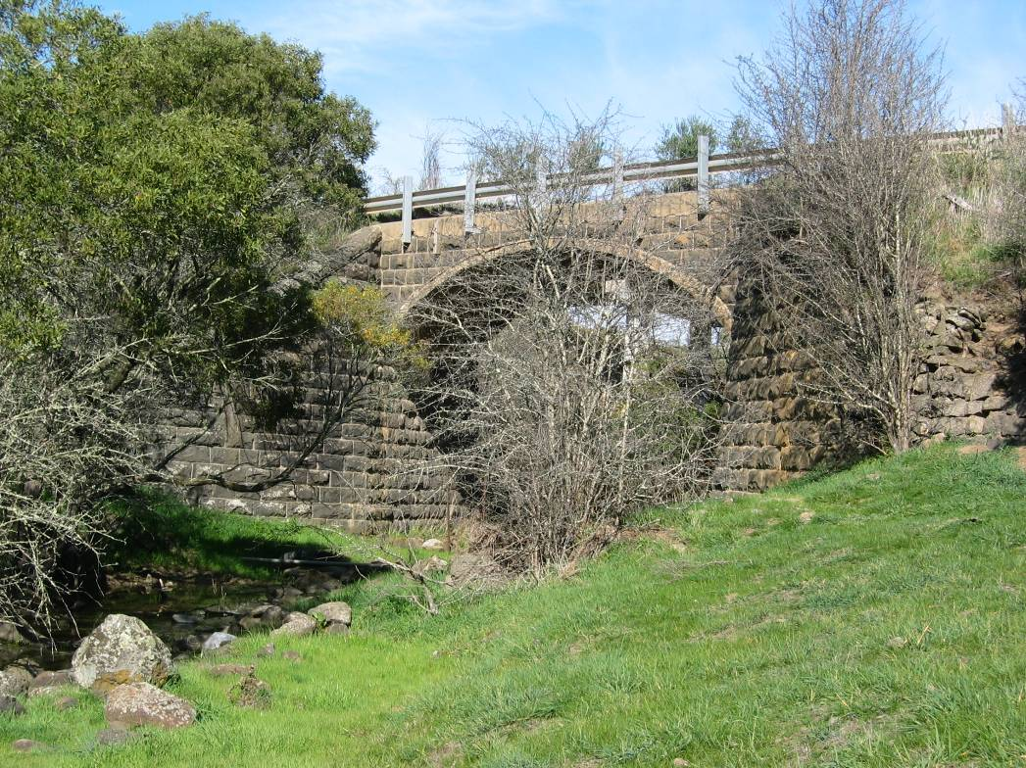
Magpie Bridge on Bridge Inn Road

Existing stone walls to properties to the west and north-west may need protection and heritage conservation strategies. Similarly, buildings with a heritage rating to remain within the park boundaries will need protection and the preparation of heritage conservation plans, including for example, the stone dairy on Property 1.

Expanded park Investigation area footprint
The Future Quarry Hills Bushland Park Investigation Area plan illustrates the following elements:
- The footprint of the ultimate park boundary Investigation Area, including the short term footprint of the existing park and the Property 1 to the north.
- Potential for urban development beyond the current Urban Growth Boundary, including revisions to the current boundary location in the north-eastern area.
- Recommended locations for visitor entry nodes and maintenance access (major entries are preferred off major distributor roads to accommodate larger vehicles).
- Circulation (track width 2.5m, rest stops / shelters); existing tracks or private roads are also shown.
- Wildlife movement corridors or habitat links, particularly along Darebin Creek.
- Remnant vegetation (this has been taken from DS&E EVC data but is not accurate: for example, there is no remnant vegetation shown to Property no. 14.
- Activity and management zones. Access to higher quality remnants or habitat will be limited by construction of exclusion fencing. Potentially destructive activities such as trail bikes/BMX and horse riding will be located away from steep slopes with high erosion potential, low-lying areas, wildlife corridors and remnant vegetation.

Phase 3. Parkland Design and Management

Methodology
This section of the report contains proposals for standards and techniques for the provision of infrastructure that will apply to both the short term and long term park footprints. The general approach to provision of standards for the park as a whole are discussed initially, prior to a more detailed discussion for the short term park footprint. Where possible, the infrastructure will mirror and continue the standards for paths, fencing, signage and shelters as established in the existing park. Design standards for the park perimeter and entries are discussed in Phase 2 under Design Standards for Interface with Residential Development.

1. General Standards

Pathway design and layout
The construction of an integrated and safe pedestrian trail system is essential to the success and management of the park, including both short term and long term footprints. The proposed pathway network for the expanded park is shown on accompanying plans but should be considered as a general guide to track location only. The pathway network is intended to provide a range of experiences for visitors without impacting on environmentally sensitive and culturally sensitive locations. Final pathway alignments may need to be fine-tuned on site or modified to suit local conditions in accordance with the following criteria:

- New paths should follow existing tracks and desire lines where possible to avoid further disturbance to the environment.
- Paths layouts should avoid long, straight sections with a constant grade.
- Avoid steep grades for path alignments where possible (refer to Path Types below).
- Paths should follow natural contours. Avoid construction of paths directly down fall-lines to minimise erosion.
- Locate paths along ridgelines slightly below the high points.
- Paths to have clear sight lines, step off points, and generous curves radii to minimise likelihood of accidents.
- Avoid constructing paths through environmentally sensitive areas unless the trail purpose is for interpretation in particular locations (for example, wetland boardwalks). Highly sensitive areas may need fences, signage and / or barriers to prevent visitors from stepping off paths.
- Path locations must avoid both documented, and potential, sites of cultural significance.
- Paths shall be sited to avoid removal of existing trees, and shall be clear of tree root zones to avoid damage: the preferred minimum distance from drip line of tree canopies is 5m.
- Avoid path construction on erosion prone slopes such as granitic soils.
- Avoid path construction that disturbs significant rock outcrops.
- Paths to Darebin Creek shall be constructed above the 1 in 10 year flood level and shall be set back from the banks.
- Paths shall be provided with rest stops at intervals not exceeding 1 km on gently sloping trails or at 100m maximum on steep grades. Rest stops may be a combination of the following: seats, view point balustrades or interpretation locations. Long trails should include shelters for both shade and rain located at appropriate rest stops. These should be visually unobtrusive and located off ridge lines.
- Paths shall include trail markers (with an indication of travel distance and / or direction) plus interpretation signs (including level of difficulty signs).
- Planted vegetation should be kept well clear of tracks so that projected foliage growth will not overhang.
- Construct boardwalks where paths cross drainage lines or swampy ground. Note that any bridges over Darebin Creek will need approval from Melbourne Water and may require building permits. Bridge crossings should be located above the 1 in 10 year flood level.

Pathway types
Pathway design should comply with Australian Standard 2156.1-2001 Walking tracks, Part 1: Classification and signage. This standard includes six classes of walking tracks and describes each in terms of the elements used for classification and the resulting management considerations. Classes 4 to 6 are essentially earthen tracks without modified surfaces, having few associated facilities and little, if any, maintenance requirements. Earthen tracks may be used for temporary paths but otherwise their use will not be considered in this report.

Reference should also be made to the following documents:
- AS 1428 Part 1: Design for access and mobility.
- Austroads’ Guide to Traffic Engineering Practice 1999, Part 14 – Bicycles.
- Melbourne Water Guidelines for approval of Constructed Paths (along waterways and within Melbourne Water property) – Dec 2002, reviewed Dec. 2003.

Path type 1: a hard-surfaced path constructed with concrete and suitable for wheelchairs, pedestrians or bicycles. This will typically be a shared path 2.5m wide and will connect with a shared path system from residential subdivisions outside the park. This path classification will also be used for short loop trails associated with major entry nodes, accessed from parking areas, and should be provided with a high level of interpretation and facilities. The path grades should be less than 1 in 20, although short sections of ramp with handrails may be provided at grades up to a maximum of 1 in 14 in accordance with AS 1428 Part 1: Design for access and mobility. Steps are only permitted in the path if alternate ramp access is provided.

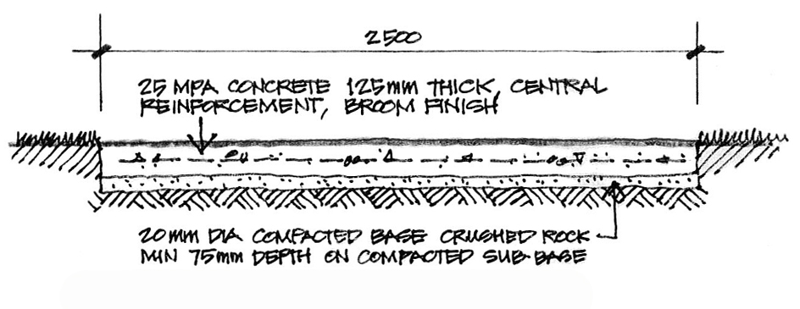

Path type 1 (concrete shared path)

Path type 2: a modified or hardened track surfaced with gravel, crushed rock or similar, suitable for pedestrians, bicycles and maintenance vehicles. This surface is also appropriate for trail bikes and horses. The track will typically be 2.5m wide and will be the general purpose path type used for the trail system throughout the expanded park. Path verges will be slashed for a width of at least one metre. The paths should have a maximum gradient of 1 in 10 to allow for a large number of visitors to walk easily. Paths should be constructed with a central crown or a single cross-fall, depending on path location and slopes. The path shall be maintained at regular 3 month intervals. Boardwalks may be necessary for low lying ground or stream crossings. The proposed path surface material should relate to the local geology, such as mudstone, sandstone, basalt, hornfels, quartzite or granite. The surface should be sufficiently cohesive to resist wear from maintenance vehicles and erosion. A recommended material is Boral’s “Coldstream Toppings”, a 10mm crushed rhyolite from Mt Dandenong, similar in appearance to hornfels produced from Boral’s Wollert quarry. Recycled alternatives such as crushed concrete and brick should be considered for use as a surface material. Minor tracks can be 1.5m wide but should have sufficient clearance each side from vegetation and other obstacles to allow for maintenance vehicle and emergency vehicle access. For 1.5m wide tracks, a minimum 0.5m wide reinforced grass verge should be provided each side: verges to be approximately 150mm deep with a mix of 1/3 feather rock, 2/3 topsoil compacted with a roller, cultivated 50mm deep and grassed.
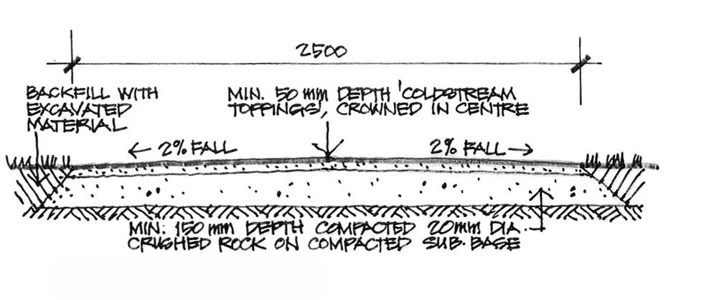
Path type 2 (Gravel or Crushed Rock)

Path type 3:
As for Path type 2 but gradients can exceed 1 in 10 for short sections. Cement or lime stabilisation may be necessary to control erosion on steep slopes. Handrails may also be necessary to assist walkers on short steep sections; steps could be provided to one side of the path. This path type is suited to walkers with a moderate level of fitness.

Maintenance access
Access points for maintenance operations and emergency vehicles, such as fire trucks and ambulances, are required at regular intervals around the park perimeter. Locations will coincide with entry nodes and secondary pathway entry points, as well as intermediate locations that can access external perimeter roads where possible. Heavy duty lockable (Council’s Abloy lock system) steel gates or boom gates are necessary to exclude the entry of unauthorised vehicles including four-wheel drives and motor bikes. Controlled pedestrian entry gates should be provided adjacent to maintenance access points at minor entries.

The general trail system is designed to allow access by maintenance and emergency vehicles to all appropriate areas of the extended park. This includes a 2.5m wide surfaced track extending from all major entry nodes and minor entries to ridgeline and valley trails. In addition, a low-level track is required for servicing the park’s perimeter (feather rock). (Refer to page 26 for CFA / maintenance access gate detail.)

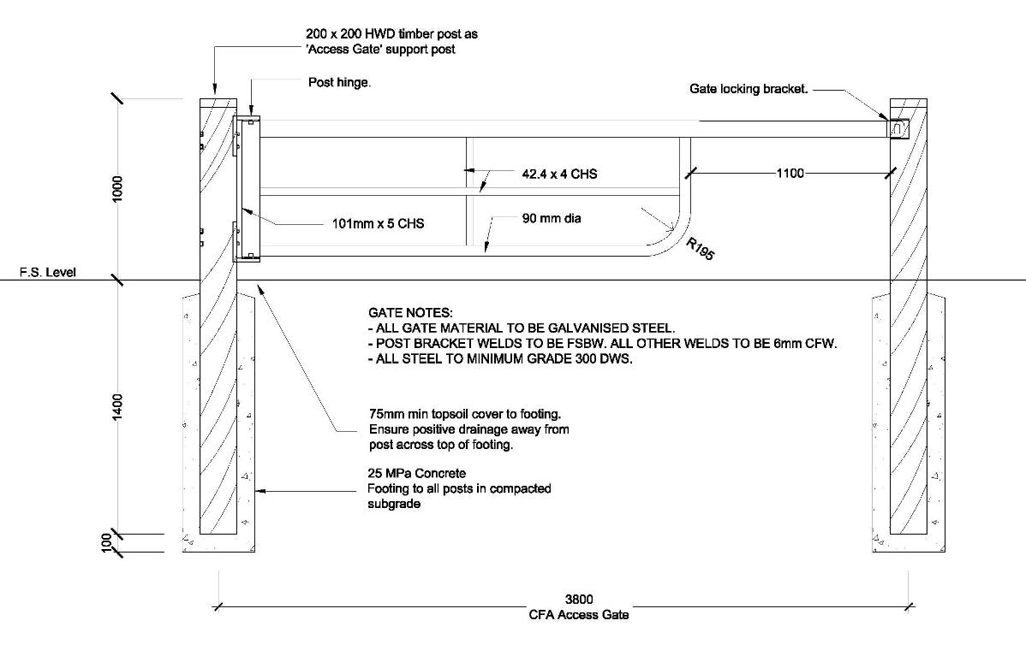
CFA / Maintenance access gate detail

Fencing
Fencing requirements will vary depending on the intended purpose of the fence and its location. Fencing types include park perimeter fencing to control entry, internal fencing for protection of conservation zones and heritage sites, or fencing to restrict access to locations such as Yarra Valley Water’s tank sites, Darebin Creek and wildlife corridors. Fencing materials should be appropriate to the location and provide a rural character. The use of treated pine posts is not recommended. Fencing types may consist of the following:

Entry node surrounds: the principal entries to the park should have a fencing style that reinforces and highlights the entry location, yet provides (or gives the impression of) a strong barrier to exclude entry to unauthorised vehicles or activities. A recommended landscape style is the timber post and rail construction to the existing Swamp Gum Gully entry and car park. Short sections of dry stone walling may be considered to entries, as part of an “entry statement”, where such walls exist in the locality. Entries to car parking areas require lockable gates to prevent after-hours use of car parks for undesirable activities. Gates should be heavy timber with steel hinges and fittings: refer to the existing Swamp Gum Gully car parking area. Where pedestrian entries are adjacent to roads, “swinging gate-corrals” should be constructed to restrict entry by motor cycles. Where separate entries are provided for maintenance access, refer to the above section. Automatic gates such as the one currently in use at the Swamp Gum Gully entry should be considered at those access nodes that provide onsite car parking. These gates should be programmed to open and close at dawn and dusk.

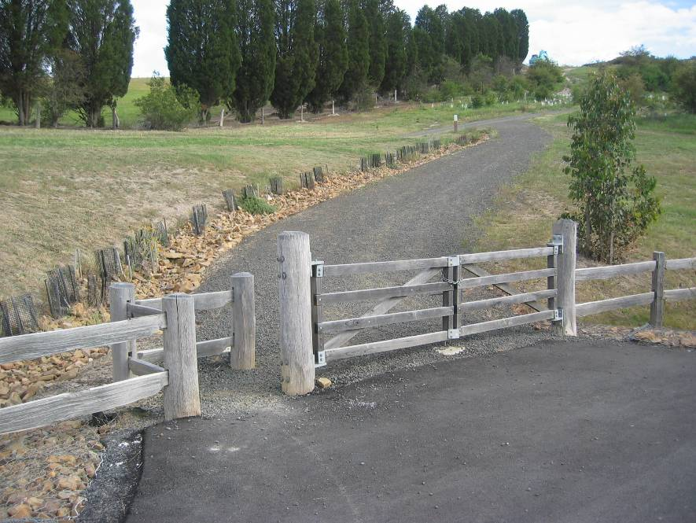
Swamp Gum Gully pedestrian access and maintenance gates
(The pedestrian opening needs modification to exclude motor bikes but allow access for prams and wheelchairs)

Park perimeter fencing: existing high timber paling fences to the rear of residential development is undesirable as it does not allow for casual surveillance into the park; such fences do not discourage undesirable activities including burglary of properties. This fencing type currently exists to the western side of Mill Park Lakes and Waterstone Hill estates. Future residential development should be fenced with 1.5m high minimum chain-wire (or similar), where rear boundaries adjoin the park, to improve surveillance of activities within the park while excluding domestic pets from the parklands. High timber paling fences may provide residential privacy, but are undesirable because they have been associated with increased crime rates where adjacent to public open space. The use of bollards to openings at court heads in the existing subdivisions is also undesirable. While allowing easy access into the park for pedestrians, this arrangement also allows access to motor bikes. Bollards in these locations should be replaced by post and cable or post and rail fencing with “swinging gate-corrals” for pedestrian access, designed to admit pedestrians, wheelchairs and prams/strollers but limit motor bike access. No gates should provide access into the park from residential lots.

The preferred interface between residential development and the park is with a perimeter road to the front of properties facing the park (Refer to Section 2 of this report: Slope issues and urban boundary). Fencing to the park side of perimeter roads can be provided by low post and cable or post and rail fences. Maintenance and pedestrian access would be as described above.

Semi-permanent construction fences must be erected to park boundaries prior to the commencement of any work in adjacent subdivisions. Construction fences shall consist of 1.5m high ring lock wire mesh secured to 100mm diameter treated pine posts set 450mm into the ground at 9m centres, and intermediate star pickets at 3m centres.

Exclusion fencing: fencing is required to restrict access to conservation zones, to control stock access to Darebin Creek and to protect heritage sites. Construction should be with timber posts, intermediate star pickets, timber strainer assemblies at gates and corners, and ring-lock wire. Weldmesh steel-framed farm gates for maintenance vehicle access should be provided with Abloy padlocks where pedestrians are not permitted to enter. Specially designed fencing may be required if kangaroos and rabbits are to be excluded from revegetation zones.

Rural property fencing: boundary fences between the existing park and adjacent rural properties should be retained and maintained as appropriate. If and when such properties are incorporated within the park, internal boundary fencing should be removed. Fencing to Melbourne Water / Yarra Valley Water assets, and the Australian Communications Authority site to the eastern hills, will be maintained by others.

Drainage
Drainage for stormwater control is generally required where trails are constructed in association with car parks and paths to entry nodes, and to the park perimeter where residential development has been constructed adjacent to slopes.

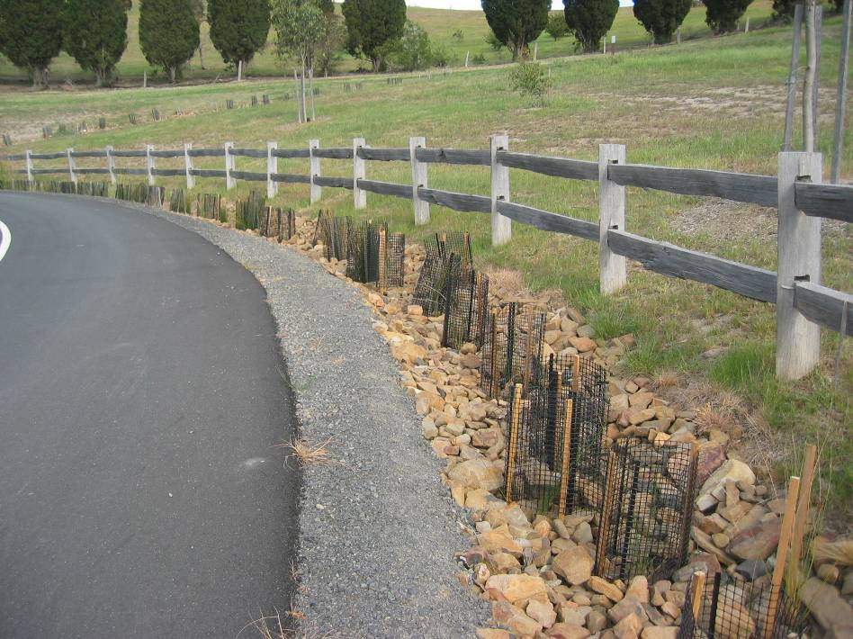
Fence and rubble drain details, Swamp Gum Gully

- Drainage design for park trails is required to restrict stormwater cross flow and limit erosion of trail surfaces. Drains should allow for infiltration into the soil to avoid concentrated flows at discharge points. Trails constructed on gentle slopes should have shallow grassed swales on the higher side. These should be up to 1.5m wide and 250mm deep. Pipes or culverts under trails will discharge water to the lower slope, with water to be dispersed by a grassed swale or rubble drain to dissipate energy of the water. Trails constructed on steeper slopes will require rubble drains to the higher side, particularly where the trails are excavated into the slope. Rubble drains are earth channels filled with coarse stone to dissipate energy of water flow. The rubble stone (50mm to 100mm diameter) should be similar material to the geology of the local area. Wetland plants in the rubble drains will assist in slowing water flow and infiltration. Trails with steep gradients may require the construction of additional rubble drains across the surface at intervals to minimise surface flow down the trail.
- Drainage swales will be required to the park perimeter where land slopes down to adjacent residential subdivisions, to prevent stormwater runoff into the development. Where slopes and space permit, swales should discharge into wetland retention and treatment ponds before passing into a Council stormwater drain. Some entry node locations may have existing farm dams that can be modified for wetlands as required. Swale dimensions should be adequate to handle 1 in 5 year storm events.
- Entry nodes will have large areas of paving for access roads, paths and car parking and will require drainage solutions. Where possible, paving areas should be permeable to allow infiltration and minimise runoff. Note that any rainwater from buildings and roofs of large structures should be collected in tanks for re-use (e.g. toilet flushing, planting bed irrigation). Open rubble drains can be constructed to collect stormwater runoff and redirect it either to infiltration drains or to wetland treatment ponds.

Signage
Signs are required to identify entry points to the Quarry Hills Bushland Park, to direct and orientate visitors and to provide interpretation. Signage must be integrated with the semi-rural nature of the park and must use appropriate colours and materials. The standards for signage used for the Swamp Gum Gully entry and other shelters along the trails should be continued.

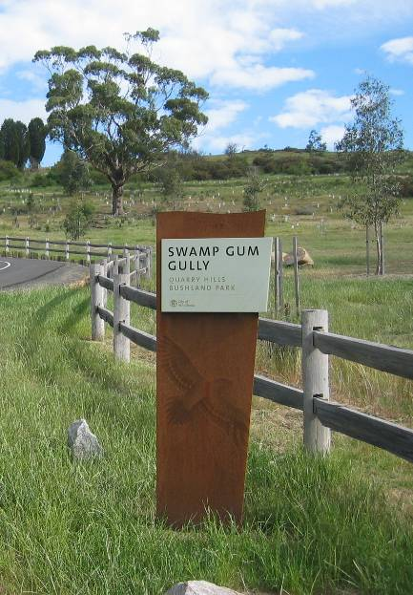 | 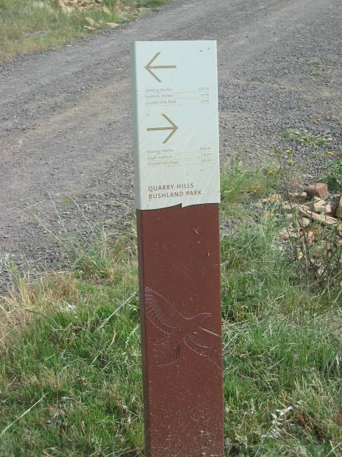
Entry signage for minor entry | Trail marker

Signage types include the following:
- Major entry signs – to regional entry nodes.
- Minor entry signs – to minor entry locations that access the trail system, adjacent to road frontages.
- Location signs – park plans with trail layout, trail information (distances, approximate travel times, degree of difficulty, rest stops and shelters, view points) facility locations and behaviour codes and be located at park entries. Note that this information should also be available in a brochure.
- Directional signs – signs indicating direction of parking areas, toilet blocks, picnic grounds, start of trails and to be located at major entry nodes.
- Interpretation signs – used at major viewing points or where significant cultural (e.g. Aboriginal scar trees, heritage structures) or environmental elements (e.g. geological formations, remnant vegetation, wetlands) are present.

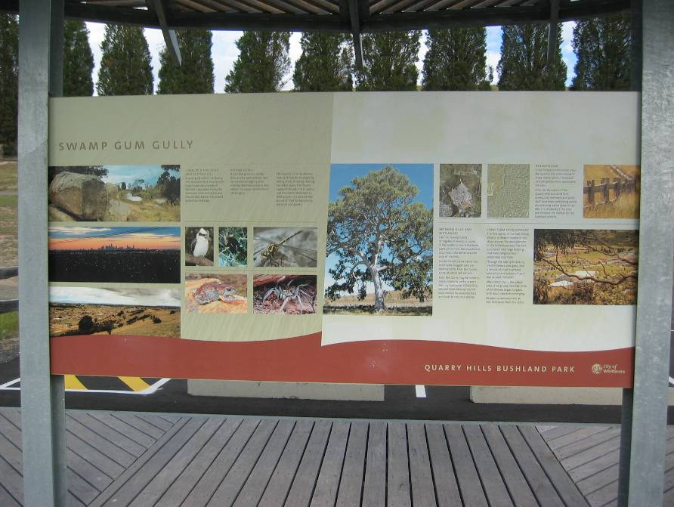
Interpretation Sign

- Hazard warning and safety signs (e.g. snakes, flood warning and bridge underpass headroom advice).
- Prohibition signs (e.g. exclusion of horses and motor cycles).
- Code of conduct signs (e.g. no dogs allowed unless on leash, take rubbish home).
- Trail markers – timber posts, or similar, located at intervals along trails, including at trail junctions, with minimal information on distances and direction.
- Directional signs outside the park to inform visitors travelling to the site.

Amenities
Amenities for the short and long term park footprint include a range of visitor facilities to be located at the park entry points as well as within the greater area of the park. All structures should be constructed with materials and colours appropriate to the semi-rural nature of the park. The siting of structures should be unobtrusive.

Major entry node facilities should include the following elements:
- Visitor parking for cars and buses. A minimum of 40 car spaces should be provided, plus 2 disabled spaces if there are trails or facilities that are accessible. Space must be allowed for bus turning movements. Parking areas should be partly screened with vegetation and shaded with trees. The paving surface should be permeable to reduce stormwater runoff and promote infiltration. If not, water should be directed to infiltration swales or wetlands. Wheel stops for vehicles are preferred to barrier kerbs.
- A picnic area with picnic tables / seating and electric barbecue facilities - rubbish and recycling bins should be provided.
- A picnic shelter with bench seating. This may have a rainwater tank attached.

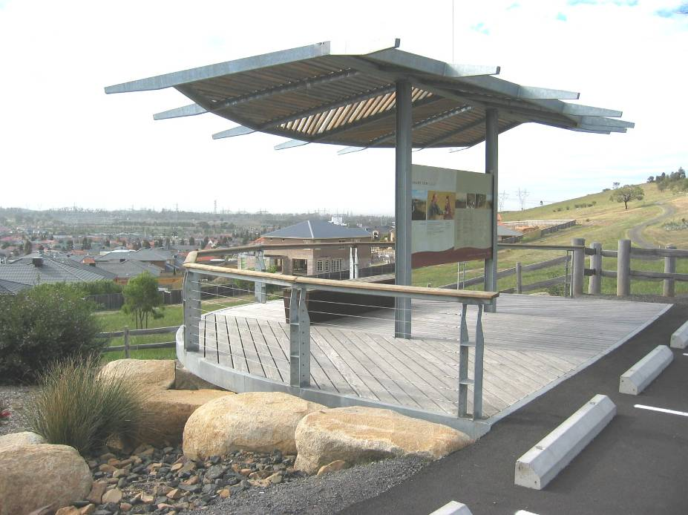
Swamp Gum Gully Viewing Deck

- Potable water point – either a tap or a disabled access drinking fountain. Drinking water will not be available within the park and will have to be carried in if a potable source is not available.
- A water point is required for maintenance purposes and for fire fighting purposes. This does not need to be potable water (i.e. can be a dam).
- A toilet block with at least one or two unisex disabled cubicles. A composting toilet is preferred to avoid septic tank installation. A rain water tank will allow for hand washing.
- A children’s playground constructed in accordance with Australian Standards.
- An information centre containing brochures and a display of park features. This could be manned by a park ranger from time to time, who would be supplied with office facilities.
- An optional sales point for snacks or a small cafe. The latter will require power, toilets and possibly sewer connection.
- Solar-powered security lighting.
- Entry sign, directional signs, and a location sign (“you are here” park plan).

Minor entry node facilities should include the following elements:
- Visitor parking for cars. A minimum of 10 car spaces should be provided, plus one disabled space if there are trails or facilities that are accessible. The parking area design should be as for major entries.
- An interpretation shelter.
- Potable water point if water is readily available – either a tap or a drinking fountain.
- A water point is required for maintenance purposes and for fire fighting purposes. This does not need to be potable water.
- Entry sign and a location sign (“you are here” park plan).

Facilities within the park should include the following elements:
- Shelters with viewing decks and seating. Shelters should provide protection from rain, wind and sun.
- Rest stops with seating. These could be combined with interpretation.
- Trail markers.
- Location signs at trail junctions.

2. Short term Footprint

Path layout
The path layout is based on the existing Quarry Hills Park trail system with extensions to the north to connect to the former Junor Property and new entry nodes at the head of the valley. Two major entry nodes are proposed: one at low level to the northern end of the Pallisades development and one on the ridge site of the former Junor farm house, accessed off Craven’s Road to the north east. A new trail will be provided from the north eastern entry parallel to the access road to the hilltop node. A connecting trail with a relatively easy gradient (not suitable for disabled access) is proposed to connect the Hilltop and Valley nodes

On the western side of the valley, the trail from the south currently finishes at the Eagle Lookout. From this point, there are a number of existing tracks leading down to the valley to the north east and east with potential for connection into the extended park but these tracks have been formed by unauthorised vehicle access over the years. They are generally rocky and steep, subject to erosion and unsuitable for general walking or cycling. These tracks should ultimately be removed and the disturbed areas regenerated. A pathway connecting the Eagle Lookout to the valley has been shown on the short term footprint plan, with one of the existing trails selected, but this route is not preferred for the long term park footprint. A connecting trail between the Eagle Lookout and the northern Valley entry node, generally following the contours around two major spurs and three gullies is proposed but as this would lead through remnant vegetation, its actual alignment will need to be carefully determined.

The preferred trail alignment for the long term footprint will connect the Eagle Lookout along a ridge to the trig point west of the current boundary. From there it will follow the ridge line to the north, before turning to the east and meeting a proposed trail leading south east to the Valley node.

On the eastern side of the valley, a ridge-top trail is proposed to link the Hilltop node, around the Yarra Valley Water tank site, to a new shelter and viewing deck at Granite Hills in the south east. A trail from the shelter will link Granite Hills with the existing trails from Topaz Grove or to Meridian Drive. A relatively steep trail (existing farm track) from the Hilltop node to the low-level valley trail may be retained for maintenance access purposes only.

A loop trail with an easy grade for disabled access is proposed for the surrounds of the Valley node and could connect into the central park spine of the Pallisades estate.

Maintenance access
Existing maintenance access points to the Quarry Hills Park are located at McCabe Drive and Bradman Terrace in the south-west, Swamp Gum Gully in the mid-west, Meridian Drive and Topaz Drive in the north east. There is no access to the western side of the valley between Swamp Gum Gully and the north west corner of Waterstone Hill estate.

A low level track, principally for maintenance but also for walking and cycling, will skirt the perimeter of the new Pallisades estate. Maintenance (and pedestrian) access will be provided to this track at the western side of the valley where it joins with the Waterstone Hill Estate, and from the eastern and western ends of the Yarra Valley Water easement across the centre of the new estate. The existing Meridian Drive maintenance access point to the Granite Hills will be retained to the north east of Waterstone Hill, although the access point will be from a new road within the Pallisades estate rather than the current access, parts of which are difficult to negotiate for emergency vehicles. Maintenance access will also be obtained via the proposed Valley node.

An additional maintenance access point will be provided by the new entry in the north eastern corner off Craven’s Road leading to the Hilltop node. The existing sheds on this property have the potential to be used as a maintenance depot, if they are to be retained on the site.

Fencing
The existing rural fences to the western, northern and eastern boundaries of the Quarry Hills Park should be retained and maintained for the expanded short term footprint. A new boundary fence will be required to the perimeter of the Pallisades estate (refer to Park Perimeter Fencing under 1. General Standards above), with feature fencing to the Valley node and Hilltop node entries. Short sections of feature fencing (e.g. timber post and rail) could also be provided to the eastern and western ends of the Yarra Valley Water easement. A temporary fence should be erected and maintained for the duration of the Pallisades subdivision construction activities to ensure that vehicles or building materials do not intrude into the park.

Drainage
A new cut off drain will be required to the perimeter of the Pallisades estate to prevent runoff into residential properties, particularly where the adjacent land is steep. The outlet locations for the drain, as well as drainage for the proposed Valley node, are yet to be resolved as it is understood that the existing dam at the head of the valley is to be filled in as part of the subdivision works. It is assumed that it will be possible to connect into the Council’s drainage system within the Pallisades subdivision. Two existing dams to the north east of the proposed Hilltop node should be retained and remodelled as necessary for wetland treatment ponds. These will collect drainage outfall from the Hilltop node area and access road. The dams will provide a potential water source for fire tankers during fire fighting operations as well as for maintenance burn offs.

Signage
A system of directional street signs is required to direct visitors to the park from surrounding arterial roads including Findon Road and Plenty Road. These signs should form part of a strategy to make visitors aware of the existence of the Quarry Hills Bushland Park.

Signs will be provided to entries and to the Valley and Hilltop nodes in accordance with existing signage standards and as described above. Interpretation signage will also be provided to the proposed Granite Hills lookout. Location and direction signs will be required to the minor entries at the eastern and western ends of the Yarra Valley Water easement through the Pallisades estate. Trail markers should be provided to new trails.

Amenities
The proposed Valley node will be a major entry node to the short term Quarry Hills Bushland Park.

The proposed Hilltop node should include all facilities as listed above for a major entry node. The existing structures on the site will be assessed for their suitability for conversion, on the basis that these structures will be retained at the end of the 5 year lease. Possibilities include use of the house for a ranger’s residence to provide a permanent staff presence for security purposes, use of part of the residence as an office, interpretation centre or visitor café and use of the sheds for maintenance vehicles and materials storage. A picnic shelter should be a new standalone structure located near barbecue facilities and a playground.

The proposed viewing shelter at Granite Hills, to be constructed by Yarra Valley Water, will have interpretation signage and seating. Rest stops and associated interpretation facilities should be provided at appropriate locations. Seating and interpretation facilities should be provided near the stone dairy in the north eastern corner near Hunter’s Lane, subject to recommendations of a conservation management plan. Similarly, interpretation signage and seating should be provided for the south eastern house site.

3. Long term Footprint

The long term footprint of the park will be divided into management zones determined by the nature of topography, underlying geology, remnant vegetation and division by major roads. The following precincts are proposed:
- (1) Central Valley (short term footprint).
- (2) Quarry Hills western ridges and slopes.
- (3) Quarry Hills northern slopes.
- (4) Granite Hills eastern slopes.
- (5) Northern Hills (south of Bridge Inn Road).
- (6) Darebin Creek and western plains.
- (7) Northern Hills (north of Bridge Inn Road). This could be further partitioned into hills and north western plains/creek valley.

Visitor activities permitted within these precincts will be determined by physical restrictions and conservation sensitivity. Management and maintenance of the precincts will be the subject of a management plan to be prepared by others.

The Central Valley and Quarry Hills western ridges have the highest scenic values and contain most of the best viewing locations. The steep nature of the terrain only allows construction of a limited number of trails for use by walkers and some cycling. Moderately high values of remnant vegetation and habitat suggest that access off trails should be restricted. No trail bikes or horse riding will be permitted. The western slopes have potential for use by hot-air balloons or hang-gliding, away from remnant vegetation.

The Quarry Hills northern slopes contain significant areas of remnant vegetation and habitat. No trails have been proposed to this zone, except for the perimeter maintenance trail and the loop trail to the Yellow Box woodland at the western end. Exclusion fencing and signage surrounding remnant vegetation should be considered. No trail bikes or horse riding will be permitted.

The Granite Hills eastern slopes provide good views over urban development and the Plenty Valley from the north east around to the south east. Vegetation cover is sparse over most of the area, except on granitic soil to Property 4 in the south and a small patch adjacent to Hunter’s Lane in the north. Trails to the ridges and around contours will allow use by walkers and cyclists. No trail bikes or horse riding will be permitted.

The Darebin Creek and western plains precinct contains the majority of the low-lying land within the expanded park. In addition to natural drainage systems, the creek forms an approximate boundary between the western basalt plains and the sedimentary geology of the Quarry Hills and Northern Hills. There are potential aboriginal heritage sites along the creek. Property 25 contains a significant stand of remnant River Red Gums. The proposed E6 arterial will form part of the boundary to the west. Revegetation of the creek line, within Melbourne Water guidelines, will provide the opportunity for a wildlife corridor and an associated walking and cycling trail. No trail bikes or horse riding will be permitted.

The Northern Hills precincts contain gentle slopes without any significant tree cover. These areas are suitable for provision of facilities for trail bikes and equestrian activities – with restrictions. Trail bikes should be contained to the western slopes away from residential areas and should not encroach on the Darebin Creek proposed wildlife corridor. Equestrian activities should be kept away from the steeper eastern slopes.

Three further major entry nodes are proposed in addition to the short term footprint nodes. These are described as follows:

- East of the saddle between the northern and southern hills. This node would be in an important location linking the southern and northern hill trails as well as providing easy access to the Darebin Creek valley. It would be at the western end of urban development that extends up the valley (Mernda West Development Plan currently being finalised) and could be accessed off an extension of Regent Street or via a subdivision perimeter road from Bridge Inn Road. The DP and the current review of the Urban Growth Boundary will need to accommodate this future major entry node.
- At the corner of Lehmann’s Road and Bindt’s Road west of Darebin Creek. This node would provide the main access point to the park from the west and link to the Darebin Creek and lower slopes trails. The current review of the Urban Growth Boundary and the final alignment and design of the E6 will need to accommodate this future major entry node.
- Off Mason’s Lane in the northern hills. This node would be at the northern end of the hill trails. Access could either be through the expanded Mernda Villages subdivision or from Mason’s Lane itself. The final location will be determined in consideration of the review of the Urban Growth Boundary and the form of the expanded Mernda Villages estate.

Additional minor entry nodes are proposed as follows:
- At the corner of Harvest Home Road and Bindt’s Road.
- Near the crossing of Bridge Inn Road and Darebin Creek.
- Near the crossing of Mason’s Road and Darebin Creek.
- Bridge Inn Road south east of the northern hills.
- MacArthur’s Road off Plenty Road in the east.

Apart from the major and minor access nodes, the park will be accessed informally at numerous other sites such as court heads, etc. No facilities, apart from directional signage, will be provided at these locations.

Path layout
The accompanying plan for the long term park footprint shows a proposed trail system. The trail system may be modified in future to accommodate appropriate access links from future developments. Trails are described as follows, from west to east:

- Darebin Creek trail: This will be established as part of revegetation and wildlife corridor along the creek valley. This trail will provide access to basalt plains with rocky knolls, remnant River Red Gums and boardwalks over wetlands. The heritage bridge at Bridge Inn Road (Magpie Bridge) and the escarpments to the north provide attractions for visitors. The southern end of the trail will link to a potential trail leading to the Yarra River and the northern end will terminate at Mason’s Road. Other links include the electrical transmission easement trails in the south-west, the lower western slopes trail and a connection to the proposed node near the saddle between the northern and southern hills.
- Lower western slopes: This trail will provide management access to the western side of the creek valley and form a link with the Foothills Park and Swamp Gum Gully in the south. The trail will link with the Darebin Creek trail and the “saddle node”. The trail could be extended to the western side of the northern hills to link with the northern entry node off Mason’s Road.
- Western ridge to Northern Hills: This trail forms the main route through the park from the Eagle Lookout in the existing park to the proposed northern entry node off Mason’s Road. The trail route follows the main ridges of the Quarry Hills and Northern Hills. It will pass through remnant hilltop vegetation and provide spectacular views at its southern end. The crossing of Bridge Inn Road clearly presents a significant problem. This will require either a pedestrian overpass at the cutting, an on grade pedestrian crossing or underpass, to the proposed four lane arterial road. The trail will link with Darebin Creek, the central saddle and to the trail to the Hilltop and Valley nodes in the east.
- Valley Node to Saddle Node: This trail will link two nodes and provide access to a loop trail to the stand of Yellow Box woodland. The Western Ridge trail links into this trail.
- South eastern Granite Hills: This trail is a continuation to the south east of the short term footprint trail to the Granite Hills lookout. A lookout/viewing shelter should be constructed to the hilltop at the termination of the path. The trail may pass through some remnant hilltop vegetation.
- North eastern Granite Hills: This trail will provide a link to the Granite Hills lookout and the proposed south eastern lookout from the McArthur’s Road entry. The trail is also proposed to pass around the north eastern slopes and connect to the entry off Craven’s Road and the Hilltop Node.

Maintenance access
Perimeter trails to the park will provide access for maintenance and emergency vehicles. Access points should be at regular intervals and should not be restricted by the layout of subdivisions. The location of access points will be facilitated by including perimeter roads and buffer zones in the planning for future subdivisions (Refer to the Residential interface standards in Phase 2). The general trail system is designed to allow access by maintenance and emergency vehicles to all appropriate areas within the extended park.

Fencing
A new boundary fence will be required to the perimeter of the long term park footprint, with feature fencing to entry nodes. Both sides of Bridge Inn Road will be fenced. Temporary or permanent fences must be erected prior to commencement of any subdivision construction activities to ensure that vehicles or building materials do not intrude into the park. Fencing must also be erected to contain construction activities and limit damage associated with the E6 arterial to the west, and for work associated with Yarra Valley Water pipelines. Fencing may be required to restrict access to the proposed wildlife corridor associated with Darebin Creek and for remnant vegetation conservation or revegetation zones.

Drainage
Cut off drains will be required to the perimeter of the park to prevent runoff into residential properties where the adjacent land is steep. Drainage systems will be required to all entry nodes to discharge or allow infiltration of stormwater runoff from roofing or hard surfaces. Drainage outlets into either the Council’s stormwater system or into Darebin Creek or any of its tributaries must first pass via wetland stormwater treatment systems. Existing dams should be retained and remodelled for wetland treatment and storage where possible. The dams will provide a potential water source for fire tankers during fire fighting operations as well as for maintenance burn-offs.

Signage
A system of directional street signs is required to direct visitors to the park from surrounding arterial roads. These signs should form part of a strategy to make visitors aware of the existence of the Quarry Hills Bushland Park.

Signs will be provided to major and minor entries in accordance with existing signage standards and as described above. Interpretation signage, location signs, direction signs and trail markers will be as described above.

Amenities
Major and minor entry nodes should include all facilities as listed above. Existing residences and associated outbuildings should be assessed for their suitability for retention. Consideration should be given to retaining residences for use by park rangers or Council staff to provide a permanent presence for security purposes.

BIBLIOGRAPHY

Contour Design Australia (2005). Quarry Hills and Darebin Creek Regional Parklands – Urban Growth Area Integration: Urban Design and Landscape Impact Assessment

Ecology Australia (2005). Quarry Hills and Darebin Creek Regional Parklands – Urban Growth Area Integration: Flora and Fauna Overview

Heritage Insight (2005). Quarry Hills and Darebin Creek Regional Parklands – Urban Growth Area Integration: Cultural Heritage Assessment

Melbourne Water (2002). Draft Melbourne Guidelines for Approval of Constructed Paths (Along Waterways & Within Melbourne Water Property)

Meredith Gould Architects Pty Ltd (1990). City of Whittlesea Heritage Study

MWH Australia (2004). Quarry Hills and Darebin Creek Regional Parklands – Urban Growth Area Integration: Infrastructure and Servicing Study

Neville Rosengren (2005). Quarry Hills Investigation Area: Geology and Geomorphology Statement of Significance

Rik Brown Botanical Consultant (2001). Environmental Management Plan: Weed Control Plan 2001 for Quarry Hills Park and Foothills Park, South Morang

Standards Australia (2001). AS 2156.1 Walking tracks, Part 1: Classification and signage

Thomson Berrill Landscape Design (2000). Quarry Hills Parkland Strategy Plan Report

APPENDICES

Site Analysis Plans
(Scale: 1:10,000 @ A1 / 1; 25,000 @ A3)

1 Geology and Geomorphology

2 Flora and Fauna

3 Views and Surveillance

4 Access and Circulation

5 Parkland Interface

6 Existing Recreational Use Patterns

7 Paving and Drainage

8 Key Opportunities

9 Key Issues and Constraints

Current Park Boundary (Short term Footprint)
(1:5,000 @ A1 / 1: 12,500 @ A3)

Future Quarry Hills Park Investigation Area (Long term Footprint)
(1:10,000 @ A1 / 1: 25,000 @ A3)

