Biodiversity Strategy

2019-2029

Acknowledgement of Traditional Owners
The City of Whittlesea recognises the rich Aboriginal heritage of this country and acknowledges the Wurundjeri Willum Clan as the Traditional Owners of this place.

Table of Contents

Overview 1
Policy Context 2
Implementation and evaluation 3
Biodiversity in the City of Whittlesea 3
What is biodiversity? 3
The story of biodiversity in the City of Whittlesea 3
City of Whittlesea’s key landscapes 4
Significant flora and fauna 5
Council’s role in protecting biodiversity 7
Legislative responsibilities 7
Managing Council reserves 8
Council’s role on private land 9
Engaging with the community 9
Data collection and management 10
Threats to Whittlesea’s Biodiversity 11
Opportunities to improve our biodiversity 13
Improving data collection and management 13
Strengthening the Planning Scheme 14
Working with rural landowners 15
Involving community in urban environments 16
Managing Councils conservation reserves 17
Working with other agencies 18
Appendix 1 19

Overview

The City of Whittlesea Biodiversity Strategy (2019-2029) provides directions to improve the management and protection of biodiversity across the Municipality into the future. It builds on the many efforts already underway by individuals, community groups, and government and aims to develop a coordinated approach that will allow for our natural environments to thrive as the City continues to grow.
In 2018, consultation was undertaken to develop the vision for our community Whittlesea 2040 – A place for all. As part of this process the community identified the value they place on our natural landscapes and biodiversity. This strategy builds on that theme, with its overarching goal:

To protect and improve local biodiversity

To achieve this goal the Biodiversity Strategy sets out six objectives, to:

- Improve our knowledge and understanding of local biodiversity
- Strengthen the Planning Scheme to achieve better biodiversity outcomes
- Support our rural landowners to protect biodiversity on their land
- Encourage awareness and participation in urban biodiversity and improvement
- Manage Council land to reduce threats and improve habitat quality
- Collaborate with other land management agencies

In implementing this Strategy, the City of Whittlesea will be committing to working with community and other agencies, to ensure that our natural values are there for future generations.

Policy Context

Every level of government has an important role in the protection of biodiversity. Council’s role falls within a global policy context and as the level of Government closest to the community, Council sits in a unique position to focus on local impacts and work directly with residents. The chart below provides more detail on the policy context and overarching goal of the City of Whittlesea Biodiversity Strategy.

International
- Australia is a party to the Convention on Biological Diversity (1993) and the Cancun Declaration on Mainstreaming the Conservation and Sustainable Use of Biodiversity for Well-Being. These set out a goal of stopping global loss of biodiversity and recognise that this protection is not only the responsibility of government environment ministries.

National
- The vision of Australia’s Biodiversity Conservation Strategy 2010 – 2030 is for Australia’s biodiversity to be healthy and resilient to threats and valued in its own right and for its essential contribution to the existence of humans.

State
- The Victorian State Government’s Protecting Victoria’s Environment – Biodiversity 2037 (2017) sets a statewide vision for building ecosystem resilience, improving habitat connectivity and protecting natural assets in priority locations.

Local
- City of Whittlesea's Whittlesea 2040 identifies the need for valued natural landscapes and biodiversity as a key direction under Goal 4: Sustainable Environment.
- The Environmental Sustainability Strategy 2012-2022 lists biodiversity as one of seven focus areas.

Biodiversity Strategy
- Goal: To protect and improve local biodiversity

Implementation and evaluation

The implementation of the Biodiversity Strategy will be guided by an Action Plan. The Action Plan identifies the tasks associated with completing each of the identified Priority Actions in the Strategy. Each task has a define measure or output of that task. An Evaluation Plan will be developed which incorporates these tasks and measures. This will be managed by Sustainability Planning.
A Project Control Group will be established to oversee the Strategy’s implementation. This will include key internal stakeholders responsible for the priority actions within the Action Plan.
A mid-cycle review of the Action Plan’s success against the Strategy’s objectives will be undertaken in year 5, which will involve a review of all actions and establishment of new actions where required.

Biodiversity in the City of Whittlesea

What is biodiversity?
Biodiversity is the number and variety of living things on the planet. It is the mix of plants, animals, and other organisms that make up landscapes from deserts to oceans. Natural areas provide ‘ecosystem services’ such as nutrient cycling, air and water purification, soil stabilisation, flood control and climate regulation.
These services are vital for human health and wellbeing. They provide us with the air we breathe, water we drink, and food we eat. The natural environment also provides important recreational opportunities and a strong cultural connection to place.

The story of biodiversity in the City of Whittlesea
Much of central Victoria including the City of Whittlesea was covered by a shallow sea 420 million years ago. As Australia collided with other land masses, uplift occurred forming the Great Dividing Range with Mount Disappointment at its southern end. Moving forward 240 million years and Victoria was covered by rainforest with a range of mammals, birds, reptiles and plants calling it home.

By the start of the Quaternary Period (2.6 million years ago) these rainforests were shrinking. The climate was warming and drying, giving way to the more familiar local landscapes dominated by Eucalypts and Wattles. Volcanoes were also active across the western region of Victoria, resulting in the basalt volcanic plains that are found in the west of the municipality.

Today the City of Whittlesea is a growth Council on the fringe of Melbourne covering an area of approximately 490km². It is bordered by Kinglake National Park and Mt Disappointment State Forest to the north, Merri Creek to the west and Plenty River to the east. The Eden Park Hills to the north-west connect the Victorian Volcanic Plains to the Great Dividing Range and an area of mostly continuous vegetation that stretches up the east coast of Australia. Along with the Merri Creek and Plenty River, the City of Whittlesea also supports Darebin and Edgars Creeks.

Whittlesea’s recent agricultural land use history has resulted in natural areas being retained in fragmented pockets within the municipality. Approximately 35% (17,000 hectares) remains of the original extent of native vegetation within Whittlesea. Of this area, approximately 29% (4,860 hectares) of remnant vegetation is retained under permanent protection on crown land. The Urban Growth Boundary (UGB) separates the well-established and developing suburbs to the south, and designated Green Wedge Land to the north.

City of Whittlesea’s key landscapes
Victorian Volcanic Plain
Victorian Volcanic Plain covers 51% of Whittlesea, including the majority of the southern section of the municipality and including most of the land within the Urban Growth Boundary. The extensive flat to undulating basaltic plain contains stony rises, old lava flows, and a volcanic scoria cone (Hayes Hill, Donnybrook). The fertile soils are dominated by Plains Grassland, Plains Grassy Woodland, and Plains Grassy Wetland.

Highlands – Southern Fall
Highlands – Southern Fall is found in the northern section of Whittlesea, covering 46% of the municipality. It is a diverse bioregion; vegetation at higher elevations is dominated by Wet Forest, Damp Forest, Herb-rich Foothill Forest and Heathy Dry Forest, with Cool Temperate Rainforest occurring in the most protected gullies. At lower elevations, Shrubby Foothill Forest, Grassy Dry Forest and Grassy Riverine Forest ecosystems are present.

Central Victorian Uplands
Central Victorian Uplands extends east-west through central Victoria, covering 5.2% of the State. However, an isolated pocket can be found in South Morang and Mernda. Central Victorian Uplands can support a variety of ecosystems; less fertile hills support Grassy Dry Forest vegetation; granitic and sedimentary terrain is dominated by Grassy Woodland vegetation; and lower lying valleys and plains are dominated by Valley Grassy Forest and Plains Grassy Woodland ecosystems.

Urban landscape
Urban areas are highly modified with ‘hard’ surfaces like bricks and asphalt dominating the landscape. Conservation reserves and waterways act as critical refuge for the remaining native flora and fauna. Parks, roadsides (particularly street trees) and residential backyards provide essential modified habitat and linkages through this fragmented landscape. In this setting many native species cannot thrive so the biodiversity is made up in a large part through introduced species and some native species that have adapted well to the new landscape.

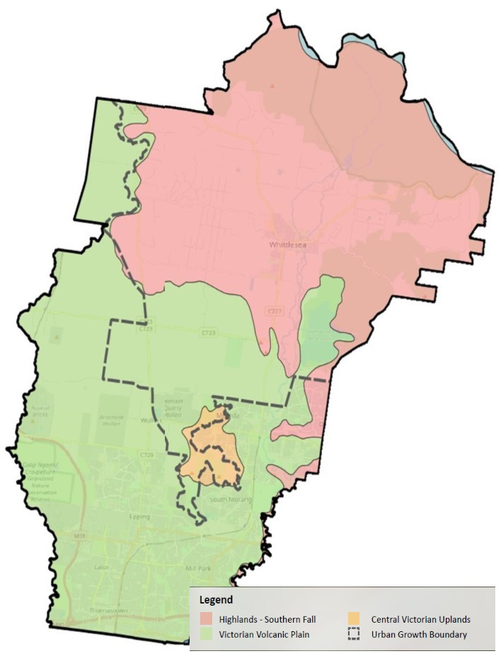

Significant flora and fauna
Whittlesea is home to a number of rare and endangered species. Within the last 30 years, 52 threatened flora and fauna species have been recorded within Whittlesea. This includes 17 flora species and 35 fauna species listed under the Commonwealth Environment Protection and Biodiversity Conservation Act 1999 (EPBC Act) or State Flora and Fauna Guarantee Act 1988 (FFG Act) Act. Additionally, six ecological communities of National or State significance are considered to potentially occur within the municipality. The full lists of these species can be found in Appendix 1.

Matted Flax Lily Dianella amoena
The Matted Flax-lily is a small native lily that is restricted to Victoria where it occurs in grassland and grassy woodland environments. It is listed as Endangered under the Commonwealth Environment Protection and Biodiversity Conservation Act 1999 and Threatened under the Victorian Flora and Fauna Guarantee Act 1988. As most of this type of vegetation has been cleared, the remaining populations of Matted Flax-lily are small and fragmented. Many of the remaining populations are on roadsides, railway lines, private land or small urban reserves. The current threats to the species survival are land clearing and weed invasion. The City of Whittlesea manages a number of reserves that contain remnant populations, as well as plants translocated from development sites for the long-term protection of the species.

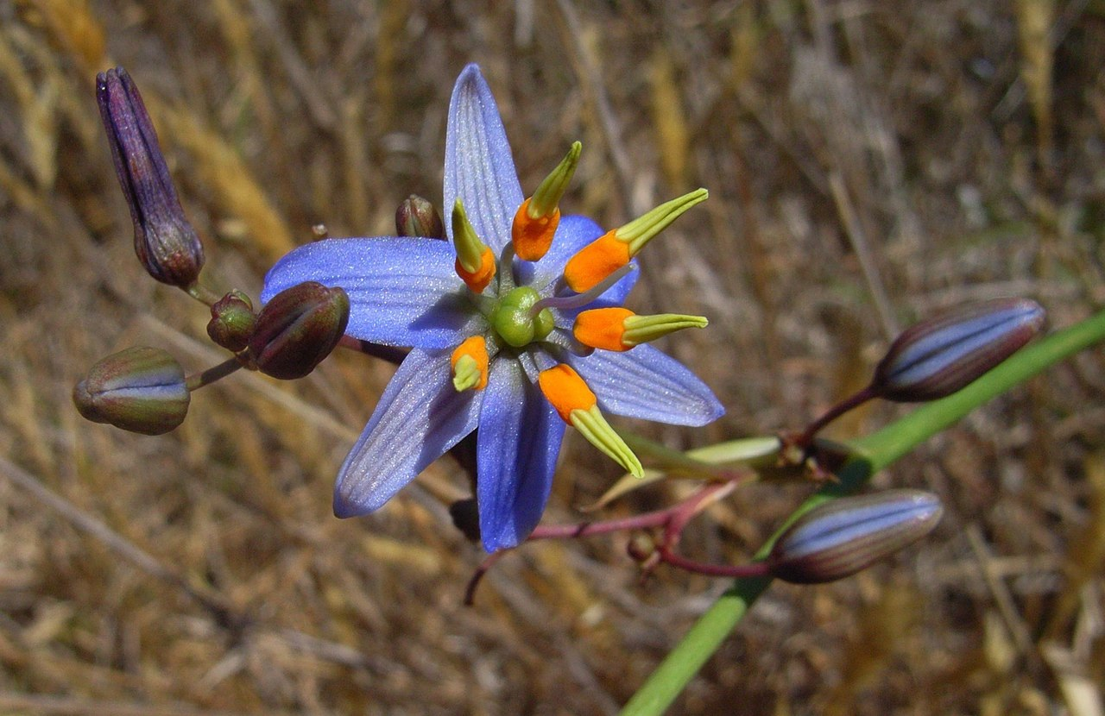

Brush-tailed Phascogale (Tuan) Phascogale tapoatafa
The Tuan is a nocturnal carnivorous marsupial. It has a large ‘bottle-brush’ tail and some people mistake it for a squirrel. This species is listed as Threatened under the Victorian Flora and Fauna Guarantee Act 1988.. The main threats to this species are loss of habitat and introduced predators (cats, dogs and foxes). Habitat loss for this species includes the removal of hollow bearing trees and fallen logs. In the City of Whittlesea, these animals have been recorded in the northern forested environments of Eden Park, Humevale and Kinglake West.

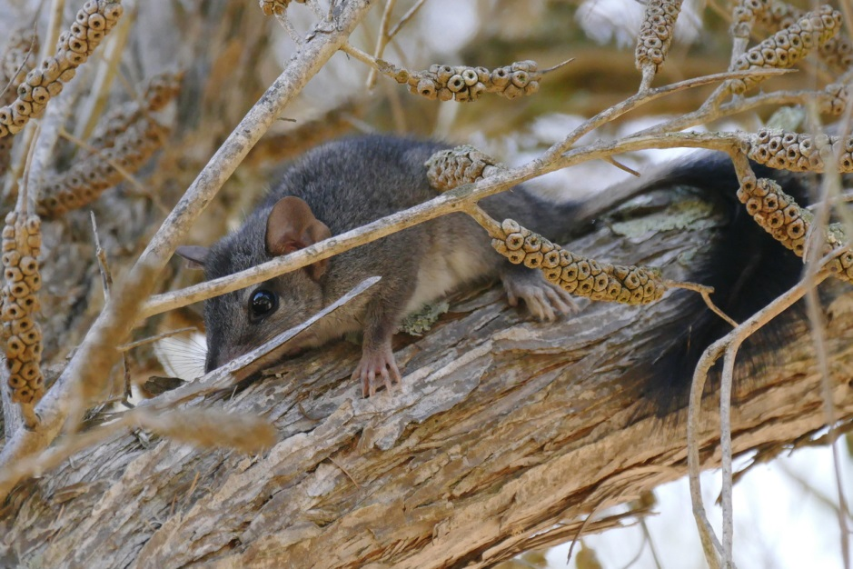

Growling Grass Frog Littoria raniformis
The Growling Grass Frog was once a common frog in south-eastern Australia but it is now listed as Vulnerable under the Commonwealth Environment Protection and Biodiversity Conservation Act 1999 and Threatened under the Victoria Flora and Fauna Guarantee Act 1988. The frog is active during the day and night and is highly mobile.
Loss of habitat, feral animals and change to hydrological regimes are the main threats to the species. Populations still exist within the City of Whittlesea and require ongoing management to ensure this species continues to persist in the area.

Council’s role in protecting biodiversity

Legislative responsibilities
Federal and State legislation provides certain protections for biodiversity within the City of Whittlesea. Different legislation focusses on separate elements from determining threatened species for protection to prohibiting certain detrimental activities. These Federal and State protections apply to all landowners including Councils. The relevant Federal and State Acts are summarised below.

Environment Protection and Biodiversity Conservation Act 1999 (EPBC Act)
The EPBC Act is Australia’s key piece of environmental legislation. One of the main aims of the EPBC Act is to provide for the conservation of biodiversity and the protection of the environment, particularly those aspects that are considered to be Matters of National Environmental Significance. This includes threatened species and communities present within the municipality

Planning and Environment Act 1987 (P&E Act)
The P&E Act establishes a framework for planning the use, development and protection of land in Victoria. The Victorian Planning Provisions and the Whittlesea Planning Scheme administered by the City of Whittlesea enable the recognition of the value and protection of biodiversity.

Guidelines for the removal, destruction or lopping of native vegetation
These guidelines are incorporated into the Victorian Planning Provisions and all planning schemes in Victoria. The Guidelines provide instructions on how an application for a permit to remove native vegetation is to be assessed.

Flora and Fauna Guarantee Act 1988 (FFG Act)
The FFG Act provides a legal framework for enabling and promoting the conservation of all Victoria’s native flora and fauna. The Act lists threatened species, communities and potentially threatening processes. It also provides Action Statements for listed matters and administers protected flora controls & permits. Public Authorities must be administered to have regard for the flora and fauna conservation management objectives of the Act.

Wildlife Act 1975
The purposes of the Wildlife Act are to establish procedures to promote:
- the protection and conservation of wildlife
- the prevention of taxa of wildlife from becoming extinct
- the sustainable use of and access to wildlife

The Wildlife Act makes it an offence to hunt, take or destroy protected or threatened wildlife without authorisation (with certain exceptions).

Catchment and Land Protection Act 1994 (CaLP Act)
The CaLP Act is a framework for management and protection of catchments through the management of land and water resources. The CaLP Act is the principle legislation relating to the management of pest plants and animals in Victoria.

Managing Council reserves
Approximately 520 ha of conservation reserve is directly owned and currently being managed by Whittlesea Council. An adaptive management approach is applied to conservation reserve management, including those with native vegetation offset requirements. Adaptive management refers to the notion that land managers are always learning from what they do. That is, as Council plans, implements and monitors their conservation management plans they continually learn and modify their activities to improve biodiversity outcomes. Traditionally this has involved weed management, pest animal control, and revegetation efforts.

In addition to this Council’s Conservation Management Team manages a Seed Production Area (SPA) for indigenous plants and a productive nursery of rare plants for later reintroductions into reserves. Large degraded areas are being restored using the ‘direct seeding’ method, where seed is harvested (either from our SPA or wild populations in our conservation reserves), and cast into designated areas in conservation reserves being restored.

In recent years, ecological burning has proven to be an effective method of weed control. Ecological burning aims to increase biodiversity through promoting the regeneration of indigenous plants over non-indigenous plants. This also leads to reduced fuel loads in reserves and reduced ongoing maintenance effort.

Council’s role on private land
Under the Planning and Environment Act, the City of Whittlesea is the responsible authority for administering and enforcing the Whittlesea Planning Scheme. The Whittlesea Planning Scheme protects biodiversity values on private land by ensuring that planning applications and developments are assessed for their impacts on environmental and biodiversity values and that removal of native vegetation is avoided or minimised prior to a permit for removal being granted. Council is also responsible for investigating, and where required, prosecuting contraventions of the Planning and Environment Act within Whittlesea’s Green Wedge where it relates to environmental impacts such as soil dumping, native vegetation removal, or de-rocking of land.

Council supports landowners in protecting biodiversity on their properties through sustainable land management programs, offering incentives and support to rural landowners within the Green Wedge area. This includes the Sustainable Land Management Rebate Scheme in which participants may be eligible for a rate rebate, or the Environmental Works Grants Program which provides financial assistance to rural landowners. Both programs encourage sustainable land management to protect and enhance biodiversity values on rural properties. These works can include revegetation, weed control, fencing of remnant vegetation and dams, and land rehabilitation. Council’s Pest Plant Local Law Education and Compliance Program offers weed mapping services, on-site consultation, provision of weed management advice, and educational materials. Where landowners fail to control listed species of pest plants on their property, Council can enforce the local law to compel landowners to undertake these works.

Engaging with the community
A number of programs currently exist for engaging with the community on biodiversity. These include the production of resources and newsletters, hosting events and directly supporting community groups wanting to learn about biodiversity or working directly to improve local biodiversity. The list below captures the variety of programs and projects that currently exist.

Information provision
- Development and promotion of biodiversity related resources such as the Your Indigenous Garden and Pest Plant Identification guides
- Production and distribution of newsletters including Rural News, Living Green e-news, and the Land Management Blog
Events
- Hosting an annual series of targeted biodiversity related events
- Sustainability presence at broader Council events i.e. Community Festival
- Tree planting activities for Schools Tree Day
Community group support
- Landcare Facilitator position actively promoting and supporting Landcare and ‘Friends of’ groups in the municipality, including Junior Landcare
- Sustainability Outreach Whittlesea Program – a program that works with community groups to provide environmental education
- Financial support for the Merri Creek Management Committee and Darebin Creek Management Committee who provide education on waterway health and biodiversity
Early Childhood support
- Facilitating Bush Kinder programs
- Promotion and support of Nature Play (guidelines currently under development)
- Nature Play Week activities including Sustainability Educators Bus Tour

Other programs also exist that align with biodiversity values but are not directly linked such as the Community Development Grants.

Data collection and management
Council collects biodiversity data from elements of planning applications, field observations during site visits and on-ground works, as well as some wildlife monitoring programs. Through the Pest Plant Local Law program data is also collected on invasive species. A monitoring program for Council managed conservation reserves is also in place to ensure management efforts are effective, threatened flora species are persisting, and native fauna is utilising the reserves.

Threats to Whittlesea’s Biodiversity

The natural environment is resilient; genetic diversity and natural selection mean that over time a balance is maintained through natural cycles of boom, bust, and the shifts in climate suitability and competition between species. However, human activity has dramatically sped up the rate of change making it harder for nature to adapt.

Urban development and land use change
Land clearance is recognised as a key threatening process to biodiversity under the EPBC Act. Whittlesea is one of the seven growth areas of Melbourne’s Urban Growth Zone. Increasing pressure from residential development within this zone is an ongoing threat to biodiversity within Whittlesea.

Habitat fragmentation
Land clearing can result in the division of large, continuous areas of habitat into smaller, isolated and fragmented patches. Fragmentation is a growing threat in Whittlesea. Smaller habitat patches are more vulnerable to the impacts of weed and pest animals, droughts and catastrophic events such as wildfire. Connectivity of habitat patches is important for animals to recolonise and disperse from.

Weeds, pest animals and pathogens
Weeds, pest animals and pathogens represent a significant threat to the biodiversity of Whittlesea. Environmental weeds are primarily introduced plants but may also be invasive, non-endemic native plants. Weeds compete (and often out-compete) with indigenous plants resulting in a change in the diversity and/or structure of habitats.

Pathogens are agents (usually microorganisms) which cause infection or disease. Pathogens of particular relevance to Whittlesea are Chytrid Fungus Batrachochytrium dendrobatidis (affects frog populations) and Cinnamon Fungus Phytophthora cinnamomi (affects plant populations).

Pest animals are introduced species that prey on, compete with or exclude native wildlife from habitat, or disturb the environment through overgrazing or soil disturbance.

Inappropriate land management
In rural areas, inappropriate land management practices pose a threat to important habitat and the environment in general. Within Whittlesea, inappropriate stocking rates (leading to overgrazing, soil compaction, disturbance and erosion), property neglect, soil dumping, loss of top soil, illegal clearing of vegetation, construction of private dams and inadequate protection of sensitive areas (including high risk erosion areas, patches of remnant vegetation, scattered River Red Gums and waterways) are some of the means by which biodiversity assets are threatened.

Climate change
Climate change has the potential to adversely affect biodiversity in Whittlesea through changes to the quality, extent and distribution of vegetation and habitat, changes to hydrology (the natural wetting and drying cycles and frequency and duration of inundation) of wetlands and watercourses, and changes in the diversity and abundance of wildlife reliant upon those habitats.

Altered fire regimes
Altered fire regimes can cause changes in vegetation structure and floristic composition. Fires that occur too frequently can lead to fire sensitive species being unable to mature and reproduce. Conversely, infrequent fires can result in species reliant on fire for reproduction being unable to set seed or germinate. Changes in structure and floristics not only affect the vegetation type but also the habitat resources available for animals.

Lack of community stewardship/connectedness to nature
Connection to a place increases the level of appreciation and likelihood of actions being taken to ensure its protection. Stewardship is an ethic that embodies responsible planning and management of resources. Groups of people and organisations working together to achieve a common goal of protecting and enhancing biodiversity will be more effective than individuals working in isolation.

Data gaps
A lack of knowledge of local flora and fauna populations is a threat to biodiversity in Whittlesea. Without a baseline understanding of the wildlife that inhabits an area or reserve, Council is unlikely to be able to adequately plan and manage for their long-term survival.

Opportunities to improve our biodiversity

Improving data collection and management
It is vital for the protection of biodiversity that we have baseline data on what already exists so that we understand what we are trying to protect and how to best protect it into the future. The more that is understood about current conditions, the better we can navigate and manage changes to local biodiversity. The last comprehensive data collection effort in the region was for the North East Regional Organisation of Councils (NEROC) which was completed in 1997.

Objective 1: Improve our local knowledge and understanding of local biodiversity

How will we get there? (Priority Actions)
- Collate existing biodiversity datasets.
- Update the NEROC study - surveying and mapping - to provide comprehensive baseline data.
- Undertake a habitat connectivity study to identify current and planned limitations to connectivity, and identify where landscape connectivity could be retained or improved.
- Update the existing biodiversity values map and validate the data to provide an accurate baseline of existing remnant vegetation in the municipality.
- Identify the impact that climate change is likely to have on keystone species in the municipality, and management actions required to best improve the outlook for these species.

What threats does this address?
Data gaps, Climate change, weeds, pests and pathogens

What is the outcome?
Management decisions are made with up to date, accurate knowledge of local biodiversity values

Strengthening the Planning Scheme

As the responsible authority for the Whittlesea Planning Scheme, Council has a degree of influence over how biodiversity is protected at both a landscape scale and at a lot level. Well thought-out strategic and land use planning will enable local species to move throughout the landscape and mitigate the impacts associated with urbanisation, land use change and climate change.

Objective 2: Strengthen the Planning Scheme to achieve better biodiversity outcomes

How will we get there? (Priority Actions)
- Assess the adequacy of current planning overlays and zones in areas of biodiversity value and identify the appropriate planning controls to inform a planning scheme amendment.
- Proactively monitor compliance with permit conditions relating to environmental outcomes and investigate breaches of the Planning and Environment Act relating to biodiversity e.g. Removal of native vegetation.
- Conduct education campaigns to inform the community about planning restrictions in Green Wedge areas.

What threats does this address?
Urban development and land use change, habitat fragmentation, weeds, pest animals and pathogens, inappropriate land management

What is the outcome?
An accurate reflection of biodiversity values in the Planning Scheme and adequate planning protections on them

Working with rural landowners

A large portion of the City of Whittlesea is contained in privately owned rural property. This means that there are considerable biodiversity assets on private land in rural areas. The protection and management of remnant vegetation, as well as the potential for improving links and stepping stones across the landscape make working with rural landowners a key opportunity.

Objective 3: Support rural landowners to protect and improve biodiversity on private land

How will we get there? (Priority Actions)
- Review current incentive programs to ensure they are the most effective way to encourage for rural landholders to undertake environmental works on private land. Establish a five-year cycle for a review of incentives.
- Provide rural landowners support to protect and improve biodiversity on private land.
- Investigate the option of creating sub-catchment management plans/objectives that can better integrate environmental works across several properties.
- Develop a pilot program of ‘Sustainable Native Forestry for Firewood’ focused on establishing a fast growth native patch that can be partially harvested for firewood while providing ongoing sustainable habitat.

What threats does this address?
Habitat fragmentation, weeds, pest animals and pathogens, inappropriate land management, lack of community stewardship

What is the outcome?
Landowners are incentivised to undertake works that protect or enhance biodiversity on their land.

Involving community in urban environments

Raising awareness and building community capacity to get involved in biodiversity enhancement is an important part of improving liveability in urban areas. There are numerous co-benefits to a biodiversity rich urban environment including improved waterway health, improved health and wellbeing outcomes for people, and (with increased tree canopy cover) a reduction in the urban heat island effect.

Objective 4: Encourage awareness and participation in urban biodiversity and improvement

How will we get there? (Priority Actions)
- Develop and deliver an urban based biodiversity campaign that coordinates programming and educational efforts across Council around a central theme(s).
- Investigate urban incentive schemes that encourage residents and schools to plant indigenous gardens.
- Continue to provide support for community groups with a focus on environmental sustainability and/or undertaking biodiversity programming.

What threats does this address?
Habitat fragmentation, weeds, pest plants, and pathogens, lack of community stewardship

What is the outcome?
A larger portion of the community who understands and respects the natural environment and actively participate in protecting or improving local biodiversity

Managing Councils conservation reserves

Currently Council manages 521 hectares of conservation area in dedicated reserves. These reserves provide vital habitat and food resources for native wildlife and important opportunities for residents to observe and appreciate the natural environment. Council should continue to find ways to improve current management practices and to increase the involvement of the community.

Objective 5: Manage Council land to reduce threats and improve habitat quality

How will we get there? (Priority Actions)
- Identify and prioritise Council reserves containing the highest biodiversity values that are not permanently protected through the Planning Scheme and work to increase their protections.
- Apply adaptive and innovative management practices to Council’s conservation reserves to ensure continuous improvement.
- Prioritise resources for weed control in moderate and high value roadside reserves, and those adjacent to properties containing high biodiversity values.
- Ensure that other Council strategies and plans prioritise improving biodiversity.

What threats does this address?
Urban development and land use change, weeds, pest animals and pathogens, altered fire regimes, data gaps

What is the outcome?
Council conservation reserves are protected for future generations, and management of Council land is efficient and effective.

Working with other agencies

Several other agencies are responsible for managing significant sites of biodiversity value both within and adjacent to the City of Whittlesea. For example, Kinglake National Park and Plenty Gorge Parklands (Parks Victoria) and the Yan Yean and Toorrourong reservoirs (Melbourne Water). Working with other agencies and neighbouring Councils is an important way of circulating new ideas and approaches and maximising the benefit of individual efforts. Kangaroo management is a key concern that came through in the community consultation, both the impact of development restricting kangaroo movement as well as kangaroos on roads. Kangaroo management is a complex issue that crosses different jurisdictions and there is an opportunity to strategically manage kangaroos across a landscape.

Objective 6: Collaborate with other land management agencies

How will we get there? (Priority Actions)
- Collaborate with Land Management agencies on pest plant and animal management programs.
- Advocate for State support to collaboratively develop a region wide kangaroo management plan (or similar) to address the issue of kangaroo movement in developing areas.
- Establish a regional network for standardised biodiversity data.
- Continue to support and advocate for the establishment of the proposed Grassy Eucalypt Woodland conservation reserve located within Whittlesea’s Green Wedge as described in the Melbourne Strategic Assessment.

What threats does this address?
Habitat fragmentation, weeds, pest plants, and pathogens, lack of community stewardship, Data gaps

What is the outcome?
Increased number of regional projects that include the City of Whittlesea, and a standardised system of collecting and sharing data

Appendix 1
Threatened flora species recorded within the last 30 years in the City of Whittlesea

Scientific name | Common name | EPBC Act | FFG Act | Victorian status (advisory list)
Acacia leprosa var. uninervia | Large-leaf Cinnamon-wattle |  |  | Rare
Adiantum capillus-veneris | Venus-hair Fern |  | Listed | Endangered
Amphibromus fluitans | River Swamp Wallaby-grass | Vulnerable | Rejected
Amphibromus pithogastrus | Plump Swamp Wallaby-grass |  | Listed | Endangered
Billardiera scandens s.s. | Velvet Apple-berry |  |  | Rare
Callitriche brachycarpa | Short Water-starwort |  | Listed | Vulnerable
Callitriche umbonata | Winged Water-starwort |  | Rejected | Rare
Carex tasmanica | Curly Sedge |  | Listed | Vulnerable
Cladium procerum | Leafy Twig-sedge |  |  | Rare
Comesperma polygaloides | Small Milkwort |  | Listed | Vulnerable
Coronidium gunnianum | Pale Swamp Everlasting |  |  | Vulnerable
Corybas fimbriatus | Fringed Helmet-orchid |  |  | Rare
Corymbia maculata | Spotted Gum |  |  | Vulnerable
Cullen tenax | Tough Scurf-pea |  | Listed | Endangered
Cyathea cunninghamii | Slender Tree-fern |  | Listed | Vulnerable
Dianella amoena | Matted Flax-lily | Endangered | Listed | Endangered
Dianella callicarpa | Swamp Flax-lily |  |  | Rare
Dianella sp. aff. longifolia (Benambra) | Arching Flax-lily |  |  | Vulnerable
Dysphania carinata | Keeled Goosefoot |  |  | Vulnerable
Eucalyptus X studleyensis | Studley Park Gum |  |  | Endangered
Eucalyptus yarraensis | Yarra Gum |  | Rejected | Rare
Geranium solanderi var. solanderi s.s. | Austral Crane's-bill |  |  | Vulnerable
Geranium sp. 1 | Large-flower Crane's-bill |  | Listed | Endangered
Geranium sp. 3 | Pale-flower Crane's-bill |  |  | Rare
Glycine latrobeana | Clover Glycine | Vulnerable | Listed | Vulnerable
Goodia medicaginea | Western Golden-tip |  |  | Rare
Goodia pubescens | Silky Golden-tip |  |  | Rare
Grevillea repens | Creeping Grevillea |  |  | Rare
Grevillea rosmarinifolia subsp. rosmarinifolia | Rosemary Grevillea |  |  | Rare
Lachnagrostis adamsonii | Adamson's Blown-grass | Endangered | Listed | Vulnerable
Lachnagrostis punicea subsp. punicea | Purple Blown-grass |  |  | Rare
Limonium australe var. australe | Yellow Sea-lavender |  |  | Rare
Lindsaea trichomanoides | Oval Wedge-fern |  | Listed | Endangered
Melaleuca armillaris subsp. armillaris | Giant Honey-myrtle |  |  | Rare
Paspalidium flavidum | Yellow Watercrown Grass |  |  | Endangered
Prasophyllum suaveolens | Fragrant Leek-orchid | Endangered | Listed | Endangered
Ranunculus diminutus | Brackish Plains Buttercup |  |  | Rare
Rhagodia parabolica | Fragrant Saltbush |  |  | Rare
Senecio macrocarpus | Large-headed Fireweed | Vulnerable | Listed | Endangered
Senecio psilocarpus | Swamp Fireweed | Vulnerable |  | Vulnerable
Thismia rodwayi | Fairy Lanterns |  | Listed | Vulnerable
Tmesipteris parva | Small Fork-fern |  |  | Rare
Tripogon loliiformis | Rye Beetle-grass |  |  | Rare

Threatened fauna species recorded within the last 30 years in the City of Whittlesea

Scientific name | Common name | EPBC Act | FFG Act | Victorian status (advisory list)
Birds
Accipiter novaehollandiae novaehollandiae | Grey Goshawk |  | Listed | Vulnerable
Alcedo azurea | Azure Kingfisher |  |  | Near threatened
Anas rhynchotis | Australasian Shoveler |  |  | Vulnerable
Anthochaera phrygia | Regent Honeyeater | Critically Endangered | Listed | Critically endangered
Ardea modesta | Eastern Great Egret |  | Listed | Vulnerable
Aythya australis | Hardhead |  |  | Vulnerable
Biziura lobata | Musk Duck |  |  | Vulnerable
Botaurus poiciloptilus | Australasian Bittern | Endangered | Listed | Endangered
Chlidonias hybridus javanicus | Whiskered Tern |  |  | Near threatened
Chlidonias leucopterus | White-winged Black Tern |  |  | Near threatened
Chrysococcyx osculans | Black-eared Cuckoo |  |  | Near threatened
Chthonicola sagittatus | Speckled Warbler |  | Listed | Vulnerable
Cinclosoma punctatum | Spotted Quail-thrush |  |  | Near threatened
Circus assimilis | Spotted Harrier |  |  | Near threatened
Climacteris picumnus victoriae | Brown Treecreeper (south-eastern ssp.) |  |  | Near threatened
Egretta garzetta nigripes | Little Egret |  | Listed | Endangered
Gallinago hardwickii | Latham's Snipe |  |  | Near threatened
Grus rubicunda | Brolga |  | Listed | Vulnerable
Haliaeetus leucogaster | White-bellied Sea-Eagle |  | Listed | Vulnerable
Hirundapus caudacutus | White-throated Needletail |  |  | Vulnerable
Hydroprogne caspia | Caspian Tern |  | Listed | Near threatened
Ixobrychus minutus dubius | Little Bittern |  | Listed | Endangered
Lathamus discolor | Swift Parrot | Critically Endangered | Listed | Endangered
Lewinia pectoralis pectoralis | Lewin's Rail |  | Listed | Vulnerable
Melanodryas cucullata cucullata | Hooded Robin |  | Listed | Near threatened
Ninox connivens connivens | Barking Owl |  | Listed | Endangered
Ninox strenua | Powerful Owl |  | Listed | Vulnerable
Nycticorax caledonicus hillii | Nankeen Night Heron |  |  | Near threatened
Oxyura australis | Blue-billed Duck |  | Listed | Endangered
Pedionomus torquatus | Plains-wanderer | Critically Endangered | Listed | Critically endangered
Phalacrocorax varius | Pied Cormorant |  |  | Near threatened
Platalea regia | Royal Spoonbill |  |  | Near threatened
Porzana pusilla palustris | Baillon's Crake |  | Listed | Vulnerable
Rostratula australis | Australian Painted Snipe | Endangered | Listed | Critically endangered
Stagonopleura guttata | Diamond Firetail |  | Listed | Near threatened
Stictonetta naevosa | Freckled Duck |  | Listed | Endangered
Tringa glareola | Wood Sandpiper |  |  | Vulnerable
Tringa nebularia | Common Greenshank |  |  | Vulnerable
Tringa stagnatilis | Marsh Sandpiper |  |  | Vulnerable
Turnix pyrrhothorax | Red-chested Button-quail |  | Listed | Vulnerable
Turnix velox | Little Button-quail |  |  | Near threatened
Tyto novaehollandiae novaehollandiae | Masked Owl |  | Listed | Endangered
Tyto tenebricosa tenebricosa | Sooty Owl |  | Listed | Vulnerable
Mammals
Gymnobelideus leadbeateri | Leadbeater's Possum | Critically Endangered | Listed | Endangered
Miniopterus schreibersii GROUP | Common Bent-wing Bat |  | Listed
Miniopterus schreibersii oceanensis | Common Bent-wing Bat (eastern ssp.) |  | Listed | Vulnerable
Myotis macropus | Southern Myotis |  |  | Near threatened
Petauroides volans | Greater Glider | Vulnerable | Listed | Vulnerable
Phascogale tapoatafa | Brush-tailed Phascogale |  | Listed | Vulnerable
Pteropus poliocephalus | Grey-headed Flying-fox | Vulnerable | Listed | Vulnerable
Sminthopsis crassicaudata | Fat-tailed Dunnart |  |  | Near threatened
Sminthopsis murina murina | Common Dunnart |  |  | Vulnerable
Reptiles
Delma impar | Striped Legless Lizard | Vulnerable | Listed | Endangered
Emydura macquarii | Murray River Turtle |  |  | Vulnerable
Pogona barbata | Bearded Dragon |  |  | Vulnerable
Pseudemoia pagenstecheri | Tussock Skink |  |  | Vulnerable
Pseudemoia rawlinsoni | Glossy Grass Skink |  |  | Vulnerable
Tympanocryptis pinguicolla | Grassland Earless Dragon | Endangered | Listed | Critically endangered
Varanus varius | Lace Monitor |  |  | Endangered
Frogs
Litoria raniformis | Growling Grass Frog | Vulnerable | Listed | Endangered
Pseudophryne bibronii | Brown Toadlet |  | Listed | Endangered
Pseudophryne semimarmorata | Southern Toadlet |  |  | Vulnerable
Fish
Macquaria ambigua | Golden Perch |  | Rejected | Near threatened
Invertebrates
Synemon plana | Golden Sun Moth | Critically Endangered | Listed | Critically endangered

Ecological communities of National or State significance occurring, or potentially occurring, within the City of Whittlesea

Nationally Significant ecological communities listed under the Environment Protection and Biodiversity Conservation (EPBC) Act
Grassy Eucalypt Woodland of the Victorian Volcanic Plain
Grey Box (Eucalyptus microcarpa) Grassy Woodland and Derived Native Grasslands of South-Eastern Australia
Natural Temperate Grasslands of the Victorian Volcanic Plain
Seasonal Herbaceous Wetlands (Freshwater) of the Temperate Lowland Plains
State Significant ecological communities listed under the Flora and Fauna Guarantee (FFG) Act
Western (Basalt) Plains Grasslands Community
Western Basalt Plains (River Red Gum) Grassy Woodland

