Spear Thistle (Cirsium vulgare)

Pest Plant Local Law

Spear Thistle
Note Number: PPLL 10
Spear Thistle is an annual / biennial broadleaf weed growing to 1.5 metres. It is a highly invasive weed of improved pasture where it favours fertile soils with high levels of nutrients. It is also a common weed of bushland areas, cultivated areas, roadsides and disturbed / waste sites, especially in moist areas. When established, it crowds out most plants by shading and competition for nutrients and water.
Spear Thistle is avoided by livestock because of its spines and overgrazing of paddocks encourages its spread.
If eaten, the spines can cause damage to stock, particularly around the mouth. Dried leaves and spines can contribute to the contamination of wool fleeces which can incur a price penalty at markets.

Local Scene
Spear Thistle is widespread in the City of Whittlesea. It favours the basalt soils in the west of the municipality where it commonly grows with Artichoke and Variegated Thistles. It is more widely distributed than other thistle species and is a common weed in the higher rainfall areas of Humevale, Whittlesea and Kinglake West.

Identification and Description

Flowers
Purple flowerheads up to 5 cm in diameter are born singularly or in groups of 2-3, and are surrounded by spiny bracts. Summer flowering (December to February).
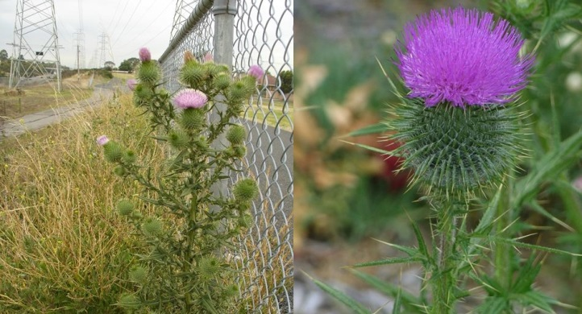
Spear Thistle in flower

Leaves
Leaves are dark green to 35 cm long and deeply divided. They are prickly on the upper surface giving them a hairy appearance. Leaves end with a distinct yellow stout spine. Initially develops as a rosette of leaves at ground level.
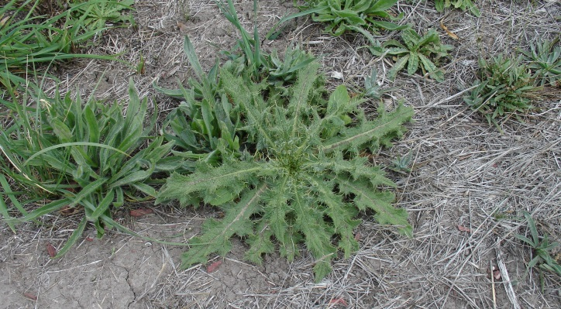
Spear thistle rosette of spiny leaves

Stems
Stems are erect with spiny wings along the length. Commonly several stems emerge from the base, but can be a single stem.

Seeds
Seed is grey / light-brown, with a tuft of bristles attached: up to 2.5 cm long. Up to 200 flower heads and 8000 seeds can be produced per plant.

Roots
Plants develop a taproot with numerous branches.

Life Cycle / Reproduction
Spear Thistle reproduces by seed and grows by a one or two-year life cycle depending on when seeds germinate. The main germination occurs after the first autumn rains with some emergence in late winter to spring. Plants die after flowering and can remain standing for 1-2 years.
Seed is relatively heavy and is only dispersed a short distance by the wind from the parent plant. Seed can be dispersed long distances in contaminated hay because plants are normally flowering when hay is cut. Seed remains viable for a relatively short time in the soil.
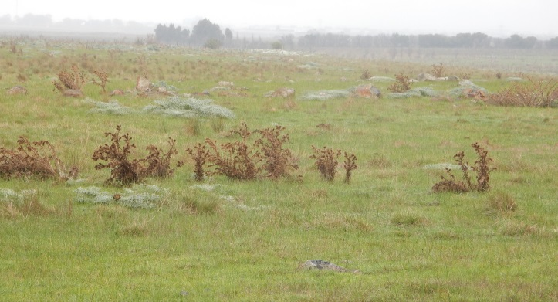
Previous seasons’ dead Spear Thistle plants

Control and Management
Clean areas should be kept free of Spear Thistle and managed to prevent infestation. Lightly infested areas should be prioritised to prevent further establishment and prevent spread. Heavily infested areas should be tackled progressively over a number of years.

Prevention
- Beware of source infestations- seed can be transported in contaminated soil, in soil attached to rock and imported in hay.
- Avoid overgrazing paddocks with stock as this will remove the competition provided by pasture grasses.
- Controlling rabbits will remove selective grazing pressure that will favour Spear Thistle establishment and spread.
- Remove individual plants as soon as identified.
- Maintain competitive groundcover to prevent establishment.

Non-chemical control
- Seedlings and small plants can be chipped out when at the rosette stage. Take care to ensure all root material is removed.
- Cultivation is effective in killing the plant but must be undertaken as a preliminary action prior to the establishment of competitive pasture or crops.
- Slashing plants is only effective once flowers are produced otherwise plants will reshoot. Be cautious, as viable seeds may already have been produced if flowers are present when cutting occurs.

Chemical Control
- Spot spray infestations using a chemical registered for Spear Thistle.
- Use a broadleaf specific herbicide to avoid off-target damage to surrounding desirable pasture grasses.
- Treat at the rosette stage. Mature plants with flowering stems are difficult to kill due to a well-established tap root.

Long-term control
- Ensure you have good coverage of perennial grasses, crops or native vegetation.
- Limit soil disturbance and monitor treated areas for re-infestation.
- Remove as soon as identified.

Similar native species
There are no similar native species

Further Information
This factsheet should be read in conjunction with Note PPLL 12- Weed Control Techniques.
Contact Council’s Land Management and Biodiversity Team for further information and assistance on the control of this weed on 9217 2147

Seasonal Guide to the Management of Spear Thistle
SUMMER |  |  | AUTUMN |  |  | WINTER |  |  | SPRING
Dec | Jan | Feb | Mar | Apr | May | Jun | Jul | Aug | Sep | Oct | Nov
Hand removal |  |  | Spot spraying |  |  | Cultivation

