Community Wellbeing Indicators Report 2017

Table of contents
Mayor’s message 5
City of Whittlesea population 6
City of Whittlesea Community Wellbeing Indicators Framework 8
Community Wellbeing Indicators: Summary of results 12
Inclusive and engaged community
Participation in community groups 16
Sense of community 17
Volunteering 18
Community acceptance of diverse cultures 19
Participation in decision making 20
Accessibility in, out and around our city
Broadband access 22
Access to public transport 23
Commuter travel time 24
Cycling facilities 25
Walking facilities 26
Growing our economy
Income 28
Unemployment 29
Underemployment 30
Highly skilled workforce 31
Local employment 32
Local jobs 33
Qualifications 34
Youth disengagement 35
Places and spaces to connect people
Use of open space 37
Community meeting spaces 38
Recreation facilities 39
Participation in sports and recreation 40
Distinct community character 41
Health and wellbeing
General health 43
Psychological distress 44
Risk factors 45
Food insecurity 47
Gambling loss 48
Affordable housing 49
Access to health services 50
Access to human services 51
Family violence 52
Safety in public areas 53
Developmental vulnerability 54
Connectedness to school 55
Access to educational services 57
Living sustainably
Household energy usage 59
Household waste generation 60
Household recycling contamination 61
Household water usage 62
Stewardship of the environment 63
Good governance
Community consultation and engagement 65
Decisions in community’s interest 66
Lobbying for community 67
Council’s overall performance 68
Data notes 69
References 70

Mayor’s Message
I would like to welcome you to the City of Whittlesea’s inaugural Community Wellbeing Indicators Report.

Every year the City of Whittlesea welcomes over 7,000 people to the municipality with our population expected to increase to more than 350,000 by 2037. As our population booms it’s important that Council carefully plans for the future so that our residents can enjoy the same access to services and facilities as those that live closer to the city.

Our Community Wellbeing Indicators Report is an important document containing a wealth of data that gives a better understanding about the wellbeing of our fast-growing and diverse community.

The Report plays an important part in enabling Council to more accurately plan for the community infrastructure and services that our residents will need and deserve. It also provides influential data and clear evidence of our needs as we lobby state and federal governments to fund the required services and infrastructure.

Here at Council, we use these indicators to help inform the planning and prioritisation of current infrastructure, services and programs. The indicators also help us to monitor the progress of our Community Plan, Council Plan and other strategies. In addition, the indicators help us to identify positive opportunities in our community and areas that require improvement.

I hope that the information within this report provides you with a unique insight into the communities that reside here in the City of Whittlesea, and assist you or your organisation in achieving better outcomes for our residents.

Cr Ricky Kirkham
MAYOR

City of Whittlesea population
The City of Whittlesea is located in Melbourne’s northern suburbs, about 20 kilometres from the city centre. It is one of Melbourne’s largest municipalities, covering a land area of approximately 490 square kilometres.

The majority of the City of Whittlesea population live in the urban areas. This is split across the major established area precincts of Bundoora, Epping, Lalor, Mill Park and Thomastown, and the current growth area precincts of Mernda, Doreen, South Morang and Epping North. Significant future growth is projected for Wollert and Donnybrook. The rural areas of the municipality are characterised by farming, forested areas and historic township communities including Whittlesea Township.

The Wurundjeri Willam people were the original inhabitants of the area and are the traditional owners of this land. Compared with other municipalities, the City of Whittlesea has the fourth largest population of Aboriginal and Torres Strait Islanders (ATSI) by person count in Metropolitan Melbourne, with 1,138 ATSI residents.

The median age of residents is 34 years of age (compared to 37 years of age for Victoria); however the median age varies widely across the municipality, ranging from 29 years of age in the growth area precincts of Epping North, Mernda and Doreen, and up to 42 years of age in the Rural North. There are more children and young people aged 0-17 years (25%) compared with the Victorian average (22%), and fewer residents aged 60 years and above (16% compared to 20%)¹. There are more families with children residing in the City of Whittlesea (43% couples with children and 13% one parent families) compared to the Victorian average (32% couples with children and 11% one parent families)1.

A culturally diverse community
The City of Whittlesea is one of the most culturally diverse municipalities in Victoria.
- 34% of residents were born overseas (compared to 26% for Victoria)1
- 43% speak a language other than English at home (compared to 23% for Victoria)1
- 27% of overseas born residents have lived in Australia for less than ten years

A fast growing community
- The estimated resident population in 2017 is 209,118.
- In 2014-15, the City of Whittlesea was the:
  - 3rd largest growing Local Government Area (LGA) in Victoria
  - 3rd fastest growing LGA in Victoria
- Growth in 2016-17 – increase of 131 people per week4
- On average 72 babies are born every week4
- By 2037, the estimated population will have grown to 353,9104
- The population is ageing; the number of adults aged 50 years and over is expected to increase by 84% in the next two decades4

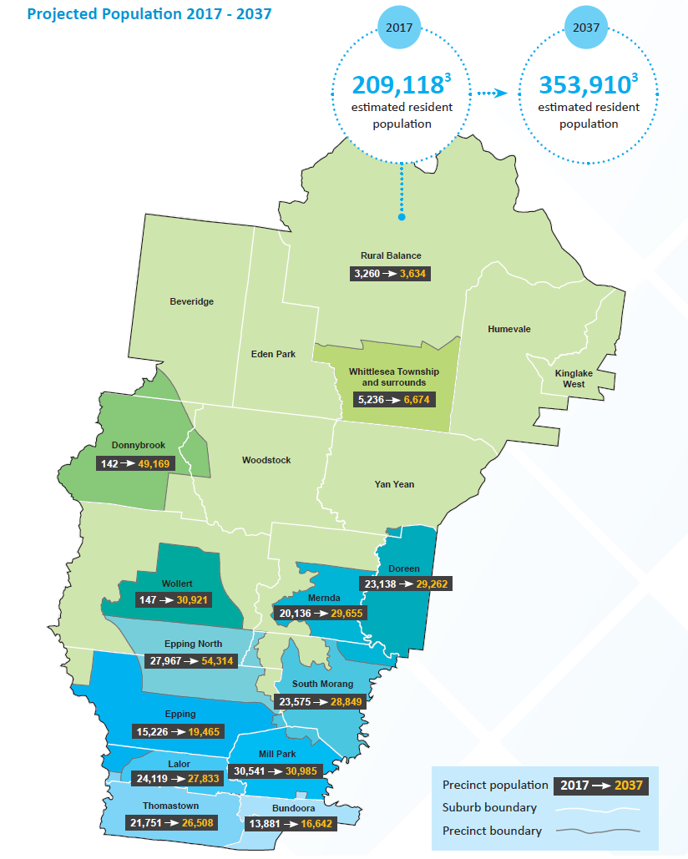

City of Whittlesea Community Wellbeing Indicators Framework

Measuring community wellbeing
The City of Whittlesea Community Wellbeing Indicators report provides a snapshot of the state of wellbeing of our community by providing a broad range of indicators. These indicators help us to identify positive outcomes and opportunities in our community and draw attention to areas that require improvement. The indicators measure current community outcomes, and also show trends and changes over time.

Monitoring community wellbeing outcomes over time is an important way to measure social progress. Increasingly, government and non-government bodies are using wellbeing indicators to supplement measures of economic growth. This is particularly important for Growth Area Councils such as the City of Whittlesea, where we experience large and rapid population growth. While population growth can be a key driver in the prosperity of a community, it can also present particular challenges. This includes a lag in the provision of services, social and physical infrastructure (particularly transport infrastructure); fewer local employment opportunities; reduced housing affordability; and lower levels of social participation and cohesion. All of these challenges may affect the liveability and overall wellbeing of communities.

How we use indicators
This inaugural report provides results for the City of Whittlesea Community Wellbeing Indicators Framework, adopted in 2016. The City of Whittlesea uses the indicators to better understand the strengths, opportunities and needs of our community, and to help inform planning and prioritisation of infrastructure, services and programs. The indicators can also be used to monitor progress towards achieving our Community Plan, Council Plan and other strategies, and to advocate with our community on issues of importance.

Continuing to strive for a strengthened community and better wellbeing outcomes is a shared responsibility. It requires support and collaboration between the City of Whittlesea, other local Councils, Victorian and Australian governments, non-government organisations, businesses and our community.

The City of Whittlesea has multiple roles as a provider, facilitator and advocate (Figure 1). The indicators in this report are not intended to be used as a measure of Council’s performance (Council reports on performance via a number of other mechanisms including the Annual Report and Know Your Council website). For some indicators, Council has no direct control or influence over the outcomes, and over time, these indicators may be influenced by many external factors including economic, social, political and environmental factors at a local, national or international level.

Figure 1. Council's three main roles
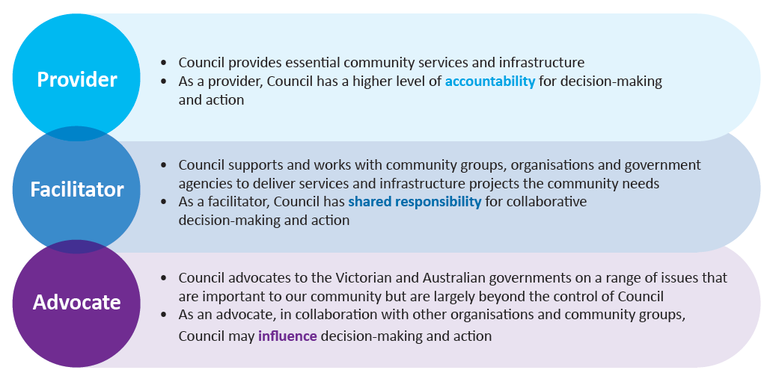

Indicator framework summary
The City of Whittlesea Community Wellbeing Indicators Framework comprises 45 broad indicators of wellbeing selected and grouped to align with the seven ‘Future Directions’ and ‘Themes’ of Council’s Community and Council Plans (Figure 2).

Figure 2. Council's seven Future Directions and themes
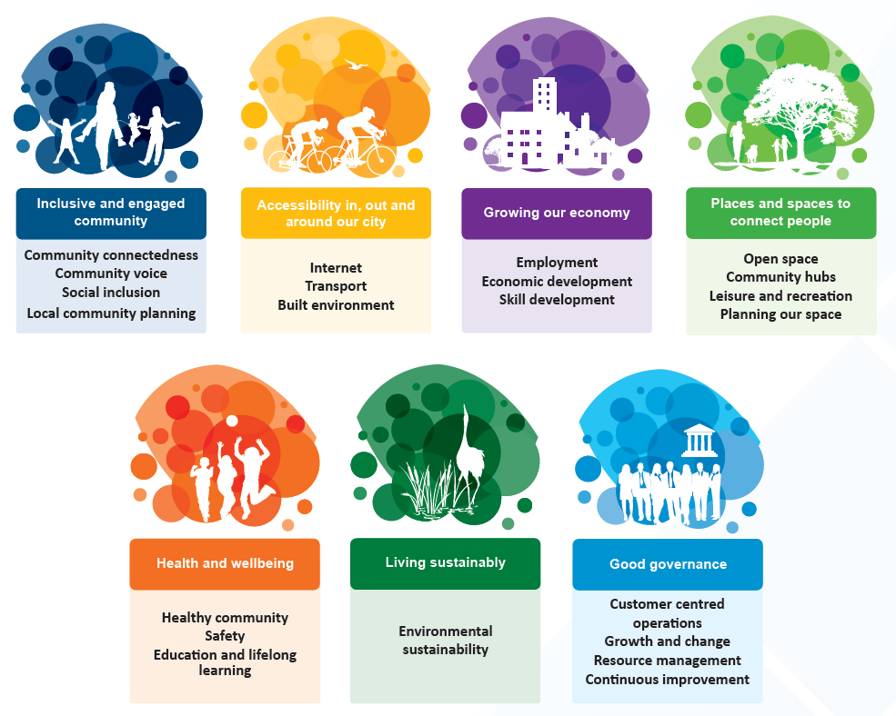

Terminology that underpins the Framework is shown in Figure 3. Each indicator includes one or more measures derived from a range of Council and external data sources referenced throughout this report. These indicators and measures were carefully chosen using the technical expertise of many individuals across Council. For each indicator, a snapshot is provided including the following information:
- why the indicator is considered important
- how the indicator is measured
- how the community is tracking against the indicator
- what role Council plays.

To make it more meaningful to our community, where possible, population-wide measures were selected that capture data at the household or individual level. The indicators and measures will be reviewed every two years. They will be updated as required to include new sources of data and to meet the changing needs of the organisation and community. Future reports published every two years will enable us to continue to monitor trends over time. While some measures in this report fluctuate from year to year, others are less sensitive to change and may even take decades to see substantial improvements at a population level.

Figure 3. Framework terminology
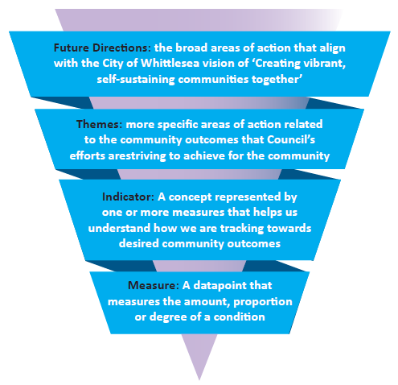

How to use this report
Other local service providers and community members can use this report to develop their understanding of the current wellbeing status of our local community, and the areas in which we are making positive progress, no progress, or where we need to focus our attention more. The indicators provide guidance for all local stakeholders around how we can all work together to achieve better outcomes for our community. The indicators focus on our population as a whole and should be viewed in the context of other data sources and reports that explore differences between population groups and geographical areas within the municipality.

The report is divided into sections based on Council’s seven Future Directions. Each indicator aligns to the Future Directions and is represented by one or more measures. Where available, historical data is presented from 2013 to demonstrate the trend over time since the Community and Council Plans were developed (refer to Figure 4 for an overview of how the assessment of trends were categorised). Refer to the data sources referenced throughout the report if you wish to cite the results elsewhere.

Figure 4. Categories for trend data
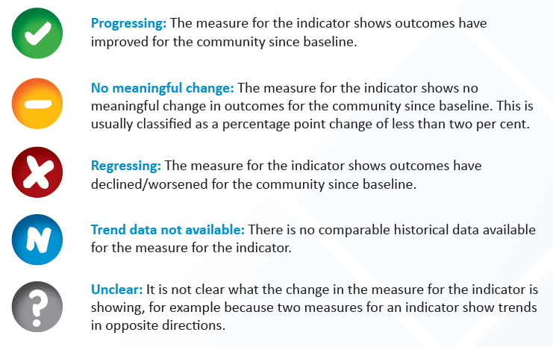
Baseline refers to the first data point available since 2013. Where there are multiple data points over the past four years, comparison is made between the most recent data and baseline data to determine the trend category. In some cases there is only one data point available and this will serve as baseline data in future reports – these are reported as ‘data not available’. For more information see ‘Data notes’.

Community Wellbeing Indicators: Summary of results

How is our community faring?

The Community Wellbeing Indicators paint a rich but complex picture of the state of wellbeing of our community. It is important to remember that the indicators presented provide a summary of our community overall, and do not enable us to demonstrate the differences that exist between some groups within our community. For example, we do not explore differences between gender, age or cultural groups, differences by place or other demographic characteristics; therefore, inequalities will not be highlighted. Nonetheless, these indicators provide a useful starting point for further exploration to guide our planning, prioritisation and advocacy efforts.

As the summary on the following page shows, the majority of indicators for which we have trend data are ‘progressing’. We are seeing improvements in community outcomes across a range of areas. For example, we are more accepting of people from diverse cultures and religions and feel our community is a special place with a distinct character. Unemployment is the lowest it has been in four years, there are more local jobs and more people in our community work in highly skilled occupations. The majority of residents use open spaces, participation in sports and recreation activities is increasing, and we value the importance of recreation facilities in the community.

Some indicators, however, highlight areas of concern for our community. There are seven indicators that appear to be ‘regressing’; that is, the measures are trending in the opposite direction to what would be optimal for our community. For example, over time we are seeing fewer people engaging in community groups, we are spending a longer time commuting to and from work each day, and there are increasing rates of food insecurity, housing payment stress and incidents of family violence.

Other indicators are unchanged or trending in the right direction, but are still areas of concern. For example, only one-third of individuals feel somewhat or very safe in public areas of our municipality at night. Despite improvements, our sense of community remains low and only 15 per cent feel there are opportunities to have a real say on issues of importance. Household water and energy consumption and waste production are relatively unchanged or in decline, which is promising, but we need to continue to drive sustainable changes. Even though results have progressed for community satisfaction with Council’s performance on consultation and engagement, and lobbying on behalf of the community, these still remain a focus for improvement.
Future direction | Indicator | Trend
Inclusive and engaged community | Participation in community groups | Regressing
 | Sense of community | Progressing
 | Volunteering | No meaningful change
 | Community acceptance of diverse cultures | Progressing
 | Participation in decision making | Progressing
Accessibility in, out and around our city | Broadband access | Trend data not available
 | Access to public transport | Trend data not available
 | Commuter travel time | Regressing
 | Cycling facilities | Trend data not available
 | Walking facilities | Trend data not available
Growing our economy | Income | Unclear
 | Unemployment | Progressing
 | Underemployment | No meaningful change
 | Highly skilled workforce | Progressing
 | Local employment | Trend data not available
 | Local jobs | Progressing
 | Qualifications | No meaningful change
 | Youth disengagement | Trend data not available
Places and spaces to connect people | Use of open space | Trend data not available
 | Community meeting spaces | Trend data not available
 | Recreation facilities | Progressing
 | Participation in sports and recreation | Progressing
 | Distinct community character | Progressing
Health and wellbeing | General health | Regressing
 | Psychological distress | Trend data not available
 | Risk factors | Trend data not available / Progressing
 | Food insecurity | Regressing
 | Gambling loss | No meaningful change
 | Affordable housing | Regressing
 | Access to health services | Trend data not available
 | Access to human services | Trend data not available
 | Family violence | Regressing
 | Safety in public areas | Progressing
 | Developmental vulnerability | Progressing
 | Connectedness to school | Unclear
 | Access to educational services | Trend data not available
Living sustainably | Household energy usage | Progressing
 | Household waste generation | Progressing
 | Household recycling contamination | No meaningful change
 | Household water usage | No meaningful change
 | Stewardship of the environment | No meaningful change
Good governance | Community consultation and engagement | Progressing
 | Decisions in community’s interest | Regressing
 | Lobbying for community | Progressing
 | Council’s overall performance | No meaningful change

Trends over time

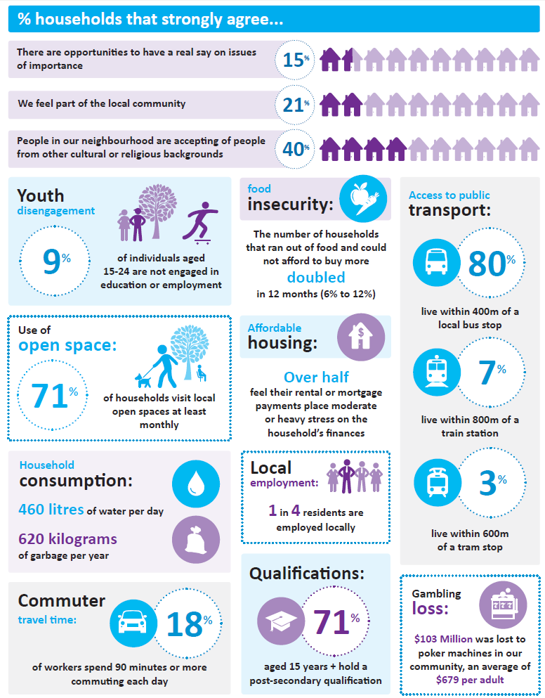
Selected findings

Inclusive and engaged community

Community connectedness
Community voice
Social inclusion
Local community planning

Participation in community groups

Why is this indicator important?
Involvement in groups and activities that help connect individuals to others within the community is an important component of wellbeing. Participation in community groups builds social capital – the linkages between individuals, families and groups within a community that fosters shared values, understanding and trust.

How is this measured?
Participation in community groups is measured every year through Council’s Annual Household Survey3. Individuals are asked to indicate if they participate in any community groups by selecting one or more from a list of suggested groups, as well as ‘Other’.

How are we tracking?

Trend: Regressing
In 2016, 43.6% of individuals in the City of Whittlesea participated in one or more community groups. This is a large and significant decrease from 55.2% in 2013, and the even higher result observed in 2014 (57.7%).

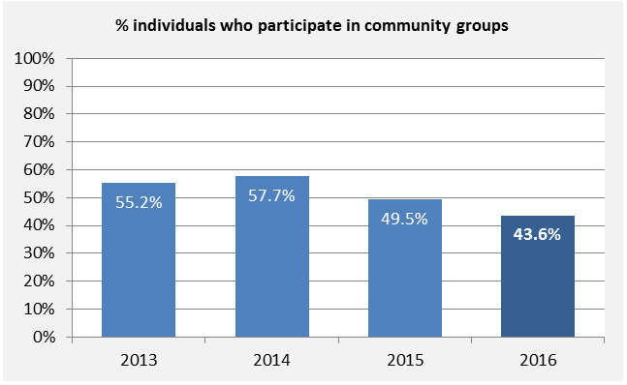

What role does Council play?
City of Whittlesea’s Better Together Community Building Strategy guides Council action to foster strong, resilient and connected communities, amplify local community voices, and enhance the capacity of communities and individuals to achieve their goals. Part of this approach includes support and grants provided to local community groups to deliver activities and events that bring the community together.

Sense of community

Why is this indicator important?
Feeling a sense of social connection is a key determinant of individual wellbeing. Increasing social connections and social cohesion directly contributes to a broad range of positive health, social and economic outcomes.

How is this measured?
Sense of community is measured every year through Council’s Annual Household Survey3. Households are asked to indicate their level of agreement on a scale from 0-10 with the statement: I/we feel part of the local community. Households that ‘strongly agree’ include those that rate their level of agreement as 8, 9 or 10.

How are we tracking?

Trend: Progressing
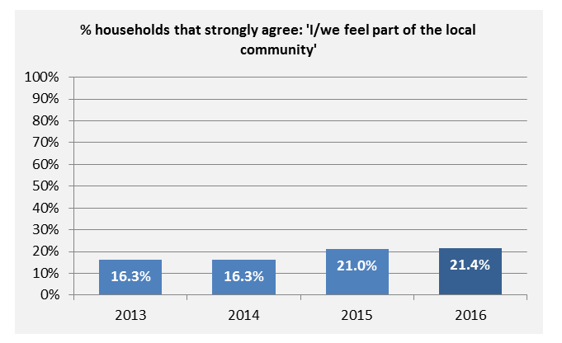
In 2016, 21.4% of households strongly agreed they felt part of the local community - a moderate and significant increase since 2013. While this result has improved over time, it tells us that there are still many community members who feel they do not belong. Other data from the VicHealth Indicators Survey suggest that the City of Whittlesea community generally has a poorer perception of their neighbourhood than the Victorian average.

What role does Council play?
Like many local governments, the City of Whittlesea adopts a community development approach to strengthen the sense of community and social cohesion across the municipality. Through Council’s Better Together Community Building Strategy, there is recognition of the role Council plays to foster opportunities for social connections through building local relationships, strengthening groups, delivering welcoming places, services, programs, events and participatory processes.

Volunteering

Why is this indicator important?
Volunteering provides benefits for individuals by encouraging community involvement, social contact and skill development. Volunteering gives people meaning and purpose in their lives and helps to strengthen social cohesion, build social networks, and foster community safety and trust.

How is this measured?
Volunteering rates are measured every year through Council’s Annual Household Survey3. Individuals aged 15 years and over are asked if they volunteer locally, non-locally or both. The question was asked slightly differently in 2013 and 2014, making comparison difficult.

How are we tracking?

Trend: No meaningful change
In 2016, 13.6% of individuals indicated they volunteer either locally or non-locally. This is marginally higher than the result in 2015, but not different enough to be considered meaningful.

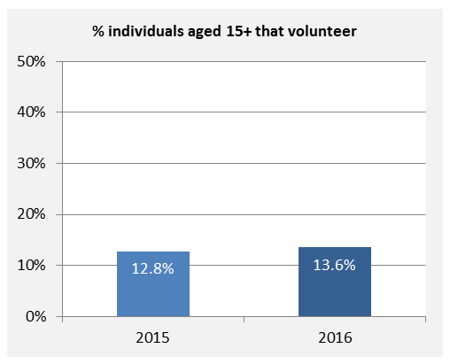

What role does Council play?
The City of Whittlesea recognises the important role Council can play to support and encourage volunteerism to enhance local service delivery and allow for wider community participation and expression of active citizenship. A number of the key services provided by Council rely on the support of local volunteers, including volunteers for the Delivered Meals Service and community-based activities and events.

Community acceptance of diverse cultures

Why is this indicator important?
Respect for, and celebration of, cultural diversity contributes to community harmony and cohesion. The experience of discrimination in all forms, including racism, contributes to poor mental and physical health and the ability to positively contribute to the community.

How is this measured?
Community acceptance of diverse cultures is measured every year through Council’s Annual Household Survey3. Households are asked to indicate their level of agreement on a scale from 0-10 with the statement: People in my neighbourhood are accepting of people from other cultural / religious backgrounds. Households that ‘strongly agree’ include those that rate their level of agreement as 8, 9 or 10. This question was not asked in 2013.

How are we tracking?

Trend: Progressing
In 2016, 39.6% of households strongly agreed that people in their neighbourhood are accepting of people from other cultural or religious backgrounds. This is a large and significant improvement from the result of 28.6% in 2014.

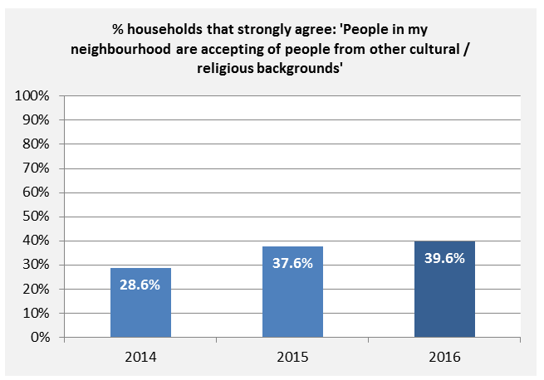

What role does Council play?
The City of Whittlesea’s Multicultural Action Plan 2013-2017, Anti-racism Strategy and Action Plan 2015-2019 and Asylum Seeker Policy demonstrate Council’s commitment to multiculturalism through inclusive practices, leadership, and facilitating relationships and networks across the community. Council also plays an important role advocating for the needs of our culturally diverse community to the Victorian and Australian Governments.

Participation in decision making

Why is this indicator important?
Participation in decision making is an essential component of local democracy. Providing opportunities to have a say on issues that affect the community promotes wellbeing and a sense of community connectedness.

How is this measured?
Participation in decision making is measured every year through Council’s Annual Household Survey3. Households are asked to indicate their level of agreement on a scale from 0-10 with the statement: There are opportunities to have a real say on issues that are important to us. Households that ‘strongly agree’ include those that rate their level of agreement as 8, 9 or 10.

How are we tracking?

Trend: Progressing
In 2016, 14.7% of households strongly agreed that there are opportunities to have a real say on issues of importance. This is a small improvement since 2013 (12.3%); however, results for the past three years have only fluctuated marginally.

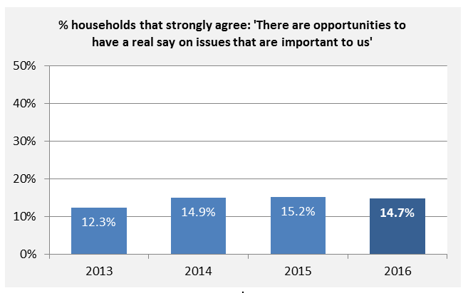

What role does Council play?
The City of Whittlesea adopts a community building approach to strengthen relationships, develop shared priorities and work together with the community to advance these priorities. This is demonstrated through Council’s Consultation and Engagement Framework that emphasises the importance of involving community in decision-making for strategic planning, advocacy, development of the Community Plan and budget, as well as general infrastructure, services and program delivery.

Accessibility in, out and around our city
Internet
Transport
Built environment

Broadband access

Why is this indicator important?
Fast internet connection is becoming essential to access information, education and services. Many individuals also have extensive social networks online and rely on the internet to regularly communicate with family and friends.

How is this measured?
Broadband access was measured in this way for the first time in the 2016 Annual Household Survey3. Households were asked to indicate which type of internet connection is used by the household. Broadband access was defined as including any households with National Broadband Network (NBN), ADSL1, ADSL2, Pay TV cable or ‘Other Broadband’.

How are we tracking?

Trend: Data not available
In 2016, 82.3% of households indicated they have broadband access. Comparable historical data is not available, however, this is would likely be an improvement from 2013 due to the recent availability of NBN in parts of South Morang, Mill Park, new estates in Mernda and the northern areas of Epping.

What role does Council play?
Council works with partners and stakeholders to address internet access and promote access to the NBN in our municipality through implementation of the Intelligent Community Strategy and the Regional Digital Economy Strategy.

Access to public transport

Why is this indicator important?
Public transport is essential for people to conduct their everyday lives, including access to shops, schools and services. It is essential to provide mobility of many groups in our community, including older and young people, those with disabilities and those who do not have access to motor vehicles. Public transport patronage also reduces car dependency and road traffic congestion, and results in health and environmental benefits.

How is this measured?
Access to public transport is measured by the proportion of all residential dwellings that are within: 600m of a tram; 400m of a Smart or local bus; or 800m of a train. Spatial analysis software was used to analyse City of Whittlesea’s transport networks. Distance is measured along the road network (ie. not a radial/ ‘as the crow flies’ distance). Each type of transport is independent of the other; a dwelling may be accessible to none, one or more transport type. One limitation of the method is that there is an assumption there is an accessible walkable footpath along the road network.

How are we tracking?

Trend: Data not available
In 2016, the majority of residential dwellings (80.1%) were within 400m of a local bus stop. Less than 8%, however, had access to a train station or Smart bus stop, and 2.7% had access to the 86 tram line that terminates in Bundoora. It is important to note that some dwellings may have access to multiple types of transport, whereas others would have no access, particularly those in the rural parts of the municipality.

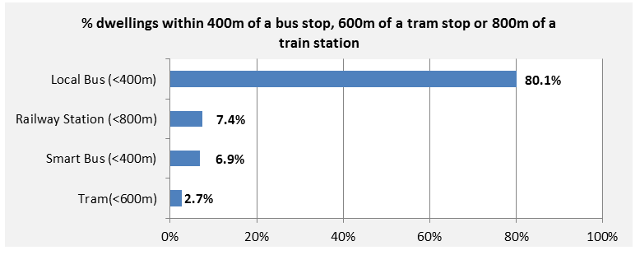

What role does Council play?
In partnership with our community and other local agencies, Council jointly advocates to the Victorian Government for more frequent and a broader catchment of public transport (for example, the ‘Access Denied’ and ‘Fund our Future’ campaigns). Council also makes improvements to the existing road network and works closely with key Victorian agencies to undertake further improvements of the transport network, especially within growth areas.

Commuter travel time

Why is this indicator important?
Long commute times are linked to stress and negative lifestyle and health outcomes. It also results in people having less time to spend with family and friends, or on health promoting and leisure activities.

How is this measured?
Commuter travel time has been measured in Council’s Annual Household Survey for the past two years3. Employed individuals are asked to indicate the usual combined total time it takes to travel to and from work each day. Respondents are categorised into groups based on total minutes taken; those spending 90 minutes or more are included in the results.

How are we tracking?

Trend: Regressing
In 2016, 17.7% of employed individuals spent 90 minutes or more commuting to and from work each day. This is a small increase from 15.0% of individuals in 2015. We know from the Annual Household Survey that ‘traffic management’ is the most commonly reported issue that residents say our community faces.

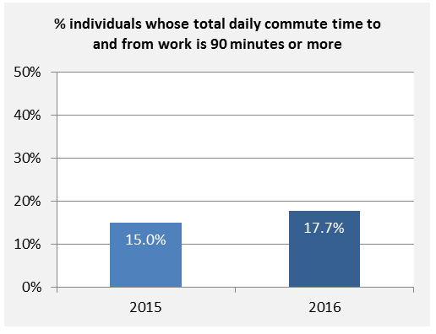

What role does Council play?
Council’s role in improving the transport network involves providing assistance to public transport providers; road maintenance; delivery of capital works programs for extra carriageways, extensions and duplications on priority Council-owned roads; and provision of Shared User paths. Council also plays a major role advocating to Victorian and Australian governments for the funding of major transport infrastructure improvements and local economic development.

Cycling facilities

Why is this indicator important?
Cycling is a practical and sustainable mode of transport for many members of the community and contributes to physical fitness. When there are good facilities for cycling, people feel safer and can use cycling as a form of transport or leisure more frequently and for different types of journeys.

How is this measured?
Residents’ perception of cycling facilities was measured for the first time through Council’s 2016 Annual Household Survey3. Households were asked to indicate their level of agreement on a scale from 0-10 with the statement: There are good facilities in Whittlesea for cycling (e.g. bicycle parking, off-road paths, on-road bicycle lanes). Households that ‘strongly agree’ include those that rated their level of agreement as 8, 9 or 10. Households that felt they could not answer questions about cycling had the option to respond with ‘can’t say’ and were excluded from analysis.

How are we tracking?

Trend: Data not available
In 2016, 27.3% of households strongly agreed that there are good facilities in the City of Whittlesea for cycling. It is important to note that approximately half of all households did not respond to the question, presumably indicating a lack of knowledge about the availability of cycling facilities. This also reflects the low proportion of respondents within the City of Whittlesea who report they currently participate in cycling.

What role does Council play?
The City of Whittlesea Bicycle Plan 2016-2020 sets out how we will advocate, facilitate and provide for more bicycle infrastructure and encourage more people to ride their bikes in our communities. It includes the design and provision of projects that create safer, more connected bike paths and lanes.

Walking facilities

Why is this indicator important?
Enabling walking through appropriate facilities is important for physical fitness, mental health and social connection, and is a sustainable mode of transport to get to local schools, shops, services, employment and public transport. Walking helps to activate public spaces and improve safety through natural surveillance.

How is this measured?
Perception of facilities for walking was measured for the first time through Council’s 2014 Annual Household Survey. Households were asked to indicate their level of agreement on a scale from 0-10 with the statement: There are good facilities in Whittlesea for walking (e.g. seating, toilets, water fountains, shelter from weather). Households that ‘strongly agree’ include those that rated their level of agreement as 8, 9 or 10. Households that felt they could not answer questions about walking had the option to respond with ‘can’t say’ and were excluded from analysis.

How are we tracking?

Trend: Data not available
In 2014, 18.3% of households strongly agreed that there are good facilities in Whittlesea for walking.

What role does Council play?
The City of Whittlesea Walking Strategy (with support via other strategies such as the Integrated Transport Strategy, Open Space Strategy, and Road Safety Strategy) leads the priorities of Council in improving walkability, through better facilities, footpath connectivity and accessibility.

Growing our economy
Employment
Economic development
Skill development

Income

Why is this indicator important?
Economic wellbeing is a crucial element of quality of life. Income affects the ability to access basic material goods and services, pay for health-related expenses, and provides opportunities for social participation and lifestyle choices.

How is this measured?
Income is measured through Council’s Annual Household Survey3. Individuals aged 15 years and over are asked to indicate their weekly total (gross pre-tax) income from all sources, including pensions and allowances. The median weekly personal income is calculated from income categories. Due to the method of data collection, it is not appropriate to compare these figures with other income data sources such as the ABS Census.

How are we tracking?

Trend: Unclear
In 2016, the median weekly personal income was $528. This has fluctuated over the past four years from a low of $495 in 2014 to a high of $581 in 2015. It is important to keep in mind that income distribution is not equal across the municipality and changes in income over time may reflect changes in the demographics of residents.

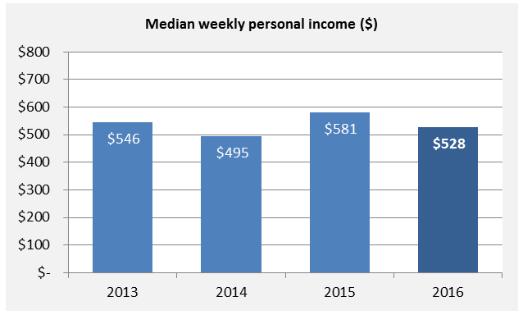

What role does Council play?
Council actively works with policy makers, the business sector and communities to advocate for increased standards of living and economic health (including income) of local residents. This includes working with partners to provide opportunities for groups who experience social and health inequities, which impacts on personal income levels.

Unemployment

Why is this indicator important?
High employment rates are important for economic growth and prosperity at a local and national level. Reasonable working conditions, stable employment and income give individuals a sense of purpose and personal satisfaction, and are associated with better health and wellbeing outcomes.

How is this measured?
Unemployment is measured through the Small Area Labour Markets data, produced quarterly by the Australian Government Department of Employment. It measures the proportion of the labour force (people who are aged 15 years and over, with some exceptions) who are currently not working.

How are we tracking?

Trend: Progressing
In the June quarter 2016, 6.1% of the labour force in the City of Whittlesea was unemployed. This figure has fluctuated over the past four years, but 2016 is the lowest unemployment rate we have observed in this time period.

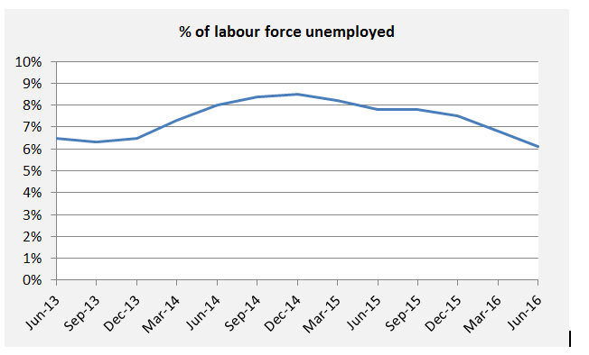

What role does Council play?
Council aims to reduce unemployment rates by encouraging new business investment in the municipality and providing support to local businesses. Additionally, Council provides and facilitates training and employment pathways for those who experience social and health inequalities.

Underemployment

Why is this indicator important?
Underemployment is a barrier for economic growth and a marker of underutilised time and skills in the labour force. For individuals, underemployment is associated with reduced earning capacity and lower personal agency, choice and satisfaction.

How is this measured?
Underemployment is measured through Council’s Annual Household Survey3. Individuals aged 15 years and over who are currently employed are asked if they are satisfied with their current employment situation. Respondents who provide one or more of the following responses are categorised as ‘underemployed’: No - too few hours; No - skills and experience doesn't match job role; or No - lack of local jobs.

How are we tracking?

Trend: No meaningful change
In 2016, 12.4% of people indicated they were underemployed. This is a marginal increase from 2015 (11.6%); however, the change is not large enough to be considered meaningful.

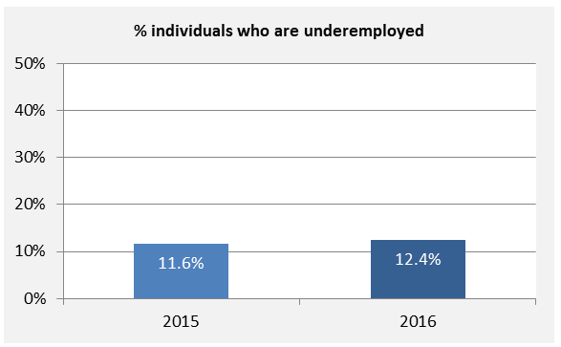

What role does Council play?
Council aims to reduce underemployment by encouraging new and diverse employment opportunities through investment attraction of new business and supporting the growth of existing businesses. Council also provides and facilitates training and employment pathways to support diversity in industry.

Highly skilled workforce

Why is this indicator important?
A highly skilled workforce is linked to a dynamic and sustainable economy with more employment opportunities. Highly skilled individuals help build the capacity of others in the workforce and may be more agile and adaptable to changing industry trends.

How is this measured?
‘Highly skilled workforce’ is measured annually through Council’s Annual Household Survey by asking individuals to describe their usual occupation3. This information is then grouped into one of nine categories. Four of these occupation categories are further grouped into two ‘highly skilled’ categories: manager or professional; and technician or trade worker.

How are we tracking?

Trend: Progressing
In 2016, 39.4% of individuals had a highly skilled occupation type, including 21.8% as a manager or professional and 17.6% as a technician or trade worker. This is a small but significant increase from 2013 when 34.5% of individuals had a highly skilled occupation type. Over the past three years, however, there has been an increasing trend towards more technicians and trade workers and a contrasting trend towards fewer managers and professionals.
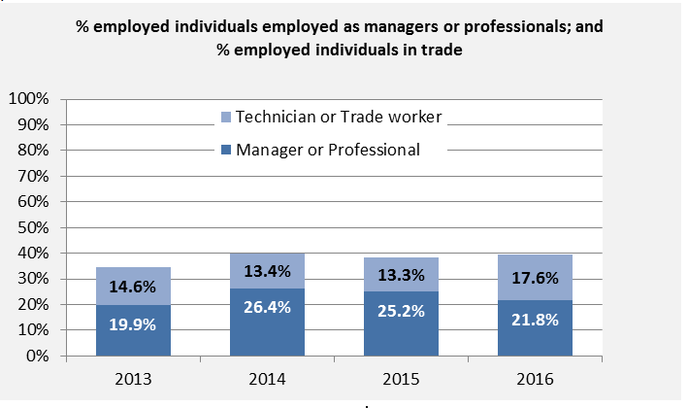

What role does Council play?
The City of Whittlesea develops strong partnerships with businesses and industry bodies to advocate for the importance of a diverse range of local education and training opportunities for residents who possess skills in a range of employment areas. Examples include the economic development partnerships Council has in place and economic development training and events managed by Council.

Local employment

Why is this indicator important?
Local employment contributes to a range of social, economic and environmental benefits. Living and working in the same local area may improve work-life balance, reduce commute time and enable people to walk or ride to work.

How is this measured?
Local employment is measured by the proportion of employed individuals living in the City of Whittlesea who are employed within the boundaries of the local government area. This is measured every five years through the ABS Census and reported via economy.id.

How are we tracking?

Trend: Data not available
In 2011, 25.7% of City of Whittlesea’s employed residents were employed locally. More recent data from the 2016 ABS Census is not available at the time of this publication.

What role does Council play?
Through Council’s Recruitment Strategy, the City of Whittlesea plays a role in directly employing a number of local residents within the organisation. Council also plays an active role in facilitating relationships between local education providers and local employers to strengthen the match between skills and employment opportunities for local residents.

Local jobs

Why is this indicator important?
Having adequate local jobs is an indicator of a strong local economy. The availability of local jobs helps to support the local economy and community as workers who live locally are more likely to buy/access local goods and services.

How is this measured?
The ‘Local jobs’ indicator is measured by the percentage change in employed persons (aged 15+) over time. ABS Census employment data reported via economy.id10 presents the total number of individuals employed across all industry sectors full-time and part-time in the City of Whittlesea boundaries, regardless of where those employed individuals live.

How are we tracking?

Trend: Progressing
Between 2006 and 2011 there was a 22.1% increase in the number of people employed across all sectors within the City of Whittlesea. This is an increase of 7,118 jobs, but should be considered in the context of our growing population. More recent data from the 2016 ABS Census is not available at the time of this publication.

What role does Council play?
The City of Whittlesea undertakes many economic development activities to position the municipality for growth and development in local jobs. Examples include marketing and promoting local investment opportunities for the government and investment sector, supporting local business associations and sponsoring a range of employment programs/initiatives (for example the Plenty Food Group and Jobs in the North employment service).

Qualifications

Why is this indicator important?
Education is the key to creating a dynamic, successful community and improving life choices and opportunities. People who engage in lifelong learning are more likely to have better employment opportunities, higher earning capacity and better health outcomes.

How is this measured?
Qualifications are measured annually through Council’s Annual Household Survey3. Individuals aged 15 years and over are asked about the highest qualification they have attained since leaving secondary school. Individuals with qualifications include those who have a Trade certificate, ‘Other’ certificate, Diploma/Advanced Diploma, Bachelor Degree, Higher qualifications or ‘Other’ qualification.

How are we tracking?

Trend: No meaningful change
In 2016, 71.1% of individuals aged 15 years and over held a post-secondary qualification. There has been a very marginal variation in this result over the past four years but not different enough to be considered meaningful. Over the past three years, however, we do observe a trend towards an increase in the proportion of people with a Certificate or Diploma qualification and a decrease in the proportion of people with a Bachelor or Higher degree qualification across the municipality.

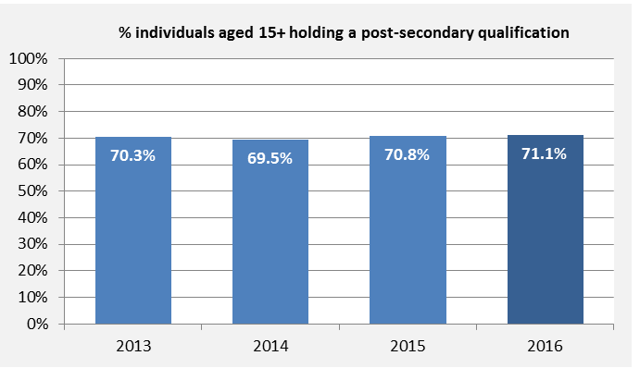

What role does Council play?
Council plays advocacy and facilitation roles to increase opportunities for lifelong learning to the community in partnership with government, community-based, non-profit education and training providers, agencies and networks. Council also provides some professional development and training opportunities for individuals.

Youth disengagement

Why is this indicator important?
Engagement in employment, education and training is a protective factor for young people. High youth disengagement may indicate the need for early detection and intervention services, or a lack of access to employment, education or training opportunities.

How is this measured?
Youth disengagement is measured every five years through the ABS Census and reported via atlas.id2. It includes the percentage of individuals aged 15-24 not engaged in education or employment. The measure is derived from an individual’s responses to two questions in the ABS Census: ‘Last week did the person have a full time or part time job of any kind?’ and ‘What type of educational institution is the person attending?’

How are we tracking?

Trend: Data not available
In 2011, 9.2% of individuals aged 15-24 were not engaged in education or employment. The City of Whittlesea has a higher rate of youth disengagement compared to the Victorian average of 8.1%. More recent data from the 2016 ABS Census is not available at the time of this publication.

What role does Council play?
Council’s Connect: A municipal plan for children, young people and their families 2013 to 2018 and YouthPlan2030 guide Council to engage and support young people with a focus on prevention, early intervention, capacity building and responding to vulnerabilities through a variety of targeted programs. Council facilitates partnerships, such as the Whittlesea Youth Commitment (WYC), to improve policy, services and infrastructure that enable positive outcomes for young people.

Places and spaces to connect people
Open space
Community hubs
Leisure and recreation
Planning our space

Use of open space

Why is this indicator important?
Open spaces provide opportunities for people of all ages and abilities to improve their physical and mental health through recreation, exercise, and socialising, as well as having environmental benefits.

How is this measured?
Use of open space was measured in 2015 through Council’s Annual Household Survey. Households were asked to indicate how frequently they typically visit local open spaces. Types of open space were listed as: walking/cycling paths, playgrounds, sporting reserves, picnic facilities, dog off lead areas, informal open grassed areas and skate facilities. Households were included in the results if they answered 'Weekly', 'Fortnightly' or 'Monthly' to one or more types of open space. A question about use of open space was asked in 2013, but this was framed differently and is therefore not comparable.

How are we tracking?

Trend: Data not available
In 2015, 71.2% of households visited one or more types of local open spaces at least monthly. However, earlier data from the 2011 VicHealth Indicators Survey showed that weekly use of open space was significantly lower in the City of Whittlesea (31.4%) compared with the Victorian average (50.7%).

What role does Council play?
Council aims to increase use of public open spaces by making them safer, more inclusive, and welcoming to encourage community gathering and connection. The approach is guided by the Open Space Strategy and includes the implementation of safety guidelines, identification and design of new sites for open space development, and the upgrading and maintenance of existing public open spaces.

Community meeting spaces

Why is this indicator important?
Community meeting spaces provide accessible, inclusive and affordable spaces for all the community to come together and can be used for community groups to meet or host events and celebrations.

How is this measured?
Community meeting spaces are measured as the proportion of residential dwellings that are within 800m of a Council-owned or managed facility where there are formal spaces for the public to meet. Spatial analysis software was used to analyse City of Whittlesea’s infrastructure7. Distance is measured along the road network (i.e. not a radial/ ‘as the crow flies’ distance). One limitation of the method is that there is an assumption there is an accessible, walkable footpath along the road network.

How are we tracking?

Trend: Data not available
In 2016, 31.7% of residential dwellings were located within 800m of a community meeting space. This is the first time that spatial analysis was used to determine access to meeting spaces so there is no historical comparison available.

What role does Council play?
Community meeting spaces are available for hire at a number of Council-managed buildings, including Community Activity Centres. These spaces allow individual residents or groups to gather formally or informally for events, to meet new people, or to access local services or programs.

Recreation facilities

Why is this indicator important?
Recreation facilities provide accessible, inclusive and affordable opportunities for people of all ages and backgrounds to make social connections, access services, exercise, learn and play.

How is this measured?
Recreation facilities are measured every year through Council’s Annual Household Survey3. Households are asked to rate the importance to the community (on a scale from 0-10) of a range of Council services and facilities, including libraries and sports facilities. Households that feel these facilities are ‘very important’ include those that rate their level of agreement as 8, 9 or 10.

How are we tracking?

Trend: Progressing
In 2016, 67.4% of households rated sports facilities and 65.0% rated libraries as very important to the community. For sports facilities, this is a large, significant increase, and for libraries it is a moderate increase compared to 2013. This is a desirable change from the previous two years, when there was a slight decline towards decreasing importance.
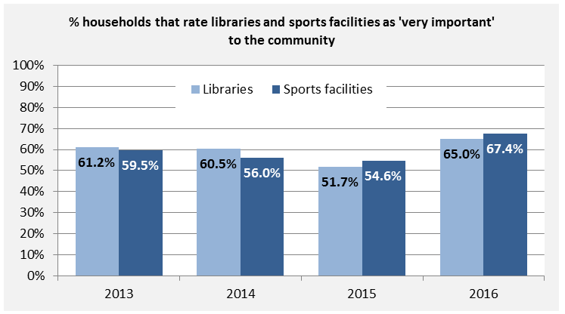

What role does Council play?
Council plans for and designs new facilities in consultation with the community and looks for innovative ways to deliver recreation services for more equitable access. Council owns several recreation facilities in the City of Whittlesea and strives to ensure they are managed and maintained in a way that meets the interests and needs of the community as outlined in the Recreation Strategy 2012-17.

Participation in sports and recreation

Why is this indicator important?
Accessible and inclusive sports and recreation activities provide opportunities for people of all ages and abilities to exercise and socialise with others, while making use of local facilities and services.

How is this measured?
Participation in sports and recreation is measured most years through Council’s Annual Household Survey11. Individuals are asked to indicate if they participate in any sports or recreation activities by selecting one or more from a list of suggested activities as well as ‘Other’. Results include individuals who selected one or more from the list, with the exception of walking (because most people do this incidentally) and gardening (because this is usually done in the home environment).

How are we tracking?

Trend: Progressing
In 2015, just under half (49.8%) of individuals participated in one or more sports and recreation activities. This is a small increase from 2013 when 47.5% of individuals participated.

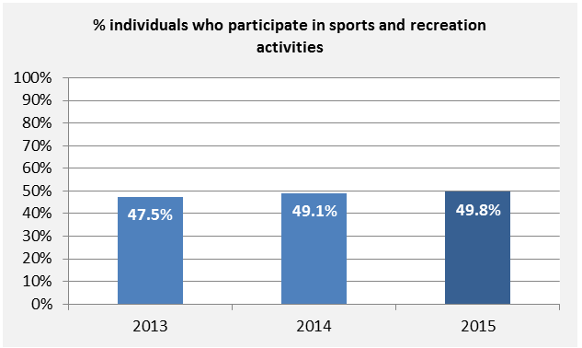

What role does Council play?
Council’s Recreation Strategy 2012-17 guides the approach taken to ensure that local sports and leisure facilities, services and clubs meet the interests and needs of our community. Council encourages the community to participate in sports and recreation activities by providing welcoming, accessible facilities and open spaces for organised and informal activities, and by providing support and grants to sports clubs to increase and diversify their membership.

Distinct community character

Why is this indicator important?
The perceived character of the local area or neighbourhood affects people's sense of belonging and connection to place. The built and natural environments and social infrastructure are important contributors to neighbourhood character.

How is this measured?
Distinct community character is measured every year through Council’s Annual Household Survey3. Households are asked to indicate their level of agreement on a scale from 0-10 with the statement: The community has a distinct character, it's a special place. Households that ‘strongly agree’ include those that rate their level of agreement as 8, 9 or 10.

How are we tracking?

Trend: Progressing
In 2016, 26.4% of households strongly agreed that the community has a distinct character. This result has been trending upwards over the past four years and is a moderate change from 22.9% in 2013. This improvement is encouraging given the enormous population growth and change that we observe every year in the community.

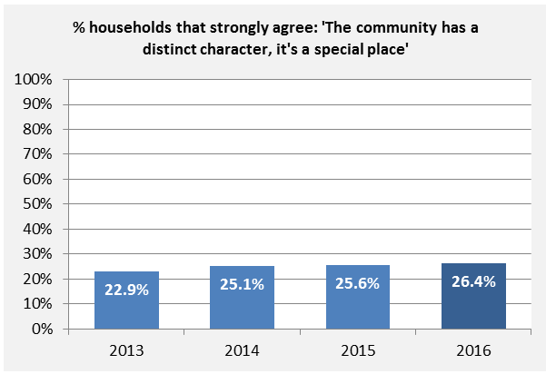

What role does Council play?
The City of Whittlesea recognises the specific characteristics that contribute to and define the municipality as a unique housing and employment location within the northern region. Key guiding documents such as the Whittlesea Planning Scheme, Housing Diversity Strategy and our Community Plan, provide direction in preferred land use planning and built form outcomes. This allows Council to articulate its role in providing, facilitating and advocating for the provision of physical and social infrastructure.

Health and wellbeing
Healthy community
Safety
Education and lifelong learning

General health

Why is this indicator important?
Self-reported health status has been shown to be a reliable predictor of health, future healthcare use and premature mortality. It is an important element of the overall concept of a person’s sense of wellbeing.

How is this measured?
General health is measured every year through Council’s Annual Household Survey3. Individuals are asked to describe their general health on a scale from ‘poor’ to ‘excellent’. The results were reported separately for adults (18 years and over) and children (up to 17 years of age).

How are we tracking?

Trend: Regressing
In 2016, 45.0% of adults rated their general health as very good or excellent. This is a large, significant decline from the 2013 result of 59.9%, although the data tends to fluctuate substantially from year to year. In 2016, the general health of three-quarters of all children (75.8%) was rated as very good or excellent. This is a large, significant decline from 83.0% reported in 2013; although, similar to adults, the result has fluctuated over the past four years.
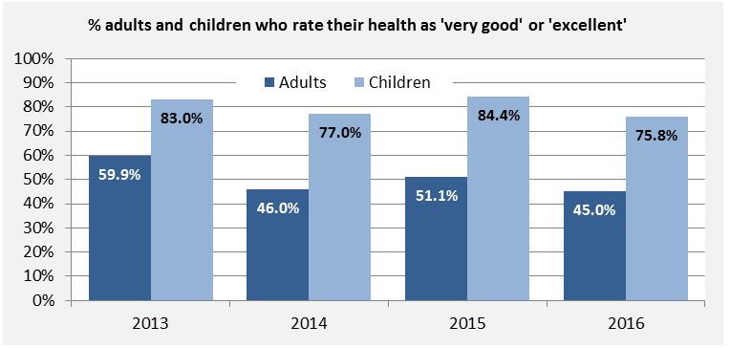

What role does Council play?
The City of Whittlesea’s Municipal Public Health and Wellbeing Plan (incorporated into the Council Plan 2013-2017) articulates Council’s commitment to improving the health and wellbeing of all who live and work in the municipality. Council adopts a ‘social determinants of health’ approach, which recognises that upstream social, physical, economic, and environmental factors such as education, employment, working conditions, income and housing are critical to health. Council plays a role as a provider of some health services (e.g. immunisation) and as a facilitator and advocate regarding health services and policy.

Psychological distress

Why is this indicator important?
Good mental health is fundamental to the wellbeing of an individual. A high level of psychological distress can have a major effect on an individual’s functioning and can impact the family and community more broadly. It is also an important risk factor for a number of health conditions and is sometimes associated with harmful behaviours.

How is this measured?
Psychological distress is measured through the Department of Health and Human Services’ Victorian Population Health Survey. This data is available at the local government level approximately every three years. The survey uses the Kessler 10 Psychological Distress Scale, which is a well-known series of questions that is used to measure the level of psychological distress of an individual. Results are adjusted to account for population age differences between local government areas and include adults only.

How are we tracking?

Trend: Data not available
In 2014, 13.0% of individuals were classified as having a high or very high level of psychological distress. More recent data is not yet available at the local government level; however, comparison shows that the rate of high and very high psychological distress in the City of Whittlesea is comparable with the state average for Victoria (12.6%).

What role does Council play?
Council works with a number of partners and stakeholders to advocate for mental health services that are accessible to our community. Council’s key advocacy priorities include a focus on strategic planning for investment in health and human services for the region, with a specific focus on mental health and wellbeing services for young people.

Risk factors

Why is this indicator important?
Common modifiable lifestyle factors such as being overweight, poor diet, lack of physical activity, smoking and high alcohol consumption, increase the risk of developing a range of common chronic diseases that can lead to disability and premature death. Social disadvantage can contribute to increased exposure to risk factors for chronic disease and barriers to healthy lifestyle choices.

How is this measured?
The ‘Risk factors’ indicator includes five different measures:
- overweight and obesity;
- healthy eating;
- alcohol intake;
- smoking; and
- physical activity.
The first four measures are collected through the Department of Health and Human Services’ Victorian Population Health Survey approximately every three years at the local government level, with the most recent data available from 201412. Results are adjusted to account for population age differences between local government areas and include adults only. The last measure - physical activity - is also collected through this survey, but a measure from the Annual Household Survey3 is used instead, as it is more frequently collected and has a larger sample size. All data are self-reported by the individuals completing the surveys.

- Overweight and obesity: Individuals are asked for their height and weight, which is calculated into a Body Mass Index (BMI) (weight in kilograms divided by height in metres squared). This is then classified according to the World Health Organisation classification where overweight is a BMI 25.0-29.9 and obesity is a BMI of 30 or greater.
- Healthy eating: Individuals are asked how many serves of vegetables and fruit they usually eat each day. This is then used to determine whether they are meeting National Health and Medical Research Council (NHMRC) intake guidelines for their age and sex.
- Alcohol intake: Individuals are asked about their usual alcohol intake in standard drinks. This is used to determine their increased risk of alcohol-related harm on a single occasion, yearly, monthly or weekly. Risk of alcohol-related injury is classified as drinking more than four standard drinks on a single occasion.
- Smoking: Individuals are asked about their usual smoking behaviour, including whether they smoke daily or occasionally.
- Physical activity: Individuals are asked how long they spent doing moderate to vigorous physical activity last week. Moderate to vigorous activity is defined as exercise that causes your heart to beat faster or shortness of breath. Results include both adults and children. Data is not available for 2013 because the categories were presented slightly differently and are therefore not comparable.

How are we tracking?

Trend: Data not available
In 2014, 31.6% of individuals in the City of Whittlesea were overweight and 24.1% were obese. 47.4% met the NHMRC daily fruit consumption guidelines, while only 4.5% met the guidelines for daily vegetable consumption. 30.5% indicated they drank alcohol to an extent that put them at risk of alcohol-related harm at least once yearly, and 15.1% of individuals smoked cigarettes daily or occasionally.

Trend: Progressing
In 2016, 44.4% of individuals in the City of Whittlesea undertook 2.5 hours or more of moderate-vigorous physical activity every week. This result has improved over the past three years from 40.5% of individuals in 2014 – a small but significant change.

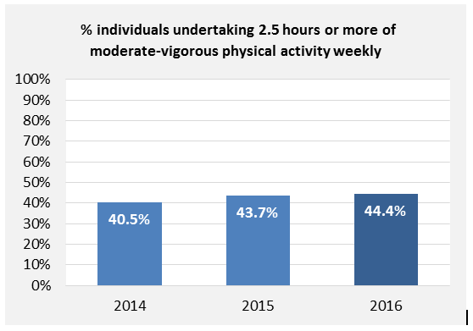

What role does Council play?
The City of Whittlesea’s Municipal Public Health and Wellbeing Plan (incorporated into the Council Plan 2013-2017) articulates the ‘social determinants of health’ approach taken by Council, which recognises that upstream social, physical, economic, and environmental factors such as education, employment, working conditions, income, and housing are integral to improvements in health outcomes. Council supports positive changes in lifestyle risk factors through the physical environment (including parks, walking and cycling paths) and service delivery (such as leisure and recreation centres and healthy lifestyle programs). Council also advocates for policy, services and environments that support communities to make healthier choices.

Food insecurity

Why is this indicator important?
Food insecurity decreases the ability to consume a nutritious diet, increases stress and affects social interactions. Poor diet, in particular the consumption of cheap, energy-dense but low nutrient foods (junk foods), is a major risk factor for many chronic diseases.

How is this measured?
Food insecurity is measured through Council’s Annual Household Survey3. Households are asked to indicate the number of times in the past 12 months that members of the household ran out of food and could not afford to buy more.

How are we tracking?

Trend: Regressing
In 2016, 12.1% of households had run out of food and could not afford to buy more at least once in the past 12 months. This is almost a doubling of households from 2015, and a small but significant increase from 2014 when 8.9% of households were affected by food insecurity.

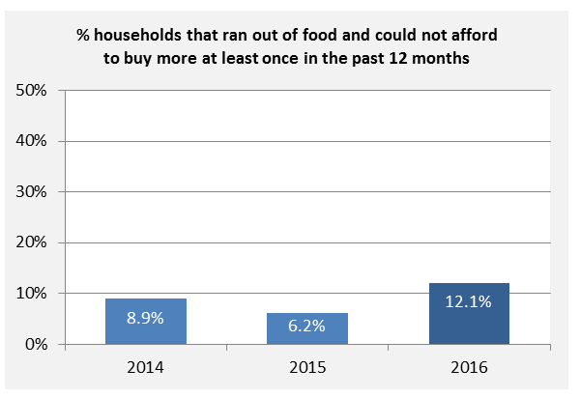

What role does Council play?
Council plays an important role advocating for the needs of our community to have affordable access to food for vulnerable households. Actions to address food insecurity are key goals in the Municipal Public Health and Wellbeing Plan (2013-2017). For example, Council is involved in several local collaborative food security initiatives. Additionally, the Whittlesea Planning Scheme and the Green Wedge Management Plan aim to protect non-urban land to encourage agricultural land use and local food production.

Gambling loss

Why is this indicator important?
Gambling has many negative social and economic outcomes, and contributes to financial problems, family and relationship breakdown, mental and emotional ill-health and social isolation. Poker machines are of particular concern due to their dominant role in the gambling industry and contribution to gambling harms.

How is this measured?
Gambling loss is measured by the average annual expenditure (loss) per adult on Electronic Gaming Machines (poker machines or ‘pokies’) in the City of Whittlesea. The data is collected from gaming venues in the municipality and regularly reported by the Victorian Commission for Gambling and Liquor Regulation (VCGLR). Although not all adults use poker machines, reporting the average per adult enables us to make comparisons over time and with other geographical areas.

How are we tracking?

Trend: No meaningful change
In 2015-16, for every adult in the City of Whittlesea, $679 was lost to poker machines. This is a slight decline from previous years; however the magnitude of change relative to the size of the problem is not considered meaningful (1.9% decline from 2013). The average loss per adult is much higher in the City of Whittlesea than the Victorian average ($553). It is also important to note that many individuals do not use poker machines, so the actual loss per player is significantly greater.
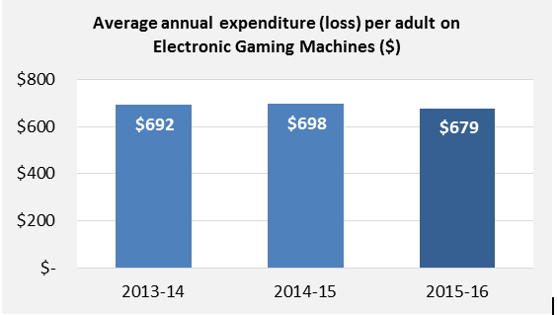

What role does Council play?
The City of Whittlesea Gambling Strategy and Action Plan 2014-2024 takes a public health approach to gambling related harm. This recognises the importance of prevention, community awareness, education, partnerships, policy and research development to achieve positive outcomes. Council also advocates for best practice gambling regulation and policy changes, and considers applications for gaming licences and planning permits for local gaming venues.

Affordable housing

Why is this indicator important?
Every person has a right to secure, affordable and appropriate housing to enable their health and wellbeing, participation and sense of belonging in community life. Housing that is affordable reduces the strain and financial stress placed on individuals and families, providing them with more opportunities and choice.

How is this measured?
Affordable housing is measured through Council’s Annual Household Survey3. Households are asked to indicate the extent to which their rental or mortgage payments placed stress on the household's finances in the last twelve months, with response options including ‘no’, ‘low’, ‘moderate’ or ‘heavy’ stress.

How are we tracking?

Trend: Regressing
In 2016, 53.8% of households reported that their rental or mortgage payments placed moderate or heavy financial stress on the household’s finances. This is a moderate increase from the previous year’s result of 48.9%.
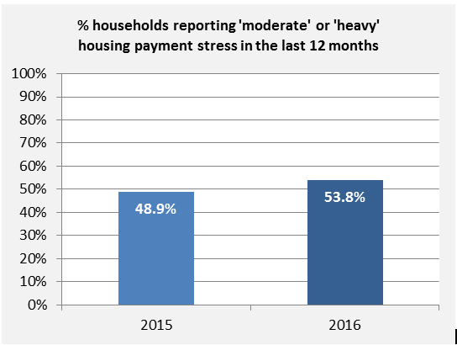

What role does Council play?
The Whittlesea Planning Scheme and Social and Affordable Housing Policy and Strategy guide Council’s approach in planning and supporting diverse housing types to accommodate the varied needs of our growing population. This includes consideration of social and affordable housing in land use planning, social and economic planning and the assessment of planning applications. Council also advocates for more social housing, housing for people with a disability and crisis accommodation, as well as policy changes that affect the high cost of housing in Australia.

Access to health services

Why is this indicator important?
Easy access to health services is fundamental for the prevention, early detection and treatment of health conditions. Access to health services can be affected by many factors including physical, financial and systemic factors (such as geographic location, restrictive funding models, eligibility criteria and waiting lists).

How is this measured?
Perceived ease of access to health services is measured through Council’s Annual Household Survey3. Households are asked to rate how easy they believe it is to access the following services within the City of Whittlesea, on a scale of 0 (very difficult) to 10 (very easy): doctors, dentists, hospitals and mental health services. Households that felt it is ‘very easy’ to access the service type include those that select a score of 8, 9 or 10. Households that felt they could not rate ease of access had the option to respond with ‘can’t say’ and were excluded from analysis. This question was asked for the first time in 2016, so there is currently no historical data available to monitor trends over time.

How are we tracking?

Trend: Data not available
In 2016, over two-thirds (67.2%) of households felt that it was ‘very easy’ to access doctors, and 56.2% and 46.6% for dentists and hospitals, respectively. Mental health services were perceived to be the most difficult to access, with less than one-quarter (24.5%) of households rating this as ‘very easy’.
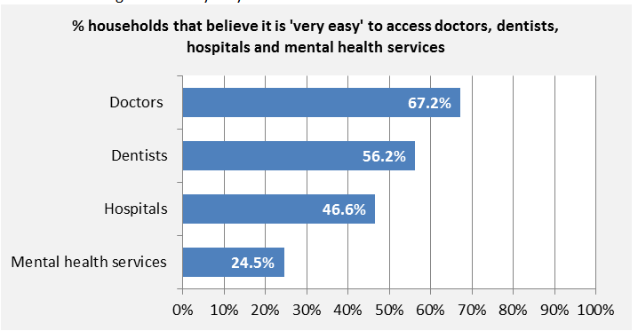

What role does Council play?
Council does not directly deliver any of these health services but can partner with the community and local service providers to advocate to the Victorian Government for better local health service provision.

Access to human services

Why is this indicator important?
Easy access to human services is important to support individuals and families through challenging or transitional life situations. Access to human services can be affected by many factors including physical, financial and systemic factors (such as geographic location, restrictive funding models, eligibility criteria and waiting lists).

How is this measured?
Perceived ease of access to human services is measured through Council’s Annual Household Survey3. Households are asked to rate how easy they believe it is to access the following services within the City of Whittlesea, on a scale of 0 (very difficult) to 10 (very easy): aged care, financial and legal support, and respite services. Households that felt it is ‘very easy’ to access the service type include those that select a score of 8, 9 or 10. Households that felt they could not rate ease of access had the option to respond with ‘can’t say’ and were excluded from analysis. This question was asked for the first time in 2016, so there is currently no historical data available to monitor trends over time.

How are we tracking?

Trend: Data not available
In 2016, 36.2% of households felt it was ‘very easy’ to access aged care services. Access to respite services and financial and legal support services was perceived to be more difficult, with only a quarter of households rating this as ‘very easy’.

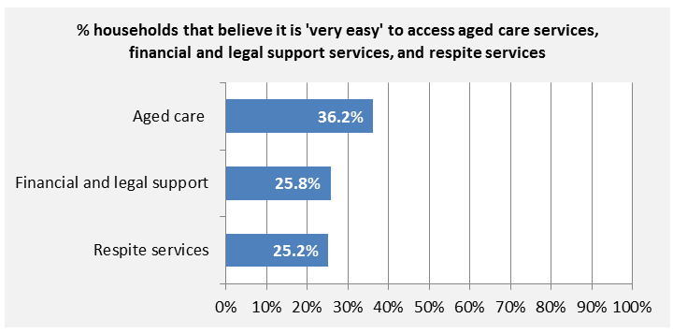

What role does Council play?
Council delivers some human services via the Commonwealth Home Support program including respite. Council also partners with the community and local service providers to advocate to the Victorian Government for better local human service provision. Council can also partner with local agencies to help facilitate these services. For example, the Epping Community Services Hub brings together multiple agencies into one Council-owned building.

Family violence

Why is this indicator important?
People who are affected by family violence are more likely to become homeless, experience mental health concerns, be injured, hospitalised or in some cases killed. Family violence is a common factor in child protection notifications and has a major impact on the family unit, as well as the broader community.

How is this measured?
Family violence incidence is measured through data collected by Victoria Police on the number of family incidents recorded. The number of incidents is reported via the Crime Statistics Agency as a rate (with reference to the population size), to enable comparison over time and with other geographical areas.

How are we tracking?

Trend: Regressing
Over the past four years, the number of family incidents per 100,000 population has increased annually from 1,127 in 2013 to 1,452 in 2016 – a 29% increase. This is higher than the Victorian average of 1,264 incidents per 100,000 population in 2016.

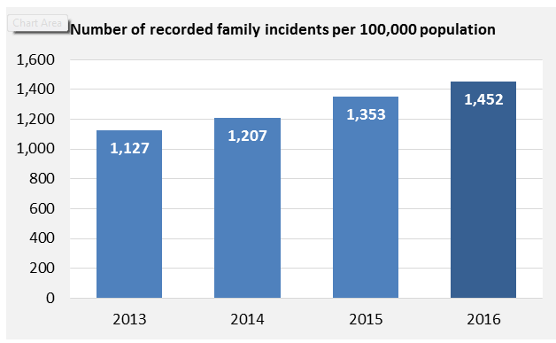

What role does Council play?
Council is committed to preventing family violence through our Safe in our homes, Safe in our communities Family Violence Strategy 2014-2018, Gender Equity Strategy 2014 and Municipal Public Health and Wellbeing Plan 2013-2017. The prevention of family violence and the provision of support services is a key advocacy issue for Council. Council provides a range of community services, safe public spaces and community facilities, which can be used as platforms to influence positive change.

Safety in public areas

Why is this indicator important?
When individuals feel safe they are more likely to experience greater levels of social connection and trust, and are more likely to engage in community life. Feeling safe in public areas also promotes the use of local facilities and community spaces such as public transport and parks.

How is this measured?
Perception of safety in public areas is measured through Council’s Annual Household Survey3. Households are asked to rate how safe they feel in the public areas of the City of Whittlesea during the day and at night, on a scale from ‘very safe’ to ‘very unsafe’.

How are we tracking?

Trend: Progressing
In 2016, 68.5% of individuals felt somewhat or very safe in the City of Whittlesea during the day. This is a marginal decline from 2015 (69.6%) – a difference that is not considered meaningful. Perceptions of safety at night are much poorer, with one-third (33.4%) of individuals feeling somewhat or very safe. This is still, however, a small improvement from 2015 (30.9%).
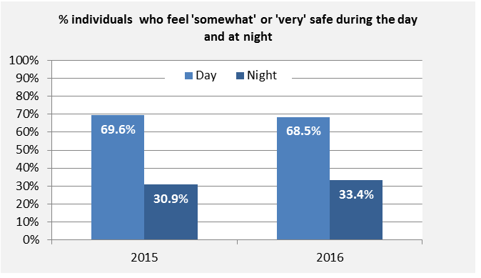

What role does Council play?
The City of Whittlesea is committed to working in partnership to improve community perceptions of safety and support crime prevention activities locally to strengthen community and social connectedness. Council’s Community Safety and Crime Prevention Policy 2016 and Strategy 2016-2020 identifies the crime prevention and advocacy actions Council has committed to addressing in partnership with local police and agencies. This work is guided by the local Community Safety and Crime Prevention Committee which is co-chaired by City of Whittlesea and Victoria Police.

Developmental vulnerability

Why is this indicator important?
Children’s physical, emotional and social health in the early years has long lasting effects on their health, social and emotional wellbeing and life achievements.

How is this measured?
Developmental vulnerability is measured through the Australian Early Development Census (AEDC), an initiative of the Australian Government Department of Education and Training. In their first year of school, all children are assessed against five developmental domains: Physical health and wellbeing; Social competence; Emotional maturity; Language and cognitive skills (school-based); Communication skills and general knowledge. This indicator includes the proportion of children assessed as 'developmentally vulnerable' on two or more of the five AEDC domains. The AEDC is conducted every three years.

How are we tracking?

Trend: Progressing
In 2015, 9.7% of students in the first year of school were assessed as being developmentally vulnerable on two or more domains. This is considered by the Australian Government to be a significant decrease from the 2012 result of 11.0%. Compared with the Victorian (9.9%) and national (11.1%) averages, children in the City of Whittlesea score better for this indicator.
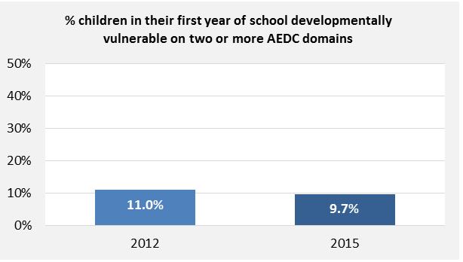

What role does Council play?
The City of Whittlesea provides a number of early childhood services including Maternal and Child Health (MCH), Enhanced MCH, MCH Outreach, immunisation services, First Time Parent groups, Playgroups, and Family Long Day Care. Council facilitates a range of partnerships and professional development that supports those providing services for children and their families. Council also plans, delivers and advocates for social and physical infrastructure and services to meet the developmental needs of children.

Connectedness to school

Why is this indicator important?
School is critical for the development of young people’s educational, social and emotional skills. Students who feel connected to school are more likely to attend, which supports longer-term life achievements.

How is this measured?
Connectedness to school is measured annually through the state-wide Attitudes to School Survey and reported through the Victorian Child and Adolescent Monitoring System. Students in Years 5 to 9 are asked to respond to a series of statements, and results are combined to determine overall connectedness to school:
- I feel good about being a student at this school
- I like school this year
- I am happy to be at this school
- I feel I belong at this school
- I look forward to going to school

How are we tracking?

Trend: Unclear
In 2015, 84.4% of Years 5 and 6 students, and 62.5% of Year 7 to 9 students reported feeling connected to school. For Years 5 and 6 students, this is a small decline since 2013. In contrast however, for Years 7 to 9 students, the result is a small improvement from 2013. The differences in results between the two middle years age groups highlight the importance of this transitional time for young people.
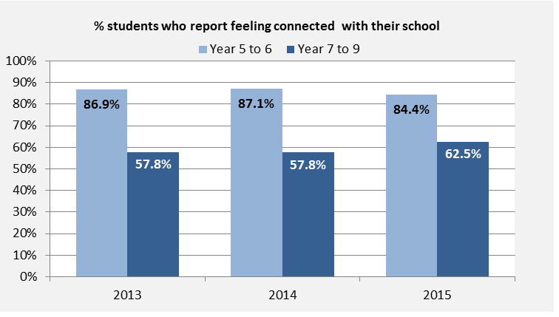

What role does Council play?
Council works to identify disengagement early and facilitate connections between young people, their families and local schools to engage young people in education. Council’s Baseline for Young People seeks to support all students in the middle years, including those that may be disengaged from school and family life. Council is committed to the best outcomes for all young people, informed by YouthPlan2030 and supports the Whittlesea Youth Commitment (WYC), which is a partnership involving community, education and employment services working to improve education and employment outcomes for young people.

Access to educational services

Why is this indicator important?
Having easy access to local educational services helps families build social connections within the schooling community, and has broader health and wellbeing impacts for students. Access to education can be affected by many factors including physical, financial and systemic factors.

How is this measured?
Perceived ease of access to education services is measured through Council’s Annual Household Survey3. Households are asked to rate how easy they believe it is to access the following services within the City of Whittlesea, on a scale of 0 (very difficult) to 10 (very easy): primary schools, secondary schools, early childhood services and tertiary education. Households that think it is ‘very easy’ to access the service type include those that select a score of 8, 9 or 10. Households that felt they could not rate ease of access had the option to respond with ‘can’t say’ and were excluded from analysis. This question was asked for the first time in 2016, so there is currently no historical data available to monitor trends over time.

How are we tracking?

Trend: Data not available
In 2016, 59.7% and 53.7% of respondent households felt it was ‘very easy’ to access primary and secondary schools, respectively. Early childhood education services and tertiary education were seen as more difficult to access with 40.2% and 37.5%, respectively, indicating this was ‘very easy’.
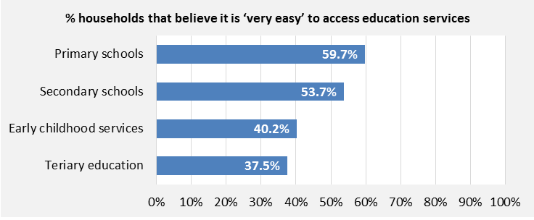

What role does Council play?
Council works with local schools and the Department of Education to ensure that schools meet the educational and social interests of local students and their families. Council also advocates to, and works with the Victorian Government to deliver new schools in growth areas to provide more educational opportunities and choice for the community. Advocating to the Victorian Government regarding the timely delivery of schools is identified as one of Council’s key advocacy priorities.

Living sustainably
Environmental sustainability

Household energy usage

Why is this indicator important?
Household energy use is a key contributor to greenhouse gas emissions, which damage our environment and communities. Reducing greenhouse gas emissions through methods such as reduced household energy use in the community can minimise the impact of climate change.

How is this measured?
The Northern Alliance for Greenhouse Action (NAGA) analyses electricity consumption data supplied by Victoria's energy distribution companies. Data for 2015 and 2016 is not yet available.

How are we tracking?

Trend: Progressing
In 2014, residents of the City of Whittlesea consumed on average 4.5kWh of electricity per day. This is a decrease from 4.9kWh in 2013. There is no equivalent data available across the State, although NAGA regional data suggests that electricity consumption in the City of Whittlesea was slightly lower in 2014.

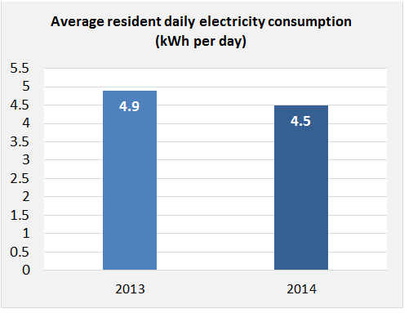

What role does Council play?
The City of Whittlesea’s Environmental Sustainability Strategy 2012-2022 has an aim to reduce the greenhouse gas emissions generated by community, as well as Council. Council facilitates programs, such as the Positive Charge solar bulk buy program, and plays an important role educating and raising awareness about household emissions, encouraging individuals to adapt lifestyle habits and to become more resilient to climate change.

Household waste generation

Why is this indicator important?
Responsible and sustainable waste management, including the appropriate diversion of waste from landfill, is important for good public health, to protect the environment and to reduce air and water pollution. Waste generation is closely linked to household consumption patterns and is a clear measure of progress towards the sustainable use of resources.

How is this measured?
Household waste generation is measured by the average annual waste production per household. Waste includes residential and commercial material that goes to landfill, including kerbside waste and hard rubbish collections. It does not include material that is recycled. This data is provided by Council’s waste management contractors on an annual basis.

How are we tracking?

Trend: Progressing
In 2015-16, on average there was 620 kilograms of waste per household. This has steadily declined and is 14% lower than in 2012-13.

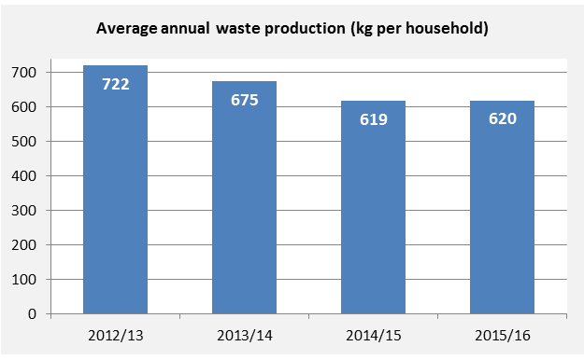

What role does Council play?
The provision of kerbside waste collection services to the municipality is one of Council’s essential responsibilities. Council also plays a role in educating the community about the responsible management of waste including recycling, composting and sustainable use of resources.

Household recycling contamination

Why is this indicator important?
Recycling measures materials diverted from landfill and is indicative of the community’s knowledge of, and commitment to, sustainable practices. Material contaminants in recycling bins leads to this resource being re-directed to landfill, which is a resource loss for the community and an added cost to the environment.

How is this measured?
Household recycling contamination is measured as the average percentage (by kilogram of weight) of waste per household that does not belong in recycling bins, such as food and bagged domestic garbage. Contaminants are materials that cannot be recycled through the kerbside recycling bin collection service. This data is collected through Council’s annual Domestic Waste and Recycling Audit and provides a snapshot of the material contaminants in recycling at the time the audit is undertaken.

How are we tracking?

Trend: No meaningful change
In 2016, on average, 12.3% of the material in household recycling bins was considered to be contaminants. The proportion of contaminants has changed only marginally over the past four years, fluctuating around 11-13%.
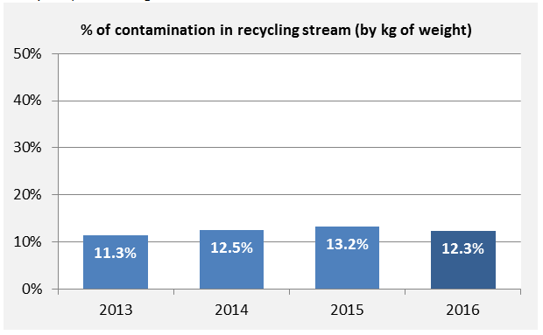

What role does Council play?
The provision of kerbside waste collection services to the municipality is one of Council’s essential responsibilities. Council also plays a role in communicating the ‘Recycle Right’ message to residents through face to face education and community engagement.

Household water usage

Why is this indicator important?
The efficient management of water resources is essential to individual and community wellbeing and for the protection of biodiversity and ecological systems. The sustainable use of our water resources in the community is imperative to ensure water security for people and the environment into the future.

How is this measured?
Household water usage is measured by Yarra Valley Water, the retail water utility that services Melbourne’s northern and eastern suburbs. Yarra Valley Water record property water usage and provide this data directly to City of Whittlesea in a summarised form.

How are we tracking?

Trend: No meaningful change
In 2015-16, on average, each residential property in the City of Whittlesea used 168 kilolitres (168,000 litres) of water. This is equivalent to approximately 460 litres per property, per day. This average figure has fluctuated only marginally over the past four years and is therefore not considered a meaningful change. In comparison with the Melbourne average, 2014-15 data suggests per person daily water usage in the City of Whittlesea is slightly lower (152 litres versus 160 litres).
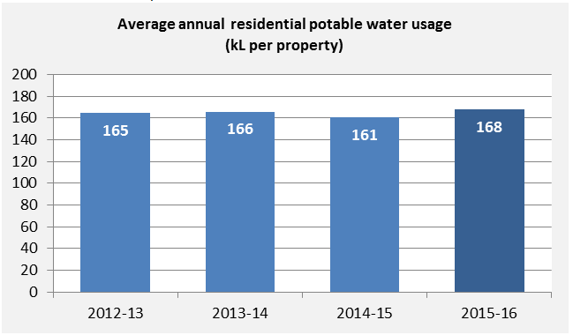

What role does Council play?
Council provides environmental education programs to encourage the community to adopt more sustainable water consumption practices, such as the showerhead exchange program. Council also looks for innovative ways to reduce potable water use across Council facilities such as sports fields. This includes the utilisation of alternative water sources such as harvested stormwater, tanks and recycled water in open space planning, design and operation.

Stewardship of the environment

Why is this indicator important?
Responsible use and protection of the natural environment, through conservation and sustainable practices and actions, has a positive impact on local biodiversity and the long term health of the natural environment and people. There are also health and wellbeing benefits to people that experience connection with the natural environment.

How is this measured?
Stewardship of the environment is measured by the number of active community-based groups that are committed to responsible use and protection of Whittlesea’s natural environment through conservation and sustainable practices. Community-based environmental groups include local ‘Friends’ groups, community garden groups and land conservation/management groups (i.e. Landcare). The number of groups is monitored by Council’s Sustainability Planning Department.

How are we tracking?

Trend: No meaningful change
In 2016, there were 12 active community-based environmental groups working in the City of Whittlesea. Five of these groups are ‘Friends’ groups that focus on tree planting, weeding, nest box programs and other environmental preservation activities. There is one land management focussed group, and six community garden groups. In 2016, a new group was established and one longstanding group disbanded. This resulted in the total number of groups remaining constant since 2013.

What role does Council play?
Council provides support services to groups including specialist environmental advice, resources for workshops, and support for funding applications. Through a new project that will establish a network for community gardens and conservation groups, Council will provide opportunities for information sharing, collaboration, mentoring and training for groups. Council also supports individual stewardship of the environment through incentive schemes (Environmental Works Grant and Sustainable Land Management Rebate Scheme) and on-site advice for land owners.

Good governance
Customer centred operations
Growth and change
Resource management
Continuous improvement

Community consultation and engagement

Why is this indicator important?
Community engagement is a valuable process to ensure communities are provided with the opportunity to participate in decisions which affect them at a level that meets their expectations, and to strengthen and enhance the relationship between communities and governments.

How is this measured?
Community satisfaction with Council’s performance on community consultation and engagement is measured every year through the state-wide Local Government Community Satisfaction Survey. Participants are asked to rate Council’s performance on a scale from ‘very good’ to ‘very poor’.

How are we tracking?

Trend: Progressing
In 2016, 45% of individuals surveyed rated Council’s performance on community consultation and engagement as ‘good’ or ‘very good’. This is a small improvement from 2013. It is also a better result than the state-wide average in 2016 of 37%.

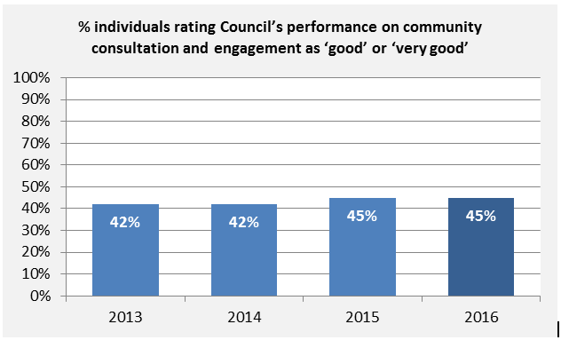

What role does Council play?
Through the City of Whittlesea’s Community Building Strategy and Consultation and Engagement Framework, Council is committed to ensuring citizens are informed and consulted about the decisions that affect their lives and are able to fully participate in decision making processes. Council fulfils these responsibilities by directly consulting on matters under Council control, and assisting or advocating to other stakeholders to consult with community on important issues and opportunities outside of Council’s control.

Decisions in community’s interest

Why is this indicator important?
Councils are empowered by law to make decisions on behalf of local communities. Decision-making processes that are transparent, responsive, equitable and inclusive, help ensure that decisions are made in community’s interest.

How is this measured?
Community satisfaction with Council’s performance on decisions made in the interest of the community was measured for the last two years through the state-wide Local Government Community Satisfaction Survey23. Participants are asked to rate Council’s performance on a scale from ‘very good’ to ‘very poor’. This question was included in the survey for the first time in 2015.

How are we tracking?

Trend: Regressing
In 2016, 43% of individuals surveyed rated Council’s performance on making decisions in the interest of the community as ‘good’ or ‘very good’. This is a moderate and significant decline from the 2015 result of 50%; however, it is a higher result than the state-wide average in 2016 of 36%.

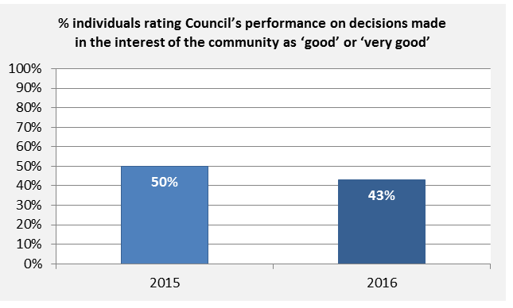

What role does Council play?
The Local Government Act requires the elected Councillors, the Chief Executive Officer and staff to carry out their roles with impartiality, integrity and accountability when making decisions that affect the community. Council is guided by robust decision-making processes, including the use of evidence and community consultation and engagement to determine our community direction.

Lobbying for community

Why is this indicator important?
To meet the needs and aspirations of the community, Council has an important role to advocate on matters beyond the control of Council or community, such as improved services and infrastructure, or on social issues.

How is this measured?
Community satisfaction with Council’s performance on lobbying on behalf of the community is measured annually through the state-wide Local Government Community Satisfaction Survey23. Participants are asked to rate Council’s performance on a scale from ‘very good’ to ‘very poor’.

How are we tracking?

Trend: Progressing
In 2016, 38% of individuals surveyed rated Council’s performance on lobbying on behalf of the community as ‘good’ or ‘very good’. This is a moderate improvement from the 2013 result (33%), and better than the state-wide average in 2016 (28%); however, the results have fluctuated considerably over the past four years.

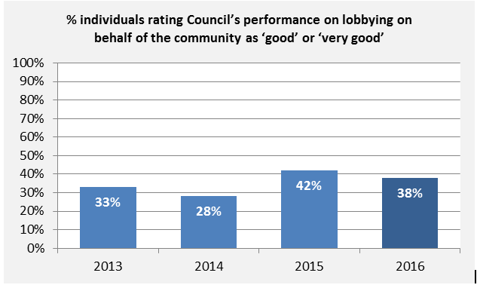

What role does Council play?
The City of Whittlesea Advocacy Strategy guides Council’s role in direct advocacy, facilitating and resourcing partnerships, building an evidence base and supporting the community to advocate on their own behalf. By working in partnership, Council has successfully advocated for important human services and a number of large infrastructure projects including the train extension, upgrades to roads, schools and community facilities.

Council’s overall performance

Why is this indicator important?
High satisfaction with the overall performance of Council indicates that the various roles we perform as provider, facilitator or advocate are meeting the needs and expectations of our community.

How is this measured?
Community satisfaction with overall Council performance is measured annually through the state-wide Local Government Community Satisfaction Survey23. Participants are asked to rate on a scale from ‘very good’ to ‘very poor’ how they perceive the performance of Council, not just on one or two issues, but overall across all responsibility areas.

How are we tracking?

Trend: No meaningful change
In 2016, 58% of individuals surveyed rated Council’s overall performance as ‘good’ or ‘very good’. This is a marginal improvement from the 2013 result of 57%, but the difference is not large enough to be considered meaningful. It is, however, a better result than the state-wide average in 2016 of 45%.

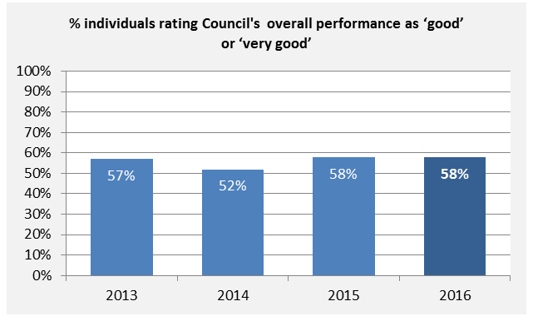

What role does Council play?
Council maintains transparency and accountability by reporting back to the community on progress, achievements and areas for improvement through a range of key reporting mechanisms including the Annual Report, the Local Government Performance Reporting Framework and Know Your Council website.

Data notes
- For most indicators, the magnitude of change described in ‘How are we tracking’ is based on the percentage point difference or percentage change between baseline and the most recent data. A marginal change was classified as <2%; small change 2<5%; moderate change 5<10%; and large change 10% or more.
- Where feasible due to known sample size, statistical tests were used to determine whether differences were statistically significant at the 95% confidence level. Where differences are statistically significant, the term ‘significant’ is used in the description.

____________________________________________

For more information about this report, please contact the City of Whittlesea Research team
p. (03) 9217 2012
e. ResearchTeam@whittlesea.vic.gov.au

References

“Largest growth” refers to the change in number of residents between June 2014 and June 2015. “Fastest growth” refers to the change in number of residents as a proportion of the population at June 2014.
profile.id (2016). City of Whittlesea Community Profile. Available: www.profile.id.com.au/whittlesea [accessed December 2016]
atlas.id (2016). City of Whittlesea Population Demographics. Available: www.atlas.id.com.au/whittlesea [accessed December 2016]
City of Whittlesea (2016). Annual Household Survey 2016 Municipal Report. Available: https://www.whittlesea.vic.gov.au
forecast.id (2016). City of Whittlesea Population Forecasts. Available: www.forecast.id.com.au/whittlesea [accessed December 2016]
Australian Bureau of Statistics (2016). Regional Population Growth, Australia, 2014-15 (cat. No. 3218.0). Available: www.abs.gov.au/AUSSTATS/abs@.nsf/DetailsPage/3218.02014-15?OpenDocument [accessed December 2016]
Parliament of Victoria Outer Suburban/Interface Services and Development Committee (2012). Inquiry into liveability options in outer suburban Melbourne Parliamentary paper. Available: http://www.parliament.vic.gov.au/57th-parliament/osisdc/article/1348 [accessed January 2017]
City of Whittlesea (2016). Internal data extracted and analysed with the City of Whittlesea’s Geographic Information System (WiGIS) and ESRI spatial analysis software[accessed October 2016]
City of Whittlesea (2014). Annual Household Survey 2014 Municipal Report. Available by contacting the City of Whittlesea Research Team.
Victorian Government Department of Employment (2016). Small Area Labour Markets – June quarter 2016. Available: https://docs.employment.gov.au/node/34693 [accessed December 2016]
economy.id (2016). City of Whittlesea Economic Profile: Employment (Census) by industry. Available: www.economy.id.com.au/whittlesea/Employment-census [accessed December 2016]
City of Whittlesea (2015). Annual Household Survey 2015 Municipal Report. Available by contacting the City of Whittlesea Research Team.
Victorian Government Department of Health and Human Services (2016). Victorian Population Health Survey 2014: Modifiable risk factors contributing to chronic disease. Available: https://www2.health.vic.gov.au/public-health/population-health-systems/health-status-of-victorians/survey-data-and-reports/victorian-population-health-survey/victorian-population-health-survey-2014 [accessed December 2016]
Victorian Commission for Gambling and Liquor Regulation (VCGLR) (2016). Data: Gambling data. Available: www.vcglr.vic.gov.au/home/resources/data+and+research/data/ [accessed December 2016]
Victoria Police, Crime Statistics Agency. Family incidents to year ending March 2016. Available: https://www.crimestatistics.vic.gov.au/crime-statistics/latest-crime-data/family-incidents-0 [accessed December 2016]
Australian Government Department of Education and Training (2016). Australian Early Development Census data explorer: Whittlesea community. Available: https://www.aedc.gov.au/data/data-explorer?id=62197 [accessed December 2016]
Victorian Government Department of Education and Training (2016). Victorian Child and Adolescent Monitoring System. Available from: http://www.education.vic.gov.au/about/research/Pages/vcamstableau.aspx [accessed December 2016]
Northern Alliance for Greenhouse Action (NAGA) (2015). Municipal energy profiles. Available directly on request from NAGA and via website: http://www.naga.org.au/municipal-energy-data.html [accessed December 2016]
City of Whittlesea (2016). Waste data provided by the City of Whittlesea’s waste management contractors and compiled internally [accessed January 2017]
City of Whittlesea (2016). Internal data extracted from the City of Whittlesea’s Domestic Waste Audit [accessed December 2016]
Yarra Valley Water (2016). City of Whittlesea community water usage data. Provided to City of Whittlesea in summarised form on request.
Melbourne Water (2016). Water Outlook 2015. Available: http://www.melbournewater.com.au/getinvolved/saveandreusewater/Documents/Water%20Outlook%20December%202015.pdf [accessed December 2016]
City of Whittlesea (2016). Internal data extracted from the City of Whittlesea’s Sustainability Planning Department [accessed December 2016]
Victorian Government Department of Environment, Land, Water and Planning (2016). Local Government Community Satisfaction Survey: Whittlesea City Council 2016 Research Report. Available: https://www.whittlesea.vic.gov.au/about-us/news-publications/latest-news/local-government-community-satisfaction-survey-2016-results/ [accessed December 2016]

