Trading Application Form 2019 – 2020
Application for Use of Footway
FOOTPATH TRADING APPLICATION FORM 2022-2023
APPLICANT DETAILS: |  |  |  |  |  |  |  |  |  |  |  |  | HOME PHONE:
GIVEN NAMES: |  |  |  |  |  |  |  |  |  |  |  |  | BUSINESS PHONE:
SURNAME: |  |  |  |  |  |  |  |  |  |  |  |  | MOBILE PHONE:
BUSINESS NAME (if applicable):
EMAIL ADDRESS:
BUSINESS ABN NUMBER:
STREET ADDRESS:
SUBURB: |  |  |  |  |  |  |  |  |  |  |  | POSTCODE:
WHAT LOCATION IS THIS PERMIT REQUIRED FOR:
STREET ADDRESS:
SUBURB: |  |  |  |  |  |  |  |  |  |  |  | POSTCODE:
WHAT TYPE OF PERMIT DO YOU REQUIRE:(PLEASE TICK)
 A FRAME SIGNS - $88.70 per sign |  TABLES AND CHAIRS ON FOOTPATH, UP TO 2 TABLES - $102   TABLES AND CHAIRS ON FOOTPATH, 3 TABLES OR MORE - $170
 DISPLAY OF GOODS ON FOOTWAY - $51 PER SQUARE METER  TOTAL SQUARE METERS: ______ TOTAL AMOUNT: $_______ |  HAVE YOU SPOKEN TO ANYBODY AT COUNCIL BEFORE APPLYING
SECTION A – A FRAME SIGNS
HOW MANY SIGNS DO YOU WISH TO DISPLAY?
 ^{ONE} |  |  |  ^{TWO}
WHAT SIZE ARE THE SIGNS? PLEASE PROVIDE DIMENSIONS. (HEIGHT X WIDTH)
^{ONE} |  |  |  |  | ^{TWO}
WHERE ARE THE SIGNS LOCATED?
^{ONE} |  |  |  |  |  | ^{TWO}
Please note that standard sign size is 0.9 metres x 1.1 metres. Fee $88.70 per A Frame sign.
SECTION B – DISPLAY OF GOODS/TABLES AND CHAIRS
^{ YES} | ^{ NO} | DO YOU WISH TO DISPLAY/USE UP TO 2 TABLES? FEE $102.00
^{ YES} | ^{ NO} | DO YOU WISH TO DISPLAY/USE 3 TABLES OR MORE? FEE $170.00
^{ YES} | ^{ NO} | DO YOU WISH TO DISPLAY GOODS ON THE FOOTPATH? (Fruit Display, the Selling of Goods etc). FEE $51.00 per square metre
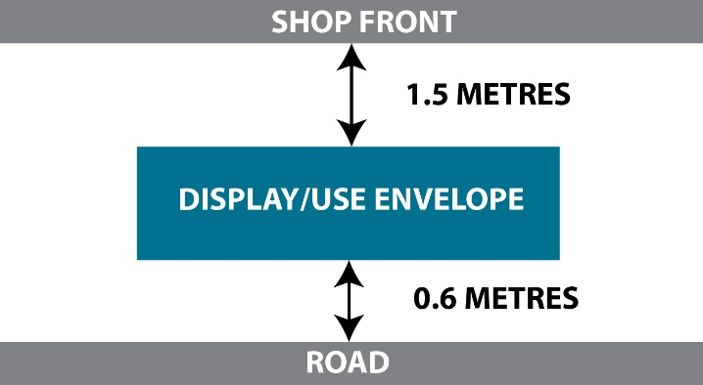

RULES OF FOOTWAY USE
 ^{YES} |  ^{NO} | DO YOU UNDERSTAND THE DISPLAY/USE ENVELOPE FOR YOUR BUSINESS?
 ^{YES} |  ^{NO} | DO YOU UNDERSTAND THAT THE PERMIT IS VALID ONLY DURING THE OPENING HOURS OF YOUR BUSINESS?
 ^{YES} |  ^{NO} | DO YOU UNDERSTAND THE REQUIREMENT TO KEEP AND MAINTAIN CURRENT PUBLIC LIABILITY INSURANCE WITH AT LEAST $20 MILLION INDEMNITY?
 ^{YES} |  ^{NO} | HAVE YOU ATTACHED A COMPLETE COPY OF YOUR PUBLIC LIABILITY INSURANCE POLICY?
 ^{YES} |  ^{NO} | FOR NEW FOOTPATH TRADING APPLICATIONS, WOULD YOU LIKE COUNCIL TO COVER YOUR PUBLIC LIABILITY INSURANCE? (You must apply before 30 June 2022 to be eligible, and the cover will expire on 30 September 2022. Please note, this offer is only valid for the placement of Tables and Chairs).
 ^{YES} |  ^{NO} | HAVE YOU READ AND UNDERSTOOD THE FOOTPATH TRADING GUIDELINES?
 ^{YES} |  ^{NO} | DO YOU AGREE TO MEET AND COMPLY WITH THE FOOTPATH TRADING GUIDELINES?
APPLICANT NAME: |  | SIGNATURE OF APPLICANT: |  | DATE: / /

OFFICE USE ONLY

FEE $ ________________________________________ DATE PAID: / /

FEE PAYABLE | A FRAME ADVERTISING SIGNS - $88.70 per sign.  TABLES & CHAIRES UP TO 2 TABLES - $102.00.  TABLES & CHAIRES 3 TABLES OR MORE - $170.00.  DISPLAY OF GOODS PER SQUARE METER - $51.00. (Total Square Meters) = _____________
ACCOUNT NUMBER | 12201.33100.61001 | Rec. Type: 410
RECEIPT NUMBER

City of Whittlesea is committed to its obligations under the Privacy & Data Protection Act 2014 (Vic.) All personal information collected by Council will be used for Council business purposes and kept confidential. It will not be disclosed to third parties unless Council is required to disclose the information under other legislation or disclosure is necessary to complete the purpose for which it is sought. You may access information you have provided to Council and make corrections if you believe that information is incorrect. For further information including Council’s information privacy policy please visit our website at www.whittlesea.vic.gov.au

