City of Whittlesea Soccer Strategy
April 2018

Acknowledgement of Traditional Owners
The City of Whittlesea recognises the rich Aboriginal heritage of this country and acknowledges the Wurundjeri Willum Clan as the Traditional Owners of this place.
Broader acknowledgements and thanks
City of Whittlesea would also like to acknowledge the support and assistance provided by:
- Victorian Government in partnering to develop the strategy
- Council staff who contributed to the completion of this project and provided their input
- Football Federation Victoria, all local soccer clubs and individuals who generously provided their time for interviews, filled in a survey or contributed in some way to the strategy
- SGL Consulting Group in helping to prepare the Soccer Strategy.

Table of Contents

Executive Summary 4
Overview 6
Demographic Snap Shot - City of Whittlesea 7
Soccer in Whittlesea 8
Comparison to State Averages 9
Existing Facility Provision & Standards 10
Current Facility Provision 10
Facility Review 11
Epping Soccer Stadium 11
Proposed Future Provision 11
Synthetic Surfaces 12
Consultation and Engagement 14
Strategy Implementation and Review 14
Soccer Strategy Action Plan 15

Executive Summary
As with the rest of Australia, soccer participation within the City of Whittlesea is increasing. Soccer participation has increased by 24% over the last five years. In 2017, there were 2416 registered players across 11 soccer clubs and potentially over 6,000 people associated with soccer in the Whittlesea area. City of Whittlesea has a strong soccer culture and is ranked ninth out of 79 Victorian municipalities with soccer in terms of soccer participation.
In recent years the sport has increased its national profile through healthy, elite, national competitions (A-League and W-League) and stronger development pathways for both men and women with the introduction of the National Premier League competition.
Given the current and anticipated future population growth and the developments of the sport, there is a clear need for a strategy to assist in the planning and delivery of soccer within the municipality.
In developing the Soccer Strategy, a comprehensive review of the sport including current industry trends, State trends, a facility audit and participation rates has been undertaken. To support this research, a consultation process was undertaken that included multiple sessions with all local soccer clubs, discussions with Football Federation Victoria and broad community consultation. The review identified the following key findings:
Participation and Growth
Participation in soccer is growing; this is being led primarily by a strong increase in junior participation. Female participation is comparatively low and declining.
Ground Capacity and Use
A number of existing facilities are at, or exceeding, capacity and cannot support the forecast demand. Furthermore, there are a number of facilities that require upgrades to the playing surfaces, training lights and the clubrooms to cater for increased participation.
Epping Soccer Stadium
The annual cost for maintenance of the Epping Soccer Stadium is significant, approximately $240K per annum. The cost should be noted against analysis that shows the stadium is under-utilised and does not adequately meet the needs of either local or elite clubs.
Growth Areas
Planning for future soccer facilities proposes that another 11 new soccer facilities (26 pitches) are to be built over the next 20 years. This will be a significant capital cost.
Synthetic Surfaces
While the initial capital cost to provide synthetic surfaces is approximately $1.3 million, a review of soccer facilities that have either been developed or redeveloped with a synthetic surface indicated substantial benefits in terms of volume of use and severe weather tolerance (i.e. drought or heavy rain). The provision of an all-weather surface enables large numbers of teams to train and play on the pitch without causing damage or overuse issues and subsequent closures, which are common with a turf pitch.
To address these key findings, a five-year plan has been developed involving five objectives and 26 actions. Delivery on these objectives and actions will enable the sport to continue to grow and cater to the needs of the Whittlesea community.
Strategic Objectives
- Ground allocations
In collaboration with all soccer clubs, review current ground allocations and where required make appropriate changes to meet facility, club and programmatic needs.
- Equitable facility provision
Plan the future upgrade and redevelopment of existing facilities and potential development of new facilities to meet the identified need and predicted growth in soccer.
- Epping Soccer Stadium
Identify the required actions to improve the use of the elite Epping Soccer Stadium to maximise the benefits of this community asset.
- Female participation and growth
Address the low ratio and decline in female participation in the municipality.
- Player pathways
Ensure a pathway of participation through the provision of facilities and services to support and encourage all levels of soccer competition and involvement from grass roots through to elite.
A five-year Action Plan outlining the timeline and expected outcomes of all actions is included as Part Two of this strategy.
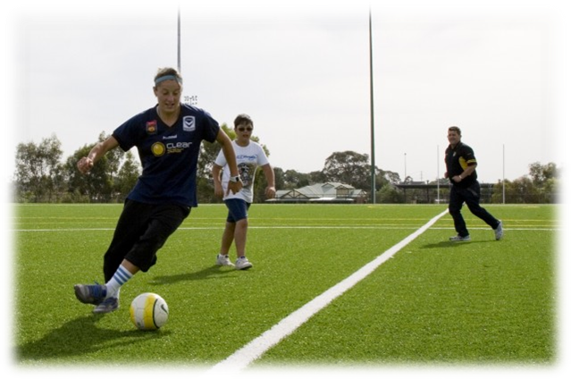

Overview
Soccer is often referred to as ‘football’; however, given the strong presence of Australian Rules football in Victoria and the possible confusion between the codes, the Strategy will refer to the round ball version of football as soccer (except where a club or organisation uses ‘Football’ in their name).
The sport of Soccer has the third highest participation rate in the municipality behind Australian Rules Football and Basketball and plays a key role in providing an outlet for physical activity.
As with the rest of Australia, soccer participation within the City of Whittlesea is growing; increasing by 24% over the last five years. In 2017, there were 2416 registered players across 11 soccer clubs in the Municipality.
The City of Whittlesea’s previous soccer strategy was drafted in 2002. Given the current and anticipated population growth, and changes to the sport since this date, there is a clear need for a contemporary strategy to be agreed and implemented.
This strategic document will guide the provision and development of services, facilities and soccer programs over the next ten years, with the associated five year action plan.
Based on discussion with the key stakeholders, the goal of the City of Whittlesea Soccer Strategy is to ensure all residents have equitable access to soccer programs, services and facilities in line with the recommended facility standards.
This strategy has three parts:
Part One: Provides the strategy rationale, evidence, demographic breakdown and five strategic directions to be addressed
Part Two: Provides an Action Plan to be delivered over the next five financial years from 2018/19 and 2022/23. An Action Plan for the following five years will be developed in 2023.
Part Three: Includes the background research and supporting information for the strategy (available on request).

Demographic Snap Shot - City of Whittlesea
To ensure the Soccer Strategy considers the community’s demographic profile, a detailed demographic analysis was undertaken with a snap shot provided below:
The 2018 population is approximately 223,000 residents and will continue to grow.
Population is expected to reach 263,000 by 2021 (+18%) and 300,000 (+35%) persons by 2028.
Whittlesea is home to Australia’s fastest growing suburb over the last ten years - South Morang.
Growth is not just occurring in the newer suburbs, there is also growth and redevelopment planned in established suburbs such as Epping, Thomastown and Lalor due to urban infill.
Currently there is a higher than average number of people aged 25 or under living in the City of Whittlesea and a lower proportion of people in older age groups.
Whittlesea is one of the most multicultural municipalities in Victoria, with almost half of residents ‘speaking a language other than English at home’. Residents come from a range of backgrounds with a very high percentage born in other countries, particularly Italy, Macedonia, Greece and India.
The established areas of Thomastown, Lalor and Epping contain a greater proportion of people from migrant backgrounds than other parts of the municipality. These residents bring with them many aspects of their own cultures, which contribute greatly to the character and identity of the City of Whittlesea.
Analysis of household income levels in the City of Whittlesea in 2011 compared to Greater Melbourne shows there was a smaller proportion of “high income” households i.e. those earning $2,500 or more per week (12.9% compared to 19.4%).
Implication for Soccer
Council will have to ensure that, as the community grows, there is equitable access to quality recreation facilities that reflect community needs. The expected increase in population will create increased demand for quality community infrastructure including soccer facilities. Significant population growth has occurred along the north-east corridor of the municipality, in particular the South Morang and more recently, Mernda areas. This growth suggests this area should be prioritised for the development of new soccer facilities in the short term.
The main soccer participants are predominantly aged between 5 years and 49 years. A review of the current population indicates that there are 130,797 people within this age grouping in Whittlesea representing 65% of the population.
The larger proportion of young residents (those under 15 years old) indicates the need to provide specific facilities for junior and sub-junior (MiniRoos) participants. This may require the addition of dedicated MiniRoos pitches at new and redeveloped soccer facilities. In addition, pitches should be designed with appropriate run offs to allow two small cross-pitch games to be operated.
The high proportion of residents from European countries that are both strong participants and supporters of soccer is one factor contributing to the large soccer participation rate in Whittlesea. This strong culture of soccer in the municipality will ensure a continued strength of the local competition and clubs.
Policy Context
The Strategy is linked to a range of existing Council Plans and Policies, most notably, Shaping Our Future: Whittlesea 2030 Strategic Community Plan. The Community Plan details our community’s vision for the City of Whittlesea to the year 2030. It provides direction for the provision of key projects and services that enable Council to meet the needs of the local community through the delivery of quality sport and recreation services and facilities. It identifies seven Future Directions to achieve this vision. This Strategy directly supports Future Direction 4 – Places and Spaces to Connect People and the associated Strategic Objective “We can access recreational facilities and open spaces that reflect and respond to local need”.
The plan is also linked to the Victorian State Government’s Active Victoria, which has a focus on increasing capacity of existing infrastructure to meet increasing demands as well as ensuring that participation is diverse and inclusive.
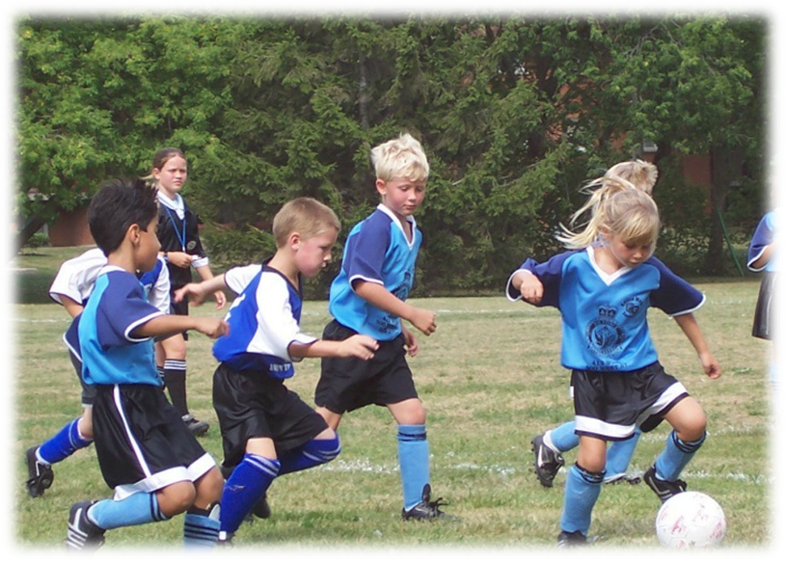

Soccer in Whittlesea
In 2017, The City of Whittlesea accommodated 11 soccer clubs with a total membership of 2,416 players. While the number of supporters, parents, volunteers and committee members involved with soccer clubs is not known, conservatively assuming for every one registered player there are two additional people affiliated with a club, this equates to 7,248 people involved with soccer.
The Clubs are affiliated with either of the following two soccer associations:
- Football Federation Victoria (FFV).
- Victorian Churches Soccer Association (VCSA).
Ten out of the eleven soccer clubs are affiliated with FFV, which is the recognised State governing body for soccer in Victoria; the Khalsa Lions Soccer Club is affiliated with the VCSA.

Table 1: Whittlesea Soccer Participation 2017
Club Name | Total Players | Males | Females | MiniRoos  (4 – 11 yrs) | Juniors  (12 – 18 yrs) | Seniors  (19 – 35 yrs) | Over 35’s  (35+ yrs)
Bundoora United Football Club | 472 | 384  (81%) | 88  (19%) | 180 | 227 | 62 | 3
Epping City Soccer Club | 312 | 270  (87%) | 42  (13%) | 111 | 107 | 70 | 24
Khalsa Lions Football Club | 135 | 95  (91%) | 40  (9%) | 20 | 45 | 55 | 15
Lalor United Football Club | 309 | 276  (89%) | 33  (11%) | 138 | 110 | 37 | 24
Mill Park Soccer Club | 375 | 333  (89%) | 42  (11%) | 134 | 161 | 65 | 15
Plenty Valley Lions Football Club | 154 | 136  (88%) | 18  (12%) | 55 | 57 | 38 | 4
Sporting Whittlesea Football Club | 63 | 63  (100%) | 0 | 17 | 31 | 15 | 0
Thomastown Raiders Football Club | 129 | 124  (96%) | 5  (4%) | 63 | 66 | 0 | 0
Uni Hill Eagles Football Club | 78 | 71  (91%) | 7  (9%) | 14 | 4 | 53 | 7
Whittlesea Ranges Football Club | 285 | 266  (93%) | 19  (7%) | 107 | 140 | 13 | 25
Whittlesea United Soccer Club | 104 | 85  (82%) | 19  (18%) | 7 | 34 | 46 | 17
WHITTLESEA TOTAL | 2416 | 2103  (87%) | 313  (13%) | 846 | 982 | 454 | 134

Comparison to State Averages
A review of Whittlesea soccer participation against state participation averages indicates:
- On average, there are 100 registered players per senior soccer pitch (not including Epping Soccer Stadium) in Whittlesea; this is in comparison to the state average of 116 per pitch. Whilst the supply of pitches appears high when compared to the state average, several clubs have indicated the poor quality of some playing surfaces (due to sub-surface conditions) impacts the capacity of the grounds to accommodate current demands.
- Soccer participation in Whittlesea has increased by 24% over the past five years; higher than the State average (15.4%).
- Male participation in Whittlesea has increased at a higher rate (30%) than the State average (18%).
- Whittlesea has a low female participation rate compared to the State average (13% Whittlesea, 19% Victoria). In addition, female participation has declined by 4% since 2013.
- Over the last five-years, junior participation (including MiniRoos) has increased at a higher rate in Whittlesea (41%) than the State average (16.3%).

Existing Facility Provision & Standards

Current Facility Provision
There are currently 14 facilities used for soccer with a total of 28 soccer pitches located within the City of Whittlesea. Of the 28 pitches, 24 have a turf surface, four have a synthetic all weather surface and three are MiniRoos pitches. There is a large variance in the quality of the facilities used by local clubs.
Figure 1 details the location of the 14 soccer facilities (with Epping Soccer Stadium and Harvest Home Road Recreation Reserve located within the same complex). The map clearly shows the concentration of existing soccer facilities in the established areas of Whittlesea, which is expected given the high proportion (70%) of rural land in the municipality.
Figure 1: Whittlesea Current and Future Soccer Facilities
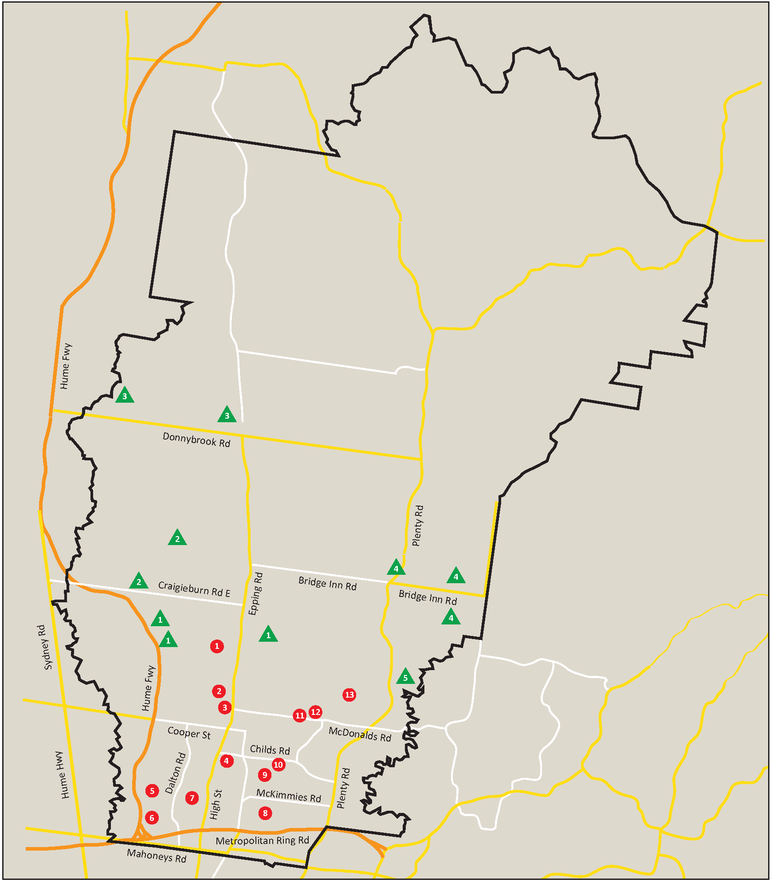

Facility Review
In preparing this strategy, a review of the soccer facilities was undertaken. The review highlights that the majority of facilities do not meet the requirements of the sport or local clubs. There are major gaps in the provision of appropriate soccer facilities at some venues, including the number of available change rooms, particularly to cater for female participants, field lighting to minimum standards and social spaces. In addition, a number of the facilities have ageing infrastructure that does not meet contemporary standards.
This Strategy recommends improving the infrastructure at a number of venues to not only meet recognised standards but also give consideration to Universal Design to ensure these facilities are catering for a diverse range of users. These items are identified and prioritised within the action plan.

Epping Soccer Stadium
Epping Soccer Stadium (ESS) provides the local community with an elite venue and a pitch that is maintained to a very high standard.
ESS is adjacent to Harvest Home Road Recreation Reserve; a three pitch soccer facility. ESS is considered a regional facility, which has regularly been used by local, national and international football teams as a training and match venue.
The Whittlesea National Premier League teams and the Melbourne Victory Youth League teams currently use the facility for home games. These clubs have expressed a concern about the high fee associated with the hire of the facility based on the quality/age of the support infrastructure.
The use of the ESS pitch is restricted to 12 hours per week; however, this is not impacting on current demand which is approximately 6-8 hours per week during the season. A review of the occupancy of this venue indicates it is under-utilised. Given the cost to maintain the pitch, a review of the usage and service level is required to ensure this asset is utilised to its maximum capacity.
Impacting ‘demand’ further is that the grandstand infrastructure is ageing and in need of an upgrade if it is to meet contemporary standards for both player amenities and spectators including change rooms, social areas, sports lighting, food and beverage and seating.
The Whittlesea Ranges and Melbourne Victory have jointly expressed interest in a more permanent arrangement at ESS. This is being explored separate to this strategy (See action 3.1).

Proposed Future Provision
Council has prepared a Community Infrastructure Report to inform the development of the individual Precinct Structure Plans (PSPs) for growth areas. Listed below are the proposed Soccer facilities highlighted in various (PSPs) and Local Structure Plans:
- Epping North – 3 facilities, 6 pitches
- Mernda/Doreen – 3 facilities, 6 pitches
- Wollert – 2 facilities, 6 pitches
- Donnybrook/Woodstock – 2 facilities, 6 pitches
- South Morang – 1 facility, 2 pitches
Football Federation Victoria (FFV) recommends one club to service approximately 20,000 residents as this makes for a sustainable club long-term and one that can be properly supported from FFV’s perspective.
Reviewing the established suburbs, each suburb has approximately two soccer clubs servicing the immediate area. Each club uses two to three pitches to operate.
The existing average is one club per 16,000 residents utilising 2.3 pitches, which is slightly lower than FFV’s recommendation of one club for every 20,000 residents. This equates to approximately one pitch for 7,000 residents.
Table 2 below provides a snapshot of the Municipality’s forecast population in 2036; proposed number of grounds; the number of existing grounds within that suburb; and the proposed ratio per-head of population. The final column in the table indicates the proposed clubs per suburb, based on a club using between 2 – 3 pitches, depending on the layout of the reserve.
Table 2: Growth Area Provision Assessment

Growth Area | Forecast Population (2036) | Proposed new Pitches | Existing Pitches | Total Pitches | Proposed pitch ratio per head of population | Proposed clubs per suburb based on current standards
Epping North | 51,562 | 6 | 4 | 10 | 1:5,156 | 4
Mernda/Doreen | 54,941 | 6 | - | 6 | 1: 9,156 | 3
Wollert | 31,911 | 6 | - | 6 | 1:5,318 | 2
Donnybrook | 36,571 | 6 | - | 6 | 1: 6,095 | 2
South Morang | 23,108 | 2 | 2 | 4 | 1:5,777 | 2

Table 2 indicates that Council will be providing soccer facilities in excess of the demand for those facilities based on the data.
While quantitative data alone is useful, planning also needs to take into account the qualitative aspects, such as club viability. Establishing and maintaining clubs requires hard work from many volunteers in areas such as club administration, coaching, sponsorship and membership. Clubs need to feel secure within their environment and not competing for members, FFV or Council support, sponsors and volunteers. Council wants to ensure the long-term viability of clubs.
FFV recommends, to ensure long-term club viability, a ratio of one club for every 20,000 residents. While this ratio can vary slightly depending on the demographic of the immediate area, Council should adopt this ratio when reviewing the growth area provision.
For example, Epping North precinct will ultimately house more than 50,000 residents at total build out, and the potential to house four soccer clubs within one suburb is not consistent with FFV’s recommendation (1 club: 20,000 residents) or the data from the established suburbs. In line with the evidence presented above, the number of clubs and facilities proposed for Epping North is excessive. It is proposed one Epping North soccer reserve be altered to cater for an alternative sport or be downgraded to an overflow facility. A detailed review will be undertaken to identify the most appropriate sites.
The planning that was done for PSPs and Local Structure Plans was relevant at that specific time. As planning moves closer to the implementation of the PSPs, it is now appropriate to review what was proposed to determine if the needs are still relevant.
It is recommended this process be reviewed at five-year intervals moving forward to ensure that community needs are being met.

Synthetic Surfaces
During our community consultations, a number of clubs identified the provision of synthetic surfaces as a means of increasing capacity of the facility and accommodating increased participation and use. While there are many recognised benefits associated with synthetic surfaces there is a need to develop a policy around the capital funding, maintenance and replacement of the surface at the end of its useful life.
Based on the significantly higher carrying capacity, extreme weather tolerance and the lower maintenance costs (and the acceptance as a surface by the governing body) all future facility developments should at a minimum include one synthetic soccer pitch. The retrofitting of synthetic pitches at existing facilities should be undertaken on a case by case basis; considering site conditions, existing membership base (particularly juniors) and forecast membership growth.
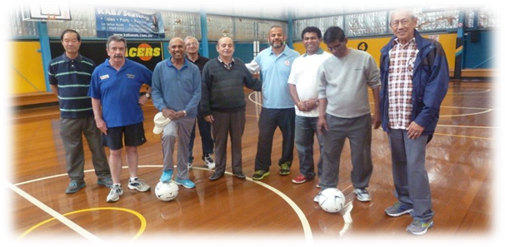

Consultation and Engagement
An extensive program of stakeholder and community engagement was undertaken to inform the Soccer Strategy.
Participating stakeholders included:
- Soccer clubs within the Whittlesea Council area
- FFV and VCSA
- Melbourne Victory and Melbourne City Football Clubs
- Neighbouring municipalities
- Sport and Recreation Victoria
- Internal Council officers workshop
- Community Survey.
The issues identified throughout the consultation period have informed the development of the strategy and associated Action Plan, a summary of the key issues identified throughout the consultation can be found in Part Three.

Strategy Implementation and Review
To achieve the strategic directions laid out in the strategy, a five-year action plan with 26 actions has been formulated. This Action Plan will guide the strategy from the financial year of 2018/19 until 2022/23.
All actions are based on current information and are subject to change if circumstances change. Therefore, before any action is delivered it should be tested against information at the time of implementation to determine if it is still valid.
Before any capital works actions are referred to Council’s New Works schedule, the action will be subject to the Project Management Framework including development of evidence based business cases. The costs provided in the implementation plan are provided as a broad indication of the likely costs to help inform Council’s overall strategic financial planning; however, actual costs are likely to vary from project to project and will be known through the development of detailed business cases. External grants may be available to offset Council costs.
Following the first five-year period, the Soccer Strategy will be reviewed to assess its currency and effectiveness. The Soccer Strategy will be updated with another five-year action plan developed for the remainder of the strategy.
Timing of each action is indicative only and will be subject to change follow annual budget review process.

Soccer Strategy Action Plan
Goal - All residents have equitable access to soccer programs, services and facilities in line with the recommended facility standards.
Objective 1 | Priority Actions | Timing | Cost Estimate | Outcome/Output
Ground Allocations:  In collaboration with all soccer clubs, review current ground allocations and where required make appropriate changes to meet facility, club and programmatic needs. | - Support Epping City Football Club in negotiating a lease extension and facility improvements at Casa D’Abruzzo Italian Social Club.  - Relocate Whittlesea Ranges FC and Thomastown Raiders FC to Harvest Home Road Recreation Reserve.  - Relocate Mill Park Soccer Club to Partridge Street Recreation Reserve.  - Allocate RGC Cook Recreation Reserve to Plenty Valley Lions Football Club.  - Relocate Whittlesea United Soccer Club to Mosaic Recreation Reserve.  - Allocate Findon Recreation Reserve to Uni Hill Eagles Football Club.  - Explore site options for a summer and winter allocation for the Khalsa Lions.  - Investigate longer term occupancy arrangements for all soccer facilities. | 2018/19  2019/20  2019/20  2019/20  2019/20  2019/20  2019/20  2018/19 | Within existing resources  Within existing resources  Within existing resources  Within existing resources  Within existing resources  Within existing resources  Within existing resources  Within existing resources | - All Clubs are relocated to a suitable venue by April 2020.  - Longer term tenancy agreements are in place by 2020.

Objective 2  Equitable facility provision :  Plan for the future upgrade and redevelopment of existing facilities and development of new facilities to meet the identified need and predicted growth in soccer. | Priority Actions  - Construct pavilion at Harvest Home Road Recreation Reserve.  - Construct two pitches and pavilion at Painted Hills Recreation Reserve.  - Construct two pitches and pavilion at Mosaic Recreation Reserve.  - Undertake a detailed review of the proposed recreation reserves in growth areas to identify the most appropriate sites based on contemporary needs assessment and cost estimates.  - Investigate redevelopment options for the Duffy Street Recreation Reserve pavilion to meet contemporary standards including female friendly design.  - Undertake pitch drainage works at Hillsview Recreation Reserve (turf pitch) to improve use capacity.  - Undertake pitch upgrade works to Partridge Street Recreation Reserve (eastern pitch) to improve the quality and capacity of the pitch.  - Extend pavilion as per agreed design and increase car parking at HR Uren Recreation Reserve.  - Design and install training standard sports lights at RGC Cook Recreation Reserve (western pitch).  - Minor pavilion extension to include an additional change room and greater storage at Hillsview Recreation Reserve.  - Undertake drainage and access works to pitch 1 at HR Uren Recreation Reserve. | Timing  Commenced  Commenced  Commenced  Commenced  2018/19  2019/20  2020/21  2020/21  2021/22  2022/23  2022/23 | Cost Estimate  $5,085,000  $7,575,000  $7,185,000  $20,000  *$1,300,000  *$700,000  *$1,300,000  *$1,000,000  *$150,000  *$500,000  *$700,000 | Outcome/Output  - Whittlesea’s soccer facilities have the capacity to cater for a 25% growth in participation (additional 600 players) by 2023  - Whittlesea’s soccer facilities have the capacity to cater for a 50% growth in participation (additional 1200 players) by 2028.
*Denotes costs are indicative only, with actual costs dependant on the development of business cases and detailed design.
Objective 3  Epping Soccer Stadium:  Improve the use of Epping Soccer Stadium to maximise the benefits of this community asset. | Priority Actions  - Develop a long-term occupancy agreement with Whittlesea Ranges and Melbourne Victory that delivers benefits to the broader community. | Timing  Commenced | Cost Estimate  Within existing resources | Outcome/Output  - Signed agreement that has measurable benefits to the community.
Objective 4  Female participation and growth:  Address the low ratio and decline in female participation in the municipality. | Priority Actions  - Prioritise capital works projects that encourage female participation through addressing ‘female friendly’ design.  - Work in collaboration with all clubs to establish a women’s NPL Club in Whittlesea to provide the pathway of participation for women. | Timing  On going  On going | Cost Estimate  Within existing resources  Within existing resources | Outcome/Output  - Increase female participation rate from 13% to 20% by 2023.  - By 2023 the number of women travelling out to other municipalities to participate in soccer is less than travelling in (positive migration).
Objective 5  Player pathways:  In collaboration with the soccer clubs, provide a pathway of participation through the provision of facilities and services to support and encourage all levels of soccer competition and involvement from grass roots through to elite. | Priority Actions  - Ensure that the delivery of community programs forms part of any Epping Soccer Stadium agreement.  - With assistance from FFV, develop and advertise an ‘expression of interest’ for the establishment of a tenant community club at Painted Hills Recreation Reserve.  - Remove seasonal allocation from any club running a private academy.  - Develop a Whittlesea Soccer Advisory Group with representatives from each club required to participate to help deliver action from the soccer strategy. | Timing  Commenced  2018/19  On going  Commenced | Cost Estimate  Within existing resources  Within existing resources  Within existing resources  Within existing resources | Outcome/Output  - An increase in the diversity of soccer programs available to the whole community.  - A functional club operating at Painted Hills Recreation Reserve by January 2020  - One soccer workshop held each year to discuss issues and projects.

Source: Profile Id 2011 Census data.
In late 2017 Sporting Whittlesea Football Club merged with Mill Park Soccer Club and will now be called the Mill Park Soccer Club.

